CONFIDENTIAL

GARRETT'S BIKE SHOP

WE OFFER HIGH-QUALITY BIKING GEAR FOR FAMILIES AND REGULAR PEOPLE, NOT JUST GEARHEADS.

BUSINESS PLAN

Prepared April 2016

CONTACT INFORMATION

 Alyssa Windell44 W Broadway #500alyssa@paloalto.comEugene, OR 97401, United States www.liveplan.com888-498-6136



GARRETT'S BIKE SHOP

i

CONFIDENTIAL DO NOT DISSEMINATE

. This business plan contains confidential, trade-secret information and is shared only with the understanding that you will not share its contents or ideas with third parties without the express written consent of the plan author.

Table of Contents

Executive Summary.........................................................................1

Opportunity...................................................................................................................................................................1Expectations..................................................................................................................................................................3

Opportunity.....................................................................................5

Problem & Solution.......................................................................................................................................................5Target Market...............................................................................................................................................................5Competition...................................................................................................................................................................6

Execution.........................................................................................8

Marketing & Sales.........................................................................................................................................................8Operations...................................................................................................................................................................10Milestones & Metrics..................................................................................................................................................11

Company.......................................................................................12

Overview.....................................................................................................................................................................12Team............................................................................................................................................................................13

Financial Plan.................................................................................14

Forecast.......................................................................................................................................................................14Financing.....................................................................................................................................................................16Statements...................................................................................................................................................................17

 Appendix.......................................................................................20

Profit and Loss Statement...........................................................................................................................................20Balance Sheet..............................................................................................................................................................27Cash Flow Statement..................................................................................................................................................34



GARRETT'S BIKE SHOP

1

CONFIDENTIAL DO NOT DISSEMINATE

. This business plan contains confidential, trade-secret information and is shared only with the understanding that you will not share its contents or ideas with third parties without the express written consent of the plan author.

Executive Summary

Opportunity

Problem

It's hard to buy a good bike in this town without being an "insider" cycling expert.

Solution

Garrett's is a snob free zone where regular people can get top notch gear and expert advice.

What We SellBicycles

. We sell new bicycles, predominantly in the mountain bike style, retro-cruiser is a close second, and sport/touring/racing road bikes a distant third. We also sell some used bikes which we take in on trade as a service to our customers who are buying new bikes.

Accessories.

 We offer a wide variety of accessories. Locks, computer speedometers, fenders, cargo racks, comfortable seats, headlights, helmets, water bottles, panniers/back packs/messenger bags, child seats and trailers, bike storage racks, and auto roof rack systems all fall in this category.

Clothing

. We rotate our clothing based on the season. For example, in Autumn, we stock jackets and Gore-Tex. In Winter, we offer helmet covers and liners, insulated jerseys and pants, gloves, and shoe covers. In the Spring, we start displaying summer jerseys, and racing shorts

Parts.

 Parts generally refers to pieces or materials necessary to the basic functioning of the bicycle. Generally, parts are installed during service and are an additional charge beyond the service fees.

Service

Garrett's Bike Shop is a full-service specialized bicycle shop. Our service offering includes, but is not limited to:•Free 30-day/100-mile tune up with every new bike sold.•Quick repairs for flat tires, broken chains, brake cables, etc.

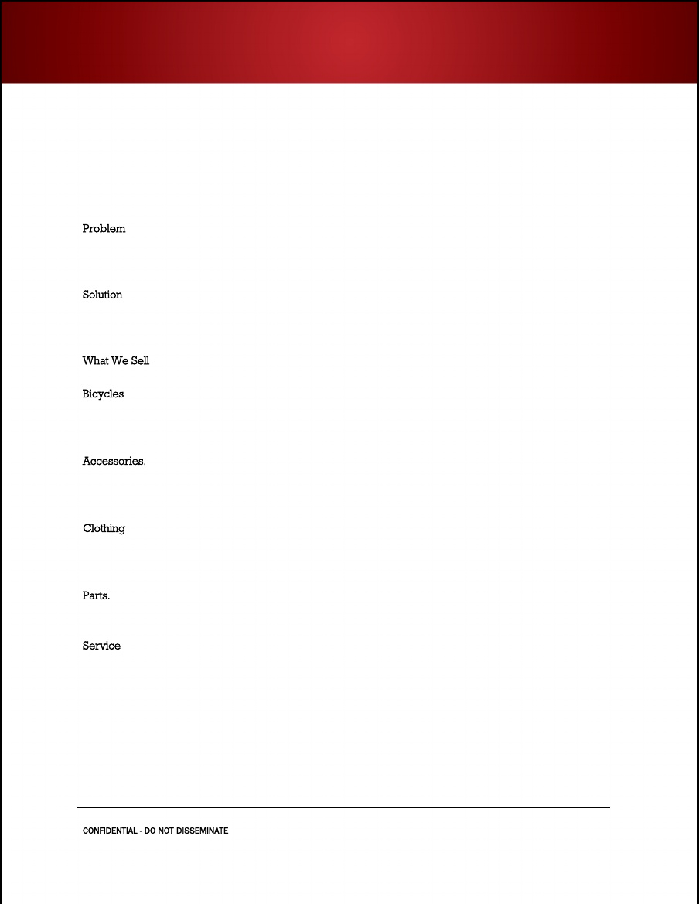

GARRETT'S BIKE SHOP

2

CONFIDENTIAL DO NOT DISSEMINATE

. This business plan contains confidential, trade-secret information and is shared only with the understanding that you will not share its contents or ideas with third parties without the express written consent of the plan author.

•Scheduled tune-ups, replacement of all bearing surfaces, repacking of lubricants, and adjustments of derailleurs and brake systems.•Installation of all accessories.•Authorized warranty repairs on the bikes.•Custom wheel building.•Frameset repairs by outsourcing to Via Porco custom frame builders.

MarketWho We Sell To

The primary market for Garrett's Bike Shop is the university student population, which normally has a turnover/growth of approximately 25% each year. The secondary market is the university faculty and staff, and the tertiary market is the greater Metroburg community.

The university students are our main target market.

1.They are mostly undergraduates, so there is a 25% annual turnover.2.The lack of parking in the university area and the general ease of bike mobility throughout Metroburg motivates them to use bicycles as inexpensive transport. Athletic pursuits draw them, and the nearby areas for use of mountain and trail bikes provides a great place to ride.3.There is a new enthusiasm for retro Cruiser bikes, and higher tech cruiser-style bikes with multiple gears, good brakes, etc. among the college age population.4.Also, main market for racks, locks, throughout, pannier/bags, fenders, rainwear, etc.5.They want convenience for sales and service.

Competition

•Big-box retailers

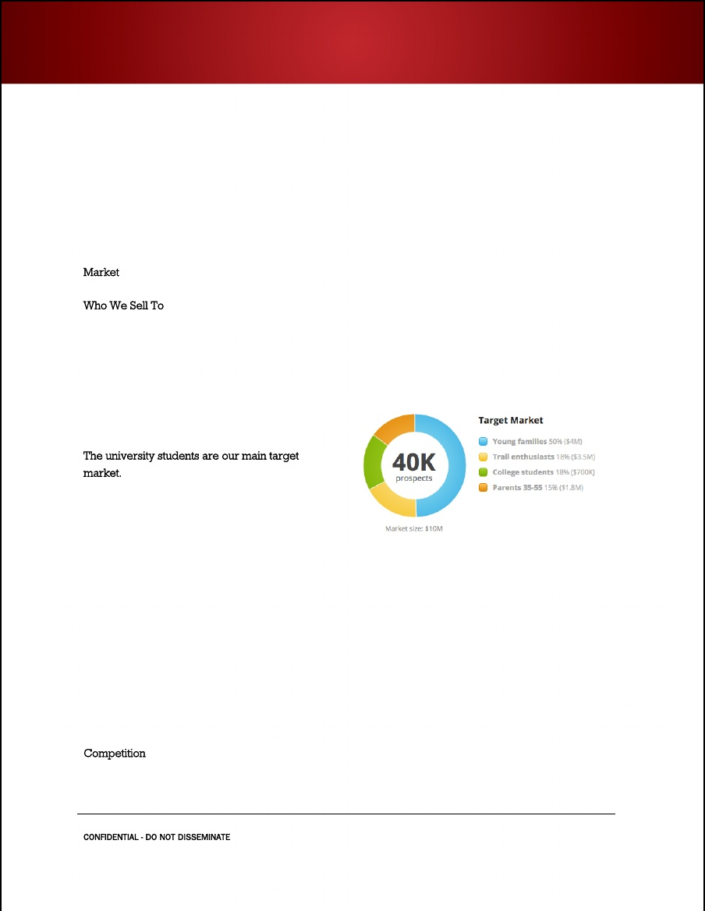

GARRETT'S BIKE SHOP

3

CONFIDENTIAL DO NOT DISSEMINATE

. This business plan contains confidential, trade-secret information and is shared only with the understanding that you will not share its contents or ideas with third parties without the express written consent of the plan author.

•Local bike shops•Online retailers

Why Us?

 We offer a welcoming, family-friendly bike shop space with higher quality gear and services.

Expectations

Forecast

This financial plan was developed based upon previous years' data for the existing store, tracking trends in revenues and expenses. A five-month track of sales, accounts receivables and payables, and inventory from a year-end benchmark was made. The current owner, Han Delbar, has sold the business to Hubert  Wheeler for $140,000. The seller, buyer, and the accountant worked together on the plan to balance optimism with reality. An attorney was consulted on specifics of the sale contract.Sales for the first year of new ownership are projected above $500,000, with a gross margin of almost 65%. Profitability is expected at the mid-way point of the fiscal year, in March.

Financial Highlights by Year

