Imagine … eliminating the fear that stops you from succeeding and then building your self-confidence so you feel terrific in ANY situation and become unstoppable in the pursuit of your goals …

**“Finally! A Proven System for Developing the Confidence You Need to Take Whatever Steps Are Necessary to Earn All the Money You Want, Enjoy the Relationships You Crave and Make the Decisions That Will Dramatically Improve Your World!”**

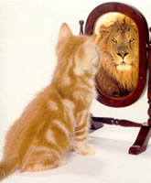

From the Desk of Brian Tracy  
San Diego, California  
2/19/2016

Dear Friend,

Let me start with a question:

Are you currently living your life exactly as you want to, doing all the things you’d ever hoped to?

If not, it may be because self-doubt, fear and lack of self-confidence are holding you back from achieving your dreams.

Does any of this sound familiar?

* There are certain things you dream of doing — asking your boss for a raise or promotion, finding a new job, getting up on stage to sing or perform a comedy routine, or writing a novel or book — but you never take the steps toward actually doing them because you’re afraid of what will happen if you try.
* You have a great message to share, but your fear of public speaking stops you from helping the thousands of people you know could benefit from your message.
* Your negative thoughts about what other people might think stop you from buying an outfit you love, trying a new hairstyle or buying a car you’ve always dreamed of owning.
* You’d love to make new friends or enter the dating scene, but you’re afraid people won’t like or accept you — so you stick to what you know: dinners at home and early nights in bed with a book.

Because I know you’re motivated to succeed I’m about to share with you everything I know about self-confidence, about conquering your fear and about changing every aspect of your world, for the better, forever.

It’s not your fault you haven’t automatically developed the self-confidence that ultimately and automatically leads to ultra-success.

Since prehistoric times, human beings have been plagued with doubts about their own abilities and fears about every imaginable thing, especially the unknown. They dwell on their own weaknesses and limitations and they eventually settle for far less than they are capable of.

**Have you been a victim of your own fears?**

As humans, our natural instinct is not to stray too far out of our comfort zone. In other words, we all avoid change as often as we can.

If you were to live your entire life this way, you would never accomplish much. Your self-esteem would suffer almost to the point where it could immobilize you to take any action involving change.

But at some point change becomes inevitable.

The fact is, although there are probably hundreds of courses and books on improving and increasing self-confidence, none of them put all the pieces together — from conquering fears from your past to becoming a receptacle for future success. That is, until now.

I’m about to share with you EVERYTHING I know about Self-Confidence.

**But first, you’re probably wondering who I am and why you should listen to me.**

You may be familiar with my work already. I've researched and studied personal development over the past 30 years. My work has been translated into dozens of different languages and has sold millions of copies worldwide. I’ve spoken to millions of people in audiences all over the world.

**But what you may NOT know is that I, too, have suffered the effects of low self-confidence.**

My life started out ordinarily — my parents were good, hard-working people, but “we don’t have enough money” was like our family mantra. I didn’t graduate high school — instead, I was awarded a “leaving certificate.” After that, I spent years washing dishes, washing cars, washing floors — and living out of my car before homelessness was fashionable. Eventually, I started my own business and started learning about success and what it took to be successful.

But there was one problem.

For years, I was very combative and critical of almost everyone I met. Eventually it got to the point where people would see me approaching and quickly disperse.

But soon, I discovered how increasing my self-esteem changed the way I looked at things. This completely changed the way I behaved in every situation.

Before I knew it, I was making better decisions. I was making more money and my business really started to take off.

I had unleashed the …

**“Science of Self-Confidence”**

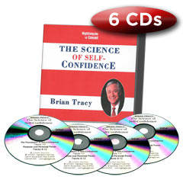

You probably already know that the most successful people have incredible levels of self-confidence. They have accomplished great levels of success and happiness in their lives and seem to be unstoppable.

The fact is, when you develop unshakeable self-confidence, you gain a kind of clarity that makes you feel bullet proof.

**When you discover the “Science of Self-Confidence,” you will:**

* Have the confidence to take whatever steps are necessary to enjoy a higher standard of living for you and your family
* Become more powerful and persuasive with other people
* Be more popular and likeable
* Speak up and speak out clearly in your interactions with others
* Be admired, respected and sought after by everyone who knows you
* Find that recognition, responsibility and opportunities will flow toward you, almost like magic

I have great news:

**Self-Confidence is Learnable.**

And I’m going to teach you.

I’m going to teach you how to think the way people with self-confidence think, how to become empowered, and how to eliminate your doubts and fears, in every area of your life.

Nothing will be impossible.

**In “The Science of Self-Confidence” you’ll learn:**

* The foundation of self-confidence and how it can transform your life … feel the power as your self-esteem grows
* How to find your true self … you must be yourself to feel truly confident
* The inner game of self-confidence and how it can work for you
* How to win with others in any situation or negotiation … experience the power of creating win-win situations in all you do
* How to get the things you want, when you want them… when you believe in yourself, others will believe in you, too
* The secret of the 4 Cs — without these, you enter an endless loop of failure
* How to live your perfect life by learning who you really are and what you really want (you might be surprised)
* How the Law of Reciprocity affects your success…develop a winning strategy using this immutable law of life
* The real difference between winners and losers — it’s not what you think
* Why you should become a good listener … this one skill alone can catapult you to success
* To totally change the results you get, using the Rule of 4
* How to tune your success radar for maximum reception … harness the power of wealth attraction to use whenever you want
* The secret of the 4 Ds … miss these at your own peril

[Order The Science of Self-Confidence Now (2-Pay Option)](http://www.briantracy.com/cart/cart.aspx?pfid=3294)

**“This sounds great, Brian! How are we going to cover all this?”**

Great question.

First of all, my “The Science of Self-Confidence” program includes 6 CDs (with more than 6 hours of audio instruction) and a CD ROM Workbook to make the instruction your own.

PLUS, as a seeker of success, you’re going to get these incredible bonuses!

**Bonus 1: “The Science of Positive Focus” DVD (2 hour DVD)**

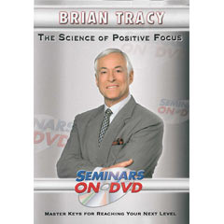

Finally you can reach your goals faster than ever before. Positive Focus will empower you to create the life you want to live. Stay positive and powerful — and laser-focused on your goals.

**The Science of Positive Focus will hand you the keys to living the life you want by teaching you:**

* How to finally eliminate negativity from your life
* The key to unlocking your true potential by using your positive mind
* How to laser focus on what is really important to you … your future
* How to increase your income in record-breaking time
* How to reach all your life goals faster

**Bonus 2: “Change Your Thinking, Change Your Life” CD (1 hour CD)**

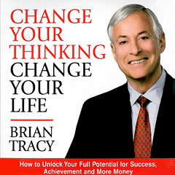

Discover how to unlock your full potential. Get all the money, success and achievement you want. Do you want to know how you can have everything you’ve ever wanted? It’s easier than you think — when you learn to think right.

**This program will teach you how to:**

* Develop unshakeable confidence
* Dramatically increase your income
* Take control of your destiny and your life in every area
* Improve and nourish your relationships
* Enjoy a higher level of health, fitness and happiness.

**Bonus 3: “Simplify Your Life” CD (1 hour CD)**

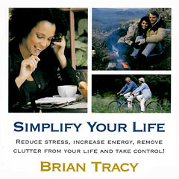

Learn how to reduce stress, increase energy, remove clutter from your life and take control!

**When you listen to this fast moving program, you'll learn to:**

* Put your number one priorities first
* Feel energized, happy and at peace
* Increase your income
* Spend more time with family and friends
* Do what you love to do

**Bonus 4: “Goals” CD (1-hour)**

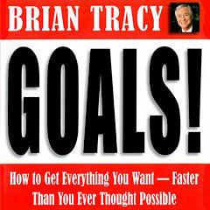

This program will teach you how to get the things you really want-faster than you ever thought possible.

**When you listen to my exciting, fast-moving program, your will learn how to:**

* Decide exactly what you want in every area of your life
* Identify the knowledge and skills you require to obtain your goal
* Make detailed plans of action for each goal
* Keep motivated, positive and focused
* Move to the top 20% of highest achievers

**Bonus 5: “Maximum Achievement Digital Goal Planner” (89-page workbook,)**

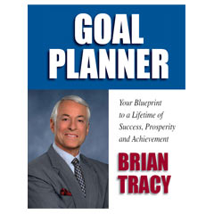

With this goal planner you can unlock your true potential to accomplish more in the next year or two than most people have in 10 or even 20 years!

If you want to set goals for yourself but don’t know where to start, this is exactly what you need.

**You’ll learn how to:**

* Think clearly about your goals
* Become results-oriented
* Increase your self-discipline exponentially
* Boost your self-esteem
* Become a highly skilled thinker and problem solver

[Order The Science of Self-Confidence Now (2-Pay Option)](http://www.briantracy.com/cart/cart.aspx?pfid=3294)

**“Wow, Brian! This ALL sounds amazing! What’s my investment?”**

[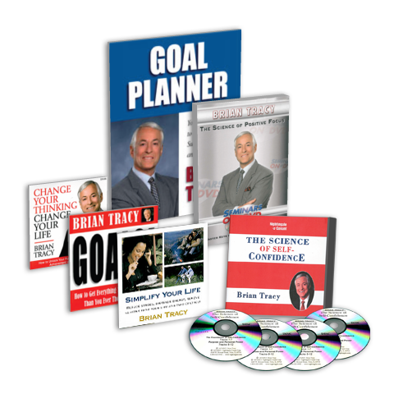](http://www.briantracy.com/cart/cart.aspx?pfid=3292)

Because I know you're highly motivated to achieve success. I'm making you my very best offer.

The dollar value for this package is $384. But when you invest today, I'm offering it to you for only $197. That's a savings of 51%.

Those are the hard numbers, and at this price, I don’t think they require much discussion. If you want to boost your self-confidence so you’re unstoppable — PLUS get in on courses that will help you achieve all your most important goals and unlock your full potential, this should be a no-brainer.

To make it even simpler, consider this:

With your increased self-confidence and productivity, how long will it take you to earn back this investment? It’s one more sale you make because your increased confidence makes you more attractive and appealing. One LESS opportunity missed because you’re too afraid to seize it.

And, because I believe so strongly that you’ll absolutely love this program, I’m offering my 365-day, 100% money-back guarantee. Try everything in this program for a full year. If you don’t believe it’s everything I’ve promised, return it for a full refund, no questions asked.

So this is absolutely risk-free.

**As a recap, here’s what you will get with this special offer:**

* “The Science of Self-Confidence” 6-CD set and CD-ROM Workbook
* “The Science of Self-Confidence” 6-CD set and CD-ROM Workbook
* “The Science of Positive Focus” 2-hour DVD
* “Change Your Thinking, Change Your Life” 1-hour CD
* “Simplify Your Life” 1-hour CD
* “Goals” 1-Hour CD
* “Maximum Achievement Goal Planner” 83-page digital workbook

Most importantly, though, you’re going to learn precisely how you can develop your Self-Confidence, conquer your doubt and fear, and get everything you’ve ever wanted in life. No more opportunities wasted, no more disappointment that you didn’t have the confidence to ask for what you wanted, no more wishing for something more but not knowing how to get it.

**So, are you ready?**

**Yes, Brian!**

I’m ready to learn “The Science of Self-Confidence” and begin getting EVERYTHING I’ve ever wanted!

**I understand that for just 2 payments of $98.50 I’ll get:**

* “The Science of Self-Confidence” 6-CD set and CD-ROM Workbook
* “The Science of Positive Focus” 2-hour DVD
* “Change Your Thinking, Change Your Life” 1-hour CD
* “Simplify Your Life” 1-hour CD
* “Goals!” 1-hour CD
* “Maximum Achievement Goal Planner” 83-page digital Workbook

(Total value of $384)

[Order The Science of Self-Confidence Now (2-Pay Option)](http://www.briantracy.com/cart/cart.aspx?pfid=3294)

**OR**

**For just $177 I'll get a completely digital version of this package including:**

* “The Science of Self-Confidence” MP3's and Digital Workbook
* “The Science of Positive Focus” 2-hour Video Download
* “Change Your Thinking, Change Your Life” 1-hour MP3
* “Simplify Your Life” 1-hour MP3
* “Goals!” 1-hour MP3
* “Maximum Achievement Goal Planner” 83-page digital Workbook

[Order The Science of Self-Confidence Digital Training Kit Now](http://www.briantracy.com/cart/cart.aspx?pfid=3293)

visaMasterCardAmerican ExpressDiscover

I urge you to take action today — because I’m making this offer available only for a limited time. And remember, this is a value-packed program at a fraction of the retail price — but it won’t last forever.

If you want to develop the kind of self-confidence that allows you to conquer your fear and self-doubt forever, order now and get on your way to the life you’ve always wanted.

And remember, you take no risk at all!

Here’s to your self-confidence,

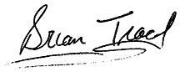  
Brian Tracy

P.S. Can you really afford not to invest in “The Science of Self-Confidence”? You and your family deserve to reap the rewards of your unshakeable self-confidence, so don’t delay, [order it now and take advantage of this value-packed offer.](http://www.briantracy.com/cart/cart.aspx?pfid=3294)

P.P.S. Remember, this offer is ONLY available for a limited time — so you’ll likely never see the high-value, low-price package again. [Don’t miss this opportunity](http://www.briantracy.com/cart/cart.aspx?pfid=3294)