Abel Philip -

sam package --s3-bucket travis-deployment-bucket1 --output-template-file out.yml --region us-east-1

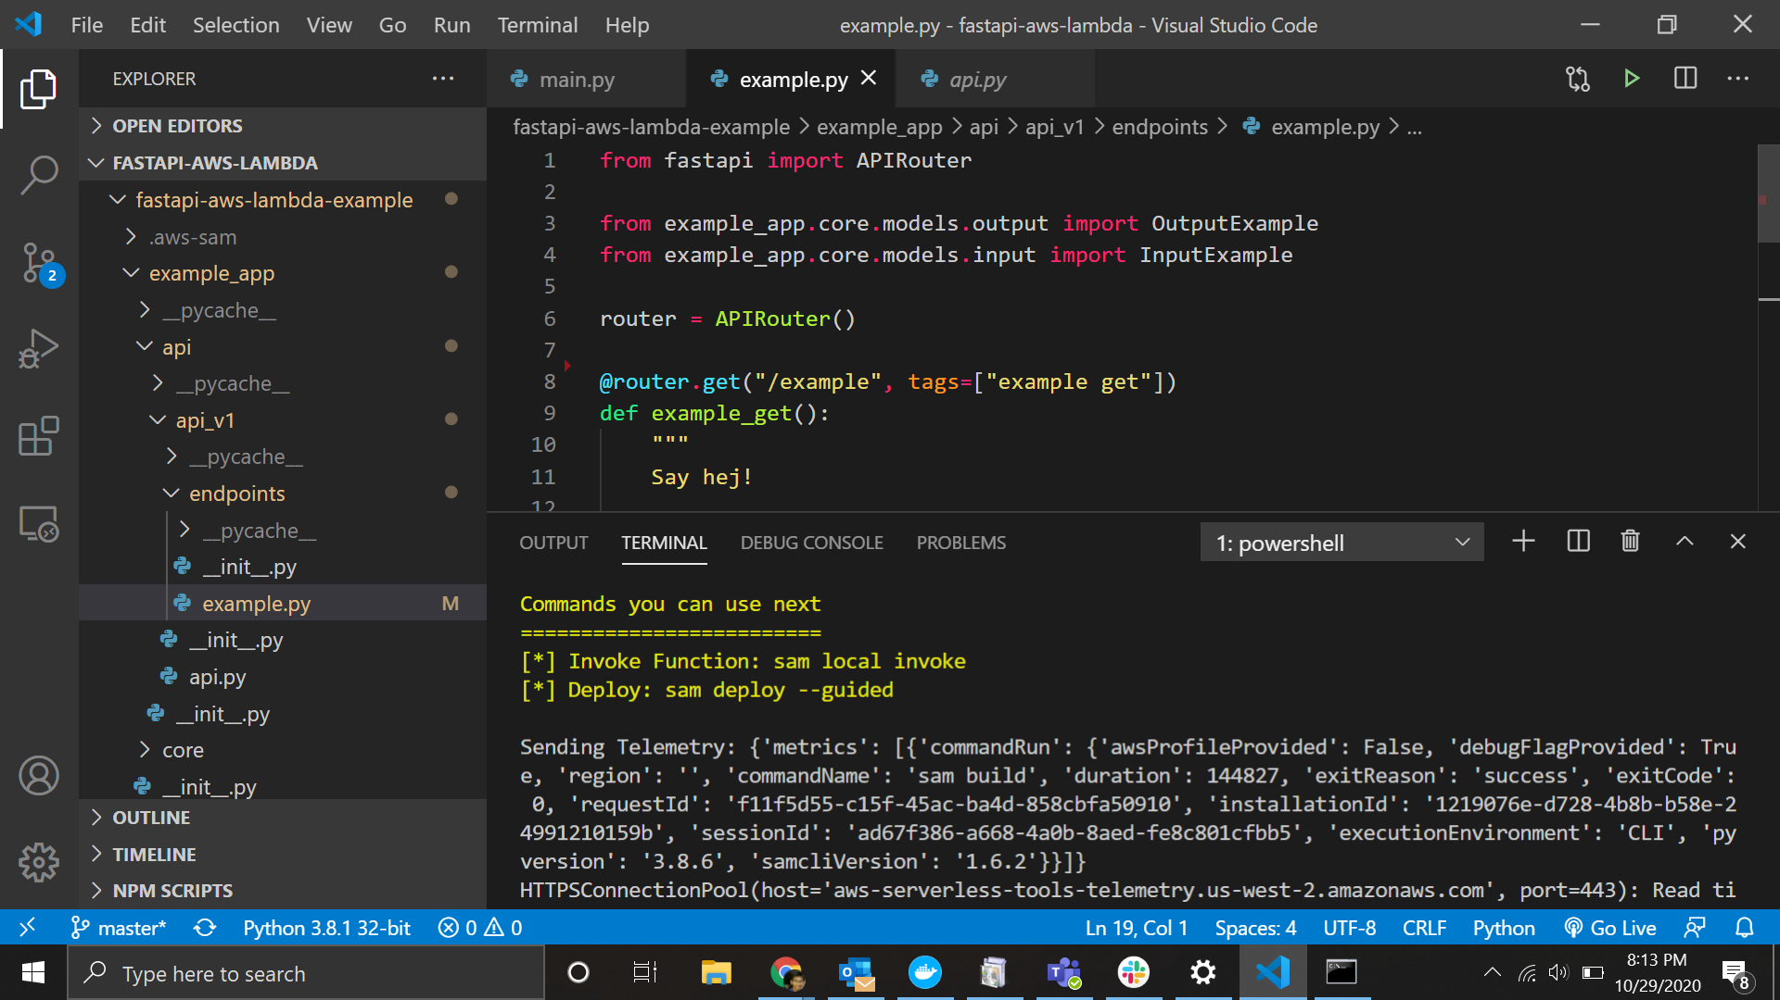

sam deploy --template-file out.yml --stack-name example-stack-name --region us-east-1 --no-fail-on-empty-changeset --capabilities CAPABILITY_IAM

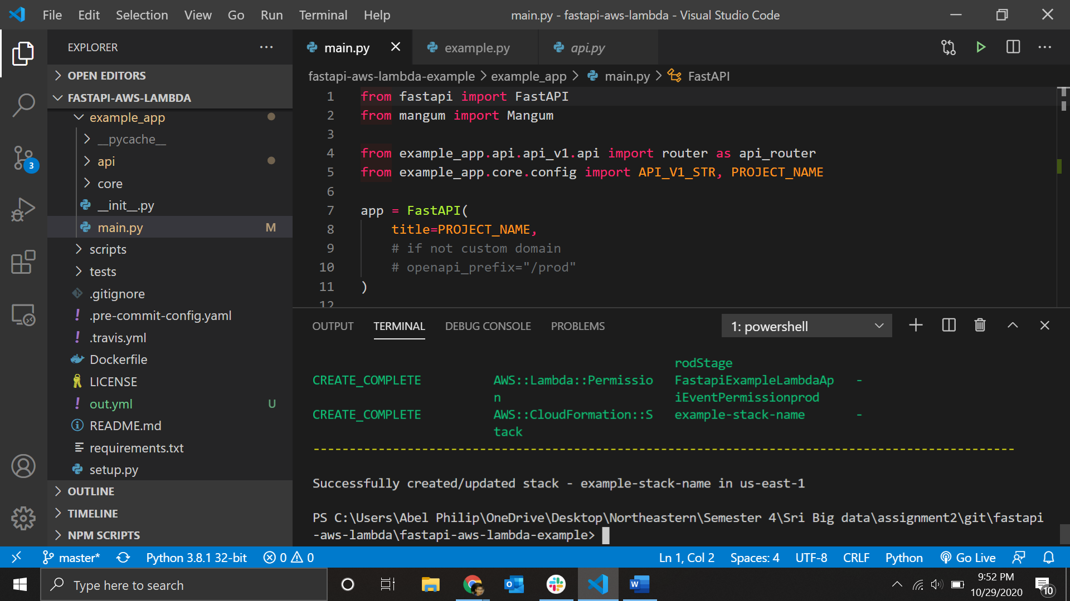

uvicorn cloudauth:app –reload

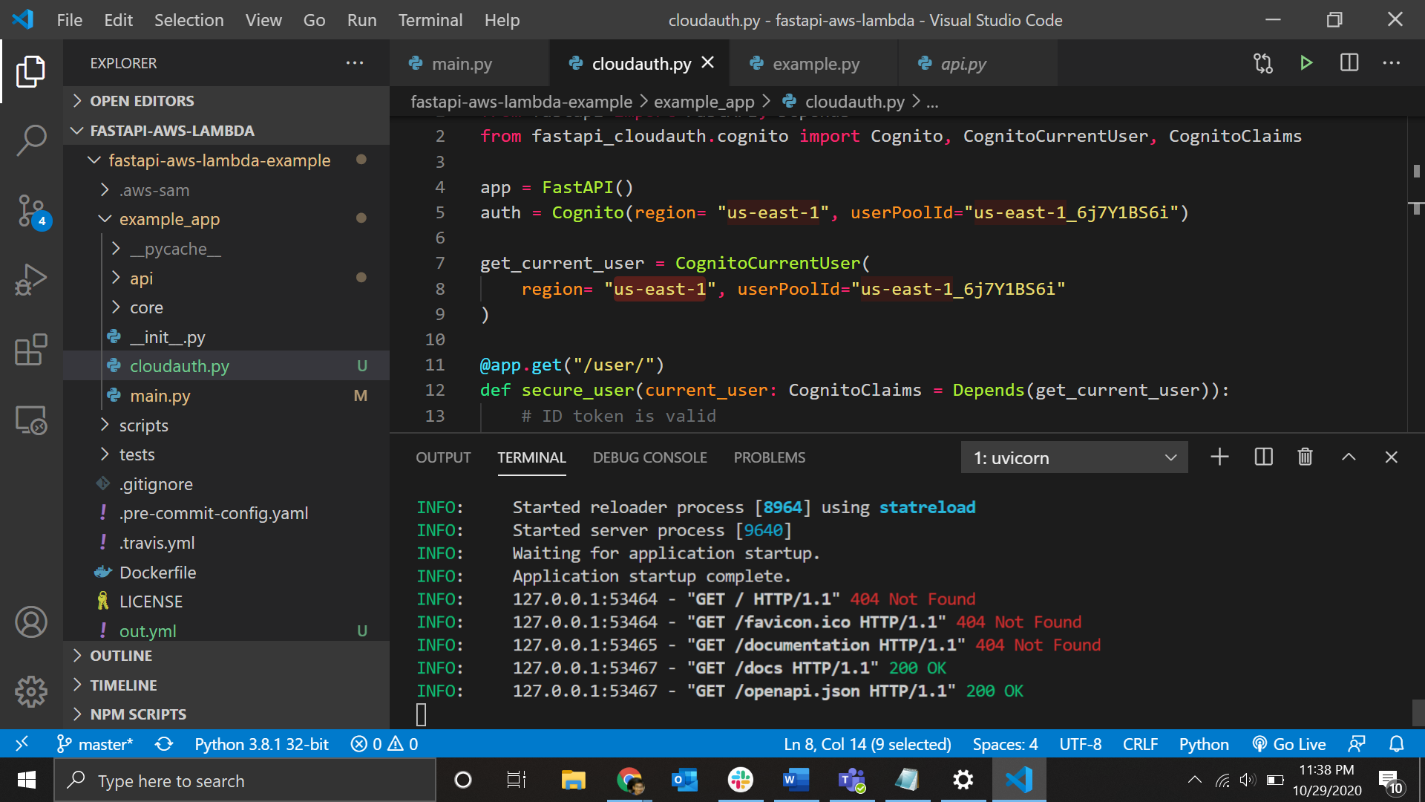

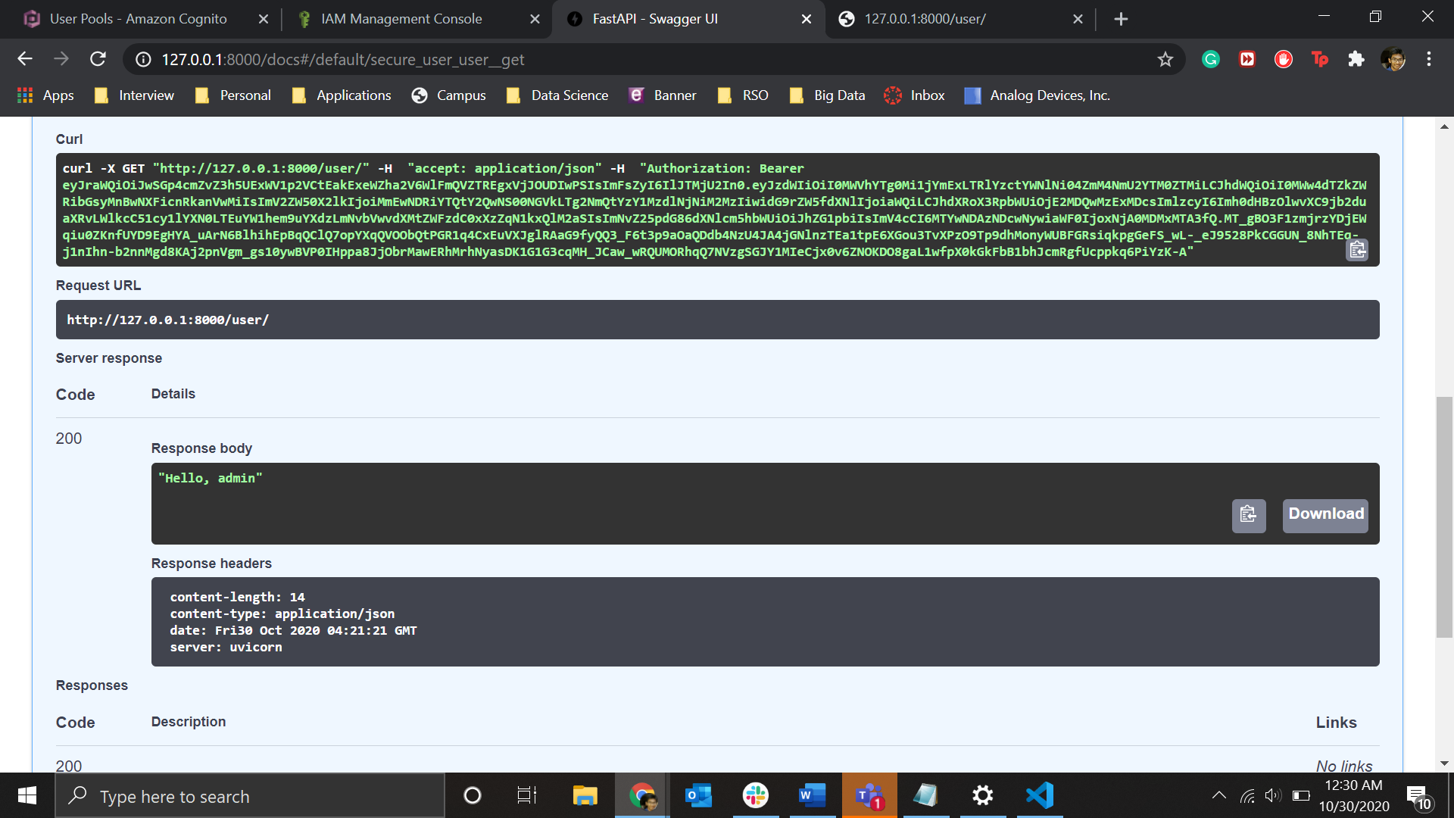

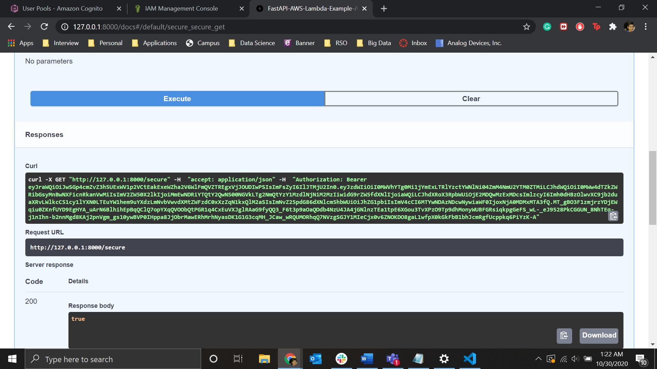

Tutorial 2

Add and multiply keys-

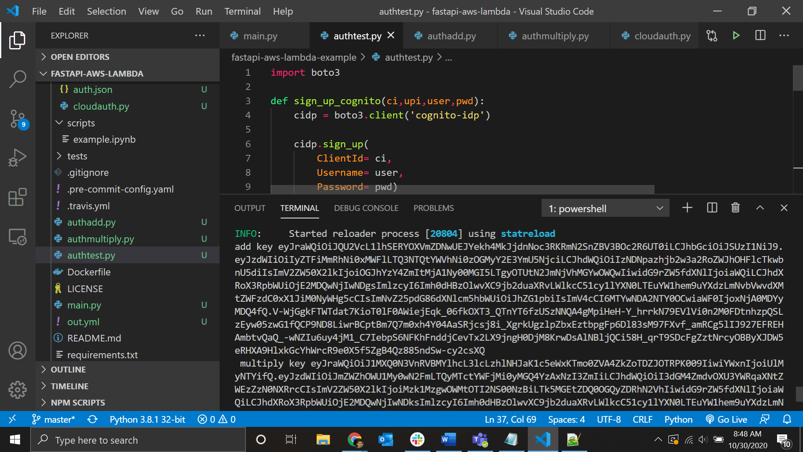

Auth Add –

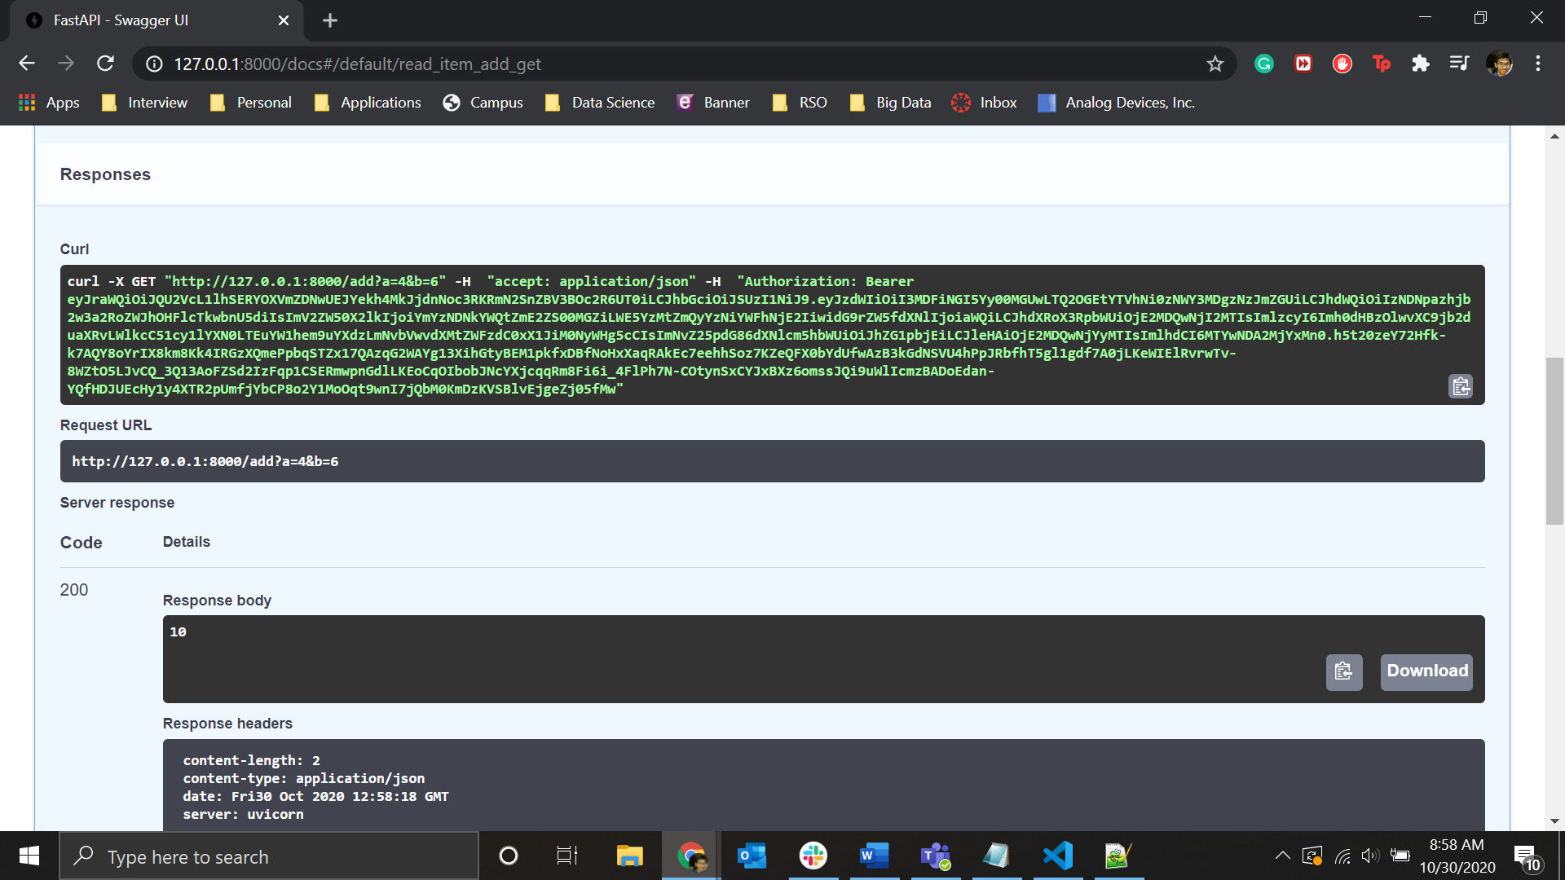

Auth Multiply-

