Firefly Jar — Delivery
Game Designer + Developer take-home assignment

1. Playable build
- Play (hosted, GitHub Pages): https://abelbascu.github.io/firefly-jar/
- Works with touch (tablet and Android phone, portrait or landscape, filling the whole screen) and mouse. Audio starts after the first tap.
- How it plays: tap a firefly and it floats into the jar (each tap plays a soft random pentatonic note). Tap empty night and nearby fireflies drift toward you (the added mechanic). Catch all 10 and the jar glows, the whole flock flies out under a rainbow, then 10 new fireflies appear and the jar is empty again. No text, no timers, no fail states.
- [YOUR THOUGHTS: how it felt on your phone/tablet; anything you would flag before a reviewer opens it]
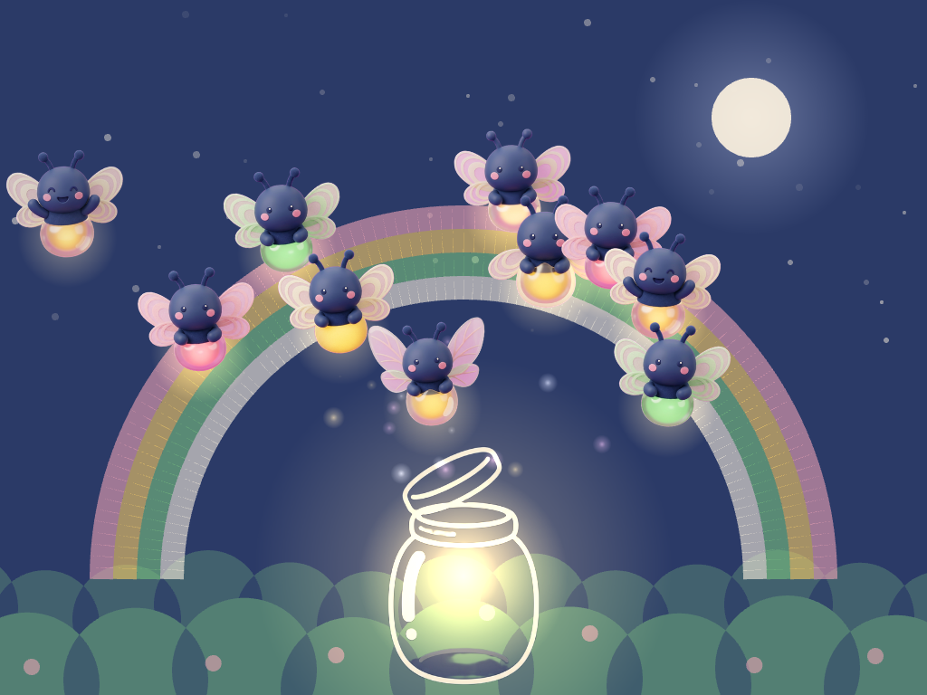  Celebration at 10 fireflies (tablet, landscape) | 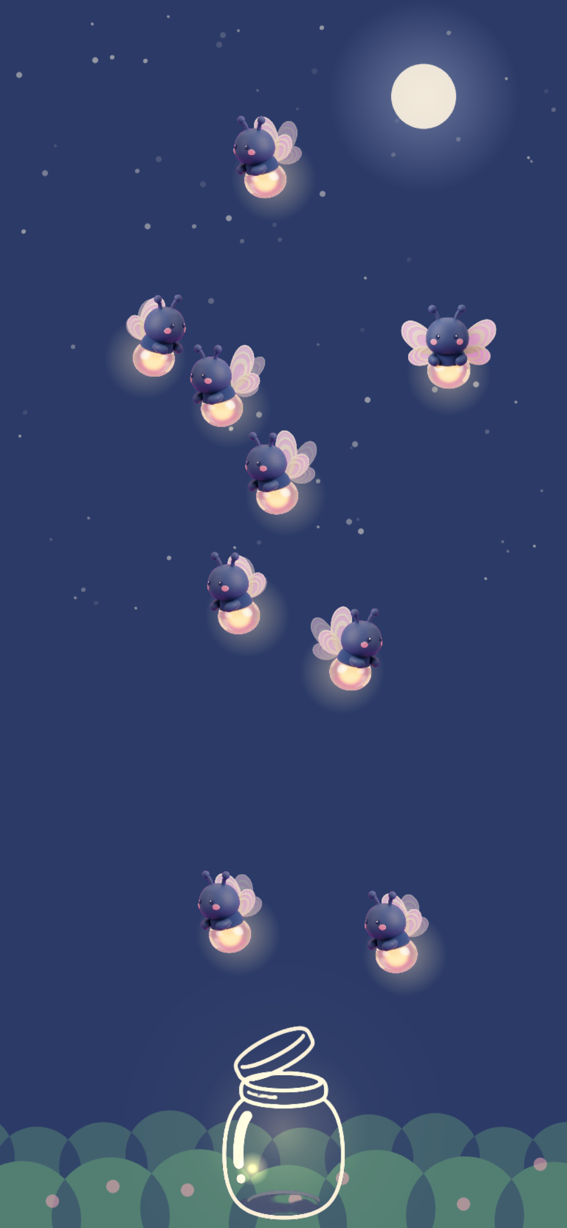  Android phone, portrait

2. Source code
- Repo: https://github.com/abelbascu/firefly-jar (public; main deploys automatically)
- Run locally: npm install && npm run dev. Tests: npx playwright test (6 tests: boot, tap to jar, full 10-catch round, Android-portrait touch, both rotation directions).
- Layout: src/config.js (palette and every tuning number), src/scenes/, src/objects/ (Firefly, Jar, Background, Celebration, glow). Sprites and audio load only via public/sprites/sprites.json and public/audio/audio.json, so an asset can be swapped with no code change.
- Stack: Phaser 3 (^3.90) + Vite, plain JS.

3. Process log
Full raw files: PROCESS_LOG.md, CHANGELOG.md, PROMPTS_VERBATIM.md (every prompt, auto-captured by a hook), docs/PLANNING_SESSION_LOG.md (the planning chat before coding).

3.1 Key prompts, verbatim
Art prompts live only in art/prompts.yaml and audio prompts in audio/prompts.yaml (the scripts read nothing else; versions are never overwritten, so the history is the log).
Planning (Claude desktop app, 10:38)
i have 4 hours to work on this job candidate assignment. I want to know what are the best tools i need to use to 100% automate dev process without hand doing anything. I use VS code normally, but if i need to use graphic models to generate the best possible images for kids, tell me how to integrate all the models and technologies. what are your recommendations?
Handing over to Claude Code (VS Code)
check @HANDOFF.md and what copilot did. verify it´s all ok and continue from there
Game build brief (code). A long brief given to a Claude Code session: goal, hard rules from the spec, asset contract with guarded fallbacks, and a six-step build order (Firefly, Jar, catch, celebration, one original mechanic, polish and tests). Full text is in the hook log in PROMPTS_VERBATIM.md.
Feedback prompts that changed the game (verbatim, typos kept)
remember the game is for kids shold be very asrm sounds gently soft
the sound is too piercing to the ears, very acute, bot the melody, which is ugly and no melodic sense and when tap to pick up the fireflies
a cool thing would be that each time a firefly is tapped, it generated a different note on the scale of do, but it should be melodic sequence
it's cool, but make that when tapping doesn't go to do re mi fa sol, la si do, but random notes that sound melodic
do not spawn a new firefly when one is catch , the player must catch the last one, then there is a celebration, then the 10 fireflies appear again and the jhar is empty again
on the celebration, only a firefly moves up... but all 10 should leave, now here we can use all the firefly color poses that we have , and maybe paint an animatied rainbow for the celeb too
the glow arond the fireflies should be restricted to the bottom lightbulb
we have lost the anim when tap a firelfy how it goes to the jar, now it just idsappears
Works with touch on a tablet and with a mouse on desktop. WE NEED THIS FIRST IT'S IMPORTANT! I WILL TEST ON MY ANDROID PHONE ONCE YOU HAVE IT
[YOUR THOUGHTS: which 2-3 prompts mattered most, and why. Also the art prompts and picks you are proudest of.]

3.2 Tools used, and why
Tool | Used for | Why
Claude (desktop app) | Planning: tool choice, setup document | Fast comparison of options before writing code
Claude Code in VS Code | Code, scripts, tests, commits, deploy | Runs commands, sees screenshots and test output, one loop, no tool-switching
Gemini image model (scripts/art.py) | Firefly, poses, flap frames | Reference-image consistency; chroma-key cutout so no manual editing in Krita or Photoshop
ElevenLabs (scripts/sfx.py) | First audio pass | API plus a candidates/pick workflow inside the repo
Python + numpy (scripts/synth_sfx.py) | Final catch, jar, celebrate sounds | ElevenLabs output was too shrill and unmelodic; synthesis gives full control (soft, low, pentatonic)
Phaser 3 + Vite, Playwright, GitHub Actions/Pages | Game, tests, hosting | Spec-friendly, touch-first, one-push deploy
[YOUR THOUGHTS] | Music: Firefly Meadow (looping ambience) | [where this track came from, and why you chose it]

3.3 Where the AI got it wrong, and how it was corrected
Taken from the logs; each was caught by a test, a screenshot, or by you listening and playing.
- Phaser v4 installed instead of v3. Caught against the spec, pinned to ^3.90.
- requirements.txt written as UTF-16 by a PowerShell redirect. Regenerated as UTF-8.
- API key committed to the public repo (pasted into .env.example); Google auto-disabled it. Keys now only in .env; the old key is still visible in history (commit 47868e1, dead). [YOUR THOUGHTS: what you did or would do about history]
- Empty mp3 files from failed audio API calls. The script now writes only after a successful response.
- Image models: the free tier quota was 0 (billing needed); glowing abdomens picked up a magenta fringe from the chroma-key background, and glow should be code anyway. Prompts changed to a semi-transparent bulb, glow drawn in code.
- Audio: the 0.4 s sound was below the API minimum (0.5 s); the Music API needs a paid plan; and the generated sounds were high-pitched, piercing, with an ugly melody. Replaced by synthesised low, soft, pentatonic sounds; each tap plays a random tuneful note.
- Portrait "sanity" was not real: the first pass only letterboxed the landscape stage, so on a phone the tap circles were about 40 px, breaking the 96 px rule. Fixed with a portrait stage and circles that scale to at least 100 CSS px, plus an Android-portrait test. Your real-phone test then found two more problems the emulator missed: the stage did not fill a tall phone screen, and rotating back from landscape to portrait left a tiny frame (phones report stale window sizes right after rotating). Fixed by sizing the stage to the screen's shape and re-checking the orientation after each load.
- A regression I introduced: reusing the config key catchScale for the note list turned the shrink factor into NaN, so caught fireflies just vanished. You spotted it while playing; the cause was found by probing tween state and a regression check was added.
- Design misses: the first celebration sent up only one firefly; the glow covered the whole body instead of the bulb; the flock respawned on every catch, which undercut "catch the last one". All fixed after your feedback.
- Test details: the full-round test hit Playwright's 30 s default timeout; the first bush art (overlapping translucent discs) looked muddy, so it became opaque shapes with a night overlay.
- [YOUR THOUGHTS: places where you overrode the AI on taste, e.g. picking the clay/plush art style (v6_02), removing the green/pink fireflies from play, and so on]

3.4 Rough time split
Session ran about 10:38 to 13:45 (deadline 14:38). Approximate, from git timestamps and the planning log:
Block | approx. time
Planning chat + setup document | ~45 min
Repo setup, pipelines, deploy, hooks (first commit 11:25) | ~1 h
Art exploration (styles v1-v8, poses, flap frames), in parallel with the build | ~1.5-2 h
Game build: fireflies, jar, catch, celebration, mechanic, background (12:51-12:58) | ~30 min of AI-run steps plus review
Audio iterations (ElevenLabs, then synthesis, notes, ambience) | ~45 min
Fixes and polish from your play-testing, phone support | ~45 min

[YOUR THOUGHTS: your own hands-on time vs. waiting-for-AI time, and what you would do differently]

4. Design note (half a page at most)
Added mechanic: "Call the fireflies". Tapping empty night sends a soft ripple and nearby fireflies drift slowly toward that spot. It is wordless, cannot fail, and turns the most common 4-year-old behaviour (tapping where nothing is) into something pleasant that also helps. Each caught firefly also plays a random note of a pentatonic scale, so the child plays a little tune without trying. [YOUR THOUGHTS: why this mechanic, in your words]
What I would build next. Tap the jar to swirl the caught fireflies once; the sleepy pose and a night-to-dawn sky between rounds; more garden reactions (flowers that open); a parent-only volume control; real-device testing across iPad and small Androids; a seamless loop point for the music. [YOUR THOUGHTS]
Deliberately cut. Any score, counter or text (the jar is the only progress display); timers, fail states and lost fireflies; drag-to-jar (too fiddly for small hands, one tap is enough); colours outside the four-colour garden palette (the rainbow uses only palette colours); ElevenLabs music (paid plan). [YOUR THOUGHTS]

5. Screen recording (optional, 3-5 min)
[YOUR LINK]. Suggested walkthrough: (1) play a full round on the phone, (2) show art/prompts.yaml, the contact sheet, the pick and the sprite, (3) show PROCESS_LOG.md and one "AI got it wrong" moment (the vanishing firefly), (4) show the tests passing.

