Bootstrap –

Mobile First and Responsive Design

Not for every project. Excellent for small, quick projects

Its also good for Prototyping and scaffolding. If I am working on functionality and am probably going to hand it off to a designer, I can develop quickly with Bootstrap first.

If I use bootstrap for larger projects, It may be better to customize my install

Two types of Installation: Basic vs Advanced

<http://getbootstrap.com>

CDN but ill probably download and install bootstrap manually. It makes it smaller and customized. Wont need to be connected to the internet either.

Bootstrap REQUIRES jQuery which I will need to download separately

<http://jquery.com>

Adding the viewport tag tells the browser to show the mobile version and not a shrunk down version

<https://gist.github.com/abelberhane/d9ff0342815f1d03d72b33f421c4f665#file-bootstrapcdn-html>

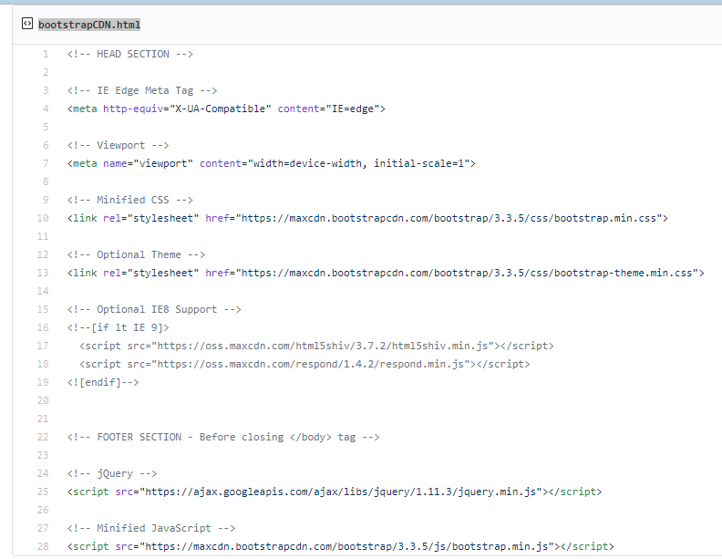

|  |
| --- |
| <!-- HEAD SECTION --> |
|  |  |
|  | <!-- IE Edge Meta Tag --> |
|  | <meta http-equiv="X-UA-Compatible" content="IE=edge"> |
|  |  |
|  | <!-- Viewport --> |
|  | <meta name="viewport" content="width=device-width, initial-scale=1"> |
|  |  |
|  | <!-- Minified CSS --> |
|  | <link rel="stylesheet" href="https://maxcdn.bootstrapcdn.com/bootstrap/3.3.5/css/bootstrap.min.css"> |
|  |  |
|  | <!-- Optional Theme --> |
|  | <link rel="stylesheet" href="https://maxcdn.bootstrapcdn.com/bootstrap/3.3.5/css/bootstrap-theme.min.css"> |
|  |  |
|  | <!-- Optional IE8 Support --> |
|  | <!--[if lt IE 9]> |
|  | <script src="https://oss.maxcdn.com/html5shiv/3.7.2/html5shiv.min.js"></script> |
|  | <script src="https://oss.maxcdn.com/respond/1.4.2/respond.min.js"></script> |
|  | <![endif]--> |
|  |  |
|  |  |
|  | <!-- FOOTER SECTION - Before closing </body> tag --> |
|  |  |
|  | <!-- jQuery --> |
|  | <script src="https://ajax.googleapis.com/ajax/libs/jquery/1.11.3/jquery.min.js"></script> |
|  |  |
|  | <!-- Minified JavaScript --> |
|  | <script src="https://maxcdn.bootstrapcdn.com/bootstrap/3.3.5/js/bootstrap.min.js"></script> |