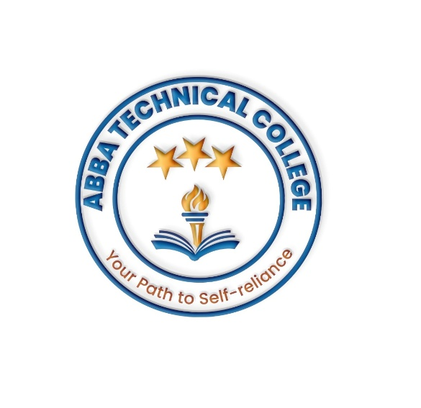

ABBA TECHNICAL COLLEGE
Motto: ‘Your path to self-reliance’
Location: OPP Kush Bank Sherikat-Juba South Sudan
0927947688, 0981593580, 0910721280 (WhatsApp)
abbatechnicalcollege@gmail.com

FEES STRUCTURE FOR ALL OUR PROGRAMS 2025

1. Enrollment & Administrative Fees
- Registration Fee: 30,000
- Identity Card: 15,000
- Examination fee: 10,000
- Certificate fee:20,000 only after completion.

COURSE | TUITION FEE (SSP) | DURATION
Computer Hardware Repair and Maintenance | 450,000 | 3 Months
Mobile Phone Repair and Maintenance | 350,000 | 3 Months
Basic Computer & Digital Literacy | 150,000 | 2 Months
Raksha Repair | 650,000 | 4 Months
Motorcycle Repair | 550,000 | 4 Months
Hairdressing & Salon Management | 300,000 | 3 Months
Note:
Pay at least 70% of school fees before enrollment.
Installation plan payment is accepted
All other requirements are included in the tuition fee.

We are grateful you chose Abba Technical College to start path to your self-reliance life. God bless your hand skills in abundance.
Best Regards
…………………………….
Abba Technical College
Abel Aleu Chol

