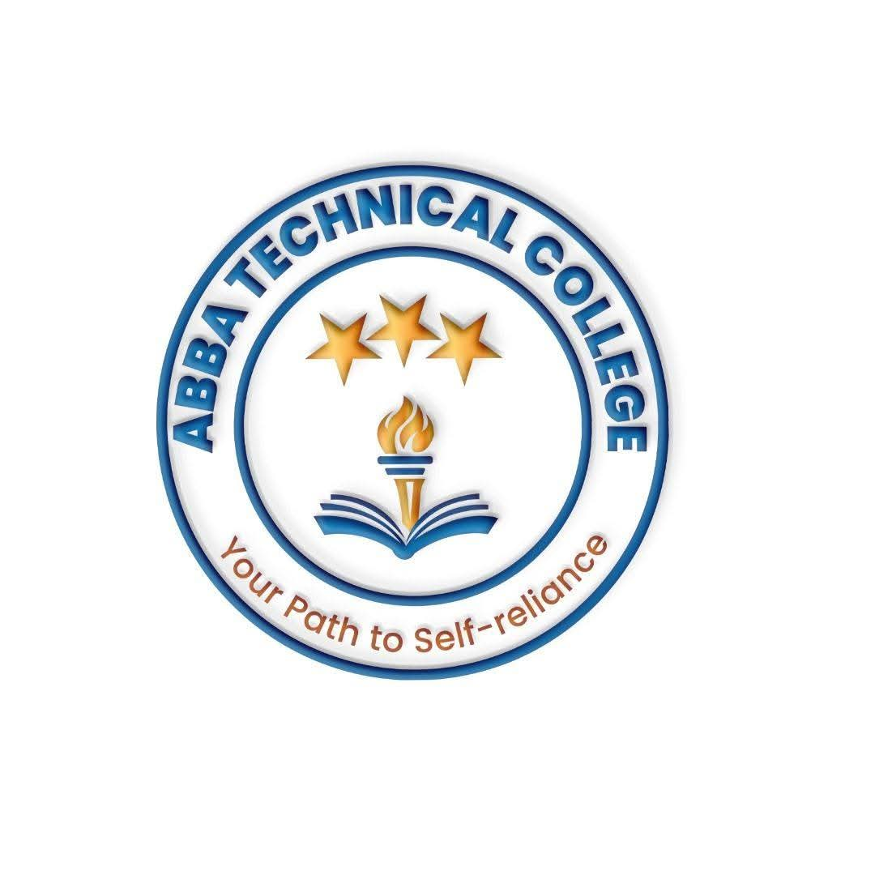
ABBA TECHNICAL COLLEGE
"Your Path to Self-Reliance"
ADMISSION LETTER
Date: ________________________
Applicant Name: ________________________________________
Course Enrolled: ________________________________________
Resumption Date: ________________________________________
Dear Applicant,
We are pleased to inform you that your application to Abba Technical College has been successful. You have been offered admission into the course indicated above. This letter confirms your place and outlines the terms of your enrollment.
Admission Fee: SSP 30,000 (non-refundable), payable before resumption to secure your place. This fee is separate from the course tuition fee listed on your course information sheet.
Kindly report to the college office on or before your resumption date with this letter, a valid form of identification, and proof of payment.
📋 Rules & Regulations
- Attendance: Students are required to maintain at least 85% attendance. Repeated unexplained absence may result in suspension from practical sessions.
- Punctuality: Students must arrive on time for all lectures and lab sessions. Late arrivals may be denied entry to that session.
- Fee Payment: The admission fee is non-refundable. Tuition must be paid in full, or according to an agreed installment plan, before the start of practical/lab modules.
- Conduct: Students must treat staff, fellow students, and college property with respect. Fighting, harassment, theft, or abusive language will result in disciplinary action, including possible dismissal.
- Lab & Equipment Care: Tools, computers, and lab equipment must be handled responsibly. Students found responsible for deliberate damage may be required to cover repair or replacement costs.
- Dress Code: Students must dress modestly and appropriately. Closed-toe shoes are required during all hardware and lab practical sessions for safety.
- Prohibited Items: Alcohol, drugs, weapons, and smoking are strictly prohibited on college premises.
- Mobile Phones: Phones must be switched to silent during lectures and practical sessions unless the instructor permits their use for coursework.
- Academic Integrity: Cheating, exam malpractice, or plagiarism in assignments and capstone projects will result in disqualification from assessment and possible dismissal.
- Certification: Official certificates are issued only to students who complete the required attendance, pass the final assessment, and have fully settled all fees.
- Withdrawal: Students who withdraw after resumption will not be entitled to a refund of admission or tuition fees already paid.
By signing below, the student (and parent/guardian, if the student is a minor) confirms they have read, understood, and agreed to abide by the rules and regulations of Abba Technical College.
Student Signature: ____________________________ Date: ______________
Parent/Guardian Signature: _____________ Date: ______________
College Representative: ____________________________ Date: ______________
800 meters from Gaga Medical Complex, near St. Andrew Church Highland, next to Don Bosco Vocational Training Center, Juba, South Sudan
Call / WhatsApp: +211 922 600 538 | 0910721280 | Email: abbatechnicalcollege@gmail.com

