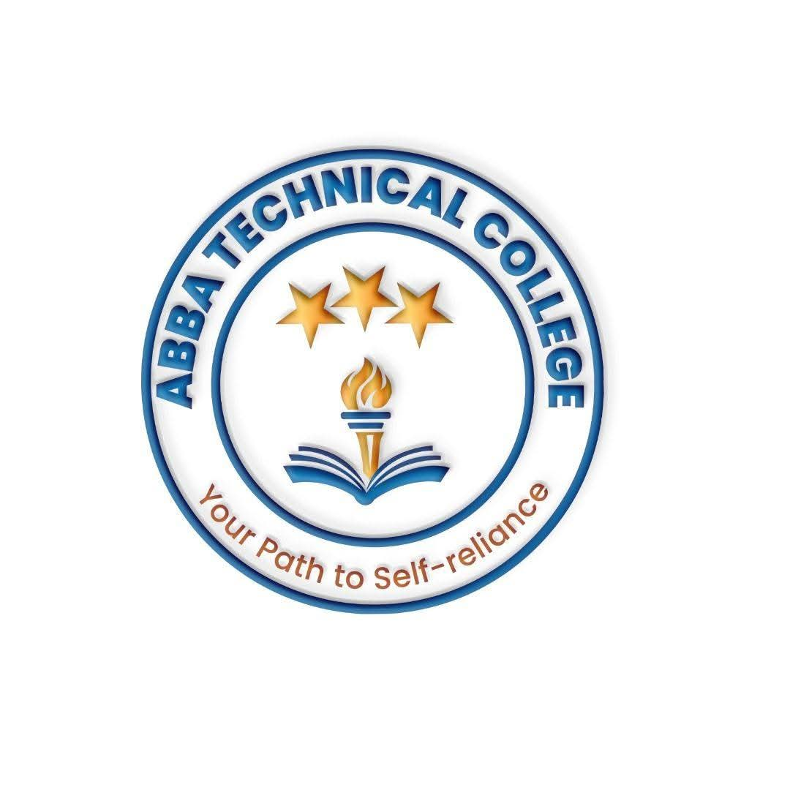
ABBA TECHNICAL COLLEGE
"Your Path to Self-Reliance"
PAYMENT POLICY
This policy applies to all courses offered at Abba Technical College.
💵 Currency & Payment Location
- Where to Pay: All payments are made in person at the Abba Technical College office. We do not currently accept remote or mobile payments.
- Primary Currency: Course fees are set and recorded in US Dollars (USD).
- Paying in South Sudanese Pounds (SSP): Students may pay in SSP using that day's market exchange rate. An additional SSP 10,000 must be added to the converted amount to cover the cost and risk of later converting the payment to USD.
- Official Receipt: Every payment, in USD or SSP, must be confirmed with an official receipt issued by the college office. Keep this receipt as proof of payment.
📅 Installment Plan (Applies to All Courses)
Course fees may be paid in full at registration, or split into three (3) installments as follows:
Installment 1 (Registration) — 70% of total course fee, due before resumption / on the first day of class.
Installment 2 — 15% of total course fee, due at the midpoint of the course.
Installment 3 — 15% of total course fee, due before the final assessment, so it is fully settled before certification.
The admission fee (SSP 30,000) is separate from and in addition to the course tuition above, and is paid once at registration.
⚠️ Important Terms
- Certificates: Official certificates are released only after all three installments have been paid in full.
- Late Payments: Students who fall behind on an installment may be suspended from lab/practical sessions until the outstanding balance is cleared.
- Non-Refundable: Admission fees and completed installments are non-refundable, including in cases of withdrawal after resumption.
- Rate Disputes: The market exchange rate used for SSP payments is the rate on the day of payment, confirmed at the college office at the time of payment.
800 meters from Gaga Medical Complex, near St. Andrew Church Highland, next to Don Bosco Vocational Training Center, Juba, South Sudan
Call / WhatsApp: +211 922 600 538 | 0910721280 | Email: abbatechnicalcollege@gmail.com

