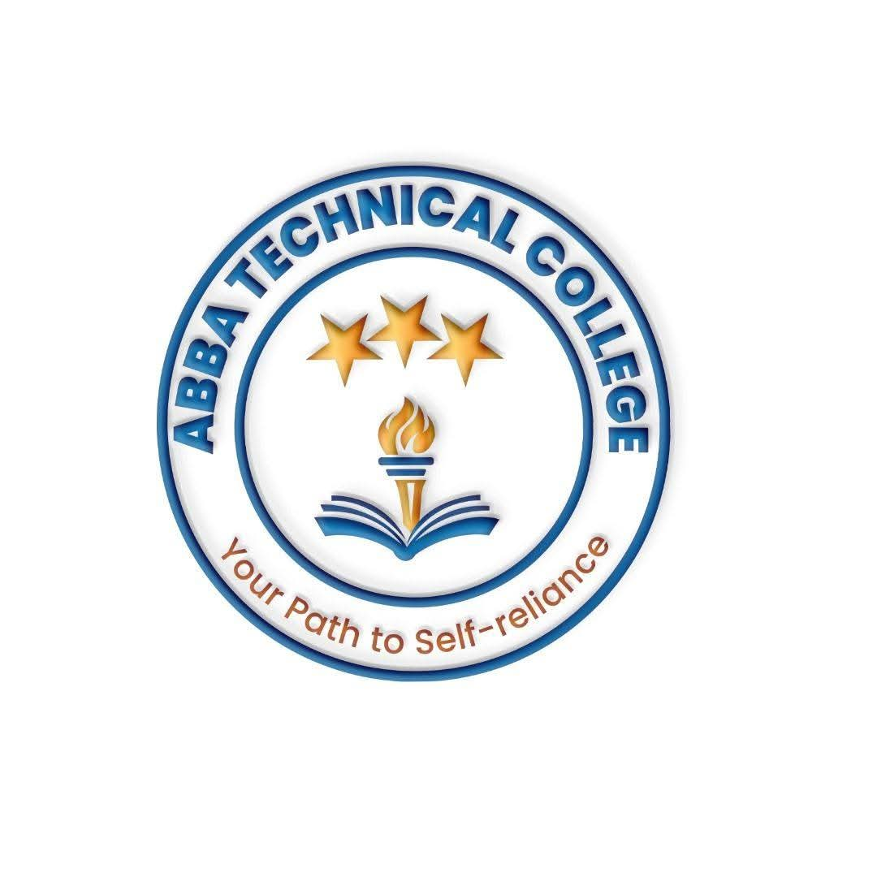
ABBA TECHNICAL COLLEGE
"Your Path to Self-Reliance"
16/08/2026
CCFL 102 FUNDAMENTALS OF COMPUTER & DIGITAL LITERACY
Duration: 6 Weeks
Price: $60
📚 What You Will Learn
- Computer Essentials: Understanding computer hardware, operating systems (Windows), desktop navigation, and file management.
- Typing & Keyboard Proficiency: Building real typing speed and accuracy, not just knowing where the keys are.
- Word Processing & Professional Documents: Creating professional documents, formatting text, working with tables, page setup, and printing.
- Resume, CV & Job Application Writing: Designing a professional CV, cover letters, and job applications using Microsoft Word.
- Spreadsheets (Microsoft Excel): Basic formulas and functions, creating data tables, organizing lists, and simple charts.
- Presentations (Microsoft PowerPoint): Designing slide decks, adding images, transitions, and basic presentation techniques.
- Internet, Email & Digital Communication: Search engines, professional email, cloud storage, and everyday tools like WhatsApp Business.
- Cybersecurity & Digital Hygiene: Password safety, recognizing online scams/phishing, safe browsing, and virus protection.
🛠️ How You Will Learn
- Hands-on Lab Practice: Regular access to computers in the IT laboratory.
- Guided Step-by-Step Exercises: Instructor-led walkthroughs for every software application.
- Practical Projects: Real-world documents, spreadsheets, presentations, and a personal job-ready CV.
- Final Assessment & Certification: A hands-on practical test before receiving your official Abba Technical College certificate.
💼 Career & Earning Opportunities
- Data Entry Clerk
- Office Assistant / Receptionist
- Cyber Café Attendant
- NGO / Organization Administrative Support Assistant
- Direct entry point into CDA 103 (Data Analytics) and CDS 104 (Data Science)

Call / WhatsApp: +211 922 600 538 | Email: abbatechnicalcollege@gmail.com

