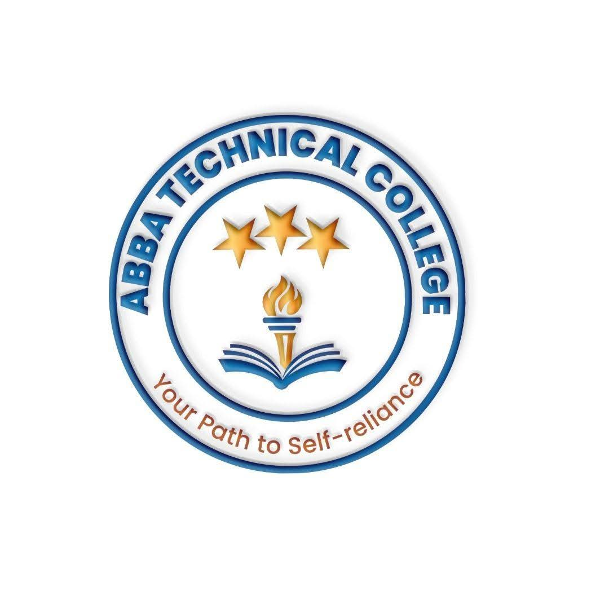
ABBA TECHNICAL COLLEGE
"Your Path to Self-Reliance"
17/08/ 2026
CCRM 100 COMPUTER REPAIR & MAINTENANCE
Duration: 24 Weeks
Price: $220
📚 What You Will Learn
- Hardware Architecture: Motherboards, CPUs, RAM, power supplies (PSU), storage drives (HDD/SSD), and expansion cards.
- PC Assembly & Upgrades: Assembling desktop PCs from individual components, upgrading laptops (RAM/SSD), and component compatibility.
- System Troubleshooting & Diagnostics: POST codes, beep codes, blue screen errors (BSOD), overheating issues, and hardware testing.
- Software & OS Installation: Windows/Linux OS installation, driver updates, dual-boot setups, system recovery, and disk partitioning.
- Networking Fundamentals: Crimping Ethernet cables (RJ45), setting up Wi-Fi routers, IP configuration, local network sharing, and basic network security.
- Preventive Maintenance & Virus Removal: Malware/ransomware cleanup, thermal paste application, dust cleaning, and system optimization.
- Electrical & ESD Safety: Safe handling of power supplies and electrostatic discharge (ESD) precautions that protect sensitive components — a habit most self-taught repairers skip.
- Sourcing Parts & Pricing Repairs: Identifying genuine vs. refurbished/counterfeit components, and quoting repair and upgrade jobs like a professional.
🛠️ How You Will Learn
- Hardware Laboratory Work: Assembling, disassembling, diagnosing, and repairing desktop computers and laptops.
- Network Setup Drills: Configuring local area networks (LAN) and wireless routers hands-on.
- Final Assessment & Certification: A supervised repair test before receiving your official Abba Technical College certificate.
💼 Career & Earning Opportunities
- Computer Repair Shop Manager / Owner
- IT Support Specialist / Helpdesk Technician
- School or Office Systems Maintenance Specialist

Call / WhatsApp: +211 922 600 538 | Email: abbatechnicalcollege@gmail.com

