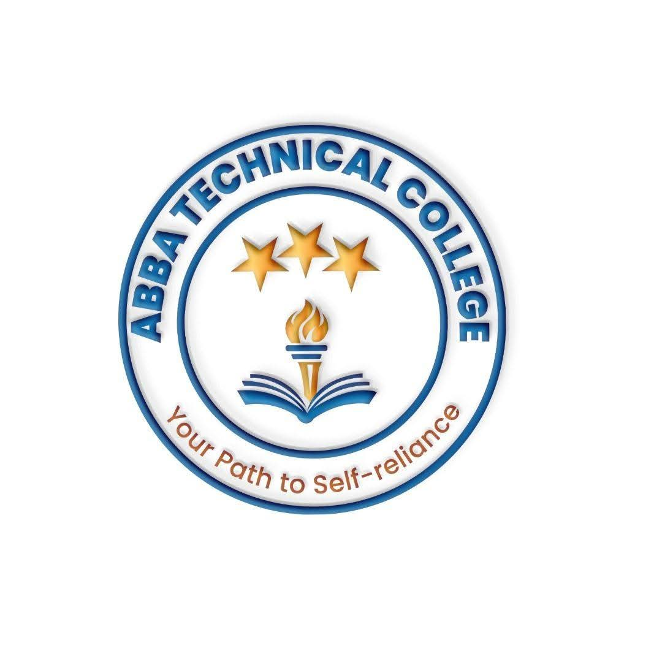
ABBA TECHNICAL COLLEGE
"Your Path to Self-Reliance"
17/08/ 2026
CDA 103 DATA ANALYTICS & BUSINESS INTELLIGENCE
Duration: 12 Weeks
Price: $150
📚 What You Will Learn
- Advanced Excel for Analytics: Pivot tables, VLOOKUP/XLOOKUP, INDEX-MATCH, data validation, conditional formatting, and dashboard creation.
- Database Management & SQL: Writing queries, SELECT statements, filtering (WHERE), joining tables (JOINs), grouping, and aggregating business data.
- Data Visualization with Power BI & Tableau: Building interactive business dashboards in both platforms — the two most requested BI tools by employers — to present insights to stakeholders.
- Statistical Analysis with SPSS: Survey analysis, significance testing, and descriptive/inferential statistics for social research and NGO M&E work.
- Health & Field Data Tools DHIS2 (District Health Information Software) & KoboToolbox: DHIS2 for tracking public health data, disease outbreaks, and clinic performance; KoboToolbox for secure mobile data collection and field surveys in remote areas — the exact platforms South Sudan's NGO and health sector runs on.
- Business Statistics: Mean, median, standard deviation, trends, variance, and data distributions for business decision-making.
- Data Cleaning & Preprocessing: Handling missing values, removing duplicates, transforming messy data, and standardizing datasets.
🛠️ How You Will Learn
- Computer Lab Practical Sessions: Working with real-world datasets from retail, finance, health, and non-profit sectors.
- Capstone Portfolio Project: Designing a complete business intelligence dashboard from scratch to show potential employers.
- Final Assessment & Certification: A hands-on practical test across your core tools before receiving your official Abba Technical College certificate.
💼 Career & Earning Opportunities
- Data Analyst / Junior Business Intelligence Analyst
- Reporting Specialist / Operations Analyst
- NGO Monitoring & Evaluation (M&E) Data Assistant
- Health / Field Data Officer (DHIS2 & KoboToolbox Specialist)

Call / WhatsApp: +211 922 600 538 | Email: abbatechnicalcollege@gmail.com

