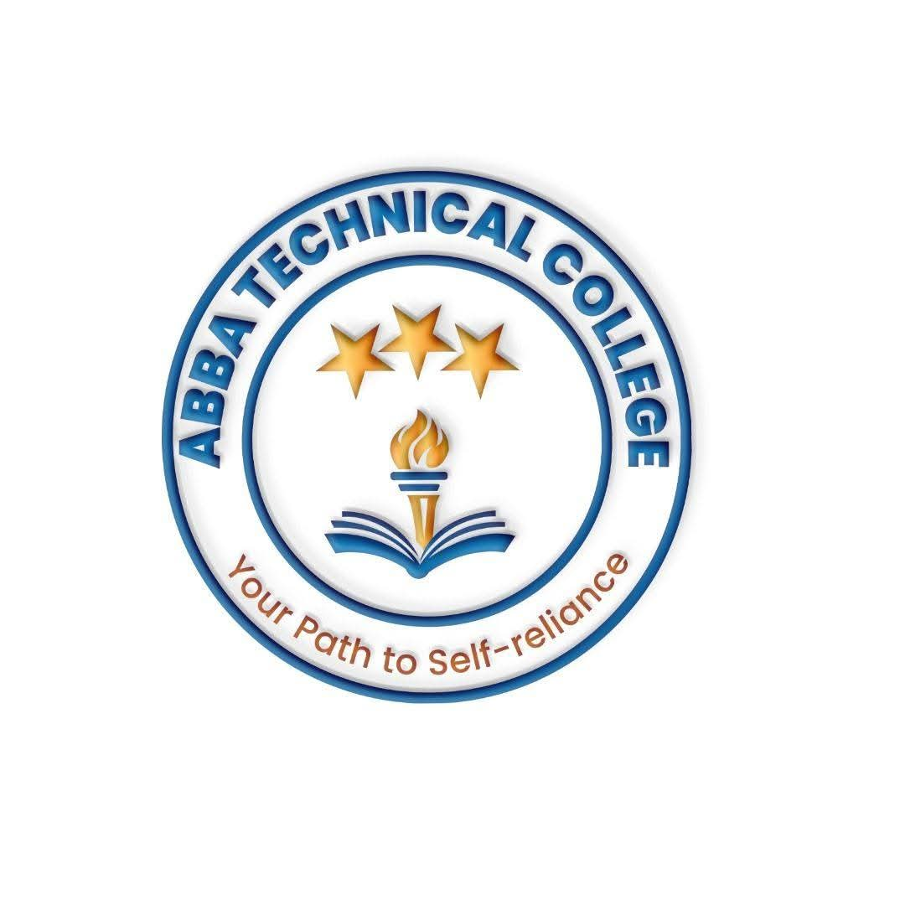
ABBA TECHNICAL COLLEGE
"Your Path to Self-Reliance"
17/08/ 2026
CDS 104 DATA SCIENCE
Duration: 24 Weeks
Price: $350
📚 What You Will Learn
- Programming for Data Science (Python): Python syntax, data structures, control flow, functions, and object-oriented programming basics.
- Data Manipulation Libraries: Working with NumPy for numerical operations and Pandas for dataframe manipulation and cleaning.
- Database Querying with SQL: Writing SELECT statements, filtering (WHERE), joining tables (JOINs), and pulling real-world data directly from databases — where most production datasets actually live.
- Exploratory Data Analysis (EDA): Visualizing complex patterns using Matplotlib and Seaborn.
- Machine Learning Fundamentals: Supervised and unsupervised learning, linear/logistic regression, decision trees, random forests, and k-means clustering.
- Applied Mathematics & Statistics: Probability theory, hypothesis testing, linear algebra concepts, and model evaluation metrics.
- Data Ethics & Responsible AI: Bias in models, data privacy, and communicating a model's limitations honestly — a habit most self-taught data scientists skip.
- Project Deployment: Basic model saving, API integration basics, and presenting data science findings to non-technical audiences.
🛠️ How You Will Learn
- Coding Workshops: Guided Python programming sessions in the computer lab.
- Version Control with Git & GitHub: Building a public portfolio that hiring managers can actually review.
- Real-World Capstone Project: Building, training, evaluating, and presenting a predictive machine learning model.
- Final Assessment & Certification: A supervised project review before receiving your official Abba Technical College certificate.
💼 Career & Earning Opportunities
- Junior Data Scientist
- Machine Learning Assistant
- Data Research Analyst

Call / WhatsApp: +211 922 600 538 | Email: abbatechnicalcollege@gmail.com

