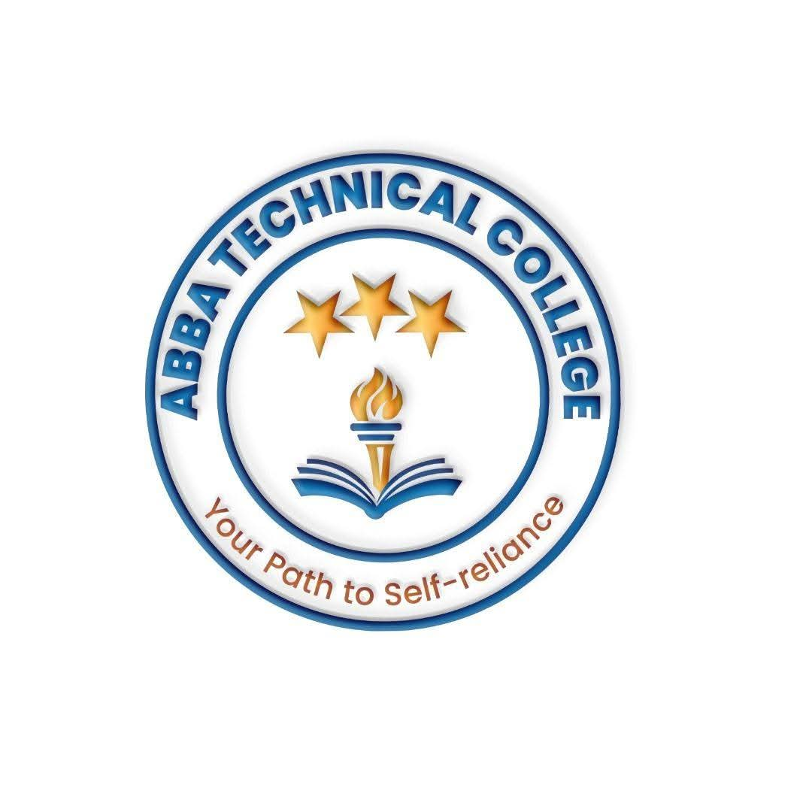
ABBA TECHNICAL COLLEGE
"Your Path to Self-Reliance"
17/08/2026
CHDB 300 HAIR DRESSING & BEAUTY
Duration: 16 Weeks
Price: $180
📚 What You Will Learn
- Hair Washing, Conditioning & Scalp Care: Client consultation, hair type identification, shampooing techniques, and deep conditioning treatments.
- Hair Styling & Braiding: Modern cornrows, box braids, dreadlocks maintenance, weaving, hair extensions, and blow-drying styles.
- Cutting & Chemical Treatments: Basic hair trimming/cutting techniques, relaxing, perming, and hair coloring, including safe handling of chemical products.
- Facial & Skincare Techniques: Cleansing, exfoliation, facial massage, skin type analysis, and applying face masks.
- Makeup Application: Daytime, evening, bridal, and specialized event makeup styling.
- Manicure, Pedicure & Nail Care: Nail shaping, cuticle care, hand/foot massages, polish application, and basic nail art.
- Salon Hygiene & Management: Tool sterilization, workstation sanitation, customer service skills, and salon business management basics — pricing your services and building a client base.
🛠️ How You Will Learn
- Live Practice: Practical sessions using mannequin heads and live models under expert guidance.
- Salon Environment Simulation: Operating in a fully equipped training salon setup.
- Final Assessment & Certification: A supervised practical assessment across hair, skin, and nails before receiving your official Abba Technical College certificate.
💼 Career & Earning Opportunities
- Beauty Salon Owner / Manager
- Professional Hair Stylist & Braider
- Professional Makeup Artist (including bridal & event styling)
- Mobile / Freelance Beauty Technician

Call / WhatsApp: +211 922 600 538 | Email: abbatechnicalcollege@gmail.com

