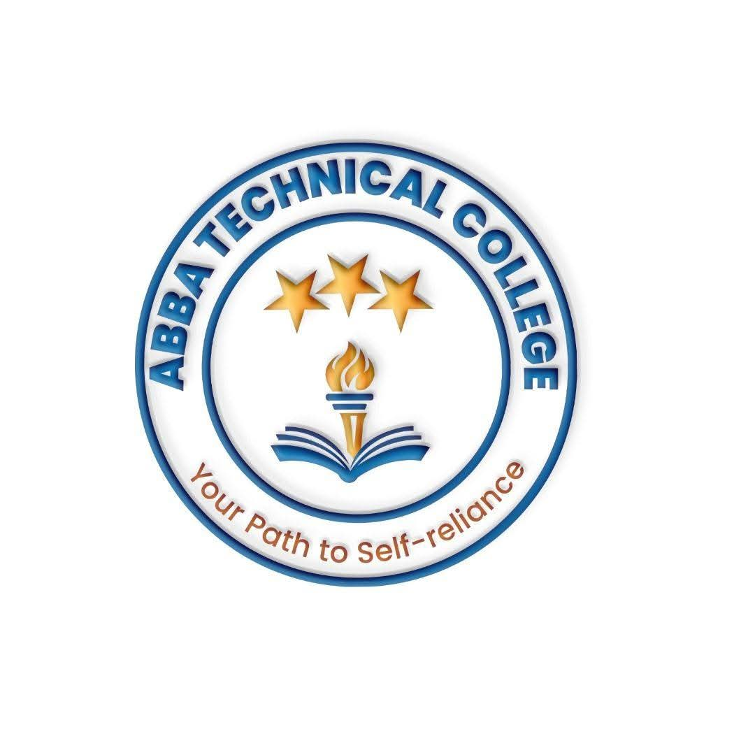
ABBA TECHNICAL COLLEGE
"Your Path to Self-Reliance"
17/08/ 2026
CMME 201 MOTORCYCLE MECHANICAL ENGINEERING
Duration: 12 Weeks
Price: $180
📚 What You Will Learn
- Engine Overhaul & Servicing: 2-stroke and 4-stroke engines, cylinder head servicing, piston ring replacement, and valve timing setup.
- Fuel & Carburetor Systems: Carburetor cleaning, tuning, fuel line maintenance, and introduction to basic fuel injection concepts.
- Electrical Systems: Wiring diagrams, battery health testing, magneto/stator testing, spark plug troubleshooting, ignition systems, and light/horn installations.
- Transmission & Clutch Systems: Clutch plate replacement, chain tensioning and sprockets, gear shift adjustment, and transmission repair.
- Braking & Suspension Systems: Servicing hydraulic disc brakes, drum brake adjustment, front fork oil replacement, and rear shock maintenance.
- Routine Maintenance & Safety Inspections: Oil changes, filter replacements, tire changing, wheel alignment, and safe workshop practices around fuel, heat, and heavy lifting.
- Sourcing Parts & Pricing Repairs: Identifying genuine vs. counterfeit parts, and quoting jobs like a professional.
🛠️ How You Will Learn
- Garage Workshop Training: Disassembling, repairing, and reassembling actual motorcycle engines and chassis.
- Real-World Troubleshooting: Diagnosing engine starting issues, electrical failures, and mechanical wear.
- Final Assessment & Certification: A supervised repair test before receiving your official Abba Technical College certificate.
💼 Career & Earning Opportunities
- Commercial Motorcycle (Boda Boda) Mechanic
- Workshop / Garage Technician
- Fleet Maintenance Specialist for transport companies
- Mobile / Roadside Repair Service — bring the garage to the customer
- Start your own motorcycle repair garage

Call / WhatsApp: +211 922 600 538 | Email: abbatechnicalcollege@gmail.com

