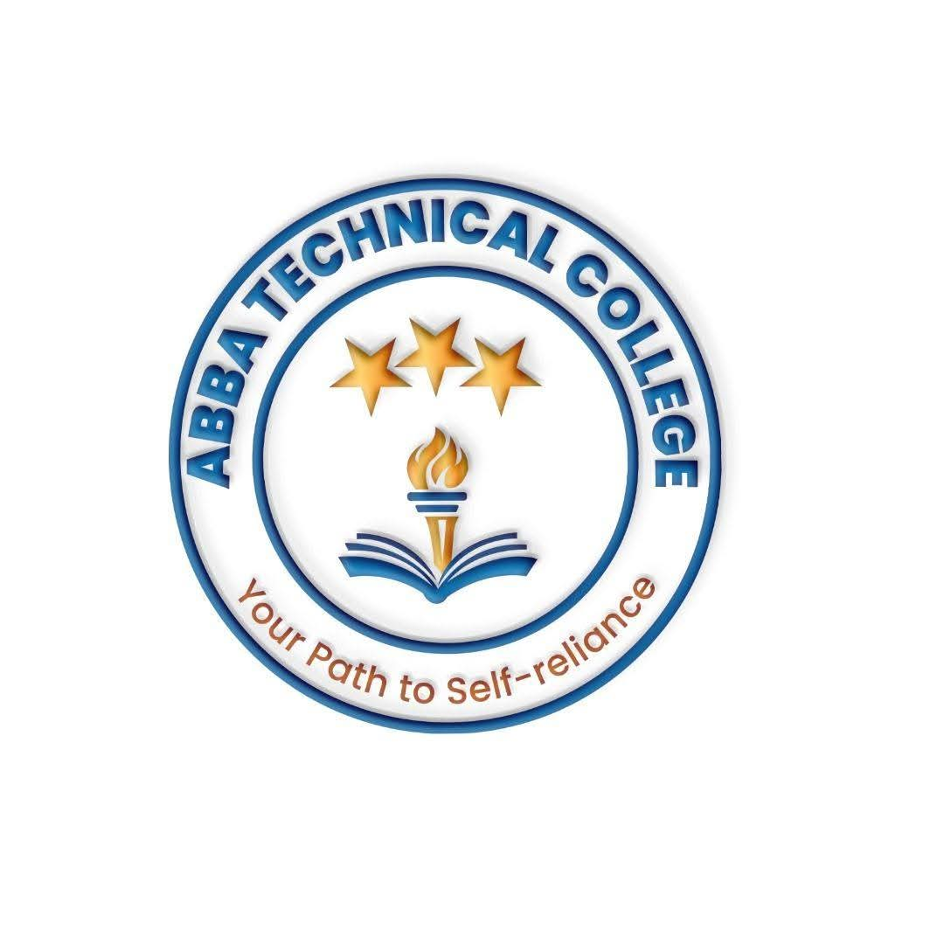
ABBA TECHNICAL COLLEGE
"Your Path to Self-Reliance"
17/08/ 2026
CMPRM 101 MOBILE PHONE REPAIR & MAINTENANCE
Duration: 12 Weeks
Price: $100
📚 What You Will Learn
- Basic Electronics & Tools: Using multimeters, soldering irons, hot air rework stations, and specialized repair toolkits safely.
- Android & iPhone Hardware Repairs: Diagnosing and replacing screens, digitizers, charging ports, batteries, speakers, microphones, and camera modules on both platforms — a rare local skill set that lets you serve customers most repair shops turn away.
- Micro-Soldering Fundamentals: An introduction to board-level precision repair — replacing connectors, charging ICs, and small motherboard components.
- Software Troubleshooting & Unlocking (Android & iOS): Flashing ROMs, unlocking password/pattern locks, FRP (Factory Reset Protection) bypass, and iCloud/iPhone software restores for devices with verified proof of ownership — one of the highest-paid specialties in phone repair.
- Water & Damage Recovery: Cleaning motherboard corrosion using ultrasonic cleaners and locating short circuits.
- Sourcing Parts & Pricing Repairs: Spotting genuine vs. counterfeit components, and quoting repair jobs like a professional.
🛠️ How You Will Learn
- Hands-on Workshop Labs: Practical work on live test devices, Android handsets, iPhones, and motherboards.
- Fault Diagnosis Drills: Finding and fixing deliberate hardware/software faults introduced by instructors.
- Final Assessment & Certification: A supervised repair test before receiving your official Abba Technical College certificate.
💼 Career & Earning Opportunities
- Owner of a Mobile Phone Repair Shop or Kiosk
- Mobile & iPhone Service Center Technician
- Freelance Mobile Technician
- Locked Phone Unlocking Specialist — a premium, high-demand service most local repair shops can't offer

Call / WhatsApp: +211 922 600 538 | Email: abbatechnicalcollege@gmail.com

