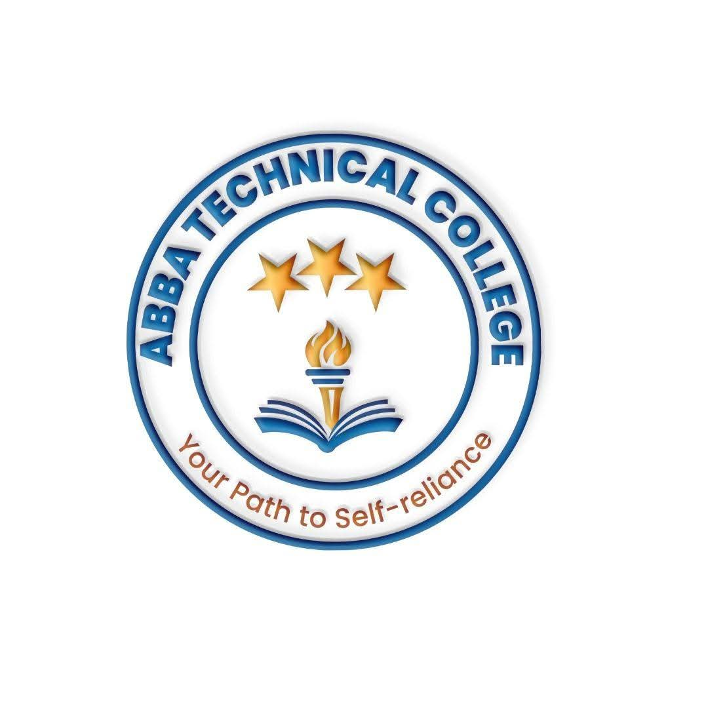
ABBA TECHNICAL COLLEGE
"Your Path to Self-Reliance"
16/08/ 2026
CRME 200 RAKSHA MECHANICAL ENGINEERING
Duration: 24 Weeks
Price: $230
📚 What You Will Learn
- 3-Wheeler Engine Architecture: Deep dive into auto-rickshaw (Raksha) engines, cooling systems, and power output mechanics.
- Complete Engine & Gearbox Overhaul: Engine block reboring concepts, crankshaft servicing, piston assembly, and gearbox reconditioning.
- Differential & Drive Systems: Repairing drive shafts, CV joints, differential gearboxes, and axle assemblies unique to three-wheelers.
- Electrical & Starter Systems: Heavy-duty starter motor repair, alternator testing, wiring harness repair, dashboard controls, and lighting systems.
- Chassis, Steering & Suspension: Front wheel fork rebuilding, handlebar alignment, rear leaf spring/shock absorber repairs, and frame straightening concepts.
- Brake & Fuel System Tuning: Hydraulic braking system bleeding, master cylinder repair, fuel pump tuning, and mileage optimization.
- Routine Maintenance & Workshop Safety: Everyday servicing schedules, plus safe handling of heavy components, hydraulic systems, and fuel.
- Sourcing Parts & Pricing Repairs: Identifying genuine vs. counterfeit parts, and quoting jobs like a professional.
🛠️ How You Will Learn
- 24-Week Intensive Practical Training: Hands-on work directly on 3-wheeler mechanical units and chassis.
- Diagnostics Practice: Identifying complex mechanical knocks, electrical shorts, and performance issues.
- Final Assessment & Certification: A supervised repair project before receiving your official Abba Technical College certificate.
💼 Career & Earning Opportunities
- Specialized Raksha Mechanics Workshop Owner
- Senior Technician in commercial 3-wheeler garages
- Fleet Maintenance Specialist for transport operators

Call / WhatsApp: +211 922 600 538 | Email: abbatechnicalcollege@gmail.com

