Auto_Dealer project

The diagram class picture: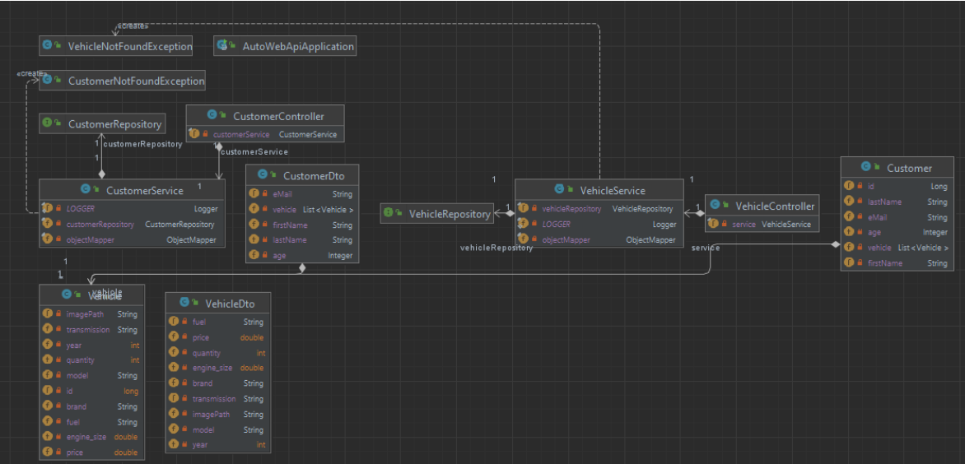

Main Components:
- AutoWebApiApplication:
  - This is likely the main application class which initializes and runs the application.
- Exceptions:
  - VehicleNotFoundException: Exception class for handling cases where a vehicle is not found.
  - CustomerNotFoundException: Exception class for handling cases where a customer is not found.
- Repositories:
  - CustomerRepository: Handles data access for customer entities.
  - VehicleRepository: Handles data access for vehicle entities.
- Services:
  - CustomerService: Business logic related to customers.
    - Dependencies: CustomerRepository, ObjectMapper, Logger.
  - VehicleService: Business logic related to vehicles.
    - Dependencies: VehicleRepository, ObjectMapper, Logger.
- Controllers:
  - CustomerController: Handles HTTP requests related to customers.
    - Dependency: CustomerService.
  - VehicleController: Handles HTTP requests related to vehicles.
    - Dependency: VehicleService.
- Data Transfer Objects (DTOs):
  - CustomerDto: Represents a customer data transfer object.
    - Fields: eMail, firstName, lastName, age, vehicle (List of vehicles).
  - VehicleDto: Represents a vehicle data transfer object.
    - Fields: fuel, price, quantity, engine_size, brand, transmission, model, year, imagePath.
- Entities:
  - Customer: Represents the customer entity.
    - Fields: id, firstName, lastName, eMail, age, vehicle (List of vehicles).
  - Vehicle: Represents the vehicle entity.
    - Fields: id, brand, model, year, quantity, transmission, engine_size, price, imagePath.
Relationships:
- CustomerRepository is used by CustomerService.
- VehicleRepository is used by VehicleService.
- CustomerService is used by CustomerController.
- VehicleService is used by VehicleController.
- Customer has a one-to-many relationship with Vehicle (a customer can have multiple vehicles).

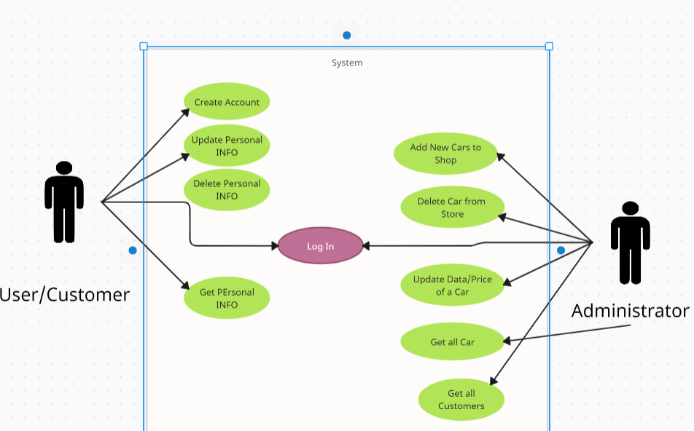

Actors:
- User/Customer:
  - Represents the general users of the system who are likely customers interacting with the application to manage their accounts and personal information.
- Administrator:
  - Represents the administrative users who manage the backend operations of the system, including managing cars and customer data.
Use Cases for User/Customer:
- Create Account:
  - Allows a user to create a new account in the system.
- Update Personal INFO:
  - Enables the user to update their personal information such as name, email, address, etc.
- Delete Personal INFO:
  - Allows the user to delete their personal information from the system.
- Get Personal INFO:
  - Permits the user to retrieve their personal information from the system.
Use Cases for Administrator:
- Add New Cars to Shop:
  - Allows the administrator to add new cars to the system, making them available for customers.
- Delete Car from Store:
  - Enables the administrator to remove a car from the system.
- Update Data/Price of a Car:
  - Allows the administrator to update the details and pricing of existing cars in the system.
- Get all Car:
  - Permits the administrator to retrieve a list of all cars in the system.
- Get all Customers:
  - Enables the administrator to retrieve a list of all customers registered in the system.

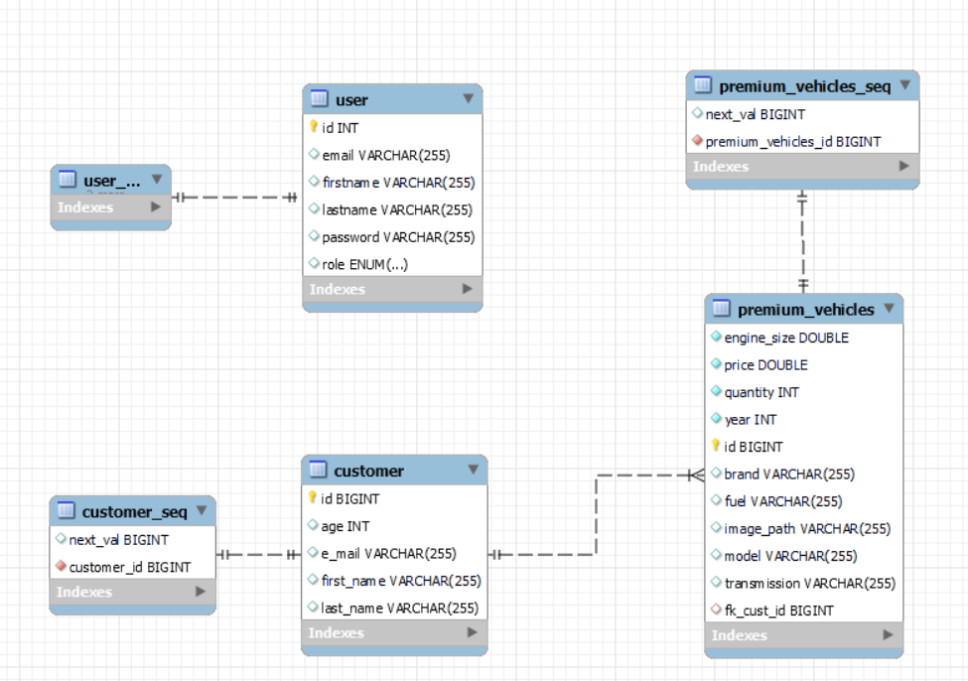

For the third assignment I added the interface for the app and I styled it with CSS components.
I routed all the pages that communicate between them with React and now is easily to navigate on the app.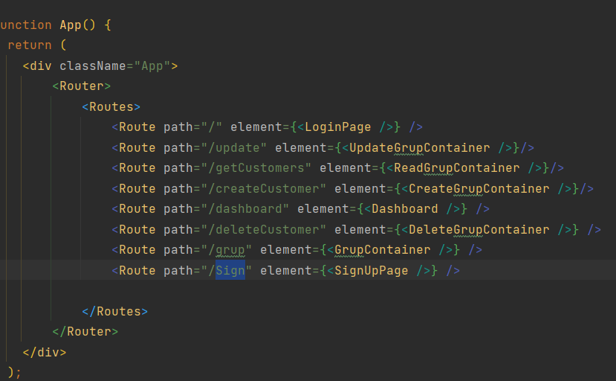
After that I create for each function a page that u can interect with buttons and textbox to manipulate the data.
This is how a page is configurated:
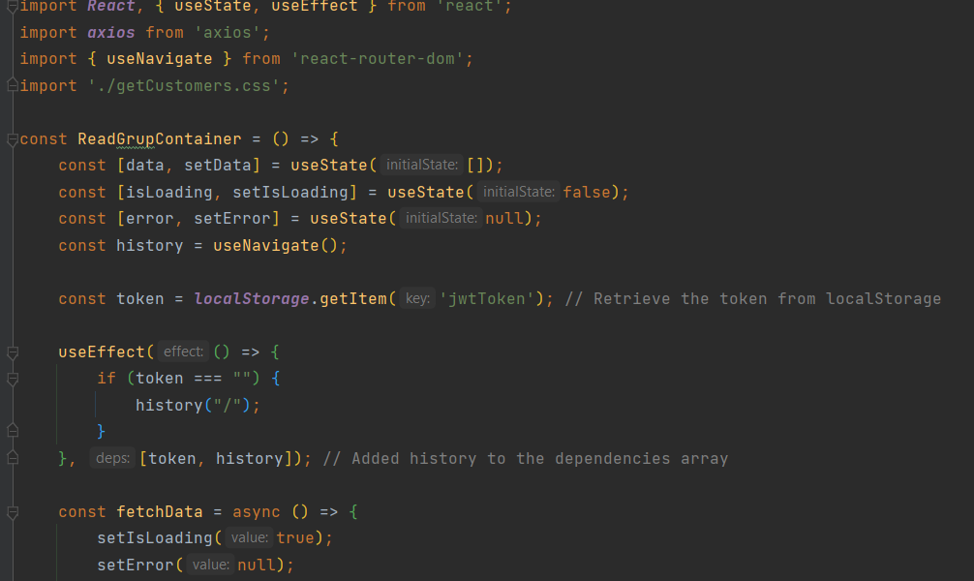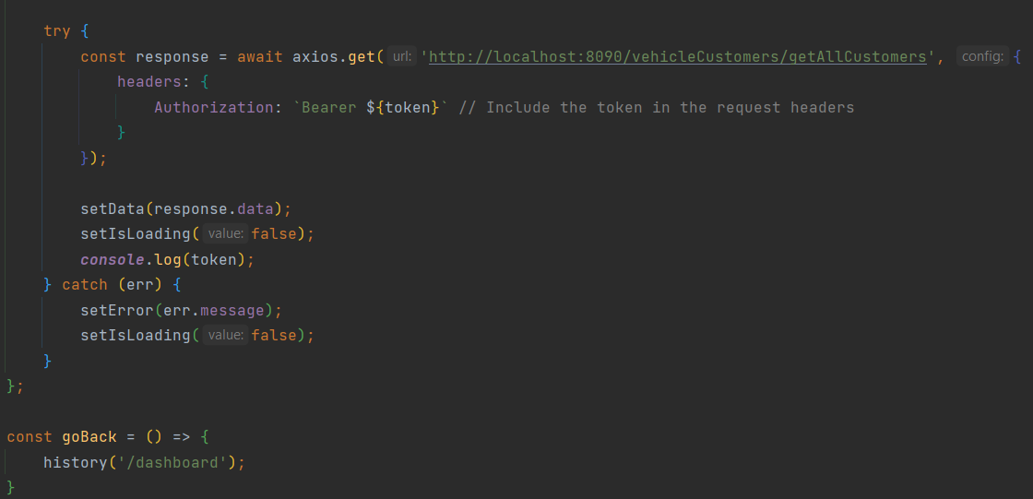
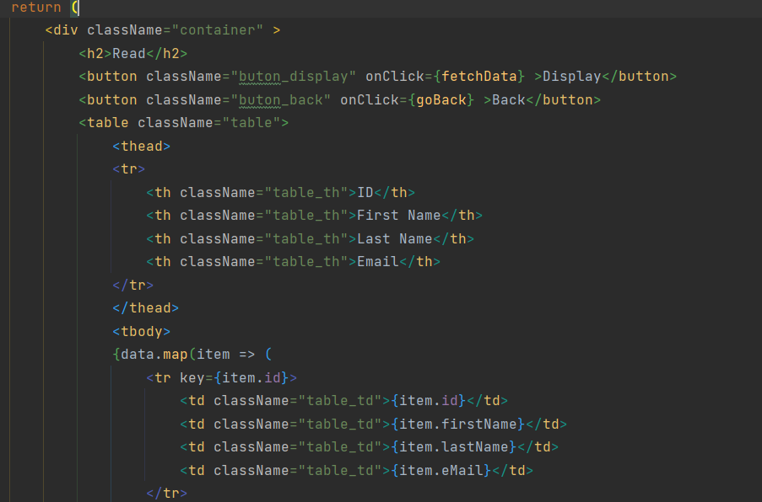

And CSS components are placed in a different file and import on the .js one
