RAG and AI tools

**How have you applied RAG systems and AI tools in your projects?**

I applied catching the user prompt and adding more details or information to be answerd back by the AI more precisely. In order to accomplish that, I collected several datasets according to what the user could ask about.Then I added or suppressed the information related to the user prompt.

**How did you manage design and optimization of prompts to make the user experience better?**

Accodring the the design, I used Microsft Visio to bulid up and show the main goal and its development to start a project. This could be an example:

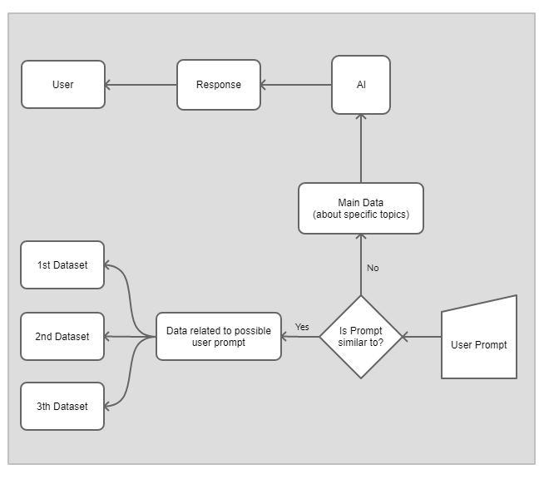

And to optimize the user experience we should get as many datasets as possible to enrich the answer from the AI.