**MODULE 4**

**HARD DISK**

**I Definition of a Hard Disk**

* A hard disk drive is a sealed unit that a PC uses for non-volatile data storage.
* Non-volatile, or semi-permanent, storage means that the storage device retains the data even when no power is supplied to the computer.
* A hard disk drive contains rigid, disk-shaped platters, usually constructed of aluminium or glass (see Figure 10.1).
* In most hard disk drives, you cannot remove the platters, which is why they are sometimes called fixed disk drives.

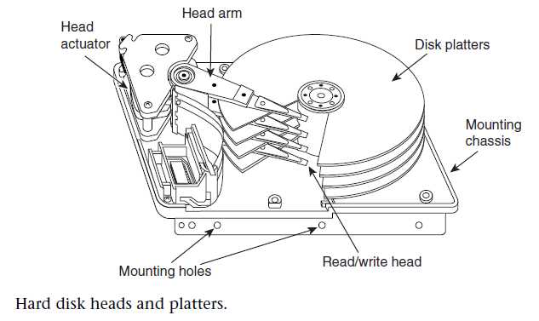

**II Hard Disk Drive Operation**

* The basic physical construction of a hard disk drive consists of spinning disks with heads that move over the disks and store data in tracks and sectors.
* The heads read and write data in concentric rings called tracks, which are divided into segments called sectors, which normally store 512 bytes each

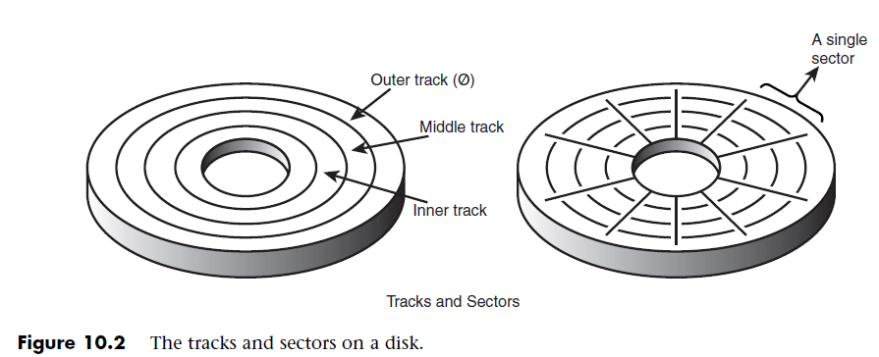

* Hard disk drives usually have multiple disks, called platters, that are stacked on top of each other and spin in unison, each with two sides on which the drive stores data.
* The identically aligned tracks on each side of every platter together make up a cylinder.
* A hard disk drive normally has one head per platter side, with all the heads mounted on a common carrier device or rack.
* The heads move radially across the disk in unison; they cannot move independently because they are mounted on the same carrier or rack, called an actuator.
* The heads in most hard disk drives do not (and should not!) touch the platters during normal operation.
* While the drive is running, a very thin cushion of air keeps each head suspended a short distance above or below the platter. If the air cushion is disturbed by a particle of dust or a shock, the head can come into contact with the platter while it is spinning at full speed.
* Most drives have special lubricants on the platters and hardened surfaces that can withstand the daily “take offs and landings” as well as more severe abuse.

**hard disk cylinders**

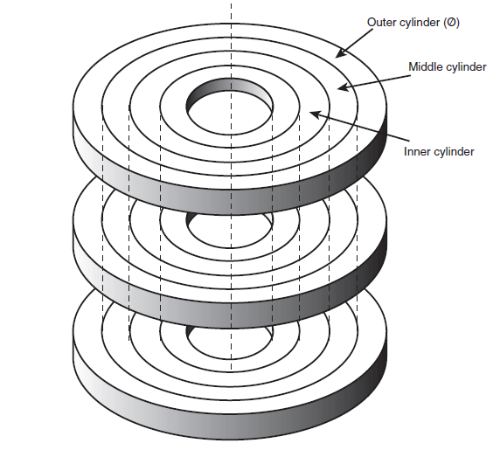

**III Disk Formatting**

Disk formatting is the process of preparing a data storage device such as a hard disk drive,

solid-state drive, floppy disk or USB flash drive for initial use.

Two formatting procedures are required before you can write user data to a disk:

1. **_ Physical, or low-level formatting**
2. **_ Logical, or high-level formatting**

A hard disk, however, requires two separate formatting operations. Moreover, a hard disk requires a third step, between the two formatting procedures, to write the partitioning information to the disk.

* Partitioning is required because a hard disk is designed to be used with more than one operating system. Using multiple operating systems on one hard drive is possible by separating the physical formatting in a procedure that is always the same, regardless of the operating system used and the disk formatting process involves,

**1.** Low-level formatting (LLF)

**2.** Partitioning

**3.** High-level formatting (HLF)

**Low-Level Formatting**

* During a low-level format, the formatting program divides the disk’s tracks into a specific number of sectors.
* The program also fills each sector’s data area with a dummy byte value or a pattern of test values.
* One way to increase the capacity of a hard drive during the low-level format is to create more sectors on the disks’ outer cylinders than on the inner ones. Because they have a larger circumference, the outer cylinders can hold more data.

**Partitioning**

Partitioning is the process of writing information into blocks of a storage device that allows access by an operating system.

It involves the division of the hard drive into logical volumes for data storage.

• Fdisk is a command used in DOS and windows 9x to partition a hard disk.

• Once your drive is partitioned, each partition will have to be formatted with a file system.

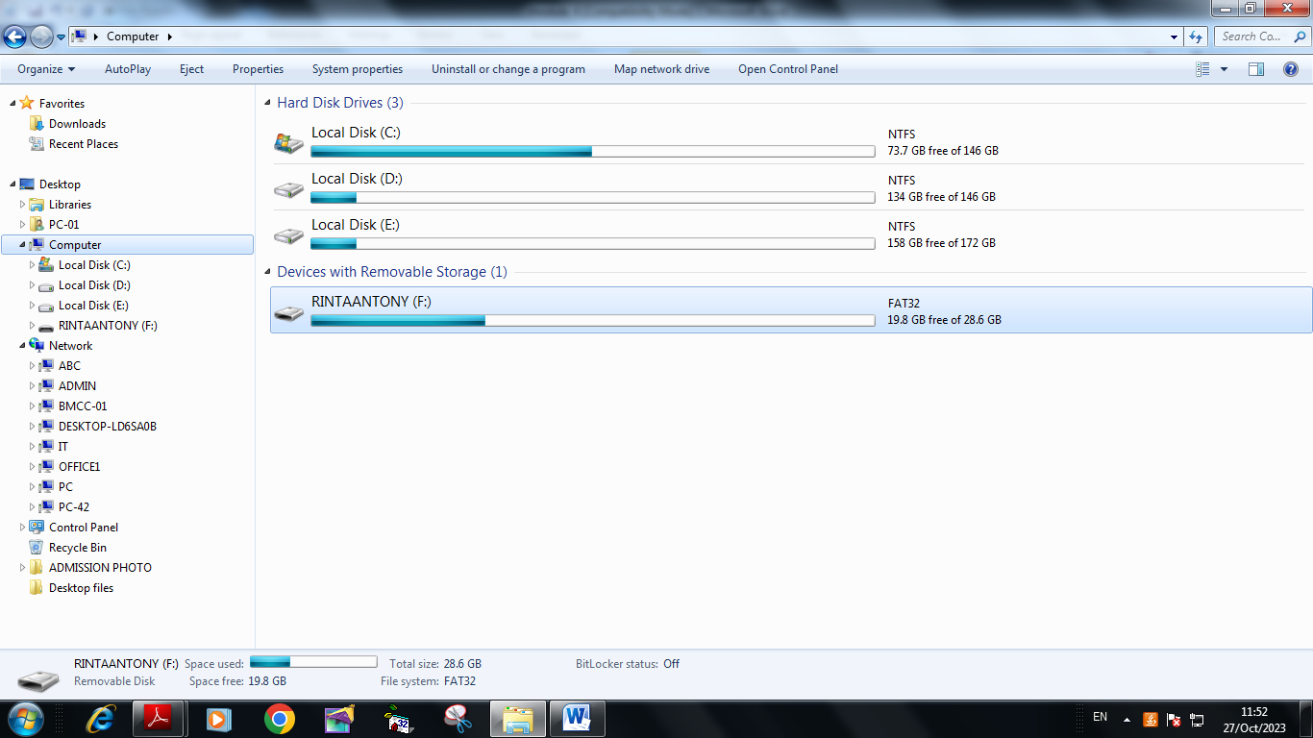

* Creating a partition on a hard disk drive enables it to support separate file systems, each in its own partition.
* Each file system can then use its own method to allocate file space in logical units called clusters or allocation units.
* Every hard disk drive must have at least one partition on it and can have up to four partitions, each of which can support the same or different type file systems.
* Three common file systems are used by PC operating systems today:

**1. FAT (File Allocation Table).** The standard file system supported by DOS, Windows 9x/Me/2000,and Windows NT

* The standard FAT file system uses 12- or 16-bit numbers to identify clusters,resulting in a maximum volume size of 2GB.

**2.FAT32 (File Allocation Table, 32-bit).** An optional file system supported by Windows 95 OSR2 (OEM Service Release 2), Windows 98, Windows Me, and Windows 2000.

* FAT32 uses 32-bit numbers to identify clusters, resulting in a maximum single volume size of 2TB or 2,048GB.

**3.NTFS (Windows NT File System).** The native file system for Windows NT/2000 that supports filenames up to 256 characters long and partitions up to (a theoretical) 16 exbibytes minus 1 kilobyte. (1exbibytes=260)

* NTFS also provides extended attributes and file system security features that do not exist in the FAT file system.
* Of these three file systems, the FAT file system is still the most popular and is accessible by nearly every operating system, which makes it the most compatible as well.

**High-Level Formatting**

* High-level formatting is not really a physical formatting of the drive, but rather the creation of a table of contents for the disk.
* In low-level formatting, which is the real physical formatting process, tracks and sectors are written on the disk.
* The third part of the process, is termed as "high level formatting" .
* It refers to the process of generating a new file system.
* It is the process of setting up an empty file system on a disk partition or logical volume and, for PCs, installing a boot sector.

**IV Basic Hard Disk Drive Components**

The basic components of a typical hard disk drive are as follows

1. _ Disk platters
2. _ Read/write heads
3. _ Head actuator mechanism
4. _ Spindle motor (inside platter hub)
5. _ Logic board (controller or Printed Circuit Board)
6. _ Cables and connectors
7. _ Configuration items (such as jumpers or switches)

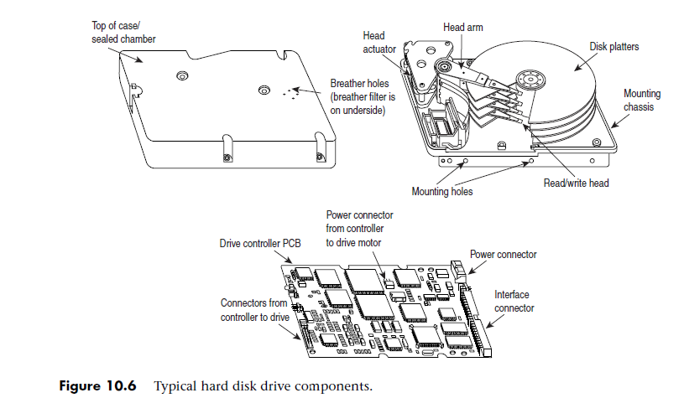

1. **Hard Disk Platters (Disks)**

* A hard disk drive has one or more platters, or disks.
* Normally, the physical size of a drive is expressed as the size of the platters.
* Following are the platter sizes that have been associated with PC hard disk drives:

_ 5 1/4-inch (actually 130mm, or 5.12 inches)

_ 3 1/2-inch (actually 95mm, or 3.74 inches)

_ 2 1/2-inch (actually 65mm, or 2.56 inches)

_ 1-inch (actually 34mm, or 1.33 inches)

**B.Recording Media**

* No matter which substrate is used, the platters are covered with a thin layer of a magnetically retentive substance, called the medium, on which magnetic information is stored.
* Two popular types of magnetic media are used on hard disk platters:

1. **_ Oxide medium**
2. **_ Thin-film medium**

**Oxide medium**

* + The oxide medium is made of various compounds, containing iron oxide as the active ingredient.
  + The magnetic layer is created on the disk by coating the aluminum platter with a syrup containing ironoxide particles.
  + syrup is spread across the disk by spinning the platters at high speed
  + The oxide coating is normally about 30 millionths of an inch thick.

**Thin-film medium**

* The thin-film medium is thinner, harder, and more perfectly formed than oxide medium.
* Thin-film plated media are manufactured by depositing the magnetic medium on the disk with an electroplating mechanism, in much the same way that chrome plating is deposited on the bumper of a car.
* Thin film was developed as a high-performance medium that enabled a new generation of drives to have lower head-floating heights, which in turn made increases in drive density possible

**C.Read/Write Heads**

* A hard disk drive usually has one read/write head for each platter surface (meaning that each platter has two sets of read/write heads—one for the top side and one for the bottom side).
* These heads are connected, or ganged, on a single movement mechanism.
* The heads, therefore, move across the platters in unison.
* Each head is on an actuator arm that is spring-loaded to force the head into contact with a platter. 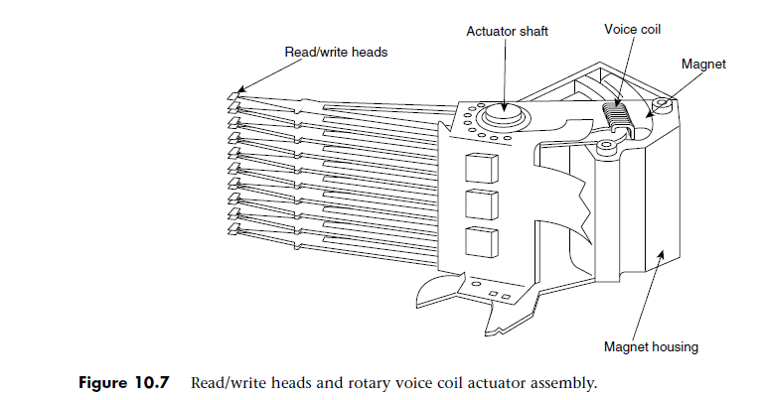

**D.Head Actuator Mechanisms**

This mechanism moves the heads across the disk and positions them accurately above the desired cylinder.

Many variations on head actuator mechanisms are in use, but all fall into one of two basic categories:

i.Stepper motor actuators

ii. Voice coil actuators

**i.Stepper Motor Actuators**

* A stepper motor is an electrical motor that can “step,” or move from position to position, with mechanical detents or click-stop positions.
* If you were to grip the spindle of one of these motors and spin it manually, you would hear a clicking or buzzing sound as the motor passed each detent position with a soft click.
* Stepper motor mechanisms are affected by a variety of problems; the greatest problem is temperature. As the drive platters heat and cool, they expand and contract, and the tracks on the platters move in relation to a predetermined track position.

Figure 10.8 shows a common stepper motor design, where a split metal band is used to transfer the movement from the rotating motor shaft to the head actuator itself.

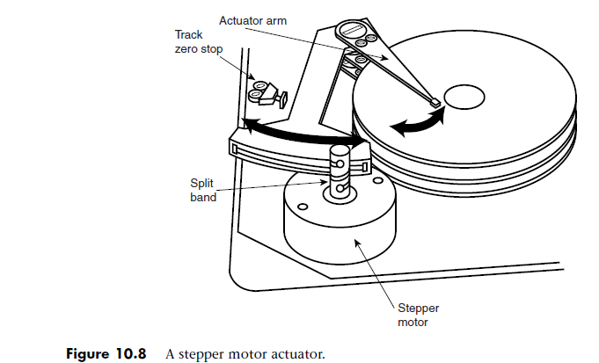

**ii.Voice Coil Actuators**

* The voice coil actuators used in virtually all hard disk drives made today—unlike stepper motor actuators—use a feedback signal from the drive to accurately determine the head positions and adjust them, if necessary.
* This arrangement provides significantly greater performance, accuracy, and reliability than traditional stepper motor actuator designs.
* A voice coil actuator works by pure electromagnetic force.
* Unlike a stepper motor, a voice coil actuator has no click-stops, or detent positions;
* Voice coil actuators use a guidance mechanism called a **servo** to tell the actuator where the heads are in relation to the cylinders and to place the heads accurately at the desired positions.
* This positioning system often is called a **closed loop feedback mechanism**.
* The two main types of voice-coil positioned mechanisms are

_ Linear voice-coil actuators

_ Rotary voice-coil actuators

**Servo Mechanisms**

Three servo mechanism designs have been used to control voice coil petitioners over the years:

_ Wedge servo

_ Embedded servo

_ Dedicated servo

All servo mechanisms rely on special information that is written to the disk when it is manufactured.

This information is usually in the form of a special code called a *gray code*

**Wedge Servo**

* Early servo-controlled drives used a technique called a *wedge servo. In these drives, the gray-code guidance*
* information is contained in a “wedge” slice of the drive in each cylinder immediately preceding the index mark
* The index mark indicates the beginning of each track, so the wedge-servo information was written in the PRE-INDEX GAP, which is at the end of each track. This area is provided for speed tolerance and normally is not used by the controller.

***Embedded Servo***

* An embedded servo is an enhancement of the wedge servo.
* Instead of placing the servo code before the beginning of each cylinder, an embedded servo design writes the servo information before the start of each sector
* This arrangement enables the positioned circuits to receive feedback many times
* in a single revolution, making the head positioning much faster and more precise

**Dedicated Servo**

* A dedicated servo is a design in which the servo information is written continuously throughout the entire track, rather than just once per track or at the beginning of each sector.
* Unfortunately, if this procedure were used on the entire drive, no room would be left for data. For this reason**, a *dedicated servo uses one side of one of the platters exclusively for the servo-positioning information.***

**Air Filters**

Nearly all hard disk drives have two air filters. One is called the **recirculating filter**, and the other is called either a **barometric or breather filter**. A hard disk on a PC system does not circulate air from inside to outside the HDA or vice versa. The recirculating filter permanently installed inside the HDA is designed to filter only the small particles scraped off the platters during head takeoffs and landings (and possibly any other small particles dislodged inside the drive).

**Hard Disk Temperature Acclimation**

Because hard drives have a filtered port to bleed air into or out of the HDA, moisture can enter the drive, and after some period of time, it must be assumed that the humidity inside any hard disk is similar to that outside the drive. Humidity can become a serious problem if it is allowed to condense—and especially if you power up the drive while this condensation is present. Most hard disk manufacturers have specified procedures for acclimating a hard drive to a new environment with different temperature and humidity ranges, and especially for bringing a drive into a warmer environment in which condensation can form.

**Spindle Motors**

The motor that spins the platters is called the spindle motor because it is connected to the spindle around which the platters revolve. Spindle motors in hard disk drives are always connected directly; no belts or gears are involved. The motor must be free of noise and vibration; otherwise, it can transmit a rumble to the platters, which can disrupt reading and writing operations.

**Logic Boards**

All hard disk drives have one or more logic boards mounted on them. The logic boards contain the electronics that control the drive’s spindle and head actuator systems and present data to the controller in some agreed-upon form

**Cables and Connectors**

Hard disk drives typically have several connectors for interfacing to the computer, receiving power, and sometimes grounding to the system chassis. Most drives have at least these three types of connectors:

_ Interface connector(s)

_ Power connector

_ Optional ground connector (tab)

Of these, the interface connectors are the most important because they carry the data and command signals between the system and the drive.

**V Hard Disk Features**

To make the best decision in purchasing a hard disk for your system or to understand what distinguishes one brand of hard disk from another, you must consider many features. This section examines some of the issues you should consider when you evaluate drives:

_ Reliability

_ Performance

_ Cost

**Reliability**

When you shop for a drive, you might notice a statistic called the Mean Time Between Failures (MTBF) described in the drive specifications. MTBF figures usually range from 300,000 to 1,000,000 hours or more. I usually ignore these figures because they are derived theoretically.

**S.M.A.R.T.**

S.M.A.R.T. (Self-Monitoring, Analysis, and Reporting Technology) is an industry standard providing failure prediction for disk drives. When S.M.A.R.T. is enabled for a given drive, the drive monitors predetermined attributes that are susceptible to or indicative of drive degradation. Based on changes in the monitored attributes, a failure prediction can be made. If a failure is deemed likely to occur,S.M.A.R.T. makes a status report available so the system BIOS or driver software can notify the user of the impending problems, perhaps enabling the user to back up the data on the drive before any real problems occur.

**Performance**

When you select a hard disk drive, one of the important features you should consider is the performance (speed) of the drive. Hard drives can have a wide range of performance capabilities. As is true of many things, one of the best indicators of a drive’s relative performance is its price. An old saying from the automobile-racing industry is appropriate here: “Speed costs money. How fast do you want to go?”

You can measure the speed of a disk drive in two ways:

_ Average seek time

_ Transfer rate

Average seek time, normally measured in milliseconds (ms), is the average amount of time it takes to move the heads from one cylinder to another a random distance away. The standard method used by many drive manufacturers to measure the average seek time involves measuring the time it takes the heads to move across one-third of the total cylinders Average seek time depends only on the drive itself; the type of interface or controller has little effect on this specification.The rating is a gauge of the capabilities of the head actuator.

**Average Access Time**

A slightly different measurement, called average access time, involves another element called latency.Latency is the average time (in milliseconds) it takes for a sector to be available after the heads have reached a track. On average, this figure is half the time it takes for the disk to rotate once. A drive that spins twice as fast would have half the latency. A measurement of a drive’s average access time is the sum of its average seek time and latency. This number provides the average amount of time required before the drive can access a randomly requested sector.

**Latency**

Latency is a factor in disk read and write performance. Decreasing the latency increases the speed of access to data or files and is accomplished only by spinning the drive platters more quickly

**Transfer Rate**

The media transfer rate is far more important than the interface transfer rate because the media transfer rate is the true rate at which data can be read from the disk, which is how fast data can be read from the drive platters (media). It is the maximum rate that any sustained transfer can hope to achieve.

**Cost**

The cost of hard disk storage is continually falling. You can now purchase a 30GB ATA drive for around $150, which is about half a cent per megabyte.A drive I bought in 1983 had a maximum capacity of 10MB and cost $1,800. At current pricing (0.5 cents per megabyte), that drive is worth about 5 cents! Of course, the cost of drives continues to fall, and eventually, even half a cent per megabyte will seem expensive. Because of the low costs of disk storage today, not many 3-1/2 inch drives with capacities of less than 10GB are even being manufactured.

**Capacity**

Four figures are commonly used in advertising drive capacity:

_ Unformatted capacity, in millions of bytes

_ Formatted capacity, in millions of bytes

_ Unformatted capacity, in megabytes

_ Formatted capacity, in megabytes