MCA

1. If y = then the n^{th} derivative is
(A)
(B)
(C)
(D)

2. If a, b, c are the direction cosines of a line then $a^{2}+b^{2}+c^{2}=$ ……………
(A) | 1
(B) | 0
(C) | –1
(D) | None of the above

3. dx = ……………
(A) | $\frac{1}{x}$+ C
(B) | + C
(C)
(D)

4. If $3\sin{θ+4\cos{θ=5}}$ then the value of $cosec θ$ = ……………
(A) | 2/3
(B) | 3/5
(C) | 3/2
(D) | 5/3

5. If $a^{\frac{1}{3}}+b^{\frac{1}{3}}+c^{\frac{1}{3}}=0$ then
(A) | a + b + c = 0
(B) | a + b + c = 3abc
(C)
(D) | ${(a+b+c)}^{3}$=27abc

6. Which of the following is not an even function?
(A)
(B)
(C)
(D)

7. Find the value of $\sqrt{6+\sqrt{6+\sqrt{6+-------}}}$
(A) | 5
(B) | 4
(C) | 3
(D) | 2

8. Ten tickets are numbered 1, 2, 3, ………, 10. Six tickets are selected at random one at a time with replacement. The probability that the largest number appearing on the selected ticket is 7 is
(A)
(B)
(C)
(D)

9. $\frac{1}{\log_{xy}(xyz)}+\frac{1}{\log_{yz}(xyz)}+\frac{1}{\log_{xz}(xyz)}=$ ……………
(A) | 1
(B) | 2
(C) | 3
(D) | 4

10. A person standing on the bank of a river observes that the angle subtended by a tree on the opposite bank is 60°. When he retreats 40 m from the bank he finds the angle to be 30°. Find the height of the tree and breadth of the river.
(A) | 31.64 m, 21 m
(B) | 32.64 m, 22 m
(C) | 33.64 m, 24 m
(D) | 34.64 m, 20 m

11. Evaluate $\lim_{x→2}{\frac{\sqrt{x^{2}+5}-3}{x^{2}-2x}}$
(A)
(B)
(C)
(D)

12. Find the slope intercept equation of the tangent line to the graph of the function
$f\left(x\right)=4x^{3}-7x^{2}$ at the point corresponding to $x=3.$
(A)
(B)
(C)
(D)

13. Find the derivative of $H\left(x\right)=\frac{3x-2}{2x+5}$
(A)
(B)
(C)
(D)

14. How many ways are there to select five players from a ten member tennis team to make a trip to a match to another school?
(A) | 120
(B) | 252
(C) | 200
(D) | 130

15. Is the “Divides” relation on the set of positive integers is symmetric or antisymmetric?
(A) | Symmetric
(B) | Antisymmetric
(C) | Both Symmetric and Antisymmetric
(D) | None of the above

16. The rank of the matrix A= $\left[\begin{matrix}1 & 2 & 3 \\ 2 & 3 & 4 \\ 0 & 2 & 2\end{matrix}\right]$
(A) | 5
(B) | 4
(C) | 3
(D) | 2

17. Suppose that there are 9 faculty members in the mathematics department and 11 in the computer science department. How many ways are there to select a committee to develop a discrete mathematics course at a school if the committee is to consist of three faculty members from the mathematics department and four from computer science department?
(A) | 27720
(B) | 27724
(C) | 27620
(D) | 27624

18. The points of intersection of the circles
$x^{2}+{\left(y-4\right)}^{2}=10 and {(x-8)}^{2}+y^{2}=50$ are
(A) | (5, 3) and (1, 0)
(B) | (3, 5) and (0, 1)
(C) | (3, 5) and (1, 1)
(D) | (5, 3) and (1, 1)

19. If the system of equations, $x-ky-z=0,kx-y-z=0,x+y+z=0$, has a non zero solution ,then the possible values of k are :
(A)
(B) | 1, 2
(C) | 0, 1
(D)

20. $\frac{d}{dx}(\sqrt{\sin{x}})$ = ……………
(A)
(B)
(C)
(D)

21. On the circle the second derivative is
(A)
(B)
(C)
(D)

22. The number of substrings of all lengths that can be formed from a character string of length n is
(A) | n
(B) | n²
(C)
(D)

23. Let A be a finite set of size n, the number of elements in the power set of A × A is
(A)
(B)
(C) | 2^{n}
(D) | n²

24. The inverse of A =$\left[\begin{matrix}5 & 3 \\ 4 & 2\end{matrix}\right]$ is
(A)
(B)
(C)
(D)

25. The number of possible binary trees with 3 unlabelled nodes is
(A) | 10
(B) | 6
(C) | 5
(D) | 15

26. If $\frac{1}{2}\log{x+\frac{1}{2}\log{y+\log{2=\log\left(x+y\right)}}}$, then
(A)
(B) | x = y
(C)
(D)

27. The total number of edges in a complete graph of n vertices is
(A) | n
(B)
(C)
(D)

28. Seven car accidents occurred in a week. What is the probability that they did not occur on Monday?
(A)
(B)
(C)
(D)

29. Let X be a binomially distributed random variable $B(n,p)$ with$E(X)=2$ and $Var(X)=4/3$, then the values for n and p are
(A)
(B)
(C)
(D)

30. ……………
(A)
(B)
(C)
(D)

31. In what proportion must water be mixed with milk so as to gain 20% by selling the mixture at the cost price of the milk? (Assume that the water is freely available).
(A) | 1:4
(B) | 1:5
(C) | 1:6
(D) | 1:12

32. The least possible integral value of a for which the equation both the roots are positive is
(A) | 1
(B) | 3
(C) | 4
(D) | 6

33. If then the value of is
(A)
(B)
(C)
(D)

34. If θ lies in the second quadrant, then = ………..….
(A)
(B)
(C)
(D)

35. If and then,
(A)
(B)
(C)
(D)

36. The solution set of is
(A)
(B)
(C)
(D)

37. The value of ${ (\frac{i+√3}{2})}^{100}+{(\frac{i-√3}{2})}^{100}$ is
(A)
(B) | 1
(C) | 0
(D) | i

38. If the multiplicative inverse of a complex number is then the complex number itself is
(A)
(B)
(C)
(D)

39. The smallest positive integer n for which ${\left(\frac{1+i}{1-i}\right)}^{n}=-1$is
(A) | 5
(B) | 1
(C) | 2
(D) | 3

40. The sides AB, BC, CA of a triangle ABC have 3, 4 and 5 interior points respectively on them. The total number of triangles that can be constructed by using these interior points as vertices are
(A) | 220
(B) | 205
(C) | 204
(D) | 195

41. A farmer buys 3 cows, 2 pigs, 4 hens from a man who has 6 cows, 5 pigs and 8 hens. How many choices does the farmer have?
(A) | 1200
(B) | 1400
(C) | 1600
(D) | 1800

42. The matrices and commute under multiplication
(A) | if or where n is an integer
(B) | always
(C) | never
(D) | if

43. Division algorithm states that let a and b be integers with then there exist integers q and r such that,
(A)
(B)
(C)
(D)

44. The set of integers z with the binary operations ‘*’ defined as for i is a group, the identity element of this group is
(A) | 0
(B) | 1
(C)
(D) | 2

45. Let L be a set with a relation R which is transitive, antisymmetric and reflexive and for any two elements. Let the least upper bound and the greatest lower bound exist. Which is true?
(A) | L is a Poset and Lattice
(B) | L is a Boolean algebra
(C) | L is Lattice
(D) | None of the above

46. Which of the following represent the sequence 1, 2, 5, 11, 26,…
(A)
(B)
(C)
(D)

47. Determine k such that the quadratic equation $x^{2}+7\left(3+2k\right)-2x\left(1+3k\right)=0$ has equal roots:
(A) | 2, 7
(B) | 7, 5
(C) | 2,
(D) | 2,

48. If the length of shadow of a vertical pole on the horizontal ground is $\sqrt{3}$ times of its height, then the angle of elevation of sun is:
(A) | 15°
(B) | 30°
(C) | 45°
(D) | 60°

49. The irrational inequality is true if
(A)
(B)
(C) | and
(D)

50. then x = ……………
(A)
(B)
(C)
(D)

51. If set A = {4, 5, 6, 7, 8, 9} and set B = {3, 5, 2, 7} then A – B is
(A) | {3, 2}
(B) | {4, 6, 8, 9}
(C) | {6, 7, 8, 9}
(D) | {1, 2, 3}

52. In a room containing 28 people, there are 18 people who speak English, 15 people who speak Hindi and 22 people who speak Kannada, 9 persons speak both English and Hindi, 11 persons speak both Hindi and Kannada whereas 13 persons speak both Kannada and English. How many people speak all the three languages?
(A) | 6
(B) | 7
(C) | 8
(D) | 9

53. A simple random sample of 100 observations was taken from a large population. The sample mean and the standard deviation were determined to be 80 and 12 respectively. The standard error of the mean is
(A) | 1.20
(B) | 0.12
(C) | 8.00
(D) | 0.80

54. Solve the equation 3x² = 5x + 2 to 2 decimal places
(A) | x = −1.00, x = −0.67
(B) | x = −0.33, x = 2.00
(C) | x = 1.00, x = 0.67
(D) | x = 0.06, x = −1.73

55. Evaluate lim_{x → 1}[(x^{x} – 1) / (x log(x))]
(A) | e^{e}
(B) | e
(C) | 1
(D) | e²

56. How many of the following numbers are divisible by 132?
264, 396, 462, 792, 968, 2178, 5184, 6336
(A) | 4
(B) | 5
(C) | 6
(D) | 7

57. The value of the following up to four places of decimals.
(A) | 1.6414
(B) | 4.6415
(C) | 1.6416
(D) | 1.6428

58. The value of [35.7 – (3 + $\frac{1}{3+\frac{1}{3}} )-( 2$ + $\frac{1}{2+\frac{1}{2}} )$ ]
(A) | 30
(B) | 34.8
(C) | 36.6
(D) | 41.4

59. If 0 < a < 1, then the values of a + $\frac{1}{a}$ is:
(A) | less than 2
(B) | greater than 2
(C) | less than 4
(D) | greater than 4

60. The value of
(A)
(B)
(C)
(D)

61. In a garden, there are 10 rows and 12 columns of mango trees. The distance between the two trees is 2 metres and a distance of one metre is left from all sides of the boundary of the garden, the length of the garden is:
(A) | 20 m
(B) | 22 m
(C) | 24 m
(D) | 26 m

62. $\sqrt{\left(x-1\right)(y+2)}=$7, x and y being positive whole numbers, then the values of x and y respectively are:
(A) | 8, 5
(B) | 15, 12
(C) | 22, 19
(D) | 5, 8

63. The average of six numbers is 3.95. The average of two of them is 3.4, while the average of the other two is 3.85. What is the average of the remaining two numbers?
(A) | 4.5
(B) | 4.6
(C) | 4.7
(D) | 4.8

64.
(A)
(B)
(C)
(D)

65. A train X starts from Meerut at 4 p.m. and reaches Ghaziabad at 5 p.m. while another train Y starts from Ghaziabad at 4 p.m. and reaches Meerut at 5.30 p.m. The two trains will cross each other at:
(A) | 4.36 p.m.
(B) | 4.42 p.m.
(C) | 4.48 p.m.
(D) | 4.50 p.m.

66. Gold is 19 times as heavy as water and copper is 9 times as heavy as water. In what ratio should these be mixed to get an alloy 15 times as heavy as water?
(A) | 1 : 1
(B) | 2 : 3
(C) | 1 : 2
(D) | 3 : 2

67. If x = a, y = b is the solution of the pair of equation x – y = 2 and x + y = 4 then what will be the value of a and b
(A) | 2, 1
(B) | 3, 1
(C) | 4, 6
(D) | 1, 2

68. Aruna has only Rs 1 and Rs 2 coins with her. If the total number of coins that she has is 50 and the amount of money with her is Rs 75, then the number of Rs 1 and Rs 2 coins are, respectively
(A) | 35 and 15
(B) | 35 and 20
(C) | 15 and 35
(D) | 25 and 25

69. What is the sum of the angles inside a heptagon?
(A) | 45°
(B) | 90°
(C) | 180°
(D) | 360°

70. What is ‘a’, if B = $\left(\begin{matrix}1 & 4 \\ 2 & a\end{matrix}\right)$ is a singular matrix?
(A) | 5
(B) | 6
(C) | 7
(D) | 8

71. Total number of possible matrices of order 2 × 3 with each entry 1 or 0 is
(A) | 6
(B) | 36
(C) | 32
(D) | 64

72. A towel, when bleached, was found to have lost 20% of its length and 10% of its breadth. The percentage of decrease in area is:
(A) | 10%
(B) | 10.08%
(C) | 20%
(D) | 28%

73. If value of mode is 14 and value of arithmetic mean is 5 then the value of median is
(A) | 12
(B) | 18
(C) | 8
(D) | 14

74. In confidence interval estimation, the confidence efficient is denoted by
(A) | 1 + β
(B) | 1 – β
(C) | 1 – α
(D) | 1 + α

75. If and and α, β lie between 0° and 45°, then ……...........
(A)
33
(C)
(D)

76. A certain number when divided by 81 leaves a remainder 53. What is the remainder if the same number be divided by 27?
(A) | 24
(B) | 25
(C) | 26
(D) | 27

77. How many numbers lying between 1 and 500, are divisible by 13?
(A) | 40
(B) | 38
(C) | 41
(D) | 46

78. A man spends 1/3 of his income on food, 1/4 of the rest on house rent and 1/5 of the rest on cloths. He still has Rs. 1,760 left with him. Find his income?
(A) | Rs. 4,000
(B) | Rs. 4,400
(C) | Rs. 3,400
(D) | Rs. 2,400

79. The simplification of $\frac{0.67×0.67×0.67-0.001}{0.67×0.67+ 0.067+0.01}$ gives
(A) | 0.57
(B) | 0.66
(C) | 0.68
(D) | 0.77

80. Find the wrong term from the series given below:
4, 11, 21, 34, 49, 69, 91
(A) | 91
(B) | 69
(C) | 49
(D) | 21

81. Find the wrong term from the series given below:
5, 12, 19, 33, 47, 75, 110
(A) | 19
(B) | 33
(C) | 75
(D) | 110

82. In a business, P, Q and R invested Rs. 50,000 Rs. 60,000 and Rs. 75,000 respectively. Find the share of R in the total profit of Rs. 9,250.
(A) | Rs. 3,000
(B) | Rs. 3,570
(C) | Rs. 3,750
(D) | None of the above

83. A Cycle and a Scooter together cost Rs. 75,000. The Scooter cost 4 times as much as the Cycle. What is the cost of the Scooter?
(A) | Rs. 30,000
(B) | Rs. 40,000
(C) | Rs. 50,000
(D) | Rs. 60,000

84. An amount of Rs. 1,25,000 is to be distributed among Sona, Soni and Sonu in the ratio 2:3:5 respectively. What will be the difference between Sona’s and Soni’s share?
(A) | Rs. 25,000
(B) | Rs. 12,500
(C) | Rs. 18,750
(D) | Rs. 13,500

85. Choose the image that completes the pattern
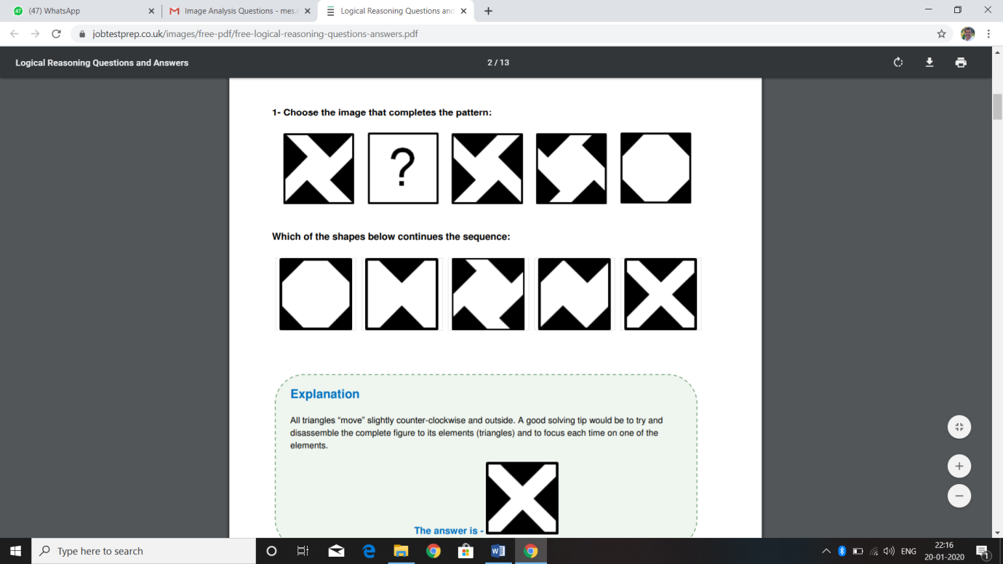
(A) | 
(B) | 
(C) | 
(D) | 

86. Choose the image that completes the pattern
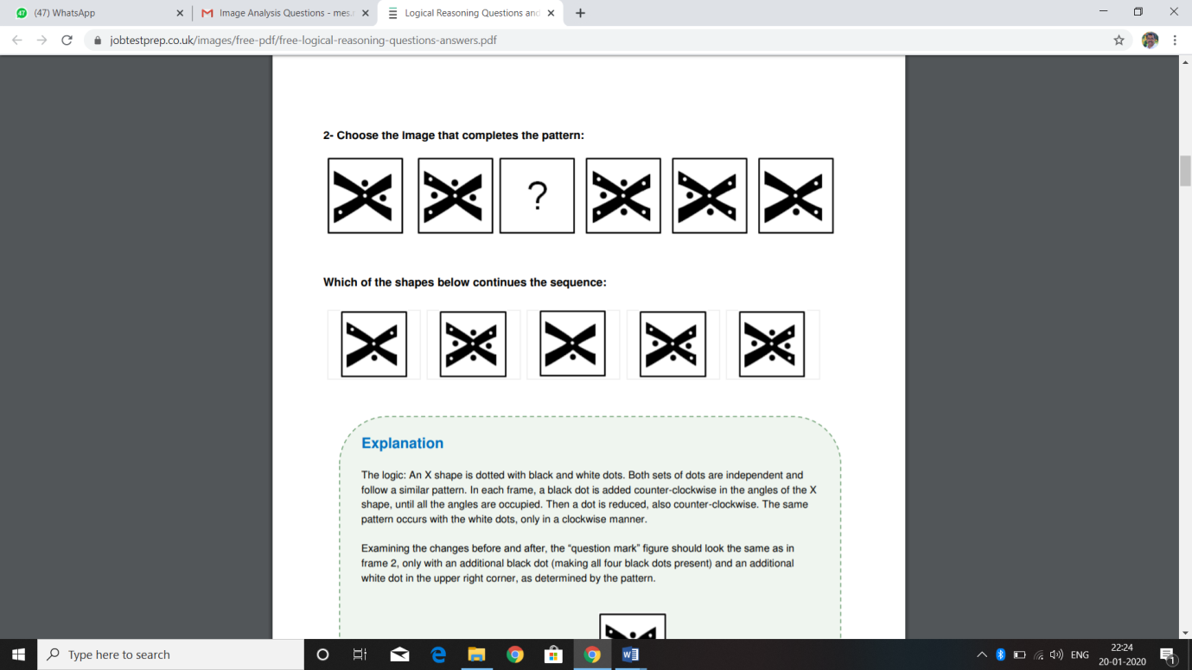
(A) | 
(B) | 
(C) | 
(D) | 

87. Choose the image that completes the pattern
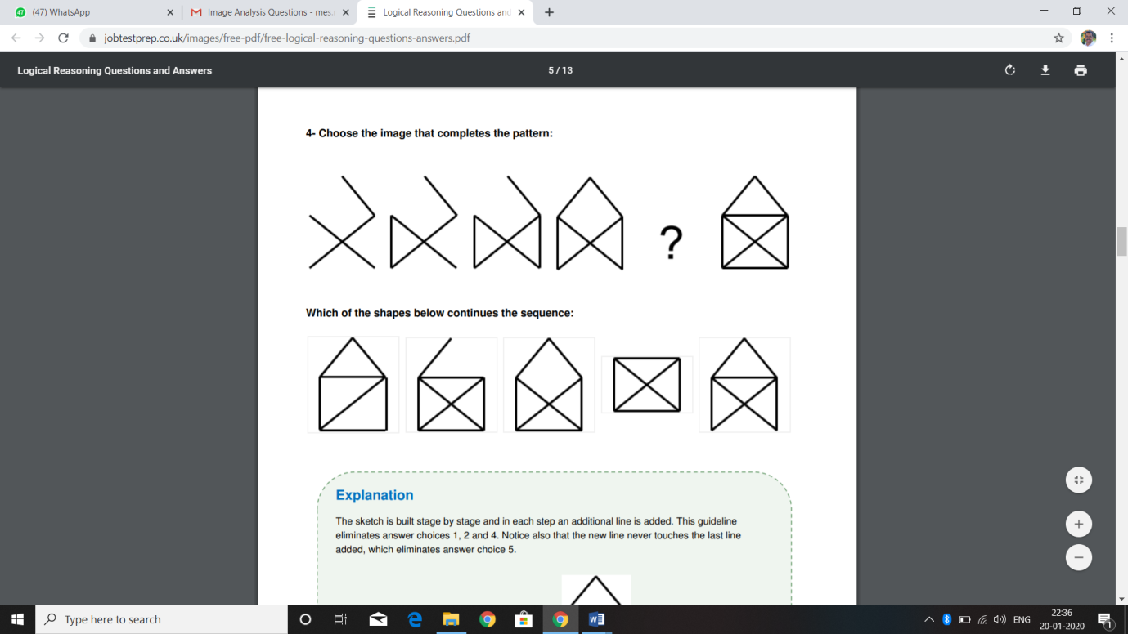
(A) | 
(B) | 
(C) | 
(D) | 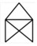

88. Choose the image that completes the pattern
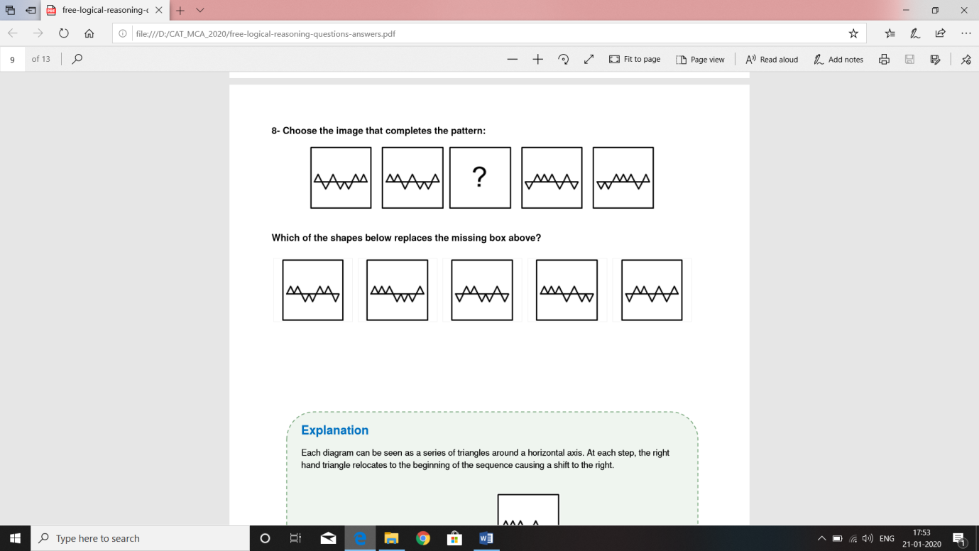
(A) | 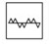
(B) | 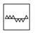
(C) | 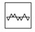
(D) | 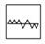

89. Choose the image that completes the pattern
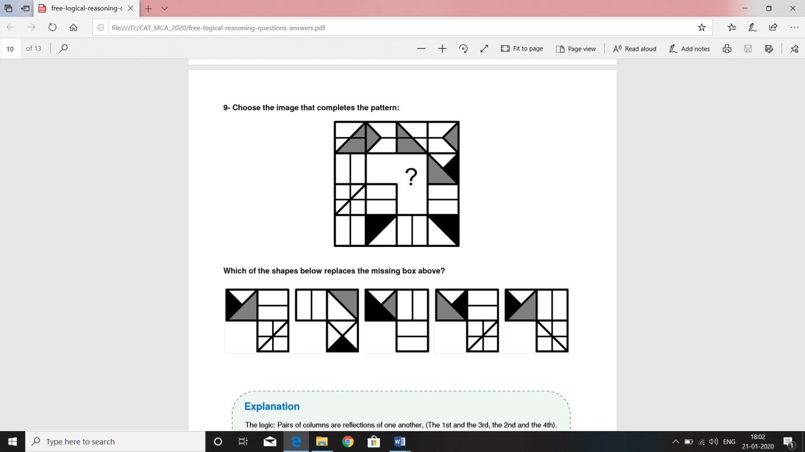
(A) | 
(B) | 
(C) | 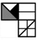
(D) | 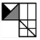

90. Ramu and Raju entered into a partnership with Rs. 30,000 and Rs. 60,000 respectively. After 4 months Ramu invested Rs. 15,000 more while Raju withdrew Rs. 30,000. Find the share of Ramu in annual profit of Rs. 1,00,000.
(A) | Rs. 45,000
(B) | Rs. 50,000
(C) | Rs. 48,000
(D) | Rs. 53,000

91. Choose the pair that best represents a similar relationship to the one expressed in the original pair of words.
(A) | display : museum
(B) | artist : carpenter
(C) | nail : hammer
(D) | frame : picture

92. If find the value of
(A)
(B)
(C)
(D)

93. The ratio of the first and second class fares between two stations is 4:1 and that of the number of passengers travelling by first and second class is 1:40. If Rs. 2200 is collected as fare, the amount collected from the first class passengers is ……………
(A) | Rs. 100
(B) | Rs. 200
(C) | Rs. 300
(D) | Rs. 400

94. Salaries of X, Y and Z were in the ratio 3 : 5 : 7 respectively. If their salaries were increased by 50%, 60% and 50% respectively, what will be the new ratio of their respective salaries?
(A) | 6 : 13 : 18
(B) | 7 : 14 : 19
(C) | 8 : 15 : 20
(D) | 9 : 16 :21

95. If m : n = 3 : 2, then (4m + 5n) : (4m – 5n)
(A) | 9 : 1
(B) | 10 : 1
(C) | 11 : 1
(D) | 12 : 1

96. In a test, minimum passing % for girls and boys is 35% and 40% respectively. A boy scored 483 marks and failed by 117 marks. What are the minimum passing marks for girls?
(A) | 500
(B) | 525
(C) | 550
(D) | 575

97. The average attendance of a college for the first three days of a week is 325, and for first four days is 320. How many present on the fourth day?
(A) | 530
(B) | 503
(C) | 350
(D) | 305

98. Out of three given numbers, the first one is twice the second and three times the third. If the average of these numbers is 88, then the difference between first and third is ……………
(A) | 96
(B) | 98
(C) | 89
(D) | 69

99. Arrange the words given below in a meaningful sequence.
1. Site 2. Plan 3. Rent 4. Money 5. Building 6. Construction
(A) | 1, 2, 3, 6, 5, 4
(B) | 2, 3, 6, 5, 1, 4
(C) | 3, 4, 2, 6, 5, 1
(D) | 4, 1, 2, 6, 5, 3

100. Arrange the words given below in a meaningful sequence.
1. Presentation 2. Recommendation 3. Arrival 4. Discussion 5. Introduction
(A) | 5, 3, 4, 1, 2
(B) | 3, 5, 4, 2, 1
(C) | 3, 5, 1, 4, 2
(D) | 5, 3, 1, 2, 4

101. If in a certain language, MADRAS is coded as NBESBT, how is BOMBAY coded in that code?
(A) | CPNCBX
(B) | CPNCBZ
(C) | CPOCBZ
(D) | CQOCBZ

102. If in a certain language, PAINT is coded as 74128 and EXCEL is coded as 93596 then how would you encode ACCEPT?
(A) | 455978
(B) | 547978
(C) | 554978
(D) | 735961

103. In a certain code IMTITJU is written as TMIIUJT. How is TEMREMP written in that code?
(A) | METERPM
(B) | METRPME
(C) | ETRMMEP
(D) | MTERPME

104. If white is called blue, blue is called red, red is called yellow, yellow is called green, green is called black, black is called violet and violet is called orange, what would be the colour of human blood?
(A) | Red
(B) | Green
(C) | Yellow
(D) | Violet

105. In a certain language, the word CASUAL is coded as DZUSDI. How is the word ZODIAC coded in that language?
(A) | AMFGDZ
(B) | ANGFDZ
(C) | ANFGDZ
(D) | ANFGDY

106. Fill the series: 1, 4, 8, 11, 22, 25, ?
(A) | 45
(B) | 40
(C) | 55
(D) | 50

107. Fill the series: 3, 4, 8, 10, 13, 16, ?, ?
(A) | 20, 25
(B) | 22, 18
(C) | 25, 20
(D) | 18, 22

108. Fill the series: 48, 24, 35, 7, 16, 8, 75, 15, 80, ?
(A) | 20
(B) | 40
(C) | 45
(D) | 60

109. Fill the series: 11, 66, 74, 370, 379, ?
(A) | 1112
(B) | 1213
(C) | 1415
(D) | 1516

110. Select a suitable figure from the four alternatives that would complete the figure matrix.
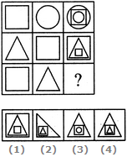
(A) | 1
(B) | 2
(C) | 3
(D) | 4

111. Select a suitable figure from the four alternatives that would complete the figure matrix.
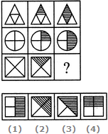
(A) | 1
(B) | 2
(C) | 3
(D) | 4

112. Select a suitable figure from the four alternatives that would complete the figure matrix.
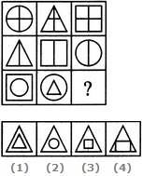
(A) | 1
(B) | 2
(C) | 3
(D) | 4

113. Select a suitable figure from the four alternatives that would complete the figure matrix.
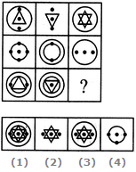
(A) | 1
(B) | 2
(C) | 3
(D) | 4

114. Select a suitable figure from the four alternatives that would complete the figure matrix.
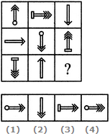
(A) | 1
(B) | 2
(C) | 3
(D) | 4

115. Find the number of triangles in the given figure.
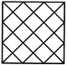
(A) | 26
(B) | 28
(C) | 36
(D) | 38

116. Find the number of triangles in the given figure.
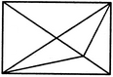
(A) | 12
(B) | 13
(C) | 14
(D) | 15

117. Which number replaces the question mark?
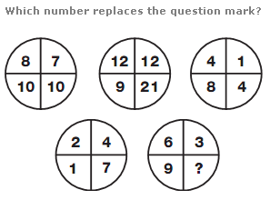
(A) | 3
(B) | 6
(C) | 9
(D) | 12

118. Which one will replace the question mark?
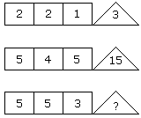
(A) | 10
(B) | 22
(C) | 15
(D) | 9

119. Which one will replace the question mark?
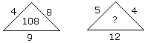
(A) | 240
(B) | 134
(C) | 114
(D) | 108

120. Find out which of the figures (1), (2), (3) and (4) can be formed from the pieces given in figure (X).
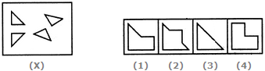
(A) | 1
(B) | 2
(C) | 3
(D) | 4

121. In each of the following number series given, one particular number is wrong. Find out that wrong number in the series:
2, 3, 10, 38, 172
(A) | 3
(B) | 10
(C) | 38
(D) | 172

122. In each of the following number series given, one particular number is wrong. Find out that wrong number in the series:
8, 19, 52, 151, 447
(A) | 19
(B) | 52
(C) | 151
(D) | 447

123. In how many different ways can the letters of the word DETAIL be arranged in such a way that the vowels occupy only the odd positions?
(A) | 6
(B) | 12
(C) | 18
(D) | 36

124. What is the angle between the two hands of a wall clock when the time is 3:40 hrs?
(A) | 130°
(B) | 120°
(C) | 150°
(D) | 160°

125. How many times do the hands of a clock coincide a day?
(A) | 22
(B) | 11
(C) | 24
(D) | 12

126. In a certain code ‘WONDER’ is written as ‘YNPCGQ’. How will ‘THINKER’ be written in that code?
(A) | VGMPMGQ
(B) | VGKMMDT
(C) | VGKPNGQ
(D) | VGOPMGQ

127. In a certain code ‘STRONG’ is written as ‘TVUSSM’. How will ‘BIGGER’ be written in that code?
(A) | CKJKJX
(B) | CKJLJX
(C) | CJKKJX
(D) | CJKKJY

128. Choose the missing letters in the repeating series:
b c _ d b _ d _ b _.
(A) | cdcd
(B) | dccd
(C) | dcdc
(D) | cddc

129. Replace the question mark from the given choice in the following:
ZYX : ABC : WVU : ?
(A) | DEF
(B) | FGH
(C) | HIJ
(D) | DFG

Direction (Questions No. 130 to 133):
Ramu and Kannan are good in Hockey and Volleyball, Sarath and Ramu are good in Hockey and Baseball. Gautham and Kannan are good in Cricket and Volleyball. Sarath, Gautham and Mohan are good in Football and Baseball.
130. Who is good in Hockey, Cricket and Volleyball?
(A) | Gautham
(B) | Sarath
(C) | Kannan
(D) | Ramu

131. Who is good in Baseball, Cricket, Volleyball and Football?
(A) | Ramu
(B) | Sarath
(C) | Gautham
(D) | Kannan

132. Who is good in Baseball, Volleyball and Hockey?
(A) | Sarath
(B) | Kannan
(C) | Gautham
(D) | Ramu

133. Who is good in Hockey, Baseball and Football?
(A) | Ramu
(B) | Kannan
(C) | Gautham
(D) | Sarath

134. Choose the figure which is different from the rest.
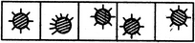
(1) | (2) | (3) | (4)

(A) | 1
(B) | 2
(C) | 3
(D) | 4

135. Choose the figure which is different from the rest.

(1) | (2) | (3) | (4)

(A) | 1
(B) | 2
(C) | 3
(D) | 4

136. From the positions of a cube shown below, which letter will be on the face opposite to face with 'A'?
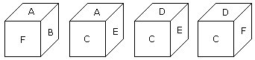
(A) | A
(B) | B
(C) | C
(D) | D

137. How many points will be on the face opposite to the face which contains 3 points?
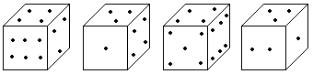
(A) | 2
(B) | 4
(C) | 5
(D) | 6

138. In a survey of 150 readers, it has been found that 75 read newspaper A, 90 read newspaper B and 70 read newspaper C. 40 read A and B; 35 read B and C; 30 read A and C and 10 read all the three. If so, how many respondents read none of the newspapers?
(A) | 30
(B) | 20
(C) | 10
(D) | 0

139. Pointing to a photograph a woman tells her friend, “He is the son of the only daughter of the father of my mother”. How is the person in the photograph related to the woman?
(A) | Nephew
(B) | Uncle
(C) | Brother
(D) | Grandfather

140. Find the missing number:
Q | 3 | ? | 8 | C | 17
2 | L | ? | E | 12 | B

(A) | H, 5
(B) | F, 6
(C) | J, 5
(D) | D, 6

141. A number when divided by 6 leaves a remainder 3. When the square of the number is divided by 6, the remainder is:
(A) | 0
(B) | 1
(C) | 2
(D) | 3

142. Insert the missing number. 34, 7, 37, 14, 40, 28, 43, ……………
(A) | 42
(B) | 56
(C) | 31
(D) | 46

143. Find the missing number. 4, 12, 48, 240, 1440, ………..….
(A) | 10020
(B) | 10080
(C) | 7620
(D) | 6200

144. Find the missing number. 1, 0.5, 0.25, 0.125, 0.0625, ?
(A) | 0.03125
(B) | 0.007812
(C) | 0.015625
(D) | 0.031267

145. If JACOB is written as QZXLY, then KENDY can be written as:
(A) | PVWMA
(B) | PVMWB
(C) | PUMWB
(D) | PVMWA

146. Arrange the words given below in a meaningful sequence.
1. Poverty 2. Population 3. Death 4. Unemployment 5. Disease
(A) | 2, 3, 4, 5, 1
(B) | 3, 4, 2, 5, 1
(C) | 2, 4, 1, 5, 3
(D) | 1, 2, 3, 4, 5

147. Mohan correctly remembers that his father's birthday is before 20th January but after 16th January whereas his sister correctly remembers that their father's birthday is after 18th January but before 23rd January. On which date in January is definitely their father's birthday?
(A) | 18th
(B) | 19th
(C) | 20th
(D) | 17th

Directions: Study the following information carefully to answer these questions.
Eight persons A, B, C, D, E, F, G and H are sitting around a circle facing the centre. F is third to the right of C and second to the left of H. D is not an immediate neighbour of C or H. E is to the immediate right of A.
148. Who sits between G and D?
(A) | H
(B) | D
(C) | F
(D) | E

149. Who is to the immediate right of C?
(A) | E
(B) | B
(C) | D
(D) | A

150. Which of the following is the correct position of B with respect to H?
I | Second to the right
II | Fourth to the right
III | Fourth to the left
IV | Second to the left

(A) | Only I
(B) | Only II
(C) | Only III
(D) | Both II and III

