# Status Server - Spring Boot & WebSockets

A distributed system for real-time monitoring of service statuses using Spring Boot microservices, Eureka for service discovery, WebSocket (STOMP) messaging, and a frontend client.

## Architecture

* **Eureka Server** (eureka-server) - Service discovery for load balancing
* **Status Service** (status-service) – Handles WebSocket messaging and broadcasting via STOMP
* **Frontend** – Next.js client connecting directly to status service via WebSocket

## 

## Tech Stack

* Spring Boot
* Spring WebSocket (STOMP)
* Eureka Discovery Service
* Docker & Docker Compose
* Next.js with TypeScript (Frontend)
* STOMP.js for WebSocket communication

## Key Endpoints

| Route | Service | Purpose |
| --- | --- | --- |
| /app/status | status-service | Endpoint to publish status updates |
| /app/request-statuses | status-service | Request existing status messages |
| /topic/status | status-service | Topic for status update broadcasts |
| /topic/init-status | status-service | Topic for initial status messages |
| /topic/status-delete | status-service | Topic for status deletion events |
| /status-websocket-* | status-service | WebSocket STOMP connection endpoint |

## WebSocket Setup

### Backend (status-service)

registry.addEndpoint("/status-websocket-{port}")  
 .setAllowedOriginPatterns("*")  
 .setAllowedOrigins("*");

## Client (frontend)

The frontend implements a real-time status dashboard that allows users to:

Connect to different server instances (ports 9001, 9002) Send status updates: Predefined statuses (UP, DOWN) or custom status messages. You can also view real-time status updates from all connected users. The status server has also a custom inactivity scheduler defined. Meaning after 2 minutes a user automatically receives an “Inactive” status. In addition to inactivity, the server also sweeps all users that are inactive more than 5 minutes. This ensures a clean and active user experience.

// WebSocket connection setup  
const gatewayWsUrl = `ws://localhost:${selectedServer.port}/status-websocket-${selectedServer.port}`;  
  
stompClientRef.current = new window.StompJs.Client({  
 brokerURL: gatewayWsUrl,  
 reconnectDelay: 5000,  
 // Configuration and handlers...  
});  
  
// Subscriptions  
stompClientRef.current.subscribe("/topic/status", (message) => {  
 const status = JSON.parse(message.body);  
 updateStatus(status);  
});  
  
stompClientRef.current.subscribe("/topic/init-status", (message) => {  
 const status = JSON.parse(message.body);  
 updateStatus(status);  
});  
  
stompClientRef.current.subscribe("/topic/status-delete", (message) => {  
 const id = Number(message.body);  
 setStatuses((prev) => prev.filter((s) => s.id !== id));  
});  
  
// Send status message  
stompClientRef.current.publish({  
 destination: "/app/status",  
 body: JSON.stringify({  
 username: connectedUsername,  
 statusText: statusText,  
 }),  
});

## Message Structure

interface StatusMessage {  
 id: number; // Unique identifier for the status  
 username: string; // Username of the status sender  
 statustext: string; // Content of the status message  
 timestamp: string; // Server timestamp when message was received  
}

## Building & Running the Project

1. Build Java services: ```bash # Build Eureka Server cd eureka-server .clean package

* # Build Status Service cd ../status-service .clean package ```

1. Build React project: bash # Build Eureka Server cd ../frontend npm install npm run build
2. Run application with Docker: docker compose up --build

## Status Replication System

The status-service implements a peer-to-peer replication mechanism to ensure all instances maintain a consistent state across the distributed system.

### Replication Configuration

Status service instances are configured with peer information through properties:

status:  
 peers:  
 - http://localhost:9001  
 - http://localhost:9002

### How Replication Works

When a status is created or updated, the service broadcasts the message to all peers. Each peer then processes the message and updates its local state accordingly.

**Replication Process Flow**: - Event Triggering: When a status update occurs (creation or modification), the originating service instance detects this change - Broadcasting: The service broadcasts the updated status message to all peers listed in its configuration - Message Reception: Each peer receives the update message, likely via a REST endpoint - Local State Update: Upon receiving the message, peers process it and update their local state

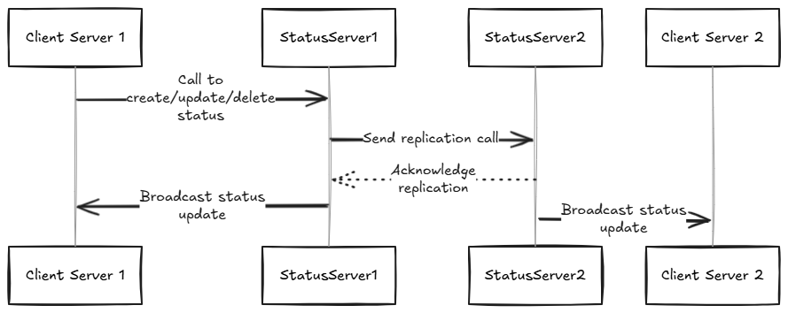

## Replication Error Queue

When the replication Call does not end successfully, the broadcasting node stores the information inside Hashmap List and checks every 30 seconds whether the missing replication can go through or not. This ensures that each node receives all informations, even if packets get lost or connections have troubles.