**Design Document for Werqout**

Group 2-HB-2

John SchraderBachar: 25 % contribution

Evan Uhlmeyer: 25% contribution

Colin Brenizer: 25% contribution

Angelo Bellizzi: 25% contribution

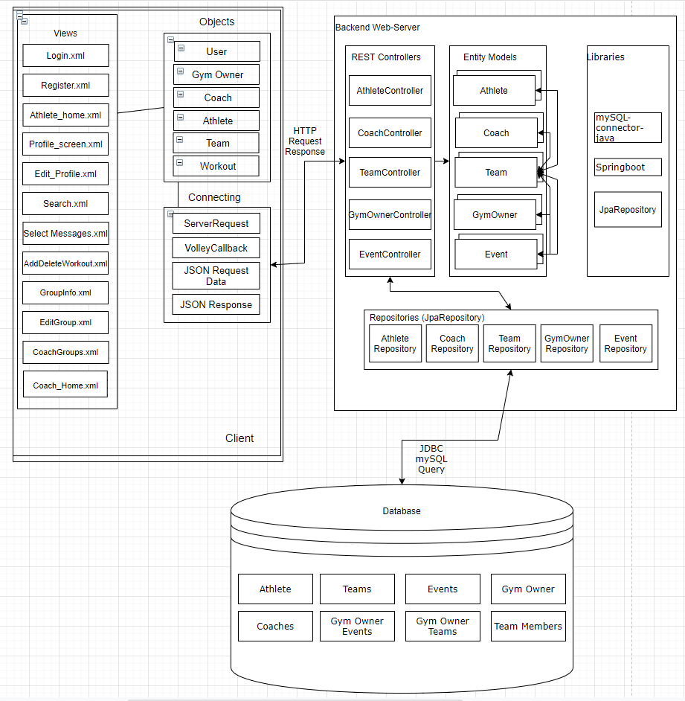

Android View: The android view is made up from both xml layout files and corresponding java classes. The xml files contain the visual elements that are viewed by the users, while the underlying java classes provide the logic to handle the functionality and events that are initiated by the user. When the user interacts with the view, information will be pulled from the server via HTTP requests and then displayed through UI components. The user will also be able to make adjustments to certain data through the view, which will then be updated on the backend server.

Android models: The six models contain data gathered from the database. Within these models, there are methods and objects that organize the data and make it easy to retrieve the data. For example, within the “Team” model, there is an ArrayList of athletes and workouts for that specific team.

Android connection: The app is able to connect to the database and retrieve/post data using these utilities. VolleyCallback is used within ServerRequest for easier method implementation. Whenever a ServerRequest is established within the app, the user can get/post/put/delete data from the json objects in the database.

Backend REST Controllers: These are Spring RestControllers which determine what paths map to specific methods. They are broken down by which entity on the database they affect, specified by the name of the class. These controllers implement a REST style API. These controllers do operations on model objects and make calls to the Repositories to save them.

Backend Entity Models: These are the main object declarations for the backend. They define the different user types, as well as objects that define relationships between the user types, for example, the Team entity has a relationship with many Athletes who are members, and one Coach who manages the group. These Entities are stored in tables on the database.

Backend Repositories: These are interfaces that extend JpaRepository which act as the main interface between the controllers and the database.

