Merchant Payment Gateway Proposal — Awash Bank MPGS Integration

Prepared for: Awash Bank S.C. — Merchant Acquiring / eCommerce Acquiring Department
Prepared by: Gadaa Istar J&M Business Group plc
Application: Gadaa Istar Export E-Commerce Platform (gcomerce)
Document version: 1.0
Date: October 2026

1. Cover Page

Company name | Gadaa Istar J&M Business Group plc
Legal address | Addis Ababa, Ethiopia
Contact email | hailubiniam73@gmail.com
Website (production) | https://gedaaistar.et
Admin portal | https://admin.gedaaistar.et
API base | https://api.gedaaistar.et
Application name | Gadaa Istar Export E-Commerce Platform
Requested service | Mastercard Payment Gateway Services (MPGS) merchant acquiring — Hosted Checkout
Purpose of this document | Business and product proposal submitted to Awash Bank for MPGS merchant onboarding

2. Executive Summary

Gadaa Istar J&M Business Group plc is an Ethiopian export company that sells Ethiopian coffee (raw and processed) and specialty agricultural products — including white products and spicy products — to international buyers. We operate a custom-built, hybrid B2B + B2C e-commerce platform at https://gedaaistar.et through which overseas retail customers and wholesale buyers browse our catalog, request quotes, place orders, and pay online.

We are requesting Awash Bank to onboard us as an MPGS merchant so that our customers can pay by card through the Awash Bank–provided Mastercard Payment Gateway Services hosted checkout. Our platform is already engineered for MPGS: the hosted checkout session flow, payment confirmation webhook, order-status reconciliation, and the admin refund path are implemented and tested — we only need Awash Bank merchant credentials and webhook configuration to go live.

Card data is never entered on, transmitted through, or stored by our servers. All card details are captured on the gateway's PCI-DSS-certified hosted payment page, which places the platform in the PCI DSS SAQ-A compliance scope — the simplest and lowest-risk category for both merchant and acquirer.

3. About the Company

Gadaa Istar J&M Business Group plc is an Addis Ababa–based export business specializing in:

- Ethiopian coffee — raw (green) and processed specialty coffee for international markets.
- White products — specialty agricultural white goods for export.
- Spicy products — Ethiopian spices and related agricultural products.

The company serves two customer segments through a single platform:

- B2C retail buyers — international consumers purchasing retail quantities at retail pricing.
- B2B wholesale buyers — importers, distributors, and roasters who register with company details, are approved by our team, receive wholesale price lists, and transact under minimum-order-quantity (MOQ) rules.

The platform was developed in-house, is fully owned and operated by Gadaa Istar, and is hosted on Ethio Telecom Cloud with Cloudflare providing TLS termination, CDN, WAF, and DDoS protection at the edge.

4. About the Product — What the Platform Does

4.1 Storefront (customer-facing)

The public storefront at https://gedaaistar.et is a server-side-rendered web application that provides:

- Product catalog — categorized catalog of coffee, white, and spicy products with rich media, variant-level pricing and inventory, and search-optimized pages (SEO meta tags, JSON-LD, sitemap).
- Guest and registered carts — visitors can build a cart before signing in; carts persist per customer account.
- Customer accounts — email + password registration, email verification, password reset, profile management, address book, and preferred currency/locale.
- Checkout — shipping method selection (domestic road, international standard/express, warehouse pickup), VAT/zero-rated export tax calculation per destination, and hosted-gateway payment.
- Order tracking — customers see live order status (pending payment → paid → fulfilling → shipped → delivered) and download invoices.
- Multilingual storefront — English, Amharic, and Afaan Oromo interface translations.
- CMS-driven content — About, Our Story, and Contact pages plus homepage banners managed by staff without code changes.

4.2 B2B wholesale features

- Company onboarding — B2B applicants register with company name, TIN, and VAT number and enter a PENDING_APPROVAL state reviewed by our customer managers.
- Customer groups and price lists — wholesale tiers (e.g., WHOLESALE_T1, WHOLESALE_T2, VIP) each receive dedicated price lists; approved B2B buyers see their tier's pricing automatically.
- MOQ enforcement — minimum order quantity multipliers per group are enforced at cart and order time.
- Quote requests — B2B buyers submit quote requests that staff price and convert to orders.
- Full transaction visibility — approved buyers see their complete order and payment history; an internal viewer role can audit all customer transactions.

4.3 Admin back-office

A separate admin application at https://admin.gedaaistar.et gives staff role-scoped tools for:

- Product, variant, price-list, and inventory management, with server-side image thumbnailing.
- Order management — payment status, pick/pack/ship workflow, shipment notification emails.
- Refunds — gateway-initiated refunds (MPGS REFUND transaction) or manual refunds, all recorded in an audit ledger.
- Customer management — approval, status changes, group assignment, admin-initiated password reset.
- CMS pages and banners, shipping methods, coupons, reports, and a notification center.

4.4 Transactional email

Verification, password-reset, B2B approval/rejection, shipment, and coupon-report emails are sent through an SMTP relay.

5. Business Model and Order Lifecycle

1. A customer (or guest) browses the catalog and adds items to a cart; inventory is reserved.
2. At checkout the customer selects a shipping method; the platform computes VAT/export tax and a grand total in the cart currency.
3. Order creation is idempotent (an Idempotency-Key prevents duplicate orders from retries). The order enters PENDING_PAYMENT.
4. The customer is redirected to the payment gateway's hosted checkout and pays by card.
5. The gateway notifies our webhook; on a verified successful payment the order becomes PAID, inventory is decremented, and an invoice is issued from a gap-free, per-fiscal-year sequence.
6. Staff fulfil the order (fulfilling → shipped → delivered); the customer is emailed at each step.
7. Unpaid orders are automatically cancelled by a scheduled sweeper after their TTL, releasing the inventory reservation.
8. Post-payment, admins can issue full or partial refunds through the gateway API; every refund is ledgered.

6. System Architecture

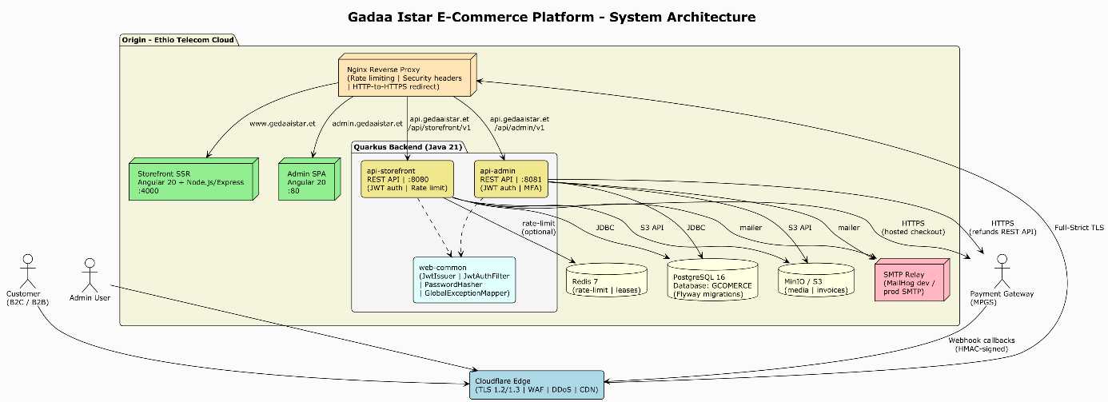

Figure 1: Platform system architecture — Cloudflare edge in front of Ethio Telecom Cloud origin.

Layer | Technology
Storefront frontend | Angular 20, server-side rendering (Node.js/Express)
Admin frontend | Angular 20 SPA
Backend APIs | Java 21 + Quarkus 3.x — separate storefront and admin runtimes
Database | PostgreSQL 16, Flyway-managed schema migrations
Object storage | MinIO / S3 — product media and invoice files
Cache / rate limiting | Redis 7 (multi-instance rate limiter, distributed lease)
Reverse proxy | Nginx — rate limiting, security headers, HTTPS redirect
Edge / CDN / WAF | Cloudflare — TLS 1.2/1.3 Full-Strict, WAF, DDoS, CDN
Hosting | Ethio Telecom Cloud
CI/CD | GitHub Actions — backend tests (JUnit 5, RestAssured, Testcontainers), frontend lint/build

The platform is stateless at the application tier (JWT authentication, no server-side sessions) so it can scale horizontally behind Nginx.

7. Payment Processing Model

7.1 Hosted checkout — no card data on our servers

The platform exclusively uses hosted payment pages. When a customer pays:

- Our backend creates a payment session/redirect payload server-side using merchant API credentials.
- The customer's browser is redirected to the gateway's hosted page.
- The customer enters card details only on the gateway page — PAN, expiry, and CVV never touch our infrastructure.
- The gateway returns the customer to our storefront and sends a server-to-server payment notification to our API.
- Our backend verifies the notification, updates the order, and stores only the transaction reference — never card data.

7.2 Existing payment integrations

Gateway | Use | Status
MPGS (Mastercard Payment Gateway Services) | International card payments via Hosted Checkout | Implemented and tested — awaiting acquiring-bank credentials
CyberSource Secure Acceptance | International card payments (Visa/Mastercard/Amex) | Implemented — alternate/acquiring option
YagoutPay | Domestic ETB payments — telebirr, CBE Birr, M-Pesa, cards | Implemented — UAT pending

The checkout presents whichever gateways are configured; customers pick their method. MPGS will be the primary card rail once Awash Bank credentials are issued.

7.3 PCI DSS posture

Because every payment method uses a hosted page, the platform qualifies for PCI DSS SAQ-A — no cardholder data is stored, processed, or transmitted by merchant systems. This is the lightest compliance scope and minimizes risk for Gadaa Istar and the acquiring bank.

8. Proposed Awash Bank MPGS Integration

8.1 Integration method

MPGS Hosted Checkout (Checkout.js lightbox / redirect), MPGS REST API version 62. This is the integration method Awash Bank offers through its MPGS merchant service and the one already implemented in our codebase.

8.2 Payment flow (implemented)

1. Customer selects Mastercard (MPGS) at checkout and confirms the order.
2. Backend calls MPGS CREATE_CHECKOUT_SESSION (Basic auth merchant.<MID>:<API password>) with the order amount, currency, our invoice number as the order reference, and return/cancel URLs on https://gedaaistar.et.
3. Storefront loads checkout.js from the gateway and opens the hosted checkout with the session id; the customer pays on the MPGS page. Merchant name, phone, and email configured by us appear on the page.
4. MPGS posts a server-to-server notification to POST /api/storefront/v1/payment/mpgs/webhook.
5. Backend verifies the notification secret (constant-time comparison), validates the payload, looks up the order by invoice number, enforces idempotency (only PENDING_PAYMENT orders transition), then marks the order PAID and decrements inventory — or CANCELLED with inventory released on failure.
6. As a fallback for notifications that arrive late, the storefront return page polls order status and the backend can call MPGS RETRIEVE_ORDER to reconcile resultIndicator/successIndicator without trusting the browser.

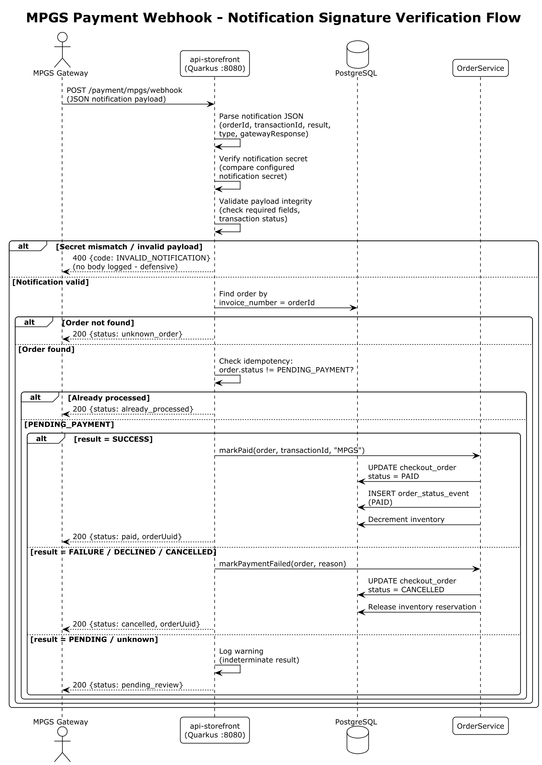

Figure 2: MPGS payment notification — secret verification and order-state handling.

8.3 Refunds (implemented)

Admins issue refunds from the back-office. For MPGS orders the backend calls the MPGS REFUND transaction API (PUT …/order/{orderId}/transaction/{txnId}) with the amount and currency; the gateway transaction id is stored against an order_refund audit row. Manual refunds are also supported and ledgered.

8.4 Environments

Environment | Gateway endpoint | Purpose
Test | https://test-gateway.mastercard.com (or Awash Bank TEST URL) | Integration verification with TEST merchant credentials
Production | Awash Bank production gateway URL | Live acquiring once UAT is signed off

All gateway URLs and credentials are configuration, not code — switching from test to production requires only new environment values and a feature flag.

9. What We Request from Awash Bank

To complete onboarding we kindly request:

# | Item | Notes
1 | Merchant agreement + MDR/settlement terms | Card-not-present e-commerce acquiring; settlement account at Awash Bank
2 | TEST merchant credentials | Merchant ID (TEST…), API password, notification/webhook secret
3 | Production merchant credentials | Issued after UAT sign-off
4 | Webhook registration | Our endpoint: https://api.gedaaistar.et/api/storefront/v1/payment/mpgs/webhook; notification secret must be configured on the merchant profile
5 | Confirmation of enabled features | Hosted Checkout, PURCHASE operation, REFUND capability, supported currencies (USD primary; ETB and others per agreement), 3-D Secure settings
6 | UAT support | Test card numbers, expected test scenarios, and a bank contact for certification
7 | Go-live approval | Confirmation to switch to production credentials

10. Security and Compliance Summary

- PCI DSS SAQ-A — card data never reaches merchant systems (Section 7.3).
- TLS everywhere — TLS 1.2/1.3 browser-to-edge and edge-to-origin (Cloudflare Full-Strict); HTTPS for all gateway calls.
- Webhook integrity — notification-secret verification with constant-time comparison; malformed payloads rejected without logging bodies.
- Idempotent payment handling — duplicate notifications and retries cannot double-pay or double-fulfil an order.
- Authentication — BCrypt-hashed passwords, short-lived JWTs, rotating refresh tokens; mandatory TOTP MFA for every admin account.
- Authorization — role-based access control at database, API, and UI layers (SUPERADMIN, PRODUCT_MANAGER, ORDER_MANAGER, CUSTOMER_MANAGER, FINANCE).
- Defense in depth — Cloudflare WAF/DDoS → Nginx rate limits → application rate limiting → JWT → RBAC → input validation → parameterized queries.
- Secrets management — all gateway credentials via environment variables in development and HashiCorp Vault in staging/production; nothing in source control.
- National compliance — Ethiopian VAT (ERCA) tax classes and gap-free fiscal-year invoice sequences; web application security audit documentation prepared for INSA assessment.

11. Implementation Readiness and Next Steps

Milestone | Owner | Status / Dependency
MPGS hosted checkout code (session create, webhook, retrieve-order fallback) | Gadaa Istar | Complete and unit/integration tested
MPGS refund flow (admin + gateway REFUND API) | Gadaa Istar | Complete
TEST credentials + webhook secret | Awash Bank | Required to begin certification
UAT against Awash Bank test gateway | Both | After credentials are issued
Production credentials + go-live flag | Awash Bank | After UAT sign-off

Because the payment seams are already built and tested, enabling Awash Bank MPGS is a configuration and certification exercise rather than a development project.

12. Contact

Name | Role | Contact
Gadaa Istar J&M Business Group plc | Company | Email: info@gedaaistar.et — Addis Ababa, Ethiopia
Technical Lead | E-commerce platform | Email: hailubiniam73@gmail.com
DevOps / Infrastructure | Hosting & network | Email: devops@gedaaistar.et

We thank Awash Bank for considering this proposal and look forward to partnering on secure, card-based online payments for Ethiopian export trade.

*Gadaa Istar J&M Business Group plc*
Addis Ababa, Ethiopia
October 2026

