System & Architecture Design Document (SDD)

Document Title: Gadaa Istar Export E-Commerce Platform — System & Architecture Design Document

Prepared for: Information Network Security Administration (INSA), Cyber Security Audit Division

Prepared by: Gadaa Istar J&M Business Group plc

Application: Gadaa Istar Export E-Commerce Platform (internal code name: gcomerce)

Document version: 1.0

Date: July 2026

1. Introduction

1.1 Purpose

This System & Architecture Design Document (SDD) describes the architecture, component design, data model, deployment topology, and security design of the Gadaa Istar Export E-Commerce Platform (gcomerce). It is submitted to the Information Network Security Administration (INSA) alongside the Software Requirements Specification (SRS) and the Web Application Security Audit Documentation as part of the package required for the web application security audit.

Where the SRS answers *what* the system does, this SDD answers *how* it is built and deployed. It is written so that an INSA auditor can trace any requirement in the SRS to the components, endpoints, data structures, and infrastructure that realise it, and so that the defense-in-depth security posture of the platform is explicit and verifiable.

1.2 Scope

This document covers the three in-scope surfaces of the platform:

1. Public storefront — https://gadaaistar.et — Angular 20 SSR application.
2. Admin back-office — https://admin.gadaaistar.et — Angular 20 SPA.
3. REST APIs — https://api.gadaaistar.et — two Quarkus runtimes (api-storefront, api-admin).

It covers the supporting infrastructure (PostgreSQL, MinIO/S3, Redis, Nginx, Cloudflare, SMTP, MPGS) as it relates to the application design. It does not redesign third-party services (MPGS hosted page, Cloudflare edge internals, Ethio Telecom Cloud hypervisor).

1.3 Definitions, Acronyms, and Abbreviations

The glossary in the SRS (Section 1.3) applies in full to this document. Additional terms used here:

Term | Definition
CDI | Contexts and Dependency Injection (Jakarta)
DDL | Data Definition Language
JDK | Java Development Kit
JOSE | JSON Object Signing and Encryption
MDC | Mapped Diagnostic Context (SLF4J)
Panache | Quarkus-specific JPA repository layer
RESTEasy Reactive | Quarkus non-blocking JAX-RS implementation
SBOM | Software Bill of Materials
Testcontainers | JUnit integration-test container library

1.4 References

- Companion: *Software Requirements Specification (SRS)*, same version and date.
- Companion: *Web Application Security Audit Documentation*, same version and date.
- OWASP Secure Coding Practices; OWASP Top 10 (2021).
- PCI DSS v4.x and SAQ-A.
- RFC 7519 (JWT), RFC 6238 (TOTP), RFC 4648 (Base32).
- Quarkus, Angular, PostgreSQL, Flyway, Nginx, Cloudflare official documentation.

1.5 Overview

Section 2 presents the system architecture and the defense-in-depth security architecture. Section 3 details the component design — backend modules, REST API surface, frontend apps, and shared libraries. Section 4 documents the data model (entities and Flyway migrations). Section 5 describes the deployment topology and infrastructure. Section 6 covers cross-cutting concerns: security design, observability, error handling, and configuration. Section 7 maps requirements to design elements for traceability.

2. System Architecture

2.1 System Architecture Diagram

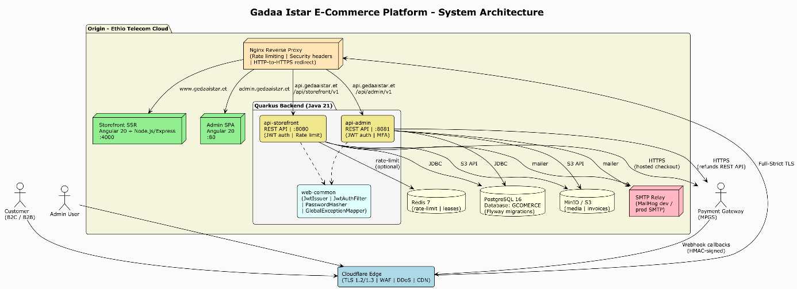

Figure 1: Gadaa Istar E-Commerce Platform — System Architecture (PlantUML source: `diagrams/01-system-architecture.puml`)

The platform is a layered, stateless, horizontally-scalable system. Traffic flows from end users (customers, admins) and the MPGS gateway through Cloudflare's edge, then to an Nginx reverse proxy on the origin (Ethio Telecom Cloud), which routes to the appropriate tier:

- gadaaistar.et → Storefront SSR (Angular 20 + Node.js/Express, port 4000)
- admin.gadaaistar.et → Admin SPA (Angular 20, port 80)
- api.gadaaistar.et/api/storefront/v1 → api-storefront Quarkus runtime (port 8080)
- api.gadaaistar.et/api/admin/v1 → api-admin Quarkus runtime (port 8081)

Both Quarkus runtimes share a single PostgreSQL 16 database (GCOMERCE) and a single schema. They also share MinIO/S3 for object storage, Redis (optional) for distributed rate limiting and leases, and an SMTP relay for transactional email. Both runtimes depend on a shared web-common module that provides JWT issuance/verification, BCrypt password hashing, the security context, correlation ID filter, and the global exception mapper.

2.2 Security Architecture — Defense in Depth

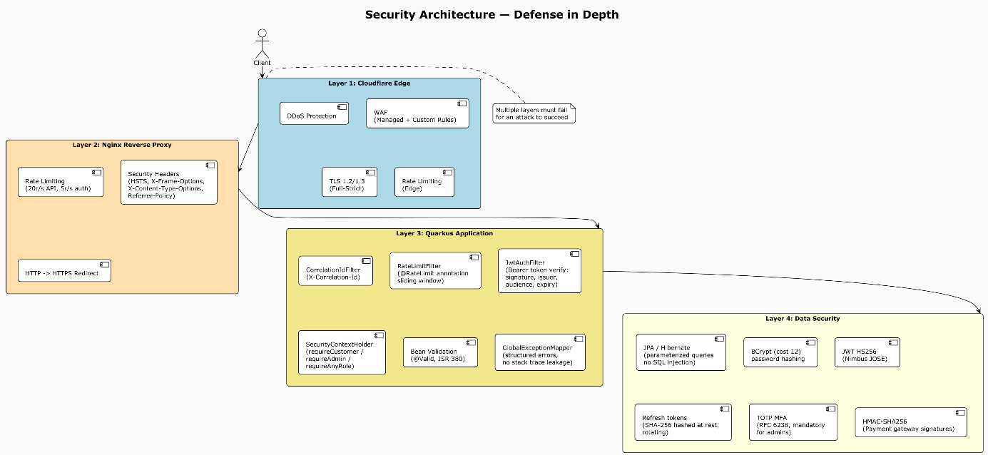

Figure 2: Security Architecture — Defense in Depth across 4 Layers (PlantUML source: `diagrams/05-security-architecture.puml`)

Security is organised in four layers so that multiple layers must fail for an attack to succeed:

- Layer 1 — Cloudflare Edge: WAF (managed + custom rules), DDoS protection, TLS 1.2/1.3 (Full-Strict), edge rate limiting.
- Layer 2 — Nginx Reverse Proxy: Rate limiting (gi_api_zone 20 r/s, gi_auth_zone 5 r/s), security headers (HSTS, X-Frame-Options, X-Content-Type-Options, Referrer-Policy, Permissions-Policy), HTTP→HTTPS redirect.
- Layer 3 — Quarkus Application: CorrelationIdFilter, RateLimitFilter (sliding window, per-endpoint buckets), JwtAuthFilter (Bearer token verify: signature, issuer, audience, expiry), SecurityContextHolder (requireCustomer / requireAdmin / requireAnyRole), Bean Validation (@Valid, JSR 380), GlobalExceptionMapper (structured errors, no stack-trace leakage).
- Layer 4 — Data Security: JPA/Hibernate (parameterised queries, no SQL injection), BCrypt cost 12 (password hashing), JWT HS256 via Nimbus JOSE, rotating refresh tokens (SHA-256 hashed at rest), TOTP MFA (RFC 6238, mandatory for admins), HMAC-SHA256 (payment gateway signatures).

2.3 Key Data Flow Diagrams

#### 2.3.1 Customer Purchase Flow (B2C)

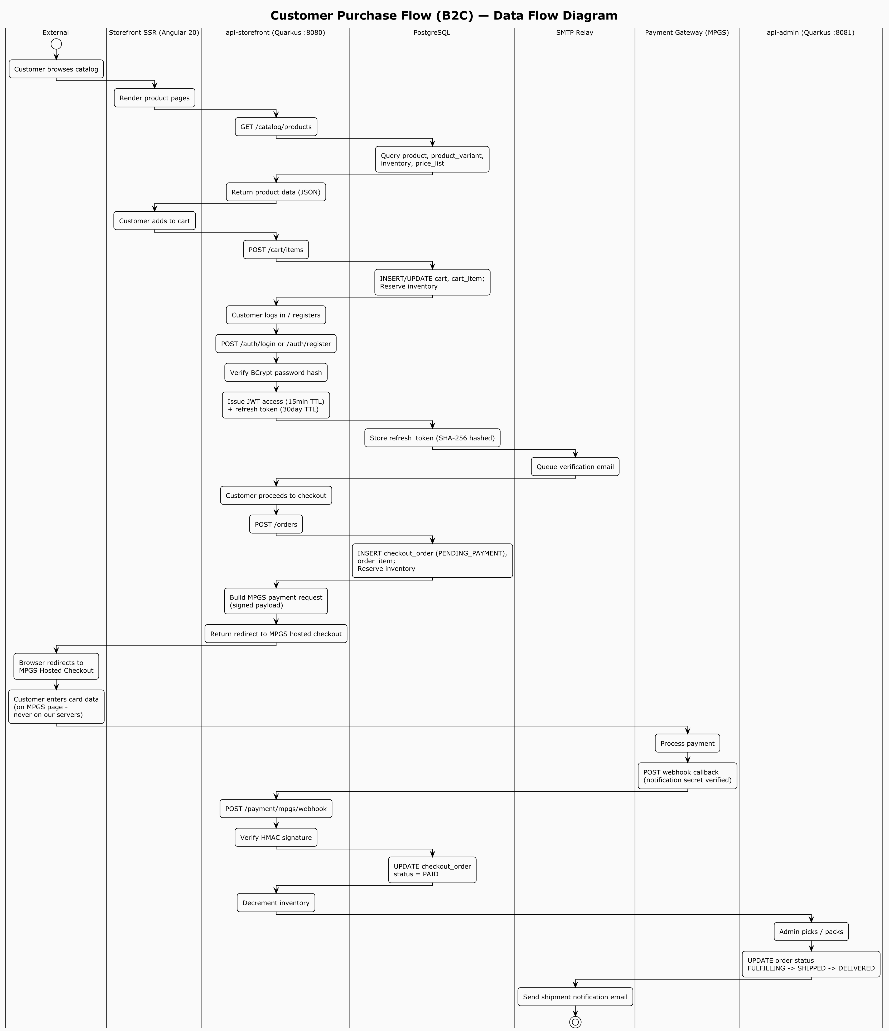

Figure 3: Customer Purchase Flow (B2C) — Data Flow Diagram (PlantUML source: `diagrams/02-customer-purchase-flow.puml`)

The B2C purchase flow: customer browses catalog → adds to cart (guest or authenticated) → signs in / checks out → selects address, shipping, coupon → places order (cart frozen into PENDING_PAYMENT order, inventory reserved) → backend creates MPGS hosted-checkout session → customer enters card on MPGS hosted page → MPGS posts HMAC-signed webhook → backend verifies signature, marks order PAID, releases reserved inventory → customer sees confirmation.

#### 2.3.2 B2B Quote Flow

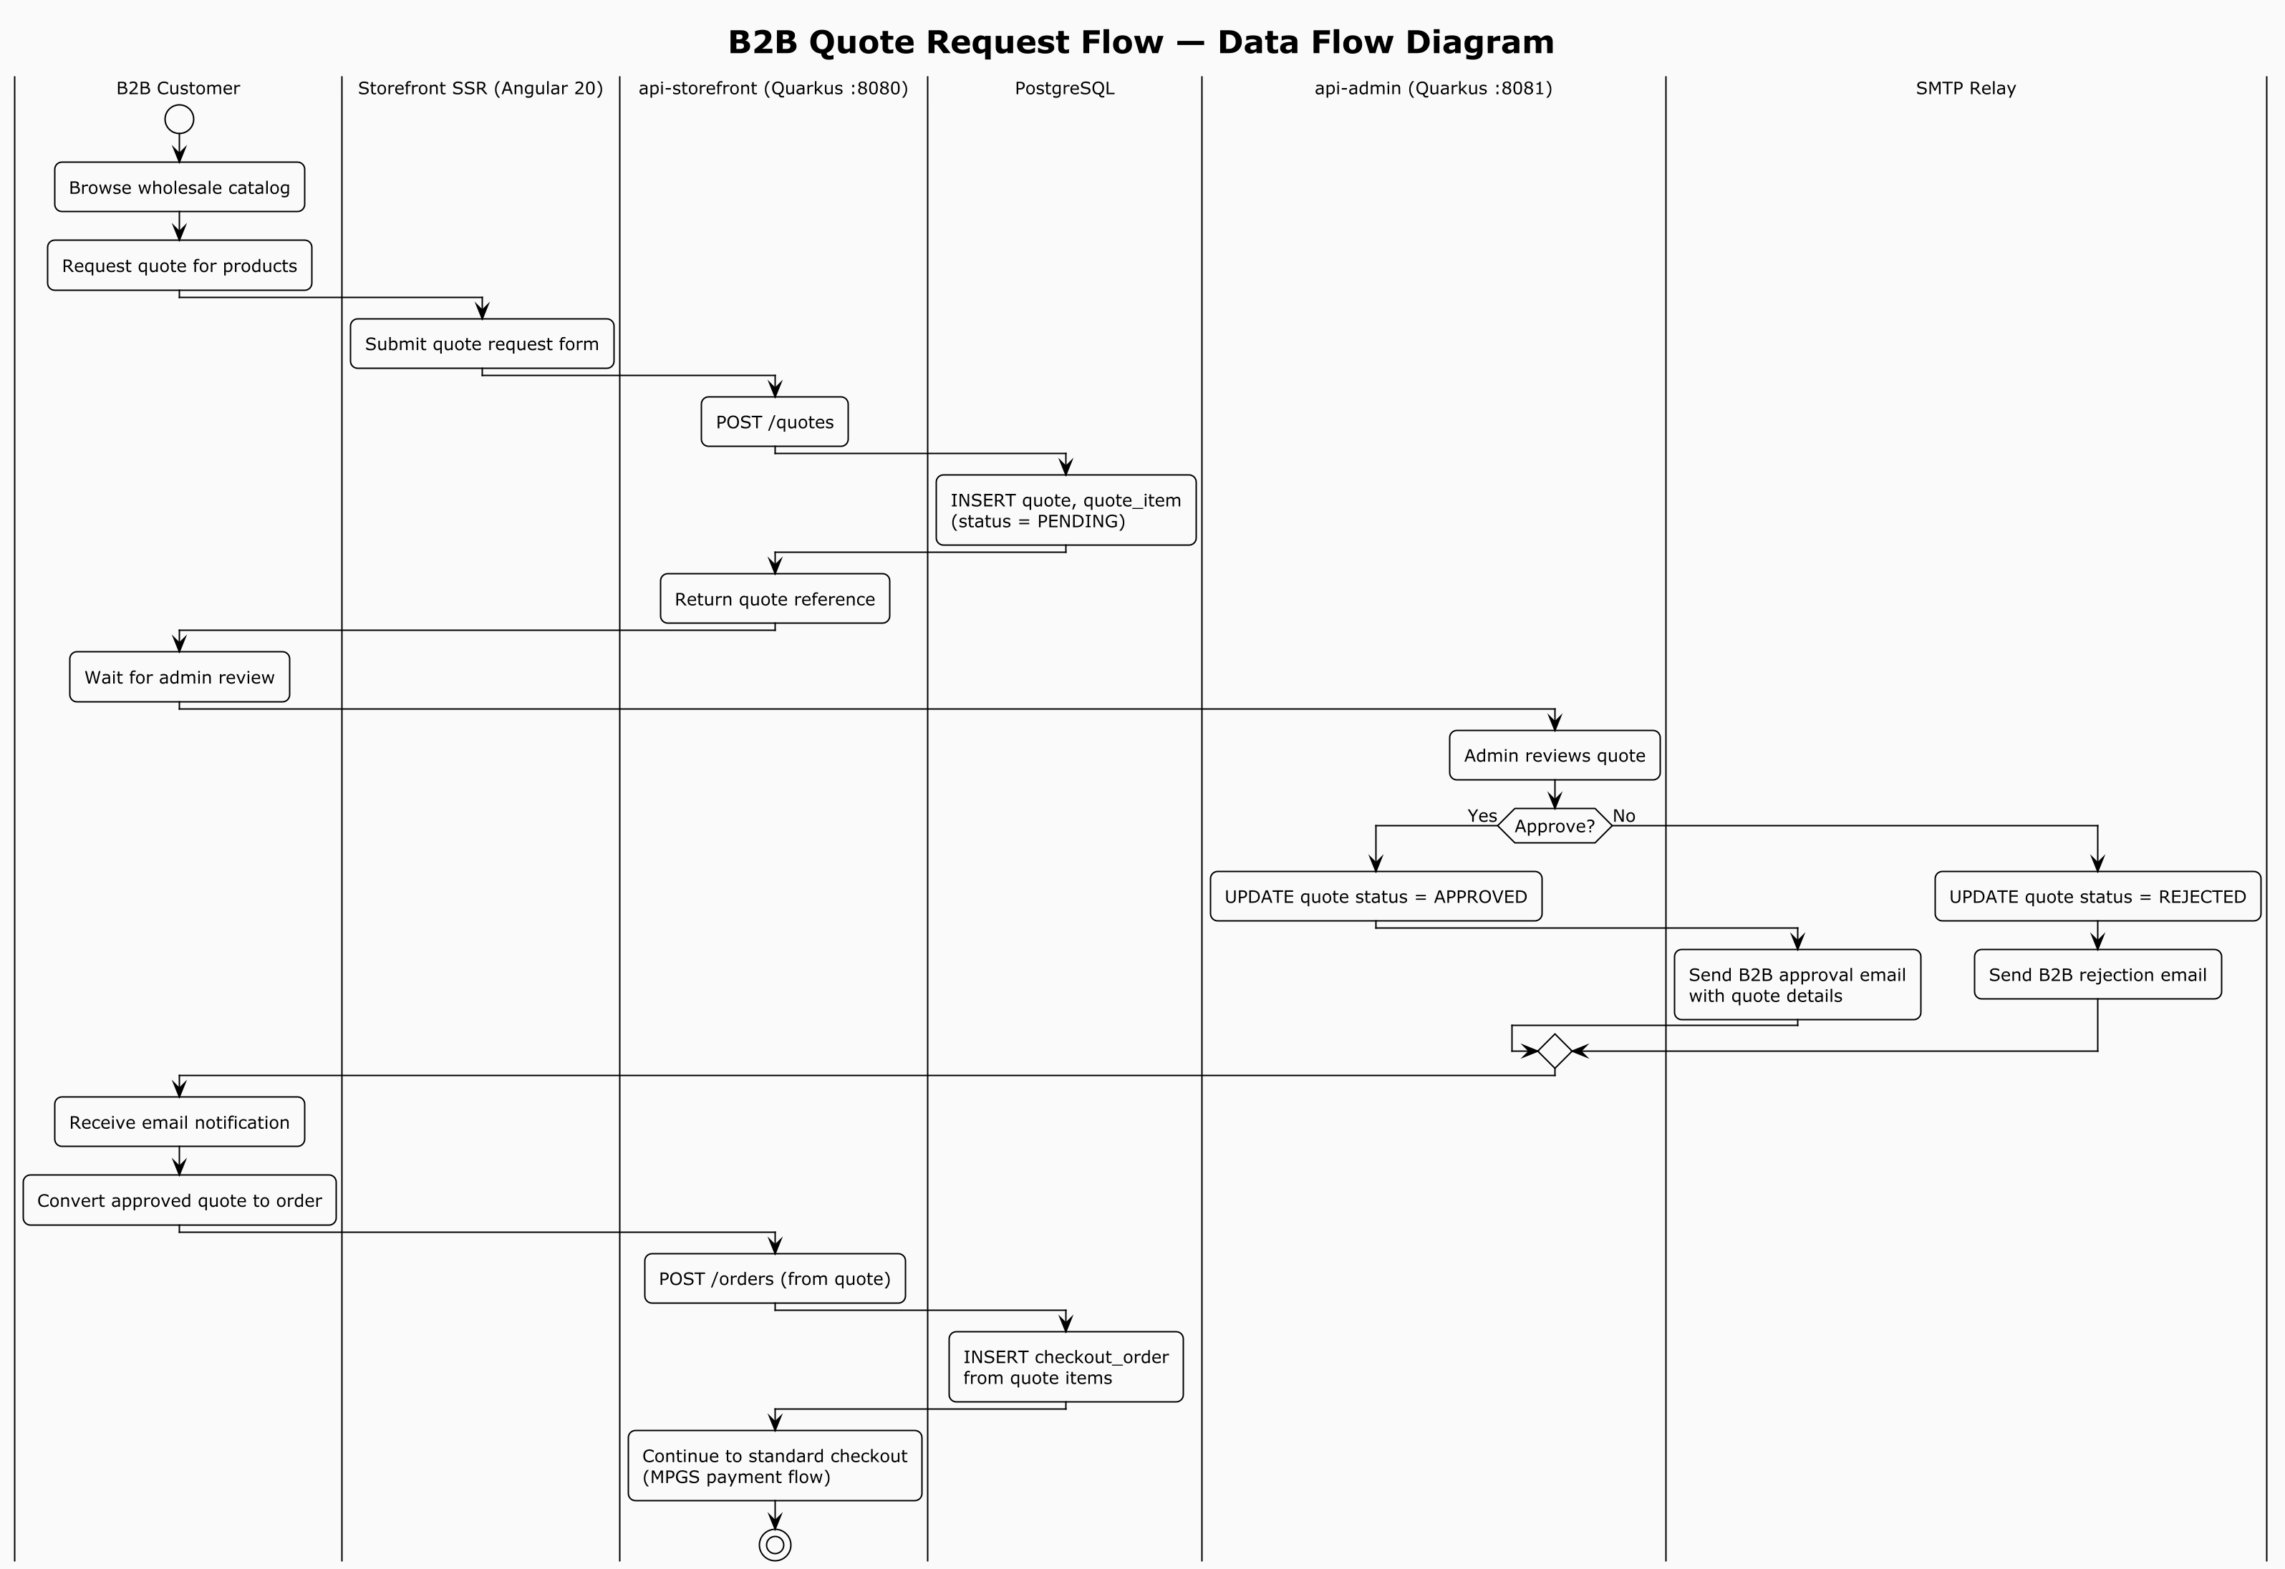

Figure 4: B2B Quote Request Flow — Data Flow Diagram (PlantUML source: `diagrams/03-b2b-quote-flow.puml`)

The B2B quote flow: B2B customer builds cart → submits quote request (SUBMITTED) → admin reviews (UNDER_REVIEW), edits proposed unit prices per line → admin sends quote (SENT) with validity period → customer accepts (ACCEPTED) → admin converts to PENDING_PAYMENT order (CONVERTED) → standard payment flow follows.

#### 2.3.3 Admin Login Flow with Mandatory MFA

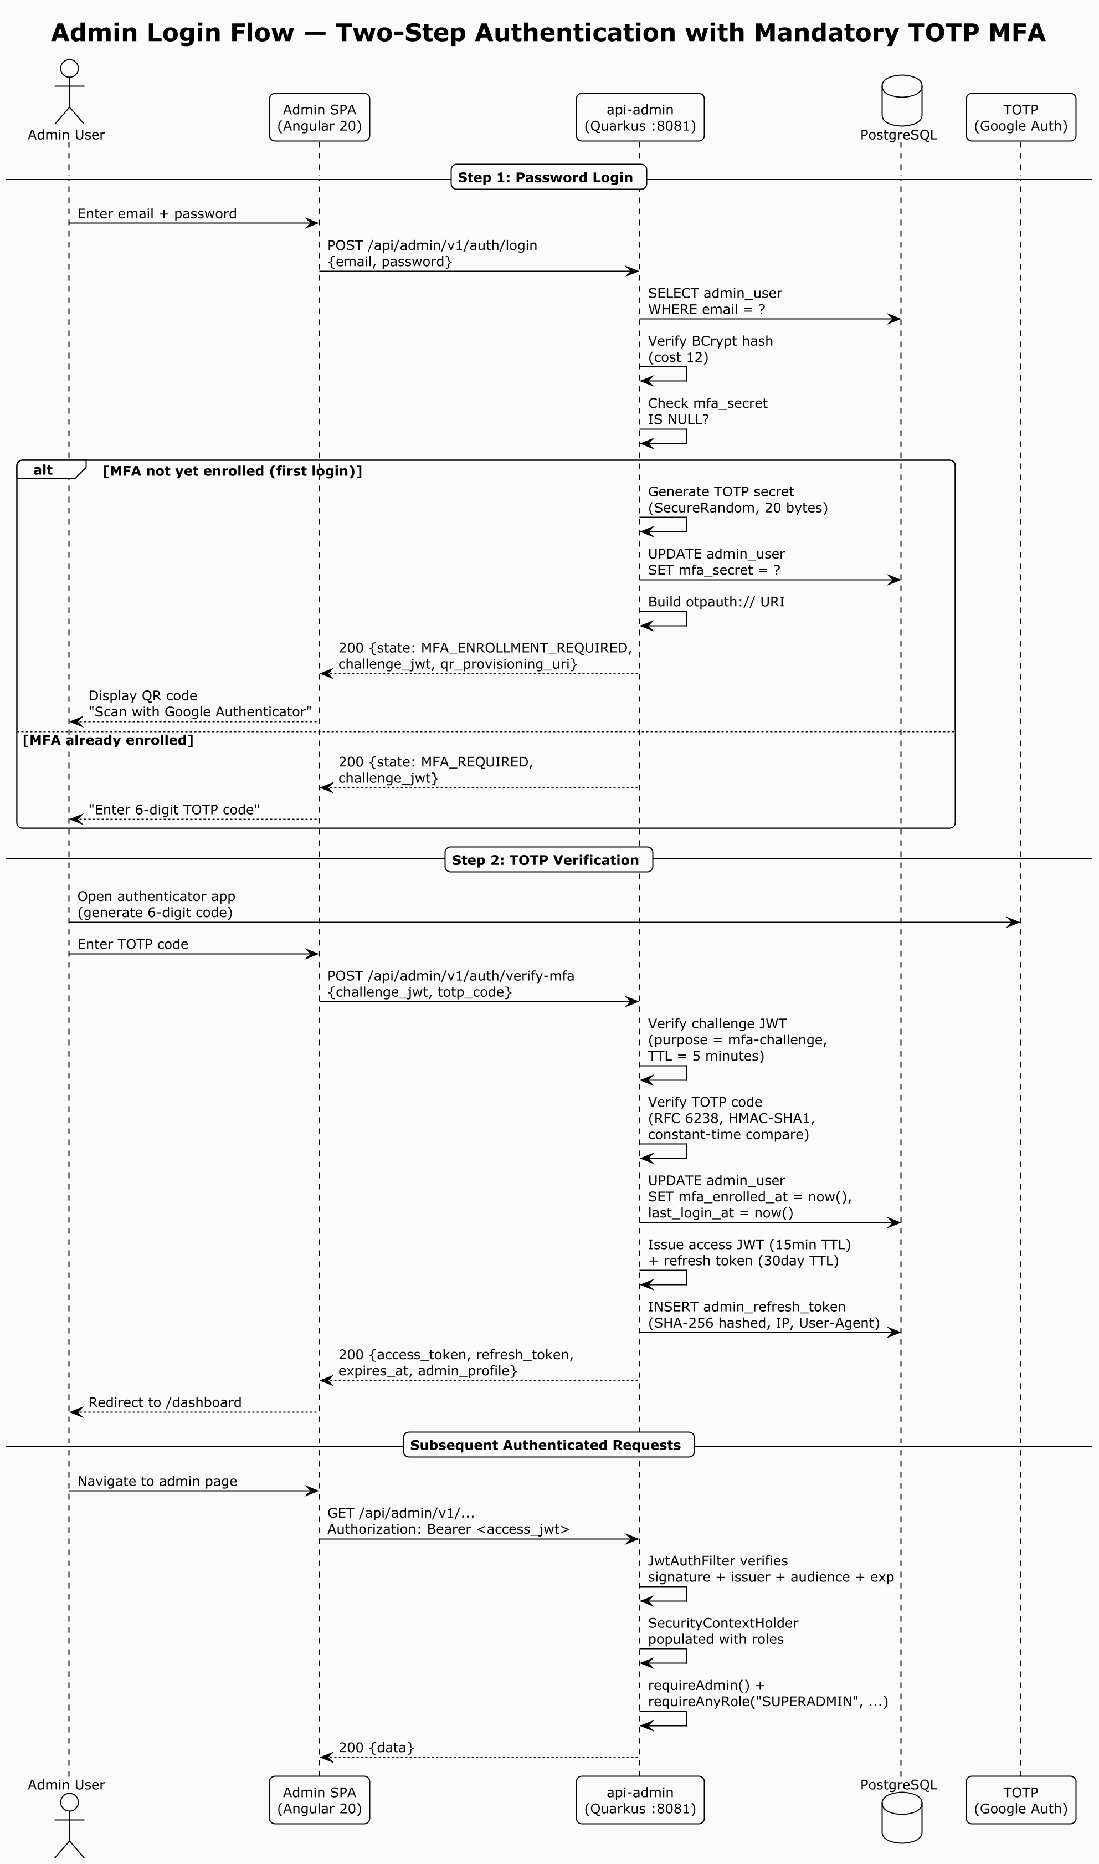

Figure 5: Admin Login Flow — Two-Step Authentication with Mandatory TOTP MFA (Sequence Diagram) (PlantUML source: `diagrams/04-admin-login-mfa-sequence.puml`)

Admin login is a two-step flow: step 1 verifies email + password and returns a short-lived MFA challenge token (purpose-scoped JWT, TTL 300s); step 2 verifies the TOTP code (RFC 6238, 30s step, 6 digits, window tolerance ±1, constant-time comparison) and issues access + refresh tokens. First-time login requires MFA enrollment via a QR code rendered from the otpauth:// provisioning URI.

#### 2.3.4 Payment Webhook Flow

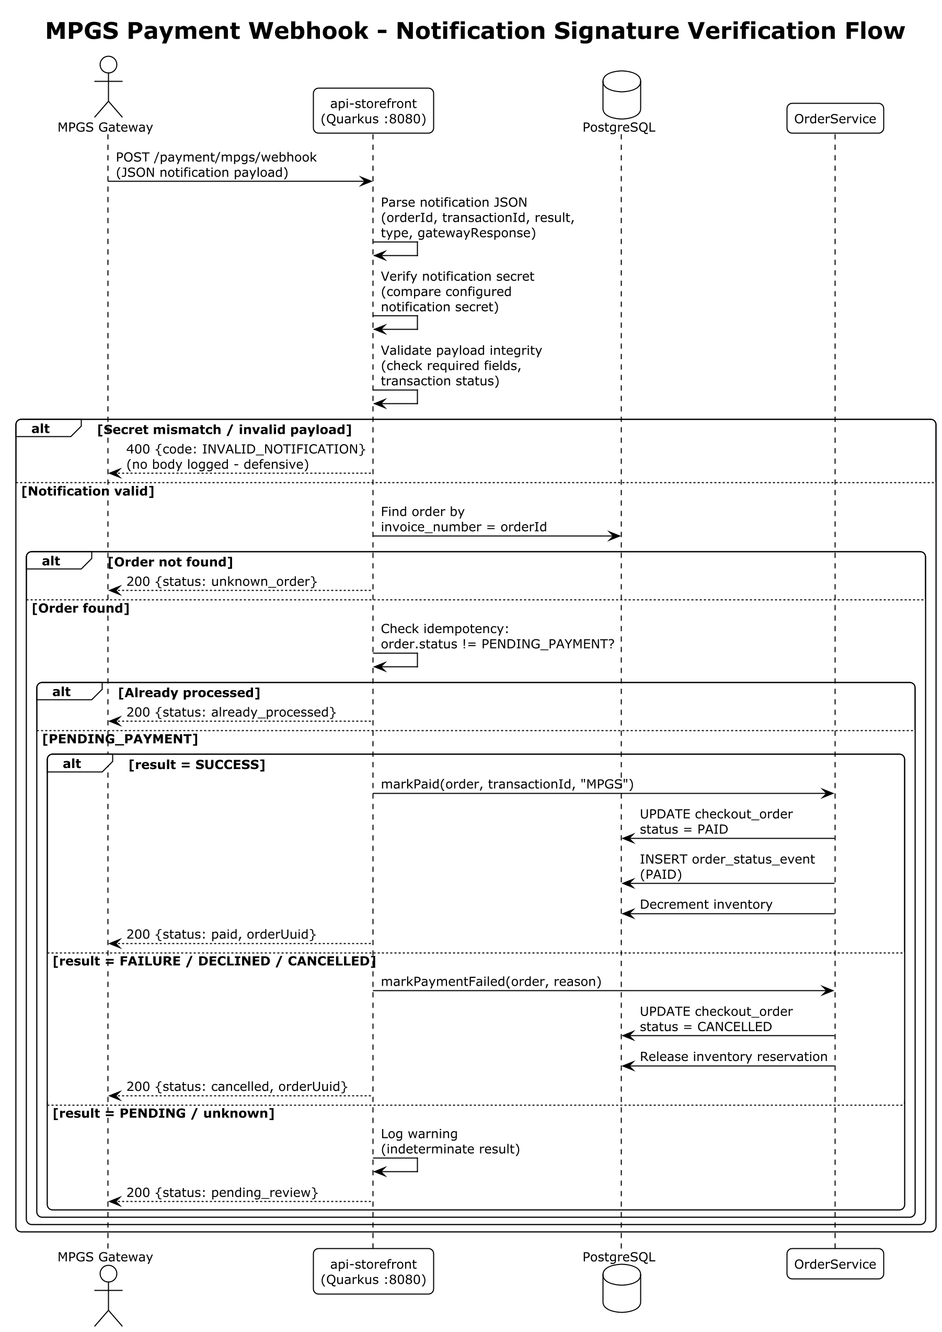

Figure 6: MPGS Payment Webhook — Notification Signature Verification Flow (PlantUML source: `diagrams/06-payment-webhook-flow.puml`)

3. Component Design

3.1 Backend Module Structure

The backend is a multi-module Gradle 8.x project. Active modules (from settings.gradle):

Module | Type | Responsibility
common | Pure Java library | Shared DTOs, enums, exceptions, utilities. No Quarkus runtime. Dependencies: jakarta.validation-api, jackson-annotations, slf4j-api.
persistence | Library | JPA entities, Panache repositories, Flyway migrations. Dependencies: quarkus-hibernate-orm-panache, quarkus-hibernate-validator, postgresql driver, quarkus-flyway.
web-common | Library | Shared JAX-RS/CDI infrastructure: JwtIssuer, PasswordHasher, SecurityContextHolder, JwtAuthFilter, CorrelationIdFilter, GlobalExceptionMapper. Dependencies: quarkus BOM, common, JAX-RS/CDI APIs, nimbus-jose-jwt.
api-storefront | Quarkus runtime (port 8080) | Public/customer REST API. Owns Flyway migrations. Dependencies: RESTEasy, Jackson, OpenAPI, Health, Micrometer/Prometheus, Mailer, Scheduler, Cache, Redis client, BCrypt, commons-codec.
api-admin | Quarkus runtime (port 8081) | Admin REST API. Flyway disabled (shared schema). Dependencies: as storefront + MinIO SDK, Thumbnailator.

3.2 REST API Surface

#### 3.2.1 Storefront API (/api/storefront/v1)

Resource class | Base path | Endpoints (method → purpose)
AuthResource | /auth | POST /register, POST /login, POST /refresh, POST /logout, GET /me, PATCH /me, POST /me/change-password, POST /resend-verification, POST /verify-email, POST /forgot-password, POST /reset-password
CartResource | /cart | GET /, POST /items, PATCH /items/{productId}, DELETE /items/{productId}, DELETE /, POST /merge
GuestCartResource | /guest-cart | GET /, POST /items, PATCH /items/{productId}, DELETE /items/{productId}, DELETE / (uses X-Guest-Session-Key header)
StorefrontCatalogResource | /catalog | GET /products, GET /products/search, GET /products/{slug}
OrderResource | /me/orders | GET /, GET /transactions, GET /{uuid}, POST /, GET /{uuid}/payment-payload, POST /{uuid}/payment-method, POST /{uuid}/confirm-mpgs
OrderTrackingResource | /me/orders/{uuid}/tracking | GET / (public, no auth)
QuoteResource | /me/quotes | POST /, GET /, GET /{uuid}, POST /{uuid}/accept
AddressResource | /me/addresses | GET /, GET /{id}, POST /, PATCH /{id}, DELETE /{id}
PaymentMethodsResource | /me/payment-methods | GET /
MpgsWebhookResource | /payment/mpgs/webhook | POST / (notification-secret verified)
CyberSourceWebhookResource | /payment/cybersource/webhook | POST / (HMAC-verified; secondary gateway)
ShippingResource | /me/shipping | GET /quotes
TaxResource | /tax | GET /rules/{countryCode}
StorefrontCmsResource | /cms | GET /pages, GET /pages/{slug}, GET /banners
CouponPreviewResource | /me/coupon-preview | GET /
SeoResource | /seo | GET /robots.txt, GET /sitemap.xml
SystemResource | /system | GET /hello

#### 3.2.2 Admin API (/api/admin/v1)

Resource class | Base path | Endpoints (method → purpose)
AdminAuthResource | /auth | POST /login (step 1 → MFA challenge), POST /verify-mfa (step 2 → tokens), POST /refresh, POST /logout, GET /me
AdminUsersResource | /admin-users | GET /, POST /{id}/mfa/reset (SUPERADMIN)
ProductsResource | /products | GET /, GET /{id}, POST /, PATCH /{id}, DELETE /{id} (archive), POST /{id}/media, DELETE /{id}/media/{mediaId}, GET /export.csv, POST /import-csv
VariantsResource | /products/{productId}/variants | GET /, POST /, PATCH /{variantId}, DELETE /{variantId}, GET /inventory, POST /{variantId}/inventory/adjust, PUT /{variantId}/inventory
InventoryResource | /inventory | GET /, GET /products/{productId}, POST /products/{productId}/adjust, PUT /products/{productId}
PriceListsResource | /price-lists | GET /, GET /{id}, POST /, PATCH /{id}, DELETE /{id}, PUT /{id}/entries, DELETE /{id}/entries/{entryId}
CustomerGroupsResource | /customer-groups | GET /, POST /, PATCH /{id}, DELETE /{id}
AdminOrderResource | /orders | GET /, GET /{uuid}, POST /{uuid}/transition
CustomersResource | /customers | GET /, GET /{id}, POST /{id}/status, POST /{id}/approve-b2b, POST /{id}/verify-email, POST /{id}/revoke-sessions, POST /{id}/reset-password, POST /{id}/group
AdminQuoteResource | /quotes | GET /, GET /{uuid}, POST /{uuid}/review, PATCH /{uuid}/items/{lineId}, POST /{uuid}/send, POST /{uuid}/reject, POST /{uuid}/convert
CouponsResource | /coupons | GET /, GET /{id}, POST /, PATCH /{id}, DELETE /{id}, POST /reports/expiry-check, POST /reports/usage-report
CmsResource | /cms | GET /pages, GET /pages/{id}, POST /pages, PATCH /pages/{id}, DELETE /pages/{id}, GET /banners, GET /banners/{id}, POST /banners, PATCH /banners/{id}, DELETE /banners/{id}
ShippingMethodsResource | /shipping-methods | GET /, GET /{id}, POST /, PATCH /{id}, DELETE /{id}, GET /{id}/zones, POST /{id}/zones, PATCH /zones/{zoneId}, DELETE /zones/{zoneId}
RefundResource | /orders/{uuid}/refunds | GET /, POST / (ORDER_MANAGER / SUPERADMIN)
UploadsResource | /uploads | POST /product-media (S3 upload)
StatsResource | /stats | GET / (dashboard KPIs)
NotificationsResource | /notifications | GET / (admin bell counts)
SystemResource | /system | GET /hello

3.3 Backend Services

#### 3.3.1 Storefront Services

Service | Responsibility
AuthService | Customer registration, login, profile management
EmailVerificationService | Email verification token lifecycle (issue, consume, TTL 60 min)
PasswordResetService | Password reset token lifecycle (issue, consume, TTL 30 min)
CartService | Cart CRUD, guest cart handling, merge-on-sign-in
StorefrontCatalogService | Product listing, search, price resolution by customer group
OrderService | Order placement (freeze cart, reserve inventory), status transitions, idempotency
QuoteService | B2B quote creation, acceptance
AddressService | Customer address CRUD
ShippingQuoteService | Live shipping quotes by cart weight and destination
TaxService | Tax rule resolution by country + tax class
StorefrontCmsService | Published CMS pages and active banners
CouponService | Coupon validation and discount computation
MpgsService | MPGS session creation, order retrieval, webhook verification
CyberSourceService | CyberSource signed payload generation and verification (secondary gateway)
RefreshTokenService | Rotating refresh token issuance and revocation for customers
MailService | Transactional email sending wrapper

#### 3.3.2 Admin Services

Service | Responsibility
AdminAuthService | Admin login with MFA challenge, token issuance
ProductsService | Product CRUD, media management, CSV import/export
VariantsService | Product variant CRUD
InventoryService | Inventory adjust/overwrite
PriceListsService | Price list and tiered entry management
CustomerGroupsService | Customer group CRUD
AdminOrderService | Order listing, status transitions
CustomersService | Customer management, B2B approvals, session revocation
AdminQuoteService | Quote review, pricing, conversion to order
CouponsService | Coupon CRUD
CmsService | CMS pages and banners
ShippingMethodsService | Shipping methods and per-country rate zones
RefundService | Refund processing (MPGS / CyberSource / MANUAL)
AdminUsersService | Admin user listing, MFA reset
CouponReportScheduler | Daily expiry check, weekly usage report
S3Service | S3/MinIO storage operations
ImageProcessingService | Thumbnail generation (300px card, 800px detail)

3.4 Scheduled Jobs

Job | Schedule | Purpose
AbandonedOrderSweeper | Every 5 minutes (configurable), delayed 30s after boot | Auto-cancel PENDING_PAYMENT orders older than TTL (default 60 min); releases inventory reservations; uses a distributed lease to prevent concurrent runs across replicas; re-checks status before cancel; ConcurrentExecution.SKIP
CouponReportScheduler (expiry) | Daily at 08:00 UTC | Find coupons expiring within warning window (default 7 days); email finance team
CouponReportScheduler (usage) | Weekly Monday at 09:00 UTC | Send coupon usage report for last N days (default 7)
InMemoryRateLimitBackend reaper | Every 5 minutes | Reap stale rate-limit queues (no hits in 15 min) to bound memory (memory backend only)

3.5 Frontend Applications

#### 3.5.1 Storefront (Angular 20 SSR)

- Workspace: frontend/apps/storefront, Angular 20.3.26, TypeScript 5.9.0.
- Rendering: Server-side rendered via @angular/ssr + Express (server.ts, port 4000). Static assets served with 1-year cache. All routes rendered via CommonEngine.
- State management: Angular signals (no NgRx). AuthService exposes currentCustomer, isAuthenticated, accessToken as computed signals; persisted to localStorage (gadaa.storefront.session).
- HTTP interceptor chain (app.config.ts): correlationInterceptor (X-Correlation-Id) → authInterceptor (Bearer token + silent refresh on 401) → timeoutInterceptor → errorInterceptor (normalises error envelope).
- Cart service: Dual mode — authenticated (/cart) vs guest (/guest-cart with X-Guest-Session-Key); auto-merge on sign-in via effect() watching auth state; guest session key in localStorage (gi-guest-session-key).
- Routes & guards: authGuard (blocks anonymous from /account, /checkout), guestGuard (prevents signed-in from /login, /register). Routes include home, shop (with :category), product detail (:slug), cart, checkout (+ /return, /cancel), account portal (profile, addresses, orders, transactions, quotes), auth flows, order tracking, wishlist, CMS pages.
- Forms: Reactive forms with Validators mirroring backend Bean Validation (email, min password 8, max lengths, B2B company fields required when type is B2B, password match custom validator).

#### 3.5.2 Admin (Angular 20 SPA)

- Workspace: frontend/apps/admin, Angular 20.3.26.
- Rendering: Single-page application, no SSR (internal tool).
- State management: Signals. AdminAuthService exposes currentAdmin, isAuthenticated (checks refresh-token wall-clock expiry against a 30s tick signal), accessToken, pendingChallenge; persisted to sessionStorage (gadaa.admin.session); pending MFA challenge in gadaa.admin.pending-mfa.
- Guards: authGuard, guestGuard, mfaChallengeGuard (only allows /verify-mfa when a pending challenge exists), roleGuard (reads route.data.roles; defined for future per-route enforcement; current RBAC enforced server-side and via sidebar canSee filtering).
- Idle timeout: IdleTimeoutService — 10 minutes of inactivity (mousemove, mousedown, keydown, touchstart, scroll, wheel), 15s check interval, immediate check on visibility change; calls forceLogout('idle'). Cannot be defeated by background API polling.
- Forced logout reasons: expired (refresh-token wall-clock elapsed), idle (10-min inactivity), refresh-failed.
- MFA enrollment UI: VerifyMfaComponent — dual mode (enrollment vs verification); QR code via angularx-qrcode rendered from otpauthUri (secret never leaves browser); manual secretBase32 entry; 6-digit input validated /^\d{6}$/.
- Routes: login, verify-mfa, dashboard, admin-users, products (list + tabbed editor: details, media, inventory, pricing, variants), price-lists, shipping-methods, orders, quotes, customers, customer-groups, coupons, CMS pages, CMS banners.

#### 3.5.3 Shared UI Kit (frontend/libs/ui-kit)

- Brand tokens (TypeScript BRAND_COLORS + SCSS CSS custom properties): navy, red (CTA), gold (accent), cream background, espresso.
- Typography: Playfair Display (display), Inter (body), Noto Sans Ethiopic.
- Material Design 3 theme with custom brand palettes.
- Semantic aliases: --gi-brand, --gi-cta, --gi-accent.

3.6 Payment Integration Design

#### 3.6.1 MPGS (Mastercard Payment Gateway Services) — Primary

Service: MpgsService.java (storefront), MpgsRefundClient.java (admin).

*Hosted-checkout flow:*

1. OrderService.createFromCart creates a PENDING_PAYMENT order (cart frozen, inventory reserved).
2. Frontend calls GET /me/orders/{uuid}/payment-payload.
3. MpgsService.createCheckoutSession calls the MPGS REST API:
- Endpoint: {gateway-url}/api/rest/version/{api-version}/merchant/{merchant-id}/session
- Operation: CREATE_CHECKOUT_SESSION with order amount, currency, return/cancel URLs.
- Returns: sessionId, successIndicator.
4. Order is updated with mpgsSessionId and mpgsSuccessIndicator.
5. Frontend loads the MPGS Checkout.js library and configures it with the session fields.
6. The customer enters card data on the MPGS-hosted page. The platform never receives PAN or CVV.
7. MPGS posts a JSON webhook to MpgsWebhookResource.
8. MpgsService.verifyNotificationSecret validates the notificationSecret field using constant-time comparison.
9. On CAPTURE/AUTHORIZE with SUCCESS → OrderService.markPaid; on FAILED/CANCELLED → OrderService.markPaymentFailed.
10. Idempotency: a webhook for an order already moved out of PENDING_PAYMENT is ignored.

Webhook verification: The notificationSecret field is compared to the configured value in constant time. The order.id is mapped to the invoice number to locate the order.

Refunds: MpgsRefundClient uses the MPGS REST API (gateway-url, merchant-id, api-password, api-version). Falls back to MANUAL mode when credentials are not configured.

Configuration keys: gadaa.mpgs.enabled, gadaa.mpgs.gateway-url, gadaa.mpgs.merchant-id, gadaa.mpgs.api-password, gadaa.mpgs.api-version, gadaa.mpgs.checkout-version, gadaa.mpgs.notification-secret, gadaa.mpgs.merchant-name/phone/email.

#### 3.6.2 CyberSource (Secondary Gateway)

A CyberSource Secure Acceptance Hosted Checkout integration is also present (CyberSourceService, CyberSourceWebhookResource, CyberSourceRefundClient). The flow is analogous: signed form fields posted to the CyberSource endpoint, HMAC-SHA256 signature verification on the return/notify webhook. It is retained as a secondary gateway option. The MPGS integration is the primary path referenced for this audit.

4. Data Model

4.1 Persistence Approach

- Database: PostgreSQL 16, single database GCOMERCE, single shared schema.
- ORM: Hibernate ORM + Panache (via Quarkus). All access via Panache repository methods — parameterised queries only; no string-concatenated SQL.
- Migrations: Flyway, 20 versioned migrations (V1–V20). api-storefront owns migration execution; api-admin has Flyway disabled. CI validates migrations apply cleanly on an empty PostgreSQL 16 database.
- Schema validation: Quarkus validates the schema on startup (quarkus.hibernate-orm.database.generation=validate).

4.2 Core Entities

Entity | Key fields | Relationships
Customer | id, email (unique), passwordHash, customerType (B2C/B2B), status (PENDING_VERIFICATION/ACTIVE/SUSPENDED), firstName, lastName, companyName, companyTin, companyVatNumber, businessLicenseUrl, phone, preferredCurrency, preferredLocale, emailVerifiedAt, lastLoginAt | ManyToOne → CustomerGroup; OneToMany → CustomerAddress
CustomerGroup | code, name, priceTier, moqMultiplier | OneToMany → Customer
CustomerAddress | addressType, isDefault, streetLine1/2, city, countryCode, region, postalCode, phone | ManyToOne → Customer
Product | sku (unique), slug (unique), name, shortDescription, description, category, status (DRAFT/ACTIVE/ARCHIVED), weightKg, hsCode, originCountry, taxClassId, baseCurrency, basePrice, costPrice, minOrderQuantity, packagingNotes | OneToMany → ProductMedia, ProductVariant
ProductVariant | sku, name, priceOverride, weightKgOverride, active, version | ManyToOne → Product; OneToMany → ProductVariantAttribute
ProductMedia | url, altText, mediaType, isPrimary, sortOrder, cardThumbnailUrl, detailThumbnailUrl | ManyToOne → Product
PriceList | customerGroupId, name, currency, effectiveFrom/to | OneToMany → PriceListEntry
PriceListEntry | priceListId, productId, price, minQuantity | ManyToOne → PriceList
Inventory | productId, variantId, quantity, reservedQuantity, restockThreshold | —
Cart | customerId (unique, nullable), sessionKey (unique), currency | OneToOne → Customer; OneToMany → CartItem
CartItem | cartId, productId, variantId, quantity, unitPriceSnap, currency | ManyToOne → Cart
CheckoutOrder | uuid (unique), invoiceNumber (unique), customerId, status (PENDING_PAYMENT/PAID/FULFILLING/SHIPPED/DELIVERED/CANCELLED), currency, subtotal, taxTotal, shippingTotal, discountTotal, refundedTotal, grandTotal, shipToAddressId, billToAddressId, shippingMethodId, shippingMethodCode/Name, paymentReference, paymentProvider, paymentMethod, mpgsSessionId, mpgsSuccessIndicator, placedAt, paidAt, cancelledAt, couponCode/Description/Discount | ManyToOne → Customer, CustomerAddress, ShippingMethod; OneToMany → OrderItem, OrderStatusEvent, OrderRefund
OrderItem | orderId, productId, variantId, sku, name, variantSku, variantName, unitPrice, quantity, taxRate, taxAmount, lineTotal, primaryImageUrl | ManyToOne → CheckoutOrder
OrderStatusEvent | orderId, fromStatus, toStatus, source, actorId, note, occurredAt | ManyToOne → CheckoutOrder
OrderRefund | uuid, orderId, amount, reason, status, gatewayProvider, gatewayReference, gatewayErrorCode, initiatedByAdminId | ManyToOne → CheckoutOrder
Quote | uuid (unique), customerId, status (DRAFT/SUBMITTED/UNDER_REVIEW/SENT/ACCEPTED/REJECTED/CONVERTED), currency, subtotal, taxTotal, shippingTotal, grandTotal, customerNotes, adminNotes, validUntil, convertedOrderId | ManyToOne → Customer, CheckoutOrder; OneToMany → QuoteItem
QuoteItem | quoteId, productId, variantId, sku, name, variantSku, variantName, quantity, proposedUnitPrice, lineTotal | ManyToOne → Quote
Coupon | code (unique), description, discountType (PERCENT/FIXED_AMOUNT), discountValue, currency, minSubtotal, freeShipping, maxRedemptions, maxPerCustomer, redeemedCount, active, startsAt, expiresAt | OneToMany → CouponRedemption
CouponRedemption | couponId, orderId, customerId, code, discountAmount, redeemedAt | ManyToOne → Coupon
ShippingMethod | code, name, currency, baseCost, perKgRate, minDays, maxDays, active | OneToMany → ShippingRateZone
ShippingRateZone | shippingMethodId, countryCode, baseCost, perKgRate, minDays, maxDays, active | ManyToOne → ShippingMethod
AdminUser | email (unique), passwordHash, fullName, roleId, status (ACTIVE/SUSPENDED/DEACTIVATED), mfaSecret, mfaEnrolledAt, lastLoginAt | ManyToOne → AdminRole
AdminRole | name, description | OneToMany → AdminUser
CustomerRefreshToken | id (UUID), tokenHash, expiresAt, revokedAt, ip, replacedById | ManyToOne → Customer
AdminRefreshToken | id (UUID), tokenHash, expiresAt, revokedAt, sessionStartedAt, ip | ManyToOne → AdminUser
EmailVerificationToken | tokenHash, expiresAt, usedAt | ManyToOne → Customer
PasswordResetToken | tokenHash, expiresAt, usedAt, ip | ManyToOne → Customer
TaxClass | code (STANDARD/EXPORT/EXEMPT), description | —
TaxRule | taxClassId, countryCode, ratePercent, zeroRated, effectiveFrom/to | ManyToOne → TaxClass
InvoiceSequence | docType, fiscalYear, prefix, currentValue | —
CmsPage | slug, title, bodyHtml, seoTitle, seoDescription, status, sortOrder | —
CmsBanner | placement, title, imageUrl, altText, linkUrl, activeFrom/to, sortOrder, active | —
Setting | key, valueJson (JSONB) | —

4.3 Flyway Migration History

Migration | Summary
V1__initial_schema | setting, role, permission, role_permission, admin_user, company_tax_profile, tax_class, tax_rule, invoice_sequence; seeds 5 admin roles, 3 tax classes, ET 15% / export 0% rules, invoice/credit-note sequences; creates update_updated_at() trigger
V2__customer_and_auth | customer_group, customer, customer_address, customer_refresh_token, email_verification_token, password_reset_token; seeds 4 customer groups (RETAIL, WHOLESALE_T1, WHOLESALE_T2, VIP)
V3__admin_auth_and_mfa | admin_role, admin_refresh_token; adds mfa_enrolled_at; seeds bootstrap super-admin
V4__product_catalog | product, product_media, price_list, price_list_entry, inventory; seeds sample products
V5__cart_and_orders | cart, cart_item, checkout_order, order_item, order_status_event
V6__shipping_methods | shipping_method; adds shipping snapshot columns to checkout_order; seeds DOMESTIC_ROAD, INTL_STANDARD, INTL_EXPRESS, PICKUP_FREE
V7__order_refunds | order_refund; adds refunded_total to checkout_order
V8__product_variants | product_variant, product_variant_attribute; adds variant_id to inventory, cart_item, order_item
V9__coupons | coupon, coupon_redemption; adds coupon snapshot columns to checkout_order
V10__guest_cart | Makes cart.customer_id nullable; adds session_key (unique) for guest carts
V11__b2b_quotes | quote, quote_item
V12__media_thumbnails | Adds card_thumbnail_url, detail_thumbnail_url to product_media
V13__shipping_rate_zones | shipping_rate_zone
V14__cms_pages_banners | cms_page, cms_banner
V15__mpgs_payment | Adds mpgs_session_id, mpgs_success_indicator, payment_method to checkout_order
V16__char_to_varchar | Converts CHAR columns to VARCHAR (UUID, currency, country codes, token hashes) for Hibernate compatibility; adds version to product_variant
V17__merge_categories | Consolidates product categories; refreshes seed products/media/pricing/inventory
V18__order_item_image_url | Adds primary_image_url to order_item for rendering without a Hibernate session
V19__seed_admin_b2b_customer | Seeds B2B admin-viewer customer
V20__admin_session_hardening | Adds session_started_at (NOT NULL) to admin_refresh_token; revokes all existing admin refresh tokens (forces re-auth)

No card data (PAN, CVV) is stored in any table. Payment columns on checkout_order hold only gateway transaction IDs and session identifiers.

5. Deployment and Infrastructure

5.1 Deployment Topology

Figure 1 (repeated): System Architecture — production topology

Edge layer: Cloudflare global PoPs — TLS termination (Full-Strict), WAF, DDoS protection, CDN, edge rate limiting.

*Origin (Ethio Telecom Cloud), internal subnet `10.0.1.0/24`:*

Tier | Nodes | Port | Notes
Nginx reverse proxy | single VM | 443/80 | Cloudflare origin cert at /etc/ssl/cloudflare/; HTTP→HTTPS redirect on :80
api-storefront | 10.0.1.10, 10.0.1.11 | 8080 | Round-robin upstream gi_api; max_fails=3, fail_timeout=15s; keepalive 32
api-admin | 10.0.1.10, 10.0.1.11 | 8081 | Same upstream as storefront (routed by path)
Storefront SSR | 10.0.1.20, 10.0.1.21 | 4000 | Round-robin upstream gi_storefront; keepalive 16
Admin SPA | 10.0.1.30 | 80 | Single node; keepalive 8
PostgreSQL | internal | 5432 | DB GCOMERCE
MinIO / S3 | internal | 9000 (API), 9001 (console) | Buckets: gadaa-media, gadaa-invoices
Redis (optional) | internal | 6379 | Multi-instance rate limiting + distributed lease

Minimum production hardware (per node): App tier (Quarkus) 2 vCPU / 4 GB RAM / 20 GB disk; SSR tier (Node.js) 2 vCPU / 2 GB RAM / 10 GB disk; DB tier (PostgreSQL) 4 vCPU / 8 GB RAM / 100 GB SSD; Redis (if used) 1 vCPU / 1 GB RAM.

5.2 Nginx Reverse Proxy

File: infra/nginx/gadaa-istar.conf.example.

- Upstreams: gi_api (10.0.1.10:8080, 10.0.1.11:8080), gi_storefront (10.0.1.20:4000, 10.0.1.21:4000), gi_admin (10.0.1.30:80).
- Rate-limit zones: gi_api_zone (20 r/s), gi_auth_zone (5 r/s, applied to ~ ^/api/(storefront|admin)/v1/auth/ with burst=10 nodelay).
- Server blocks:
- www.gadaaistar.com / gadaaistar.com (443 ssl http2) → gi_storefront; full security headers.
- api.gadaaistar.com (443 ssl http2) → gi_api; webhook path /api/storefront/v1/payments/cybersource/notify excluded from rate limiting; auth paths use gi_auth_zone; default uses gi_api_zone (burst=40 nodelay).
- admin.gadaaistar.com (443 ssl http2) → gi_admin; optional IP allowlist (commented); X-Robots-Tag: noindex,nofollow; Referrer-Policy: no-referrer.
- :80 default_server → 301 redirect to HTTPS.
- TLS: Cloudflare origin cert at /etc/ssl/cloudflare/origin.pem; protocols TLSv1.2, TLSv1.3.

5.3 Docker Compose (Local Dev / Staging)

File: infra/docker-compose.yml.

Service | Image | Ports | Profile
postgres | postgres:16 | 5432 | default
minio | minio/minio:latest | 9000, 9001 | default
mailhog | mailhog/mailhog:latest | 1025, 8025 | default
redis | redis:7-alpine | 6379 | redis, app
api-storefront | built from ../backend (MODULE: api-storefront) | 8080 | app
api-admin | built from ../backend (MODULE: api-admin) | 8081 | app
storefront | built from ../frontend/apps/storefront | 4200:80 | app
admin | built from ../frontend/apps/admin | 4300:80 | app

Volumes: postgres-data, minio-data. Health checks on postgres (pg_isready) and redis (redis-cli ping). api-storefront owns Flyway migrations; api-admin has Flyway disabled.

5.4 CI/CD (GitHub Actions)

Backend CI (.github/workflows/backend-ci.yml): triggers on push/PR to main/develop for backend/**; JDK 21 (Temurin); PostgreSQL 16 service container; jobs: (1) build & test (./gradlew build, uploads test reports, 7-day retention); (2) Flyway migrate + validate (:persistence:flywayMigrate, flywayValidate). Concurrency cancels in-progress runs per ref.

Frontend CI (.github/workflows/frontend-ci.yml): triggers on push/PR for frontend/**; Node 20; npm ci; format:check; lint (ESLint, zero errors); build:storefront; build:admin; uploads storefront and admin bundles (3-day retention). Concurrency cancels in-progress runs per ref.

5.5 Configuration Management

All configuration is externalised via environment variables with dev defaults. No secrets in source code or committed config. Dev loads from environment; staging/production loads secrets from HashiCorp Vault. Key configuration groups (from .env.example and application.properties):

- PostgreSQL: QUARKUS_DATASOURCE_URL, USERNAME, PASSWORD, POSTGRES_DB=GCOMERCE.
- JWT: GADAA_JWT_STOREFRONT_SECRET, GADAA_JWT_ADMIN_SECRET (32+ chars, validated on startup), GADAA_JWT_ACCESS_TTL_MINUTES=15, GADAA_JWT_REFRESH_TTL_DAYS=30, per-audience issuers.
- Auth TTLs: GADAA_EMAIL_VERIFICATION_TTL_MINUTES=60, GADAA_PASSWORD_RESET_TTL_MINUTES=30.
- Admin MFA: GADAA_ADMIN_MFA_ISSUER, GADAA_ADMIN_MFA_CHALLENGE_TTL_SECONDS=300, GADAA_ADMIN_MFA_WINDOW_TOLERANCE=1.
- Admin session: max lifetime 480 min, idle timeout 10 min.
- Rate limiting: GADAA_RATELIMIT_ENABLED=true, GADAA_RATELIMIT_BACKEND=memory|redis, GADAA_RATELIMIT_MAX_QUEUE_SIZE=1024.
- MPGS: MPGS_ENABLED, MPGS_GATEWAY_URL, MPGS_MERCHANT_ID, MPGS_API_PASSWORD, MPGS_API_VERSION=62, MPGS_CHECKOUT_VERSION=62, MPGS_NOTIFICATION_SECRET.
- S3/MinIO: S3_ENDPOINT, S3_PUBLIC_BASE_URL, S3_ACCESS_KEY, S3_SECRET_KEY, S3_BUCKET_MEDIA, S3_BUCKET_INVOICES, S3_MAX_UPLOAD_BYTES=20971520.
- SMTP: SMTP_HOST, SMTP_PORT, SMTP_FROM_ADDRESS, SMTP_FROM_NAME.
- Company/tax: GADAA_COMPANY_LEGAL_NAME, GADAA_COMPANY_TIN, GADAA_COMPANY_VAT_NUMBER, GADAA_INVOICE_PREFIX=GI, GADAA_CREDIT_NOTE_PREFIX=CN, GADAA_FISCAL_YEAR_START_MONTH=7.
- Abandoned-order sweeper: enabled, TTL 60 min, batch 100, interval 5 min.
- Coupon reports: expiry check daily 08:00 UTC (7-day warning), usage report weekly Monday 09:00 UTC (7-day window), email to finance.

6. Cross-Cutting Concerns

6.1 Security Design (Detailed)

#### 6.1.1 Authentication

- Customer: email + password (BCrypt cost 12, Favre library) → JWT HS256 access token (15-min TTL) + rotating refresh token (30-day TTL, SHA-256 hashed at rest in customer_refresh_token). Refresh rotation invalidates the previous token and links via replaced_by_id for audit; IP and User-Agent recorded. All refresh tokens revoked on password change/reset.
- Admin: two-step — password then TOTP (RFC 6238). Step 1 returns a purpose-scoped short-lived JWT (typ=mfa-challenge, TTL 300s); step 2 verifies the TOTP and issues access + refresh tokens. TOTP secret is 20 random bytes, base32-encoded; verification uses constant-time comparison across window tolerance ±1. MFA is mandatory; no bypass path. SUPERADMIN can reset another admin's MFA (wipes secret, revokes sessions); cannot reset own.
- JWT: HS256 via Nimbus JOSE; separate secrets and issuers for storefront and admin audiences; aud_type claim enforces audience separation (a storefront token cannot access admin endpoints and vice versa); path-based routing in JwtAuthFilter (/api/admin/* → admin secret). Purpose-scoped tokens (JOSE typ header) prevent token reuse across flows (e.g., MFA challenge tokens cannot be used as access tokens). Invalid JWTs are treated as anonymous so public endpoints work; endpoint-level requireCustomer()/requireAdmin() enforce auth where needed.
- Token secret management: GADAA_JWT_STOREFRONT_SECRET / GADAA_JWT_ADMIN_SECRET from environment (dev) or Vault (prod); minimum 32 characters, validated on startup.

#### 6.1.2 Authorisation (RBAC)

Three-layer enforcement:

1. Database: role, permission, role_permission tables (Flyway V1). Five seeded admin roles: SUPERADMIN, PRODUCT_MANAGER, ORDER_MANAGER, CUSTOMER_MANAGER, FINANCE.
2. Application: SecurityContextHolder (@RequestScoped, populated by JwtAuthFilter from the JWT roles claim). Endpoints call requireCustomer(), requireAdmin(), or requireAnyRole(String...); the latter throws ForbiddenException (403) if the caller lacks any allowed role.
3. Frontend: Angular route guards (authGuard, guestGuard, roleGuard, mfaChallengeGuard) prevent unauthorized navigation; roleGuard reads data: { roles: [...] }. Sidebar nav filtered by canSee(item) using hasRole. Server-side enforcement is authoritative; frontend is defense-in-depth.

#### 6.1.3 Input Validation and Sanitisation

- Bean Validation (JSR 380): all request DTOs use @Valid + @NotBlank, @Email, @Size, @Pattern, @Min, @Max, custom validators. Quarkus Hibernate Validator enforces at the JAX-RS layer before the request reaches the service.
- Email normalisation: all email inputs trimmed and lowercased before DB lookup/insert.
- SQL injection: JPA/Hibernate + Panache parameterised queries only; no string-concatenated SQL; Flyway migrations use parameterised DDL.
- XSS: Angular contextual template escaping; innerHTML avoided or sanitized via DomSanitizer; backend returns JSON only.
- File uploads: max size enforced (S3_MAX_UPLOAD_BYTES=20MB, quarkus.http.limits.max-body-size=25M); RESTEasy Reactive streams multipart to disk (not in-memory) to prevent OOM; MIME validation; server-side thumbnail generation via Thumbnailator; files stored in MinIO/S3 (never on the app server filesystem).

#### 6.1.4 Session Management

- Access tokens: JWT HS256, 15-min TTL, claims sub, iss, aud, exp, iat, jti (UUID), email, roles, aud_type.
- Refresh tokens: rotating, 30-day TTL, SHA-256 hashed at rest, revoked on password change/reset, IP + User-Agent recorded.
- Logout: revokes the presented refresh token.
- Stateless backend; all session state in the JWT (simplifies horizontal scaling).
- Idempotency: order creation supports Idempotency-Key header.

#### 6.1.5 Rate Limiting

- Edge: Cloudflare WAF + rate limiting.
- Nginx: gi_api_zone 20 r/s, gi_auth_zone 5 r/s (auth endpoints).
- Application: RateLimitService + @RateLimit annotation; pluggable backend — InMemoryRateLimitBackend (single-instance sliding window, ConcurrentHashMap) or RedisRateLimitBackend (multi-instance Lua ZSET sliding window). Per-endpoint buckets (e.g., login 10/60s, register 5/10min, forgot-password 3/10min, cart 60/60s, order 6/60s, quote 5/300s). Redis backend fails open on Redis errors. Disableable in staging via GADAA_RATELIMIT_ENABLED=false. Prometheus metrics: gi_ratelimit_requests_total{backend,result}, gi_ratelimit_active_keys{backend}.

#### 6.1.6 Cryptographic Practices

- BCrypt (passwords, cost 12); HMAC-SHA256 (JWT signing + payment gateway signatures); SHA-256 (refresh token hashing at rest); SecureRandom for TOTP secret generation. No custom cryptography.

#### 6.1.7 Secure Communications

- TLS 1.2/1.3 everywhere (edge + origin); HSTS (max-age=63072000; includeSubDomains; preload); HTTPS-only for all external API calls (MPGS, SMTP STARTTLS in prod); no plaintext secrets over public networks. JDBC TLS configurable (quarkus.datasource.jdbc.ssl-mode=require); Redis rediss:// upgradeable.

#### 6.1.8 Security Headers (injected by Nginx)

Strict-Transport-Security: max-age=63072000; includeSubDomains; preload
X-Frame-Options: DENY
X-Content-Type-Options: nosniff
Referrer-Policy: strict-origin-when-cross-origin
Permissions-Policy: geolocation=(), microphone=(), camera()
X-Robots-Tag: noindex, nofollow (admin only)

#### 6.1.9 OWASP Secure Coding Practices — Adoption

OWASP Practice | Implementation
Secure Input Handling | Bean Validation on all DTOs; email normalisation; length limits; @Pattern for enums; Angular auto-escaping; DomSanitizer
Secure File Handling | Max upload size; streamed multipart; MIME validation; Thumbnailator; S3 storage (not local FS)
Authentication & Session Management | BCrypt cost 12; JWT HS256 15-min access; rotating 30-day refresh (hashed at rest); mandatory TOTP MFA for admins; email verification + password reset with time-limited tokens; session revocation on password change
Software Patching & Updates | Dependabot/GitHub dependency scanning; Quarkus BOM pins transitive versions; CI on every push/PR
Review Third-Party Components | All deps pinned to specific versions (no floating latest); new deps require code review; SBOM via Gradle dependencies and npm ls
Secure Communication | TLS 1.2/1.3 everywhere; HSTS; HTTPS-only external calls; no plaintext secrets over public networks
Error Handling | Global exception mapper; no stack traces/internal messages on 5xx; structured error envelopes with correlation IDs; no sensitive data in logs
Access Control | RBAC at DB + app + frontend; audience-separated JWTs; requireAnyRole() on every sensitive endpoint; Angular route guards
Cryptographic Practices | BCrypt, HMAC-SHA256, SHA-256, SecureRandom; no custom crypto

#### 6.1.10 Additional Secure Coding Rules

1. Never log secrets (passwords, tokens, payment keys, card data). CorrelationIdFilter ensures traceability without exposing payloads.
2. Never trust user input — all external input passes Bean Validation before service logic.
3. Parameterized queries only — code review rejects any raw SQL.
4. Fail secure on auth — invalid JWTs treated as anonymous; invalid passwords return same error as unknown emails (INVALID_CREDENTIALS) to prevent enumeration.
5. Idempotency for mutations — order creation and payment webhooks support idempotency keys / state checks.
6. Constant-time comparisons — TOTP verification and webhook signature verification use constant-time comparison.
7. No cookies for auth — Bearer headers only; no CSRF risk for auth.
8. CORS explicit — only configured storefront/admin origins; dev allows /.*/ for local development only.
9. Secrets in Vault (prod) — no secrets in source or config files.
10. Defense in depth — WAF → Nginx rate limiting → application rate limiting → JWT auth → RBAC → input validation → parameterized queries.

6.2 Error Handling and Logging

- Global exception mapper (GlobalExceptionMapper, single @Provider): maps every uncaught exception to a standard error envelope (ErrorResponse with code, message, details, correlationId, timestamp). Priority: ApiException (domain) → ConstraintViolationException (400 with field-error map) → JAX-RS NotFoundException (404 ROUTE_NOT_FOUND) → WebApplicationException (pass-through) → anything else (500 INTERNAL_ERROR, logged with stack trace, generic message to client, no internal leakage).
- Correlation IDs: CorrelationIdFilter attaches a UUID to every request (from X-Correlation-Id header or generated), writes to SLF4J MDC, stores on request context, echoes in response header. Enables end-to-end log tracing.
- Structured logging: production profile uses JSON console logging (%prod.quarkus.log.console.json=true); SQL logging disabled in production.
- Rate-limit errors: HTTP 429 with Retry-After header.
- No sensitive data in logs: passwords, tokens, card data never logged; failed webhook signature bodies not logged (defence against attackers spraying malformed POSTs).

6.3 Observability

- Health: /q/health on both runtimes.
- Metrics: /q/metrics (Prometheus), including gi_ratelimit_requests_total{backend,result} and gi_ratelimit_active_keys{backend}.
- OpenAPI: /q/swagger-ui and OpenAPI 3 spec.
- Correlation IDs: every request traceable end-to-end via X-Correlation-Id.

6.4 Devices That May Impact Penetration Test Results

Device / Service | Location | Impact on testing
Cloudflare WAF | Edge | May block/challenge SQLi, XSS, abnormal payloads; managed + custom rules; edge rate limiting. INSA's IP can be allowlisted on request.
Cloudflare DDoS protection | Edge | May rate-limit or challenge high-volume requests.
Cloudflare TLS (Full-Strict) | Edge | TLS 1.2/1.3 only; origin cert required.
Nginx reverse proxy | Origin | Rate limiting (limit_req_zone): 20 r/s general API, 5 r/s auth. HTTP→HTTPS redirect. Security headers.
Application rate limiter | Quarkus (api-storefront) | Per-endpoint sliding window. Disableable in staging via GADAA_RATELIMIT_ENABLED=false.
Redis-backed rate limiter | Quarkus (if enabled) | Multi-instance sliding window via Lua ZSET. Fails open on Redis errors.

> Note for testers: To bypass Cloudflare WAF and Nginx rate limiting for thorough testing, INSA may provide source IPs for allowlisting. Application-level rate limiting can be disabled in a staging environment. Please coordinate with the technical contact (see SRS Section 4.3).

7. Requirements-to-Design Traceability

SRS requirement group | Realising components (this SDD)
FR-AUTH (customer auth) | AuthResource, AuthService, EmailVerificationService, PasswordResetService, RefreshTokenService, JwtIssuer, PasswordHasher, JwtAuthFilter, SecurityContextHolder; tables customer, customer_refresh_token, email_verification_token, password_reset_token
FR-ADMIN-AUTH (admin + MFA) | AdminAuthResource, AdminAuthService, TotpService, JwtIssuer; VerifyMfaComponent (admin frontend); tables admin_user, admin_role, admin_refresh_token
FR-CATALOG | StorefrontCatalogResource, StorefrontCatalogService, SeoResource, StorefrontCmsResource; SSR storefront; tables product, product_media, cms_page, cms_banner
FR-CART | CartResource, GuestCartResource, CartService; CartService (frontend); tables cart, cart_item
FR-QUOTE | QuoteResource, QuoteService, AdminQuoteResource, AdminQuoteService; tables quote, quote_item
FR-ORDER | OrderResource, OrderService, AdminOrderResource, AdminOrderService, OrderTrackingResource, AbandonedOrderSweeper; tables checkout_order, order_item, order_status_event
FR-PAY | MpgsService, MpgsWebhookResource, MpgsRefundClient, RefundResource, RefundService; tables checkout_order (mpgs columns), order_refund
FR-TAX | TaxResource, TaxService; tables tax_class, tax_rule, invoice_sequence
FR-PROD | ProductsResource, VariantsResource, InventoryResource, PriceListsResource, UploadsResource, S3Service, ImageProcessingService; tables product, product_variant, inventory, price_list, price_list_entry, product_media
FR-ADMIN | CustomersResource, CustomerGroupsResource, ShippingMethodsResource, CouponsResource, CmsResource, StatsResource, CouponReportScheduler; tables customer, customer_group, shipping_method, shipping_rate_zone, coupon, coupon_redemption, cms_page, cms_banner
FR-OPS | Quarkus SmallRye Health, Micrometer Prometheus, CorrelationIdFilter, SmallRye OpenAPI, InMemoryRateLimitBackend reaper
NFR-SEC | web-common (JwtIssuer, PasswordHasher, SecurityContextHolder, JwtAuthFilter, CorrelationIdFilter, GlobalExceptionMapper), RateLimitService, TotpService, Nginx security headers, Cloudflare edge

8. Conclusion

This System & Architecture Design Document describes a defense-in-depth, stateless, horizontally-scalable e-commerce platform built on Java 21 + Quarkus (backend), Angular 20 (frontend), PostgreSQL 16 (data), and MPGS (hosted-checkout payment). The architecture separates concerns across five Gradle modules, enforces RBAC at three layers, mandates TOTP MFA for all admin accounts, keeps card data entirely off the platform's servers (PCI DSS SAQ-A), and externalises all secrets to environment variables or HashiCorp Vault. Together with the companion SRS and the Web Application Security Audit Documentation, it provides INSA with a complete, verifiable picture of the system under test. The Gadaa Istar engineering team is available to support the audit with test accounts, IP allowlisting on Cloudflare/WAF, and staging configuration (rate-limit bypass) as needed.

End of System & Architecture Design Document — Document version 1.0, July 2026.

