| **Round** | **Server Card** | **Client 1 Card** | **Client 2 Card** | **Client 3 Card** | **Each Round Winner** |
| --- | --- | --- | --- | --- | --- |
| **1** | Ace | 5 | 2 | 5 | Client 1 & Client 3 |
| **2** | 4 | 2 | 3 | 4 | Client 3 |
| **3** | 8 | Ace | 5 | 3 | Client 2 |
| **4** | 7 | 6 | Jack | 10 | Client 2 |
| **5** | Jack | 3 | Ace | 2 | Client 1 |
| **6** | King | King | 10 | 6 | Client 1 |
| **7** | 5 | 10 | Queen | 8 | Client 2 |
| **8** | 2 | 4 | 7 | Ace | Client 2 |
| **9** | 6 | Jack | 6 | King | Client 3 |
| **10** | 3 | 8 | 4 | 9 | Client 3 |
| **11** | Queen | 7 | 8 | Queen | Client 3 |
| **12** | 9 | 9 | 9 | 7 | Client 1 & Client 2 |
| **13** | 10 | Queen | King | Jack | Client 2 |

| **Round** | **Client 1 Score** | **Client 2 Score** | **Client 3 Score** |
| --- | --- | --- | --- |
| **0 (initialization)** | 0 | 0 | 0 |
| **1** | 1 | 0 | 1 |
| **2** | 1 | 0 | 5 |
| **3** | 1 | 8 | 5 |
| **4** | 1 | 15 | 5 |
| **5** | 12 | 15 | 5 |
| **6** | 25 | 15 | 5 |
| **7** | 25 | 20 | 5 |
| **8** | 25 | 22 | 5 |
| **9** | 25 | 22 | 11 |
| **10** | 25 | 22 | 14 |
| **11** | 25 | 22 | 26 |
| **12** | 34 | 31 | 26 |
| **13** | 34 | 41 | 26 |

**\*\*\*\*\*CLIENT 2 WINS\*\*\*\*\***

**Clients Registering With the Server**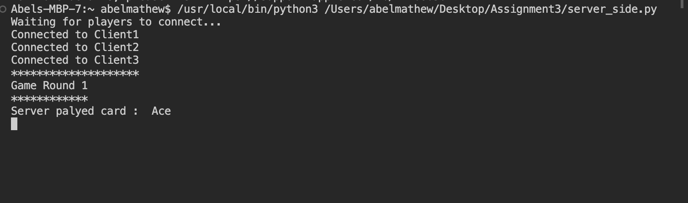

**Client 1 Connection**

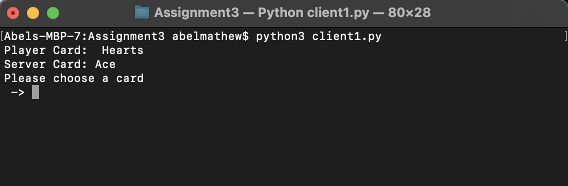

**Client 2 Connection**

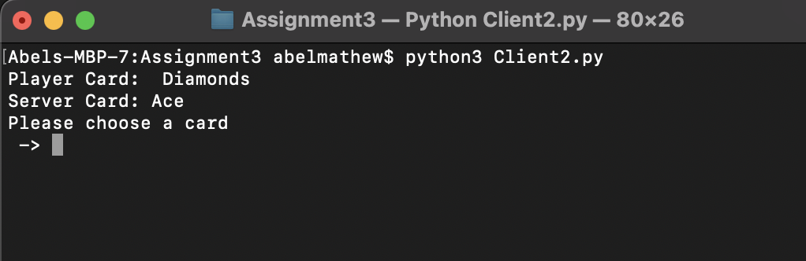

**Client 3 Connection**

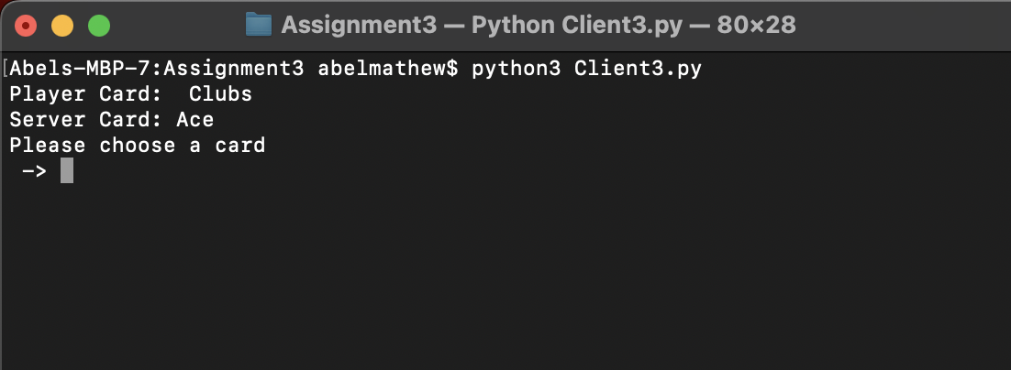

**Server Side (Round 1 - 5)**

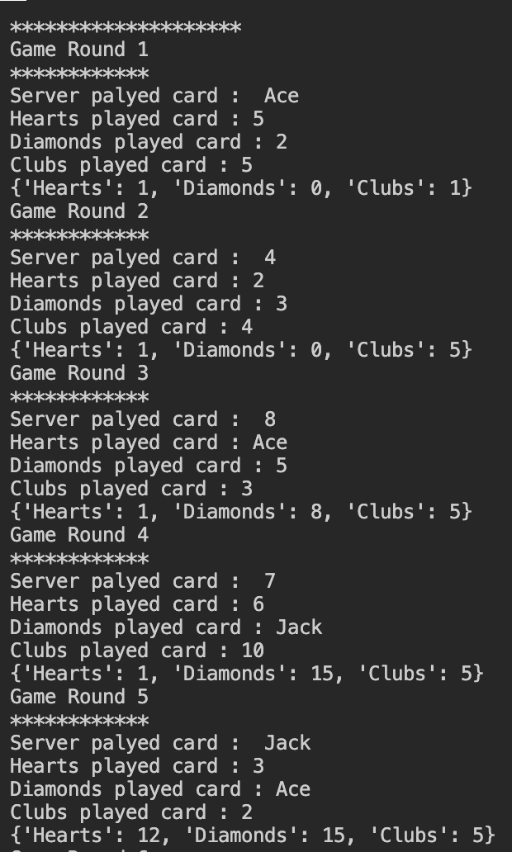

**Server Side (Round 6 - 13)**

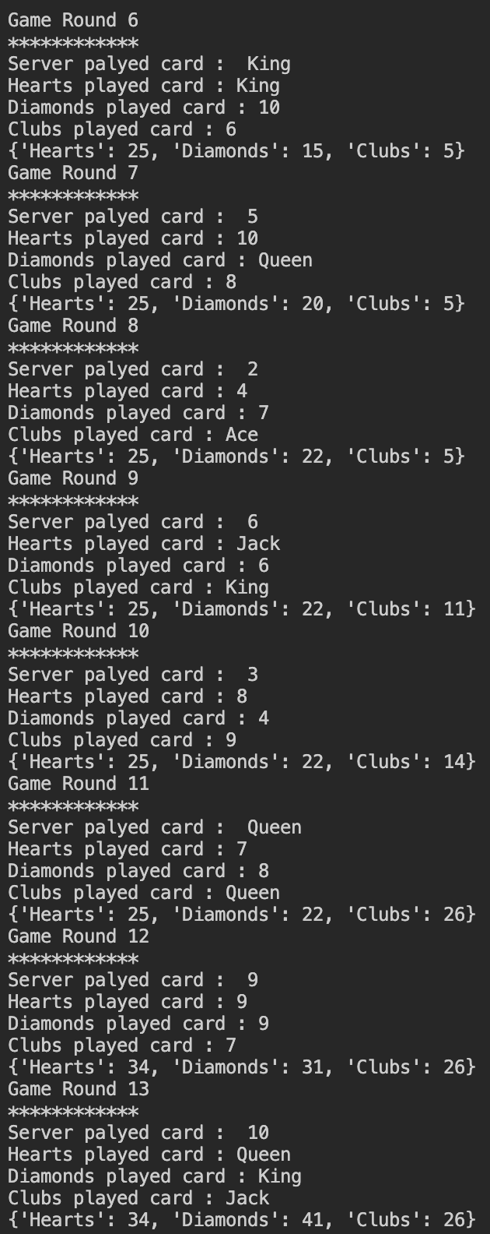

**Client 1**

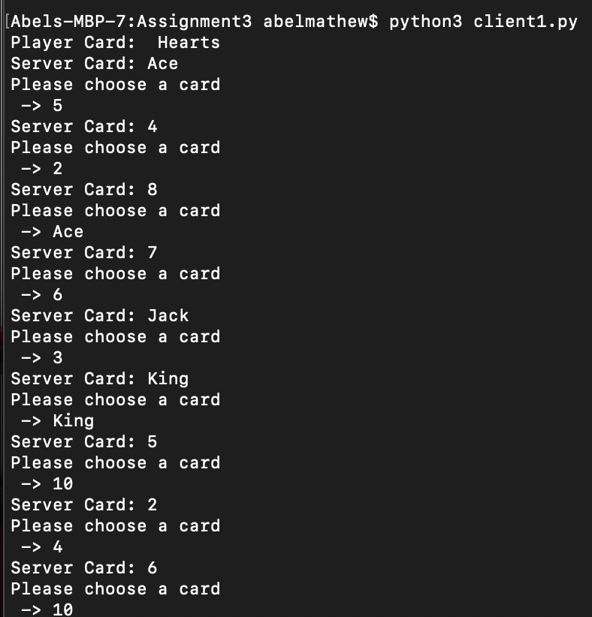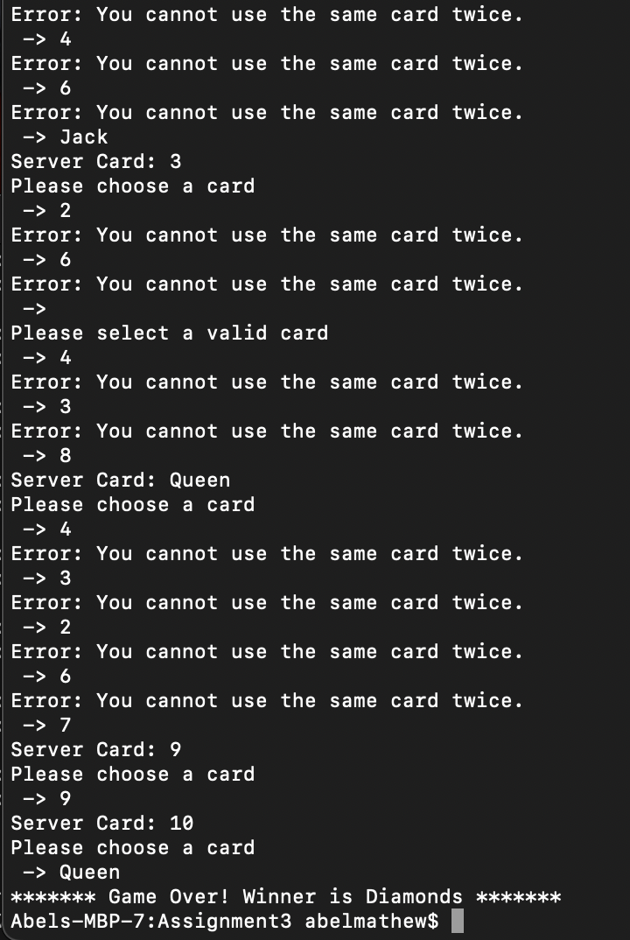

**Client 2 Side**

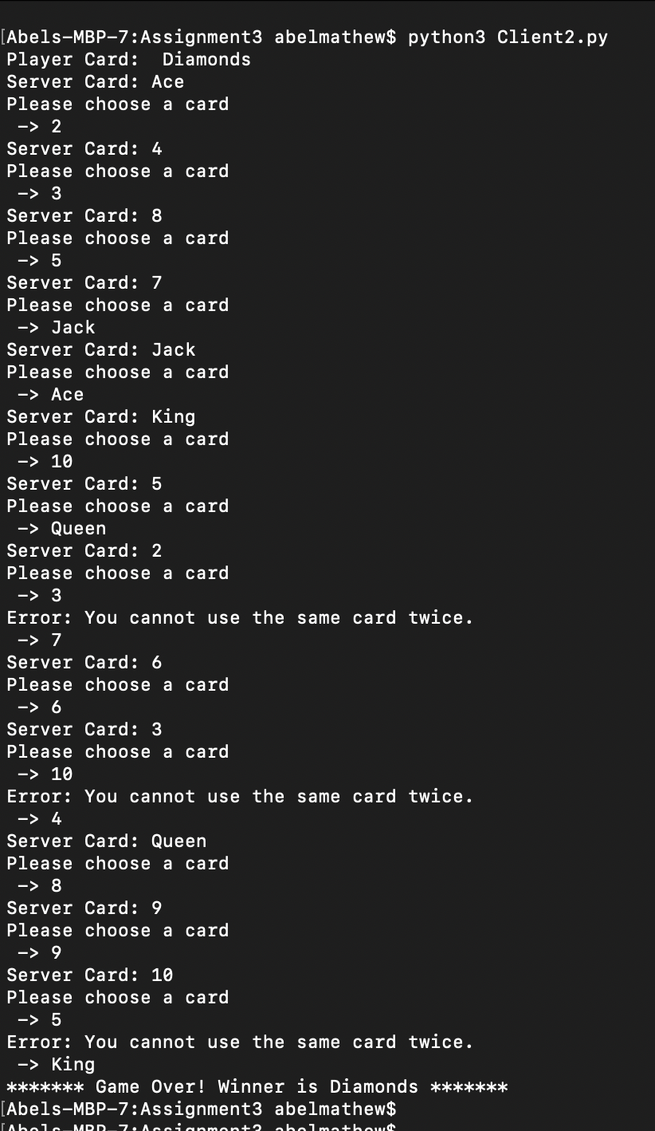

**Client 3 Side**

