Unblocking Node Packets on TXSTATEBOBCAT WIFI

# Summary & Recommendation

When Klingon members attempted to view or work on our project on the Texas State WIFI we had issues viewing our application via Expo Client due to the amount of node modules necessary to run the application. After testing two different methods in two different locations (Library & Linux Lab in Derrick), it is my recommendation that Klingons use the **Tunnel** option when Expo loads the modules. It is my further recommendation that for future demos, Klingons should do a screen record of either as a backup:

* casting the application to Quicktime (Mac&iPhone users) from Expo
* running the application via Snack

# SOCKS Proxy

Working with a SOCKS proxy would have been a bit more involved process; however, would be exchanging messages with the school’s WIFI via SOCKS server on Zeus or Eros. I had tested the connection several times before bringing it to the group and marking the task as done. However, I never tested it in the most important area – inside Derrick! Which lead to the inconsistent results.

# Tunnel

Sarah then pointed out to me that the Expo Client had a built-in process called Tunnel in which she had tried and noted it was slow. I then tested it in Derrick and had great success with it. The download speed is a little slow but it achieves the result we need and does it in a similar way to the SOCKS proxy but much more behind the scenes so it’s just a simple click on our end.

## The Process

1. cd to project directory -> App/foo-app
2. run npm start
3. In the Expo Client, change connection mode to **Tunnel**

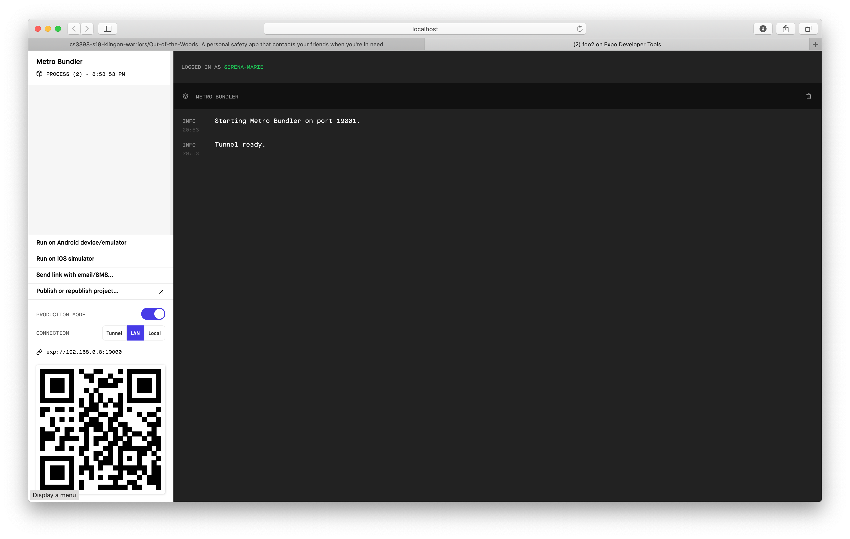

1. Business as usual! Scan QR code and it’ll load up on your phone