# Redirects Tester App

# 

1. Results panel: in this panel you will see the Source and Destiny URLs, among with the status of the test.
2. Environment Configuration: here you can choose to change Akamai’s test IP and the URL, but also if you are going to test in staging or live servers. Notice that the IP is directly requested from [*www.solarwinds.com-v1.edgekey-staging.net*](http://www.solarwinds.com-v1.edgekey-staging.net) so probably you will need to change the IP only in very specific cases.
3. Response: in this section, users can select to test between permanent or temporary redirects. It is important to notice that this tool test all the bath of URLs using the selected response code, so if you try to test different response codes in a single batch you will receive an error message in the status field of the result panel. The application will mark as invalid the URLs that do not match with the selected response code.
4. Buttons layout: in this section you can paste the URLs from the clipboard, start the test or exit from the application.

# Using the application

The use of this application was intended to automate the test of redirects. To complete this, the app will need, as minimum, one source and one destiny IP.

## Copy your URLs to the clipboard

You can copy the URLs to your clipboard from sources that divide the URLs into 2 columns: source and destiny.

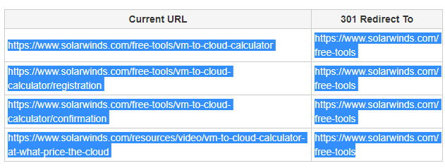

Figure 1 Jira table example

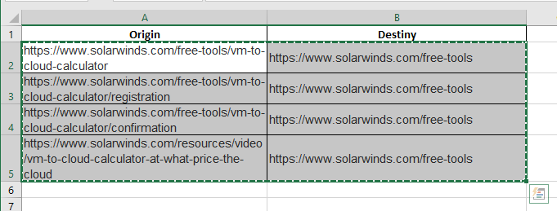

Figure 2 MS Excel table example

Notice that for both examples the titles of the columns are *NOT* selected. Selecting the titles of the tables might produce the application crashes.

## Adding the URLs

Once you copied the URLs into the clipboard, click on the “Paste from Clipboard” button:

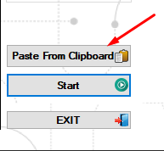

This will automatically validate and add the URLs to the application. Once the process is done, you will receive a notification message and the URLs will be visible in the results panel:

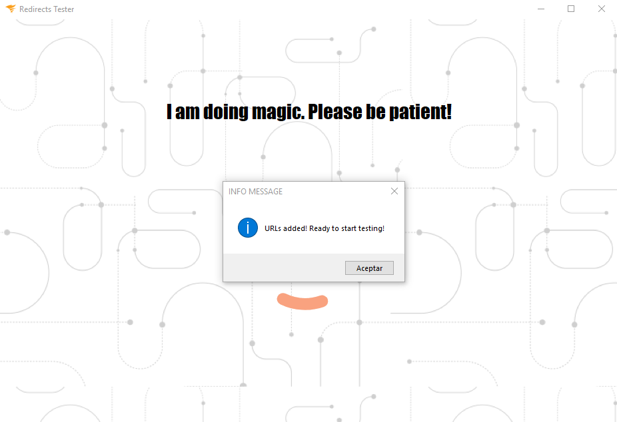

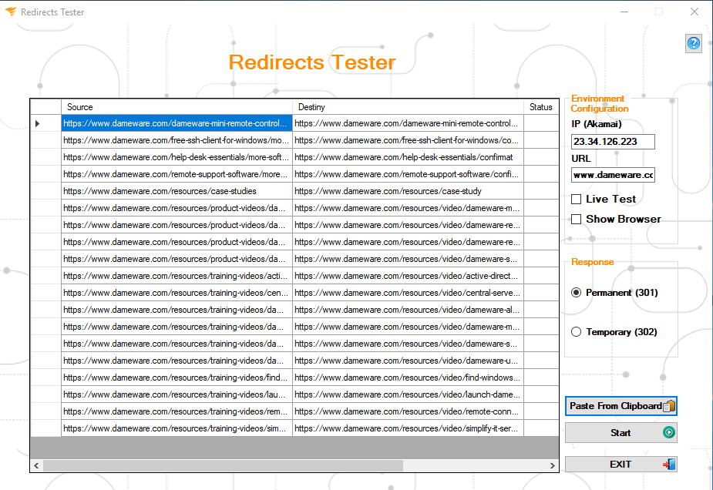

## Starting to test

Once you added the URLs, you can change the configurations on the right side of the application. For ***staging*** test, make sure both the IP and URL on the *“Environment Configuration”* box are according to the ones provided by Akamai.

**IMPORTANT:** If you leave the ***“Live Test”*** check unchecked, the system will write in the hosts file using the information provided in the “Environment Configuration” box. So, it is very important to make sure the data on these fields are right, otherwise the test will fail.

On the other hand, the “Show Browser” check lets you choose if you want to watch the browser running the test or not. This option is unmarked by default.

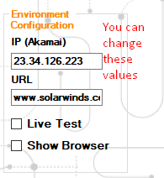

Next step is to choose the proper response code you want to test in the “Response” box:

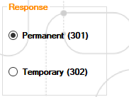

Once the configuration is done, you can start testing by clicking on the ***“Start”*** button. A modal window will open while the tests is running: 

In case the system finds any invalid redirect, the progress bar will turn its color into red:

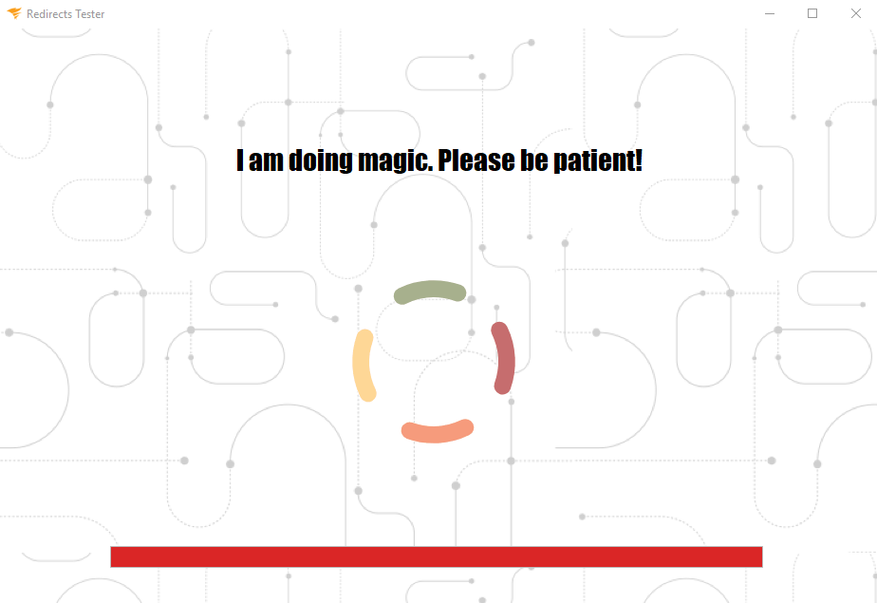

After the test is done, you will receive a confirmation message and will be able to see the results in the results panel:

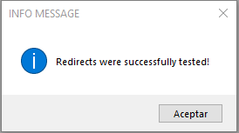

## Additional notes

This application runs with Selenium Web driver, so it is necessary to have Chrome driver installed in the same path of the app