**Assignment – 4**

1.Sum a Specific CSV Column

#!/bin/bash

FILE="$1"

COL="$2"

if [ ! -f "$FILE" ]; then

echo "File not found!"

exit 1

fi

awk -F',' -v col="$COL" '{sum += $col} END {print "Sum:", sum}' "$FILE"

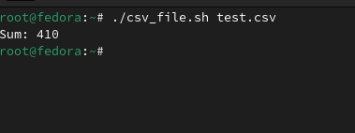

2. Extract Frequent IPs from Log File

#!/bin/bash

LOGFILE="$1"

THRESHOLD="$2"

if [ ! -f "$LOGFILE" ]; then

echo "Log file not found!"

exit 1

fi

awk '{print $1}' "$LOGFILE" | sort | uniq -c | awk -v t="$THRESHOLD" '$1 > t {print $2, "made", $1, "requests"}'

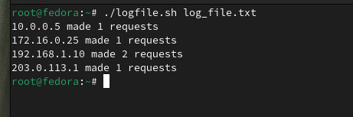

3. Words in a sentence

#!/bin/bash

# Read sentence from user

echo "Enter a sentence:"

read sentence

# Process words and count

echo "$sentence" | tr '[:space:]' '\n' | tr -d '[:punct:]' | grep -v '^$' | sort | uniq -c

