**Assignment -2**

**1. List Files in a Directory**

#!/bin/bash

# Check if directory path is provided

if [ -z "$1" ]; then

echo "Usage: $0 <directory_path>"

exit 1

fi

# Check if the argument is a directory

if [ -d "$1" ]; then

echo "Files in directory $1:"

ls -p "$1" | grep -v /

else

echo "Error: $1 is not a valid directory."

exit 1

fi

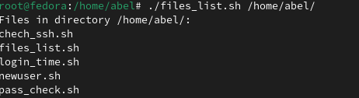

**2. Rename .txt Files with "backup_"**

if [ ! -d "$1" ]; then

echo "Error: $1 is not a valid directory."

exit 1

fi

# Rename .txt files

for file in "$1"/*.txt; do

[ -e "$file" ] || continue # Skip if no .txt files

base=$(basename "$file")

mv "$file" "$1/backup_$base"

done

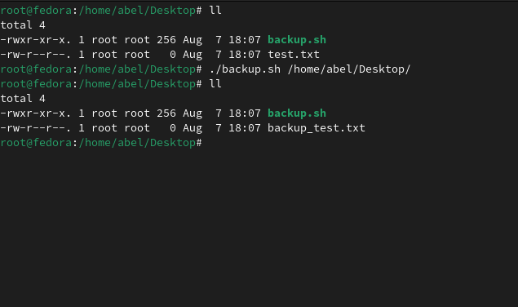

**3. Compare Two Files**

#!/bin/bash

# Check if two file paths are given

if [ $# -ne 2 ]; then

echo "Usage: $0 <file1> <file2>"

exit 1

fi

# Check if files exist

if [ ! -f "$1" ] || [ ! -f "$2" ]; then

echo "One or both files do not exist."

exit 1

fi

# Compare files

if cmp -s "$1" "$2"; then

echo "The files are identical."

else

echo "The files are different. Differences:"

diff "$1" "$2"

fi

