**Assignment3**

**1.OS information**

#!/bin/bash

echo "Operating System: $(uname -o)"

echo "Kernel Version: $(uname -r)"

echo "CPU Info:"

lscpu | grep "Model name"

echo "Available Memory:"

free -h | grep "Mem:"

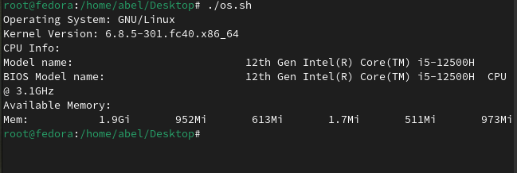

**2. Check and Start Process**

#!/bin/bash

PROCESS_NAME="your_process_here"

if pgrep "$PROCESS_NAME" > /dev/null; then

echo "$PROCESS_NAME is already running."

else

echo "$PROCESS_NAME is not running. Starting it..."

"$PROCESS_NAME" &

Fi

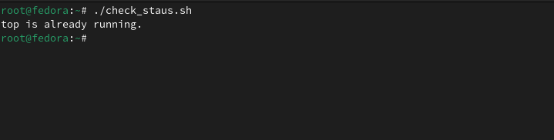

**3. Disk Usage**

#!/bin/bash

# Set partition and threshold

PARTITION=""/dev/sr0

THRESHOLD=80

# Get usage percent without the % sign

USAGE=$(df "$PARTITION" | awk 'NR==2 {gsub("%",""); print $5}')

if [ "$USAGE" -gt "$THRESHOLD" ]; then

echo "Disk usage on $PARTITION is ${USAGE}% – over threshold of ${THRESHOLD}%" | \

mail -s "Disk Space Alert" abelvj67@gmail.com

fi