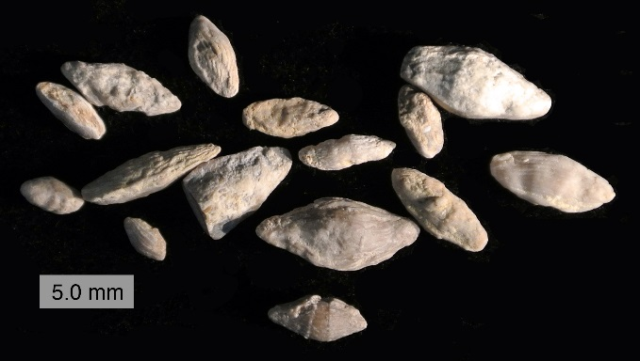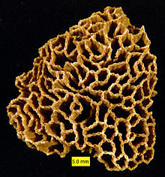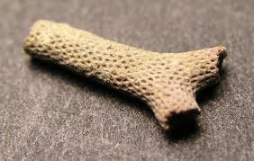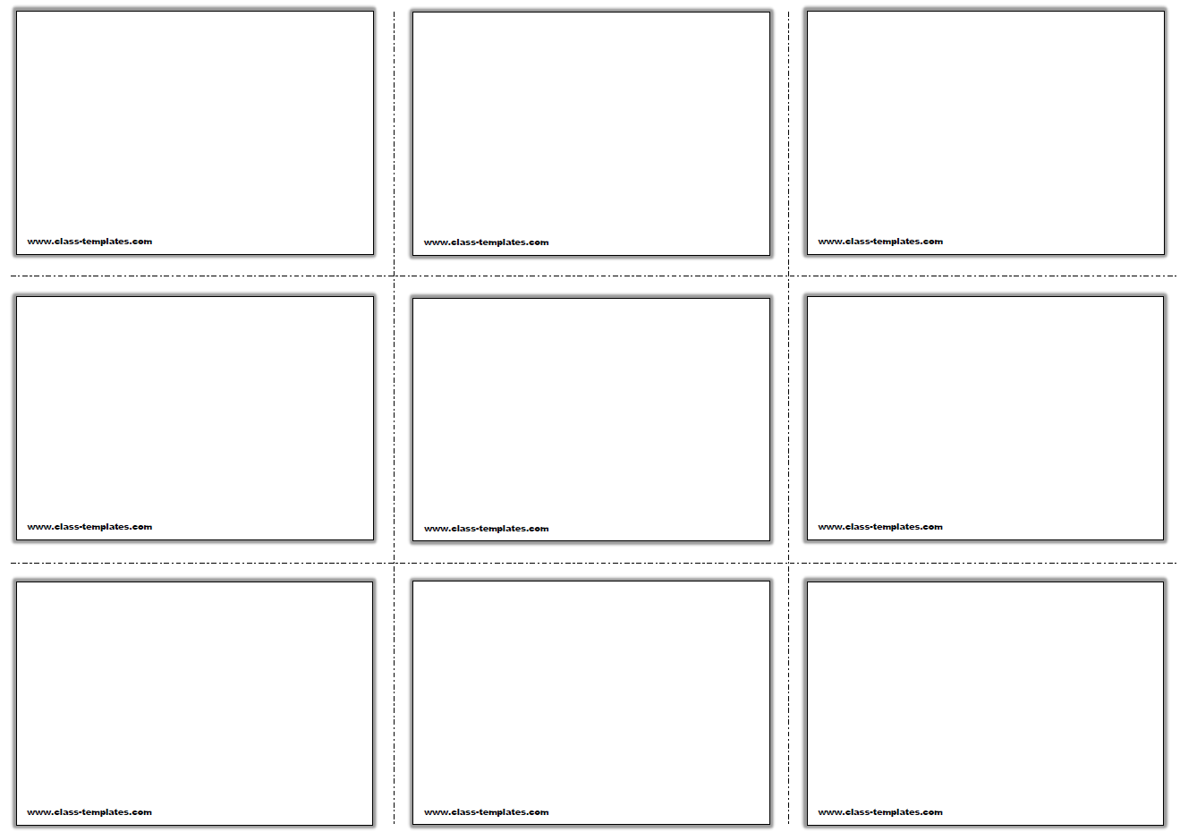\

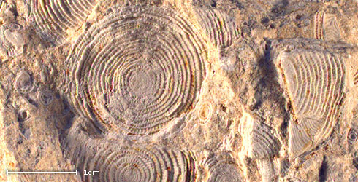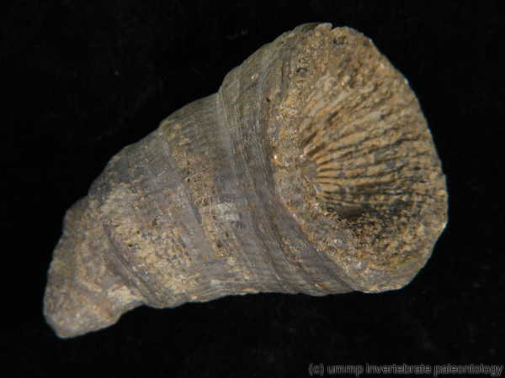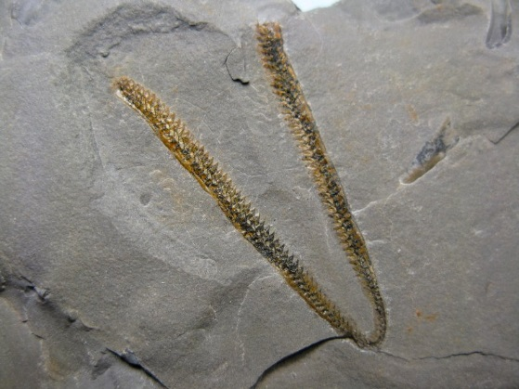

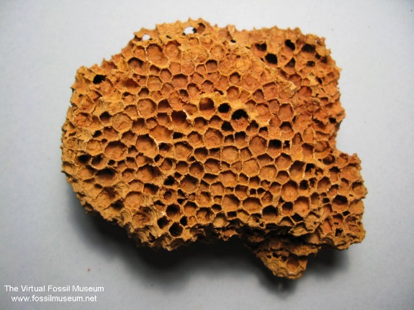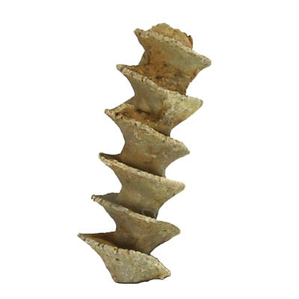

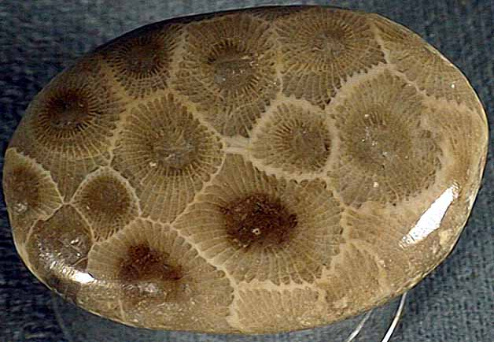



**Genus - Hexagonaria**

Colonial rugose coral

Widely distributed around the earth (state fossil of Michigan)

Lived in warm shallow salt water

Lived during the Devonian period

**Genus - Heliophyllum**

Solitary horn coral that lived during the Devonian period

Fed using its nematocysts to stun prey

**Genus - Halysites**

Known as the “chain coral” due to its growth pattern

Lived in warm, shallow waters from the middle of the Ordovician to the late Silurian

**Genus - Favosites**

Colonial tabulate coral that lived from Ordovician to Devonian

Commonly found in Silurian limeston and recognized by honeycomb-like appearance

Found worldwide

**Class - Graptolithina**

Extinct, colonial, marine organisms

Secreted chitinous exoskeleton with growth bands and lines

First appeared in Middle Cambrian and last known in Lower Carboniferous

**Genus - Rhombopora**

Bryocoan “moss animals”

Sessil, benthic and filter feeding

Lived from Carboniferous to Permian

**Genus - Archimedes**

Looks like a water screw

Mississippian Period about 320 to 260 million years old (Carboniferous period)

Marine animals with many fresh water

Lived by filtering sea water from microscopic organisms

Individual animals are called zooids

**Genus - Nummulites**

Small, single celled marine animals

Secrete a tiny shell

Late Middle Palaeocene epoch to Oligocene epoch

Used to assign relative ages of rock strata using the fossils so referred to as index or guide fossils

**Order - Fusulindia**

Small, single celled organisms marine organisms

Pennsylvanian and Permian Periods

Extinct during mass extinction at end of Permian Period