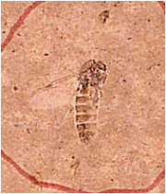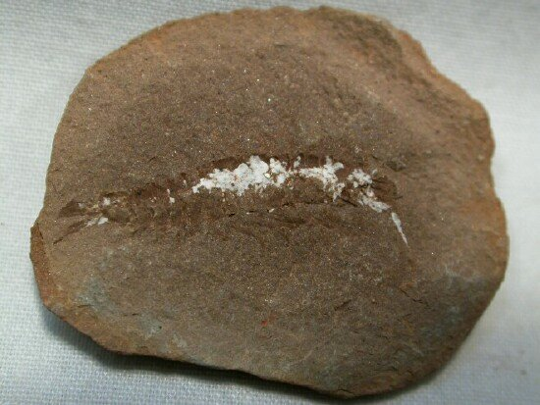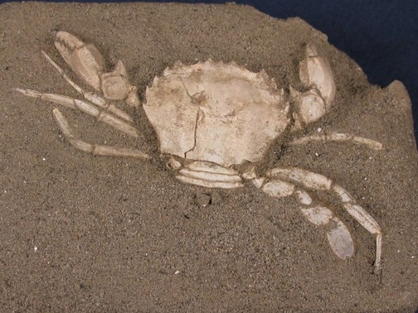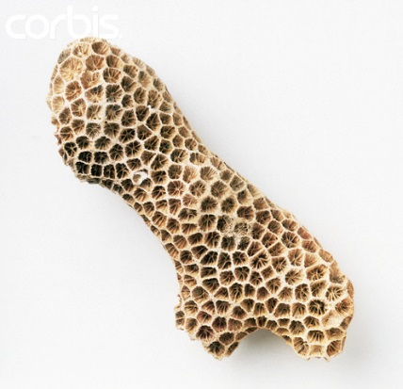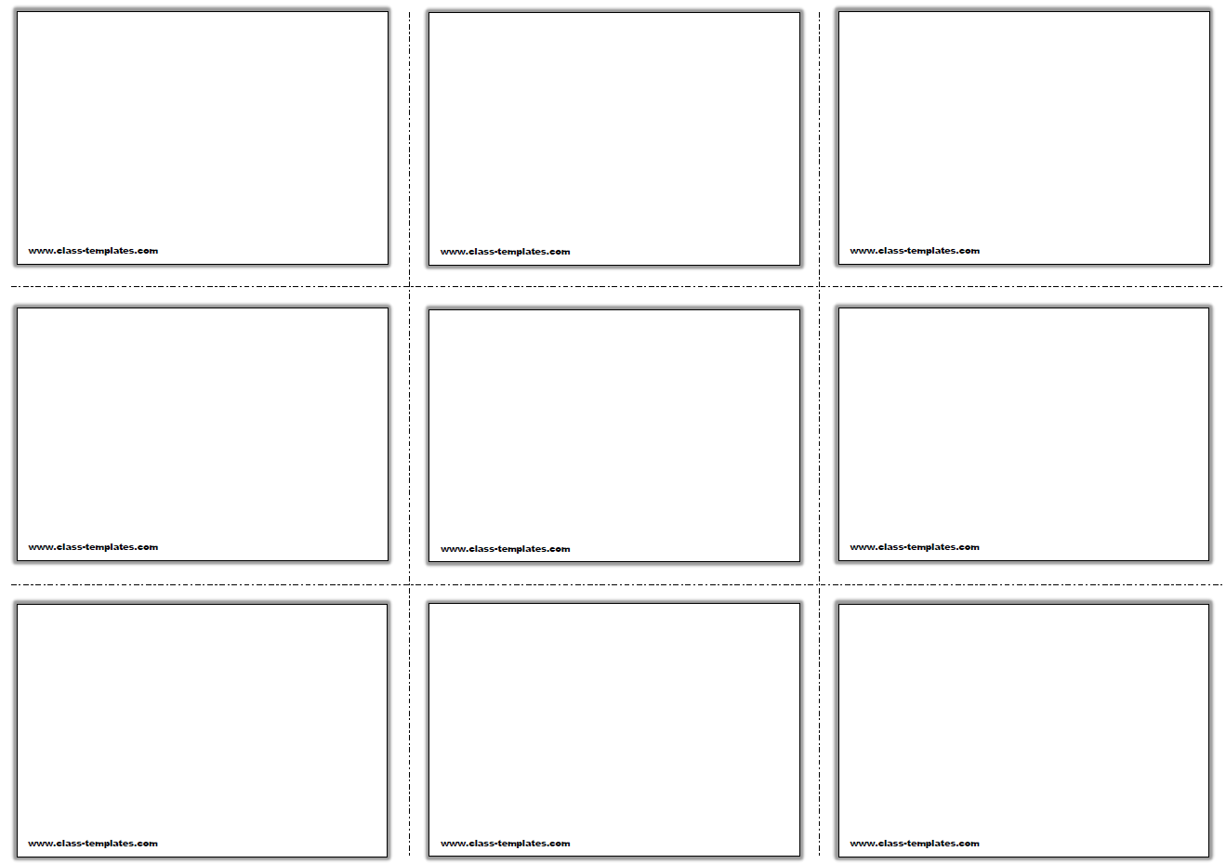

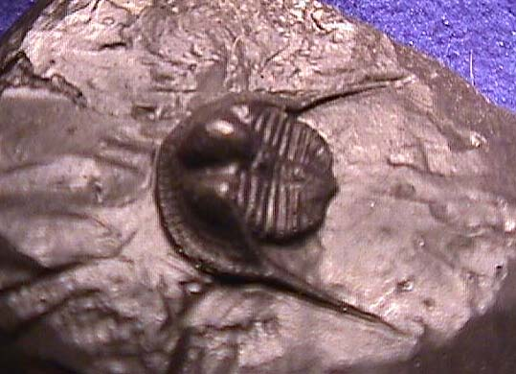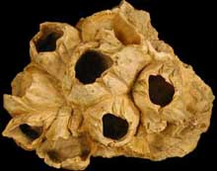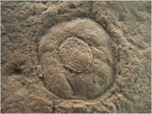

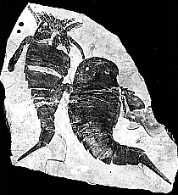

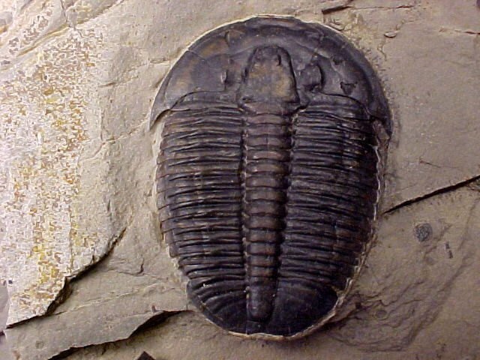



**Class - Insecta**

Been on earth since Devonian period

Group of terrestrial and freshwater arthropods

Divided 3 sections (head, thorax and abdomen) 6 legs attached to thorax

Evolved wings in Carboniferous period

True flies date back to Triassic

**Class - Maxillopoda**

Extends back to the Cambrian period

Generally small animals with barnacles being the execption

Reduced abdomen that lacks appendages

**Order - Septastraea**

Most recent coral on the list

Lived from the Miocene to the Pleistocene during the Neogene and Quaternary periods

Lived in warm, shallow water reefs

**Infraclass - Cirripedia**

Barnacles that are specialized to live within a specific substrate

Some exist as parasites

Because bodes have hard calcerous plates they are readily fossilizable

Fossil history from the middle Cambrian to present

Oldest is *Priscanesrmarinus barnetti* from Burgess Shale

**Genus - Elrathia**

Oldest trilobite on the list

Identifiable by its small head and well defined axial lobe

Divided into thirteen narrow segments and dates back to Cambrian period

**Genus - Cryptolithus**

Small tribolite that lived during the Ordovician

Almost completely blind and just ate detritus on the bottom of the ocean

Identifiable by its free long cheeks

**Order - Eurypterida**

Belonged to same group as modern day horseshoe crabs

Date back to Ordovician

Modern day spiders and scoprions

Largest known arthropod to exist

**Class - Malacostraca**

Shrimp, lobster, crabs, isopods

First appeared in the Cambrian period

**Class - Scyphozoa**

Jellyfish that are extremely rare as fossils as their bodies are made mostly of water

Two life stages the polyp and the medusa

Polyp are sessils and mature to medusa which is planktonic