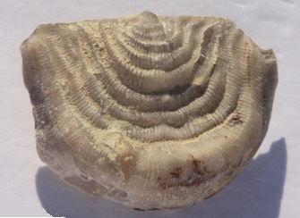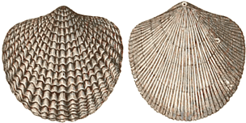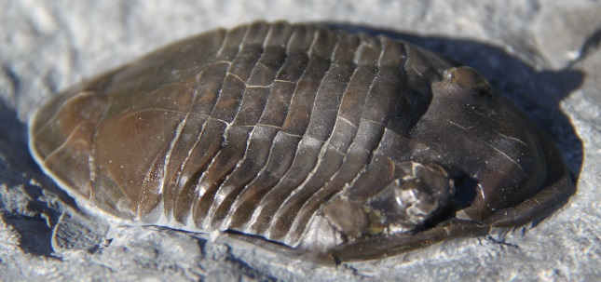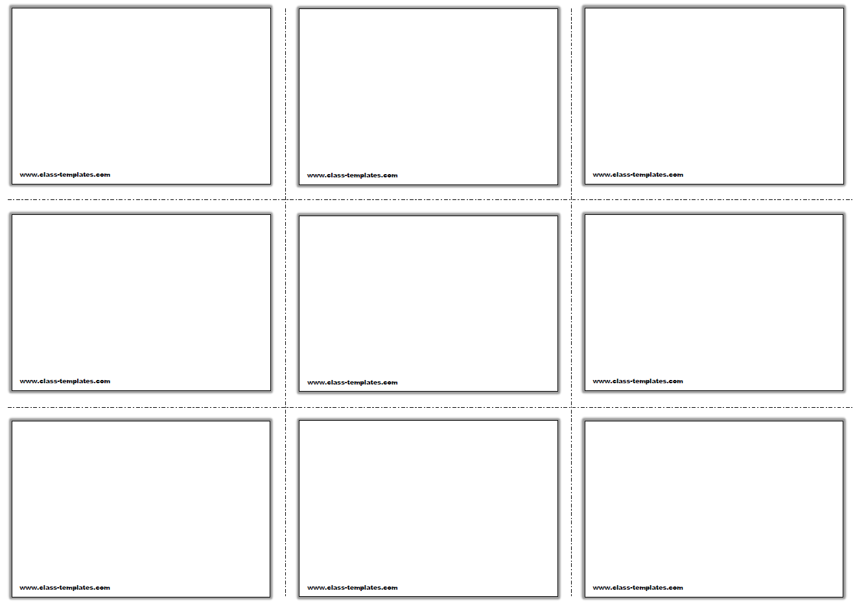

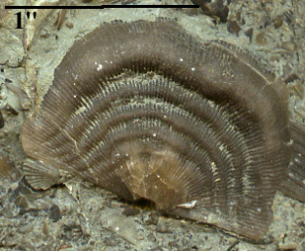

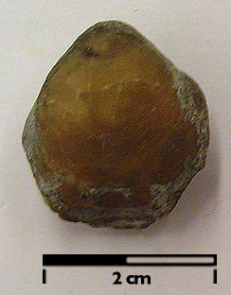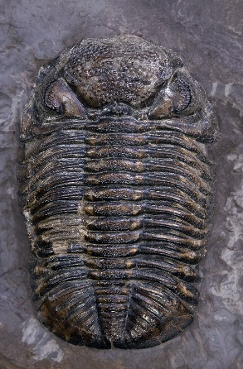

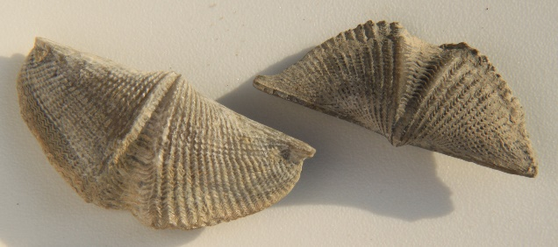

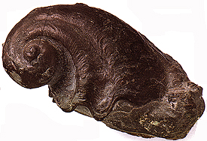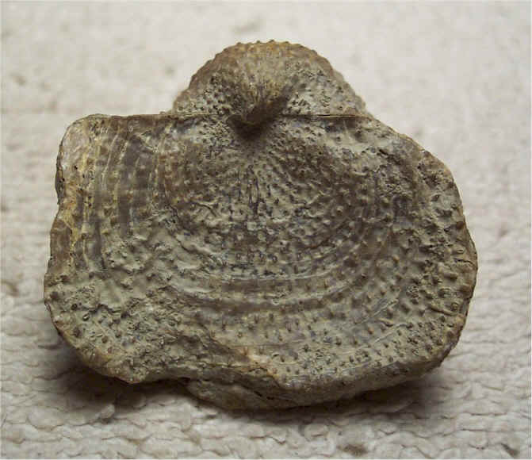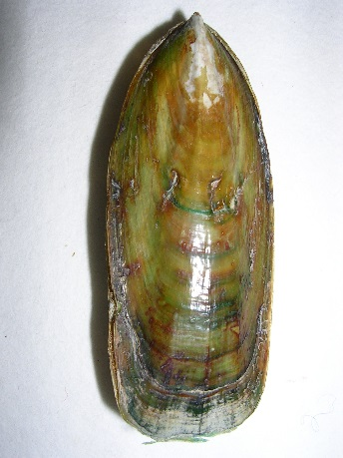

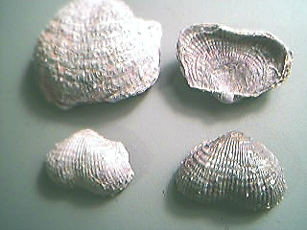

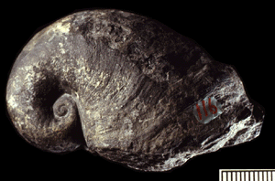



**Genus -Platystrophia**

Jellyfish that are extremely rare as fossils as their bodies are made mostly of water

Two life stages the polyp and the medusa

Polyp are sessils and mature to medusa which is planktonic

**Genus -Mucrospirifer**

Jellyfish that are extremely rare as fossils as their bodies are made mostly of water

Two life stages the polyp and the medusa

Polyp are sessils and mature to medusa which is planktonic

**Genus -Leptaena**

Jellyfish that are extremely rare as fossils as their bodies are made mostly of water

Two life stages the polyp and the medusa

Polyp are sessils and mature to medusa which is planktonic

**Genus -Juresania**

Jellyfish that are extremely rare as fossils as their bodies are made mostly of water

Two life stages the polyp and the medusa

Polyp are sessils and mature to medusa which is planktonic

**Genus - Composita**

No longer living – lived during the Devonian to the Permian

Smooth shell with a more or less distinct fold

**Genus - Atrypa**

No longer living – lived during the Silurian through Early Carboniferous

Recognized by its distinctive concentric growth lines and peculiar outgrowths of the shell

Marine rocks

**Genus - Lingula**

Livving fossil that evolved in Ordovian period

Known for having a very long pedicle which anchored it to the sea floor (sessil)

**Genus - Phacops**

Notable for its huge glabella

Had eyes with fewer lenses than other trilobites (better vision)

Lived in warm shallow seas during the Devonian period – index fossil

Commonly found rolled up into a ball

**Genus - Isotelus**

Trilobite that lived during the Ordovician period

Largest trilobite – 3 species of Isotelus grew to almost a meter long

Possessed pits around the body with sensory hairs