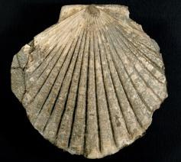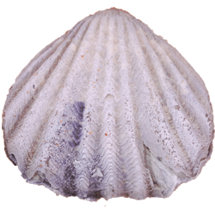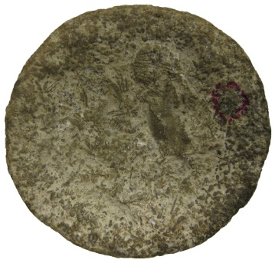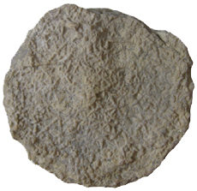

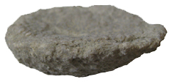

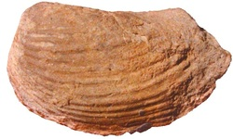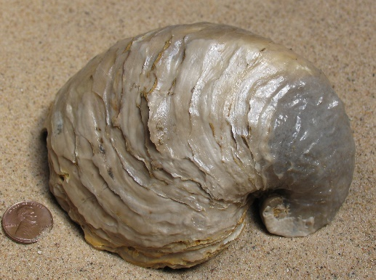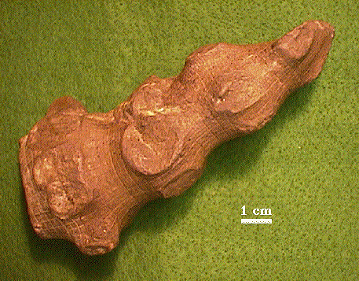

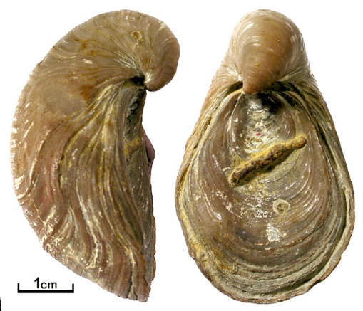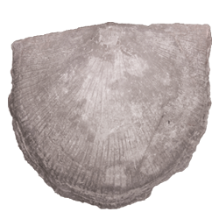

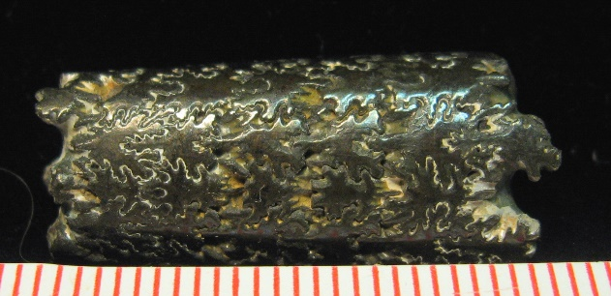



**Genus - Pecten**

Genus of large scallops or clams

Have flat shells and distinct flat extensions to the hinge line called “wings”

**Order - Rhynchonelida**

Biconvex shell

Usually fold on the dorsal valve and sulcus on the ventral valve

Early Ordovician to Recent

**Genus - Astraeospongia**

Sponges are the simplest animals and do not have tissues or organs

Basket spong

Simplest form of multi-cellular life

Found from Silurian to Devonian

Produce both sexually and asexually

**Genus - Hydnoceras**

Devonian to the Pennsylvanian

Sponges are the simplest animals and do not have tissues or organs

Simplest form of multi-cellular life

"glass sponge", which means it was composed of silica spicules, which provided structural support and deterred enemies. Glass sponges are extant, but are now found only in the deep ocean.

**Genus - Baculites**

Genus of extinct cephalopods related to the modern squid, octopus

Found in late Cretaceous

Excellent guide or index fossil for Late Cretaceous time and rocks

Shell begins with a tightly coiled portion that becomes straight in form

**Genus - Pholadomya**

Genus of fossil salwater clams

Lived during Triassic to Tertiary

Perfectly spaced growth lines and has no ridges and has an asymmetrical shell

**Genus – Gryphaea**

Extinct molluskan from Jurassic Period to the Eocene Epoch

Related to the oysters

Distincively convoluted shape

Left valve much larger and more convoluted than the flattish right valve

**Genus – Exogyra**

Shallow water marine deposits of the Jurassic and Cetaceous periods

Thick shell

Longitudinal pattern of ribbing is well developed in the left valve, and pitting is common

**Genus Rafinesquina**

Suspension feeder

Lived during the Ordovician to Devonian