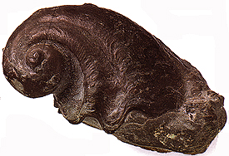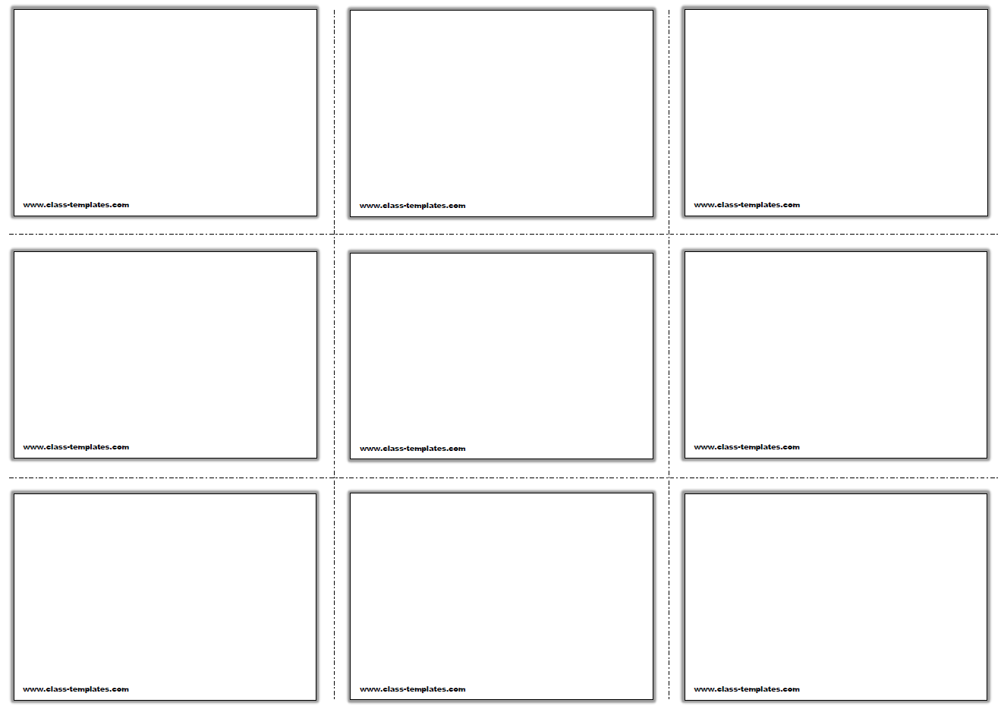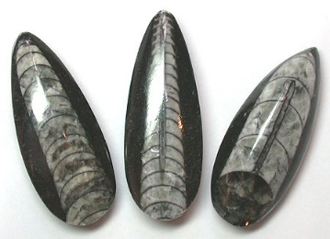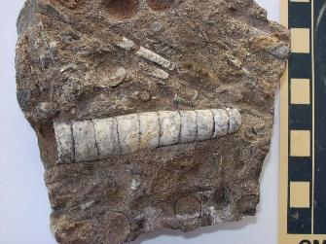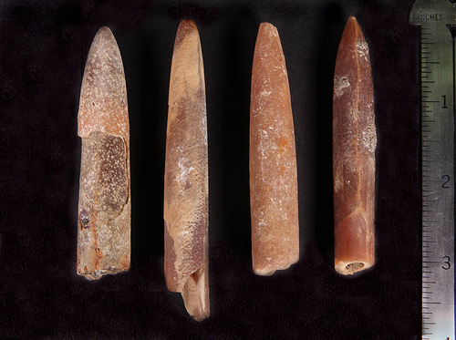

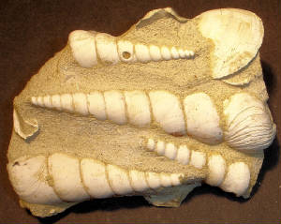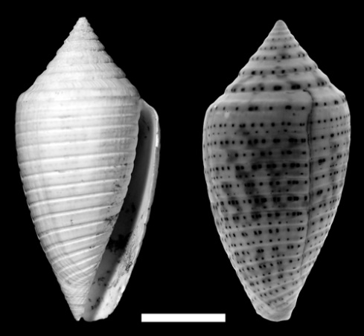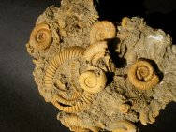

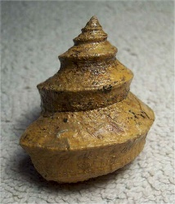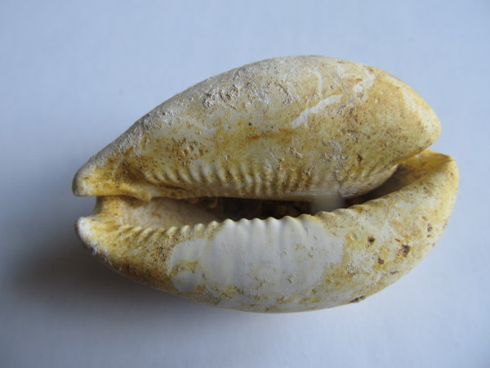

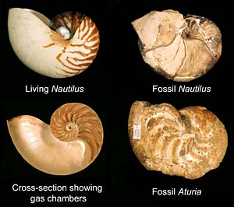



**Genus - Conus**

Predatory sea snail, a marine gastropod mollusk

Also called cone shells

Used to increase our understanding of species-level patterns of evolution,

**Genus - Turritella**

Known from Cretaceous to the recent periods

Referred to as Turritella limestone or Turritella agate if silicified

**Genus - Belemnitella**

Belong to a diverse grouop of cephalopods

Most common cephalopod at Big Brook

Lived during the Jurassic and Cretaceous Periods

Official fossil of Delaware

**Genus - Orthoceras**

Ancient mollusk

Extinct cephalopod

Dated from lower Ordovician to Triassic ages

Ancestors of the modern day squid

**Genus – Platyceras**

Extinct genus of gastropod

Lived from Ordovician to the Permian

Shell has a typical spiral form of helical spires and extremely flattened

**Genus – Worthenia**

Extint gastropods preserved as common fossils in rocks of Devonian to Triassic age

In the midcontinent region of North America

Characterized by a turban-shaped shell in which a raised ridge follows the margin of the whorls

**Genus – Cypraea**

Medium sized to large sea snails or cories, marine gastropodmollusks

**Genus - Nautilus**

A pelagic marine mollusk of the cephalopod family

Appeared in the Late Trassic

**Genus - Dactylioceras**

Geological Time: Jurassic

Classic ammonite species best known from Germany

Yellow/tan and found in sandy brown matrix

Key index fossil for identifying their region of the Jurassic