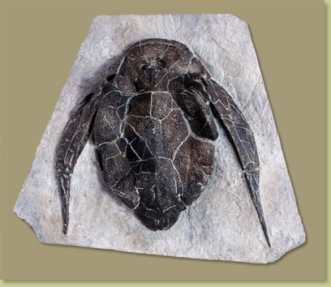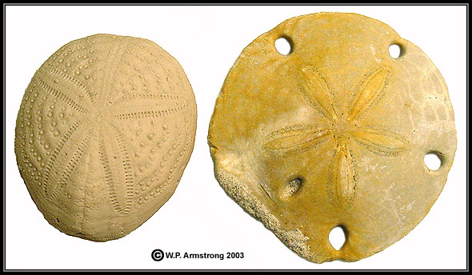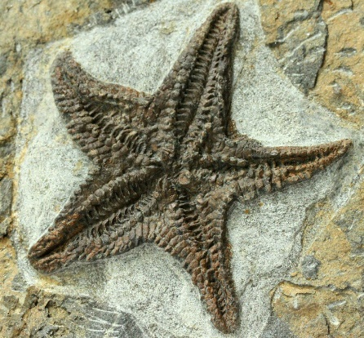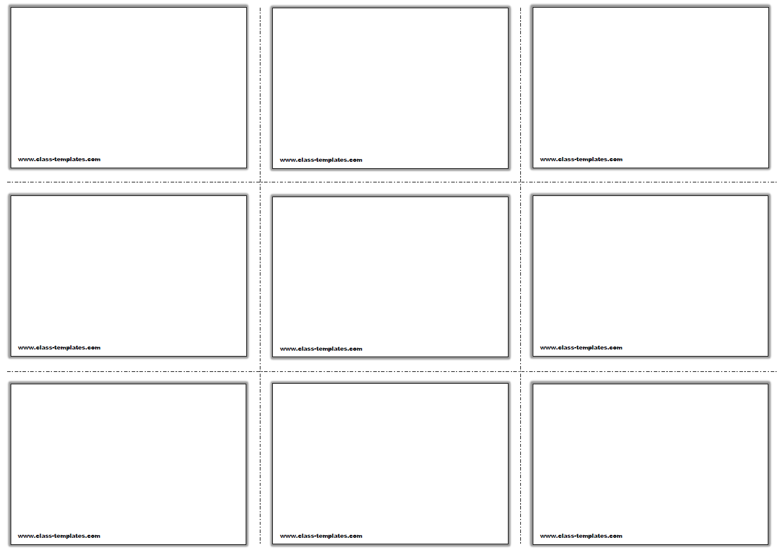

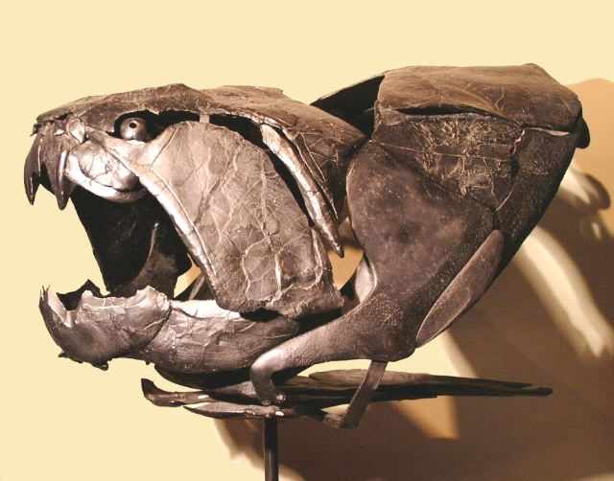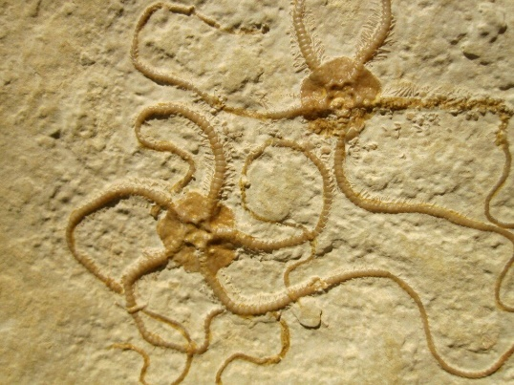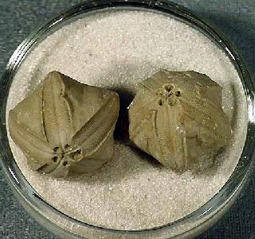

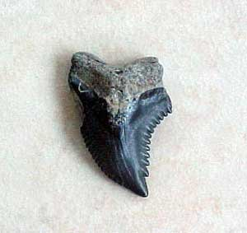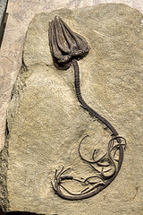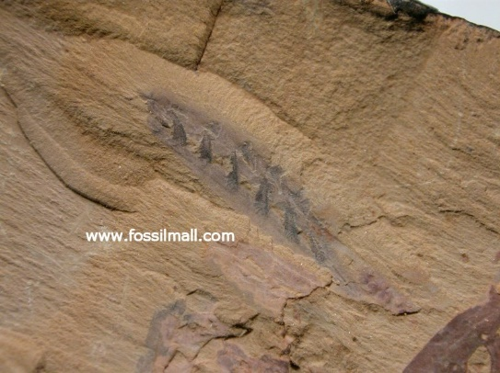



**Genus -Bothriolepis**

Period Givetian to Fammenian of the Devonian

Found on every continent

Lived at the bottom of aquatic environments and shifted through the mud and silt for organice matter

Had gills and pouches that connected to the oesophagus (rudimentary lungs)

**Class – Echinoidea**

Most diverse and successful echinoderm groups

Classified by the symmetry of the test, the number and arrangement of plate rows making up the test

First appeared in the Orddovician

**Class- Asteroidea**

Earliest appeared in the Ordovician

2 major faunal transitions in the Late Devonian and late Permian

Paucity of the asteroid fossil record help us understand the asteroid evolution

**Superorder - Selachii**

Oldest known shark lived in the Devonian period

Predators of modern day

A shark’s teeth are constantly replaced throughout its life

**Genus -Dunkleosteus**

Prehistoric fish existing during the Late Devonian period

Known locations: Canada, USA, Europe and Morocco

Largest predatory placoderm fish known in the fossil record

Powerful bite but not the stronges

**Superclass – Agnatha (Jawless Fish)**

Last survivors of the world’s first vertebrate animals

Diverged from other fish during the Cambrian

Prominent in early Paleozoic

Filter feeders

**Class – Ophiuroidea**

Large group of echinoderms that includes the brittle starts and basket starts

Appear in early Ordovician and not common as fossils

**Class – Crinoidea**

Lived from the beginning Ordovician Period

Flourished during the Paleozoic Era

3 main body parts, the stem, the cuplike calyx which contains the mouth, the digestive system and anus and the food-gathering arms

**Genus -Pentremites**

Extinct genus of blastoid echinoderm

They were immobile echinoders

Lived in the early Carrboniferous and fossils found in North America