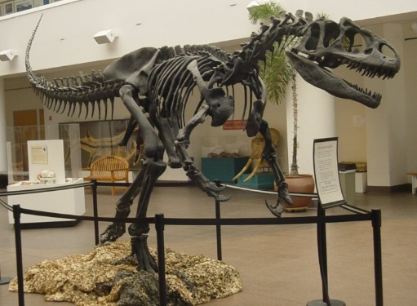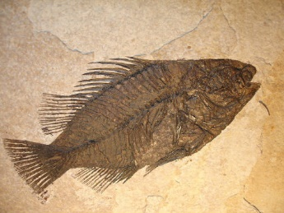

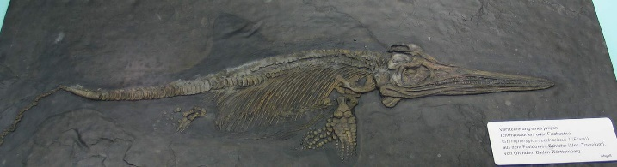

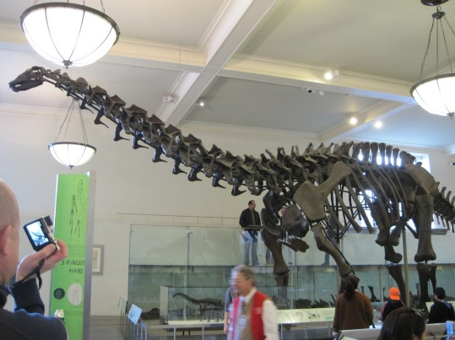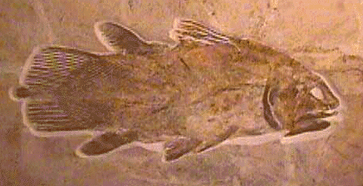

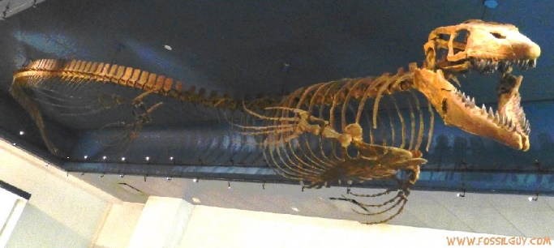

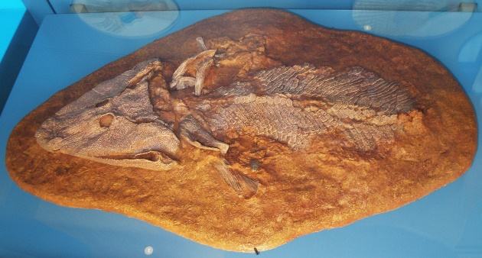

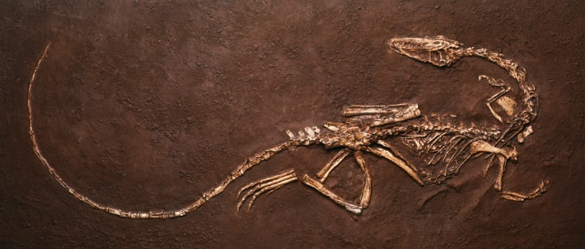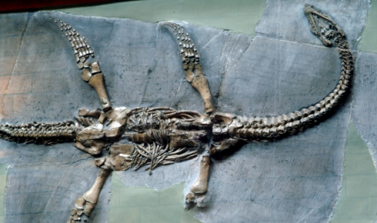



**Order – Ichthyosauria**

The name means “fish lizard”

Long flexible bodies and probably swam by undulating like living eels

Rare fossils have been found

Not dinosaurs but represent a separate group of marine vertebrates

First appeared in the Triassic and reached highest diversity in Jurassic and disappeared In the Cretaceous

**Genus – Allosaurus**

Means “different lizard”

Carnivore

Lived during the Late Jurassic period

Found in the US, Portugal and Africa and Australia

Top predator with a huge head, sharp serrated teeth, short arms and 3 fingered hands

**Superorder - Osteichthyes**

Occur in the late Silurian

Bony fish

First vertebrates, the first vertebrates with jaws, to evolve lungs and have bony skeleton

Abundant from the early Devonian and major radiation underway by mid-Devonian

Both groups still surviving

**Genus – Apatosaurus**

Plant eater

Largest land animal that ever existed and had a very long neck

Lived during the late Jurassic Period

Found in the USA

**Family – Mosasauridae**

Great Marine reptiles and ruled the seas during the late Cretaceous and became extinct during the Cretaceous

THEY ARE NOT DINOSAURS

Large and vicious predators

**Order - Coelacanthiformes**

Rare order of fish that includes 2 extant species

Occurred beginning the Devonian period

Thought to have bee extinct during the Cretaceous-Paleogene extinction

Closely related to lungfish, reptiles and mammals

Found coastlines of Indian Ocean and Indonesia

**Genus - Coelophysis**

Small lightly-built dinosaur that walked on 2 long legs

Lived during the Triassic period

Carnivore a meat eater and scavenger

**Order – Plesiosauria**

Lived between the Jurassic to Cretaceous period

Ocean-dwelling reptiles

NOT DINOSAURS

Found on every continent

Chief predators of the ancient seas

First kinds of extinct animal known to science

**Genus - Tiktaalik**

Known as “fisapod”

Discovered in the Devonian period in Canada

This is the pivotal point in history of life on Earth, when fish first ventured out onto land

Mix of fish and amphibian traits