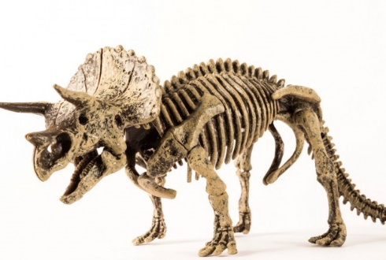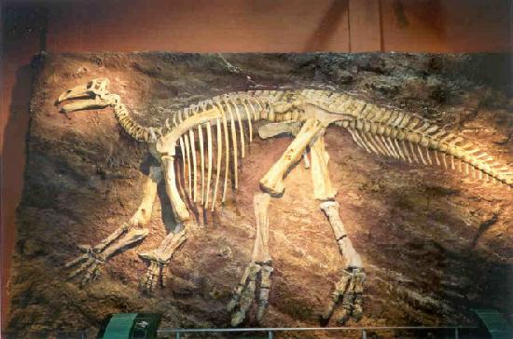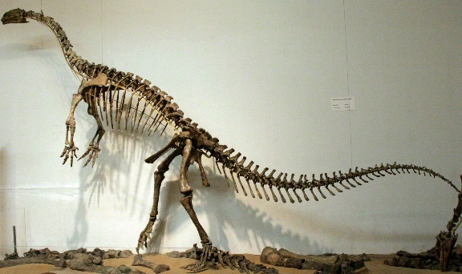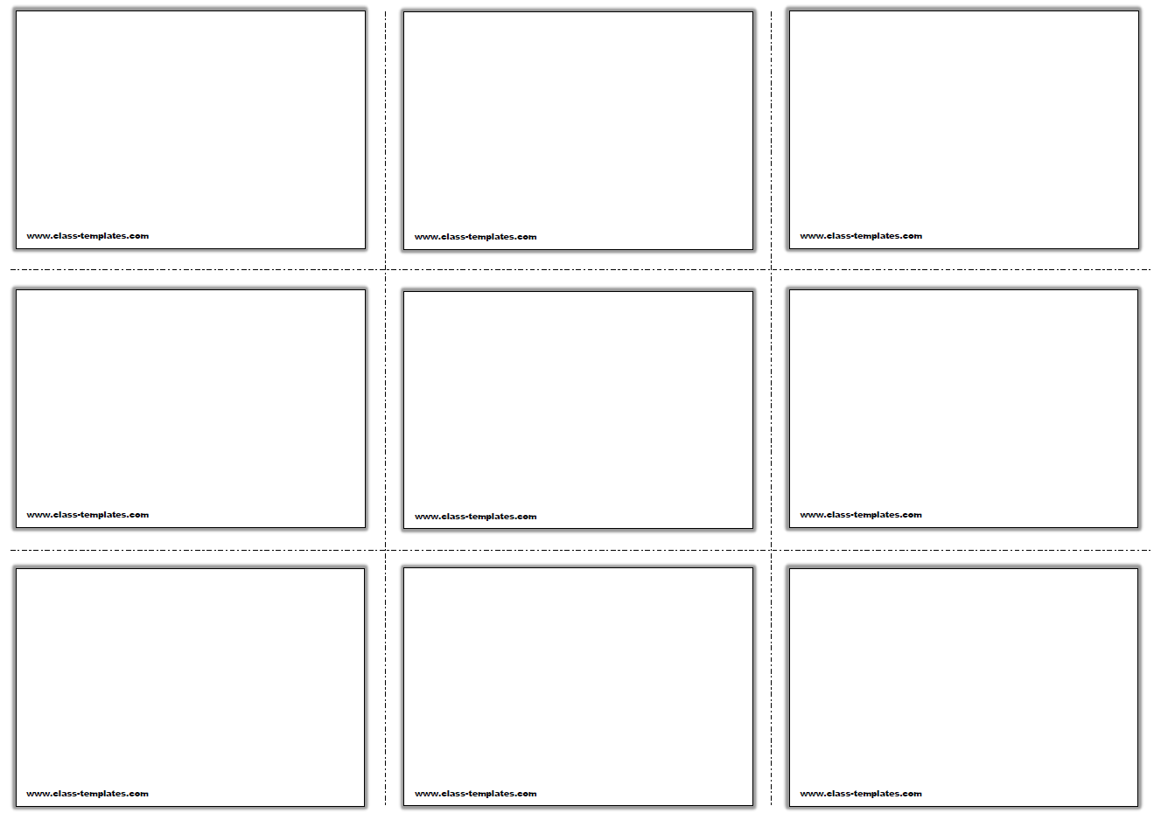

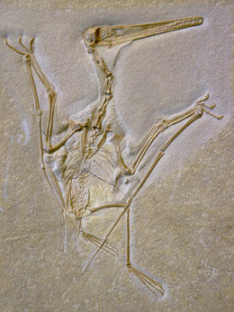

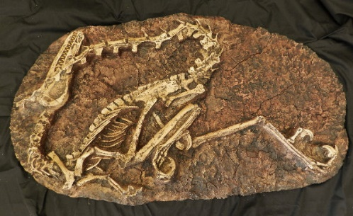

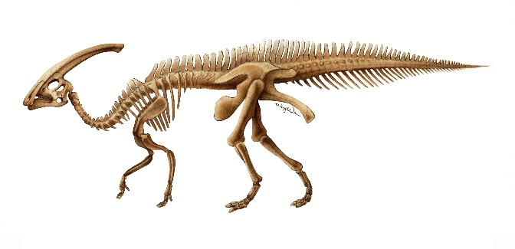

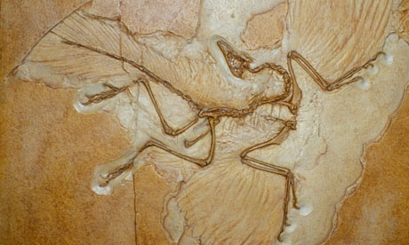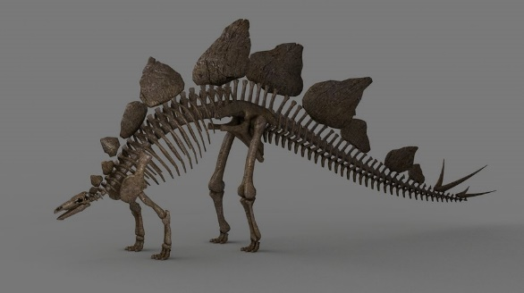

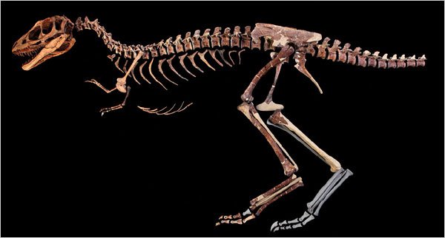



**Genus - Iguanodon**

Horny, toothless beak and tightly packed cheek teeth

Four fingers plus a thumb spike on each hand

Lived in the early Cretaceous period toward the end of Mesozoic

Herbivore

Found in Belgium, England, Germany, North Africa, and the USA

**Genus - Triceratops**

Rhinoceros-like dinosaur

Walked on four sturdy legs and had 3 horns on its face and a large boney plate projecting from the back of its skull

Lived in late Cretaceous period toward end of the Mesozoic

Herbivore

Fossils found in the North America

**Genus - Plateosaurus**

“Flat lizard”

Large and an early herbivore

Long neck, long tail and small head with a long snout and 5 fingered hands

Lived during the late Triassic period

Discovered in Europe

**Genus - Archaeopteryx**

Name means “ancient wing”

Found in Europe

Lived in Jurassic period

Carnivore

Oldest-known bird unlike modern-day birds it had teeth, 3 claws on each wing, a flat sternum, belly ribs and a long bony tail

**Order – Pterosuria**

Extinct group of reptiles

NOT FLYING DINOSAURS

First vertebrates to evolve powered flight

Lived during the Mesozoic era

Largest flying animals of all time

**Genus – Stegosaurus**

About 26-30 feet long

Had 17 bony plates that were embedded in its back

Lived in the late Jurassic Peiod

Fossils found in US, Eurpoe, India, China and southern Africa

Herbivores

**Genus - Parasaurolophus**

Long-crested, duck billed dinosaur

Produce low-frequency, foghorn like sound that was used to enhance sense of smell or in courtship display

Herbivore

Lived during the late Cretaceous period and end of Mesozoic (Age of Reptiles)

Fossils found in the US and Canada

**Genus - Tyrannosaurus**

Only 30 fossils have been found in the United States and none of them are complete

Lived during the late Cretaceous period

Arms are only about 3 ft and had 2 fingered hands

Fierce predator

**Genus - Velociraptor**

“Speedy thief” – fast running two-legged dinasour

Meat eater

Lived in the late Cretaceous period

Fossils found in Mongolia, Russia and China