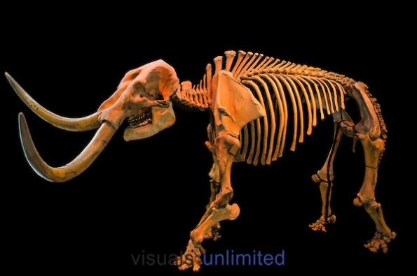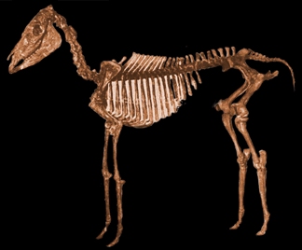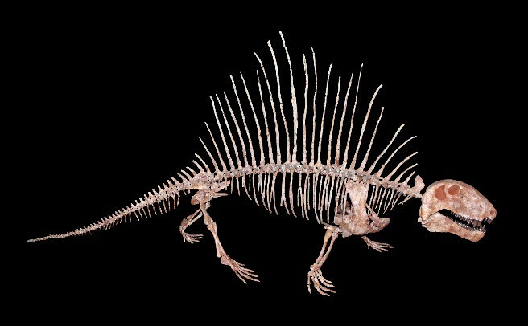

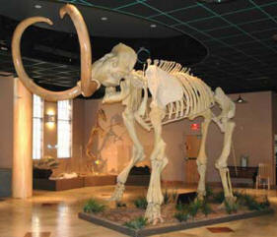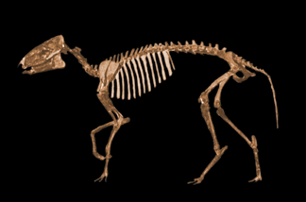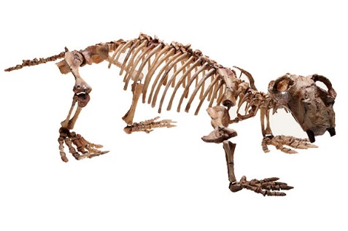

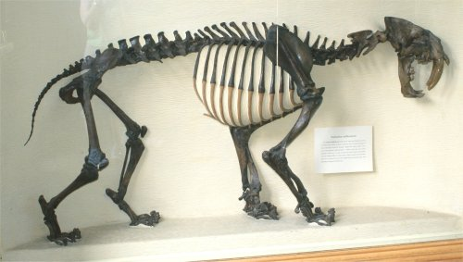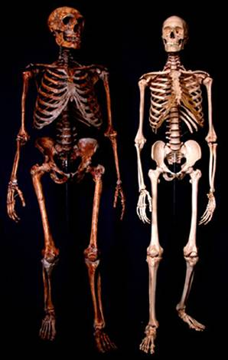

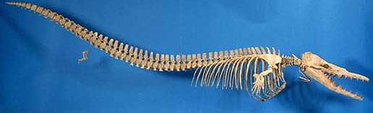



**Genus – Mammut**

Herbivore

Lived during the early Oligocene through to the end of Pleistocene/early Holocene

Found in Africa, North America and Central America

Known as ‘mastodons’

Robust skeletons and skulls

**Genus - Equus**

Evolved in Florida in the late Miocene and Pliocene Period

Fossil horst!

Went extinct in Florida and North America about 11,000 years ago and then reintroduced by the Spanish in 1500’s

**Genus - Dimetrodon**

Lived during the Permian Period

Name means “Two-measures Tooth”

Not a dinosaur but a pelycosaur

Lived before the dinosaurs

A carnivore

Had a spiny sail along its back

Walked on four, side sprawling legs

**Genus – Mammuthus**

Herbivore

Lived during the Calabrian through to Tarantian of the Pleistocene

Found in Canada, US, Mexico and Nicaragua

Mammoths!!

**Species – Smilodon**

Largest saber-toothed cat

Name means “Knife tooth”

Fierce predator – Carnivore

Smaller than the modern day lion

Lived during the Pleistocene Epoch

**Species - neanderthalensis**

Human’s closest extinct human relative

Bodies were shorter and stockier than ours and adapted to live in cold environments but their brains were just as large or larger than ours

Lived 200,000 – 40,000 years ago

Lived in Europe to central Asia

**Genus - Hyracotherium**

Herbivore

Lived during the Eocene period

Found in the Northern hemisphere

Seen as a primitive horse, still had toes rather than hooves, with 4 on the front feet and 3 on the rear feet

**Genus - Basilosaurus**

Lived during the Bartonian to Priabonian of the Eocene

Carnivore

Represents one of the earliest whales

Found in USA, Egypt, Pakistan

**Genus – Lystrosaurus**

Lacking teeth had 2 tusks that were thought to have been used to dig up the nutritious roots of plants

Herbivore

Found in South Africa, Antartica, China, India, Mongolia and Russia

Lived during the Late Permian to early Triassic