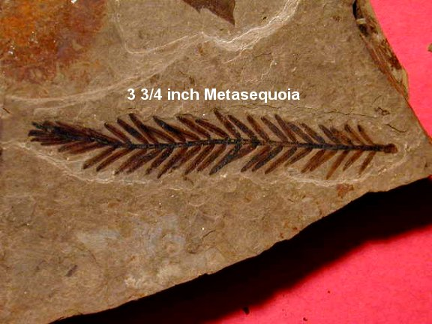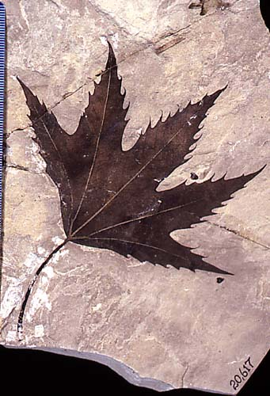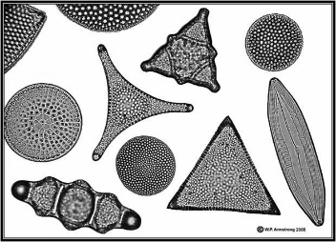

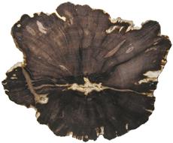

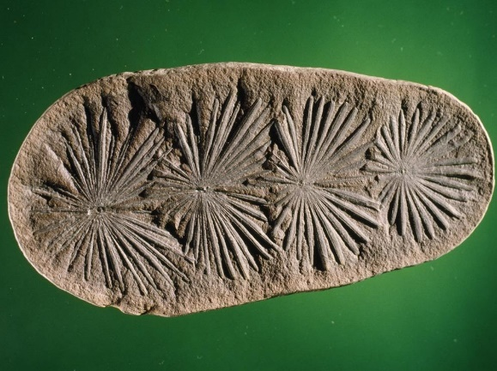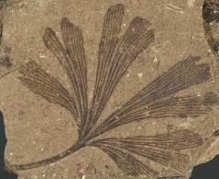

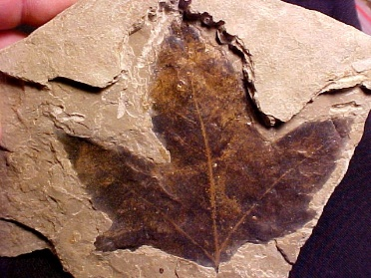

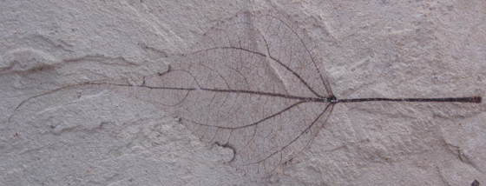

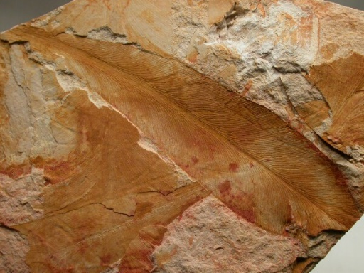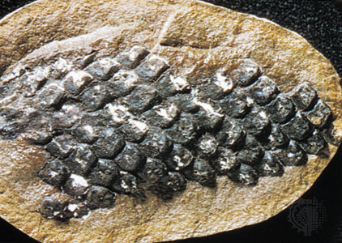

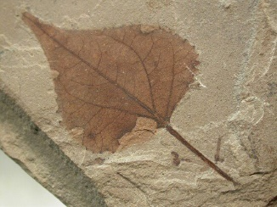



**Genus – Metasequoia**

Dawn Redwood is a conifer that shed its leaves e ery year

Fossils date back to the late Creteceous and occur all over the northern hemisphere

**Genus – Platanus**

Group of Angiosperms which is the are the figs

First appeared during the Early Cretaceous and then went under rapid adaptive radiation

They have flowers that develop fruits that allows the seed to be layered

**Class – Bacillariophyceae**

“Diatom” mean cut in half

Been around since lower Cretaceous

Major group of one-celle dalgae

Cell wall made of silica

Microscopic and able to carry out photosynthesis and found in both marine and fresh water environments

**Genus – Glossopteris**

Dated back to Permian and Triassic periods

Reproduced by seeds

**Genus – Calamites**

**Plant leaf Annularia**

Tree-sized spore bearing plants that lived during the Carboniferous and Permian periods

Stems were woody and connected by an underground runner

**Genus - Lepidodendron**

One of the most common plant fossils found in the Pennsylvanian age rocks

Extinct genus of tree sized lycopsid plants that lived during the Carboniferous Period

Grew up to 130 feet

As it grew it shed leaves from older parts of the stem

**Genus - Ginkgo**

Dates back to the Lower Jurassic

Plant that plays a crucial role in Chinese herbal medicine for many centuries

One species that is still surviving

Group of gymnosperms

**Genus – Populus**

Group of Angiosperms which is the cottonwood and aspen

First appeared during the Early Cretaceous and then went under rapid adaptive radiation

They have flowers that develop fruits that allows the seed to be layered

**Genus - Acer**

Group of Angiosperms which is the maple genus (Like maple trees!!)

First appeared during the Early Cretaceous and then went under rapid adaptive radiation

They have flowers that develop fruits that allows the seed to be layered