# Introduction

This is a study of the income distribution of students who took HKDSE public examination and the students who were admitted to HKU in 2015. We want to compare the distribution to see if it is true that students from family of higher income are easier to get to HKU.

We choose HKU because it is a well-known and international university. It would be representative enough for the study of university students in general. There are other famous universities in Hong Kong but to save the time of data mining, we only use one university.

# Results

* Assumption:
* All candidates who took HKDSE 2015 applied for HKU. (**74131**)
* The candidates’ household income distribution approximates the figures given by HK Government in 2015 Q1.
* As 586 of 3822 HKU 2015 undergraduates were non-local students, I will use the difference, **3236** as the total number of HKU undergraduates in the survey.
* Limitation:
* Students who got to HKU may not be HKDSE candidates.
* Not all HKDSE candidates applied for HKU.
* There were 3822 new students registered for a full-time undergraduate degree programme. Only 1,215 of them responded to the survey.
* 586 of 3822 were non-local students and so they were not HKDSE candidates. Their survey results were mixed with local students and so it is difficult to differentiate.
* The students who were not admitted to HKU may be due to other factors: choosing other universities, studying abroad or working. The assumption of all candidates applying for HKU is not that accurate, but it is for simple calculation of the odds ratio.
* Income distribution of HKDSE candidates and HKU undergraduates in 2015:

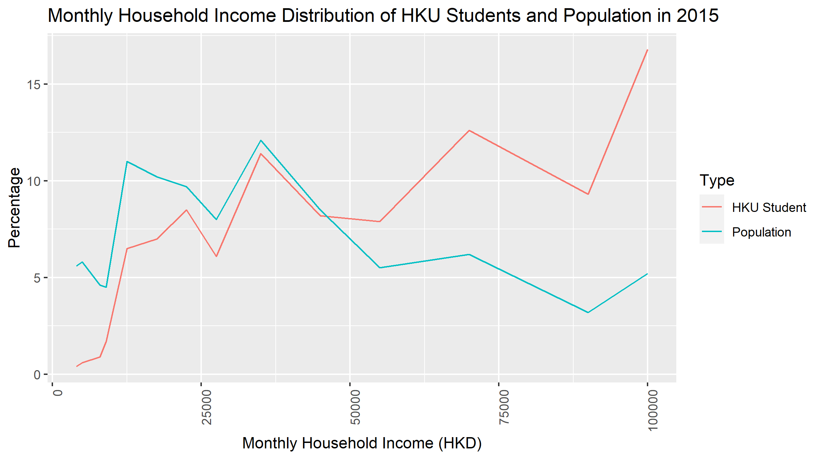

* 2016 Q1 median income is 25,000.

Define X = 0 if household income below 25,000. X = 1 if household income above 25,000.

Define Y = 0 if candidate does get to HKU. Y = 1 if candidate gets to HKU.

Odds of students getting HKU if they are below median income = 0.0222.

Odds of students getting HKU if they are above median income = 0.0693.

The ratio of the odds for students below 25,00 to the odds for students above 25,000

= 0.0222/0.0693 = 0.3205.

The result is much lower than one. It is statistically significant that students from poorer families were harder to get into HKU in 2015.