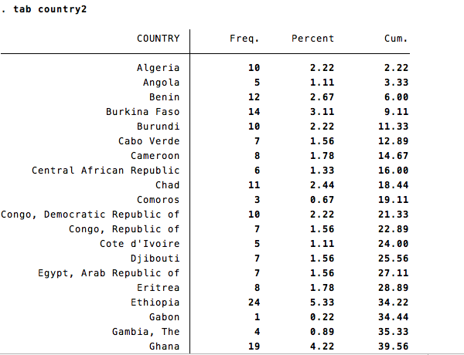

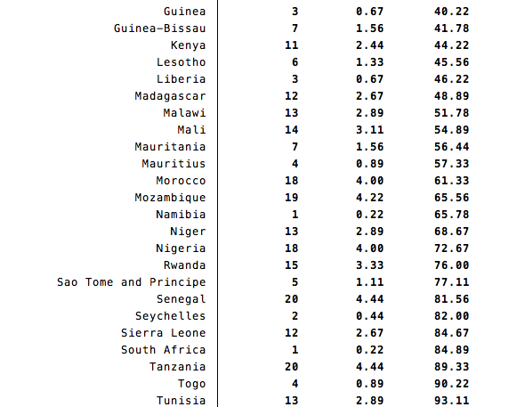

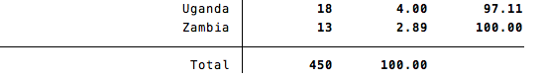

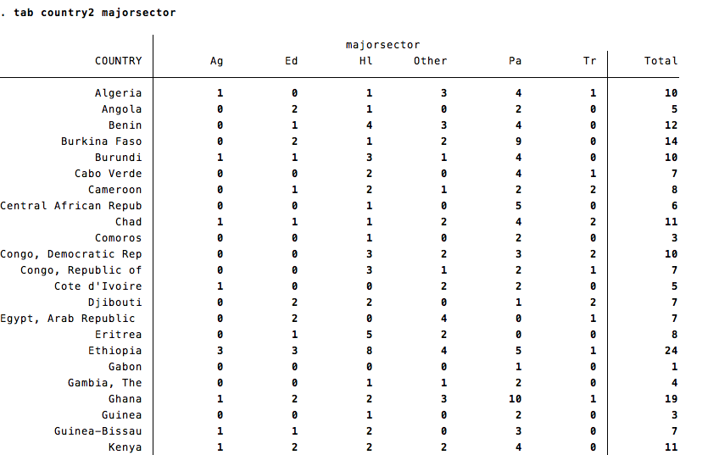

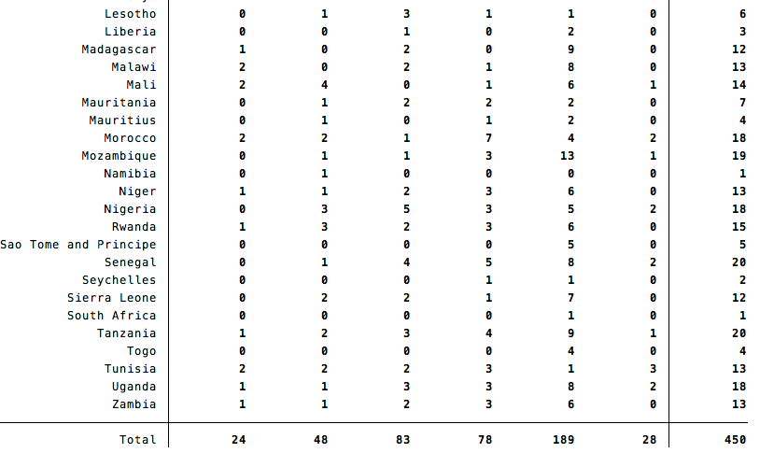

For reference:

Ag = Agriculture, fishing, and forestry

Ed = Education

Hl = Health and other social services

Other = Other sectors

Pa = Public Administration, Law, and Justice

Tr = Transportation