

**Functional Specification Documentation**

**DeTronics Pte Ltd**

**Version No.: 1.0**

**Date: 26-Sep-16**

**Table of Content**

1. Master Data Sync Program 2

# Master Data Sync Program

* 1. **Overview**
* Synchronization of Master Data including UDFs from SG database to HK database
* Scheduled job to run every 1 hour and option to run manually
* “Sync Status” UDF in SG database (Synchronized/Pending): Only sync “Pending” items
  1. **Item Master Sync**
* Whenever Item Master updated, status change to “Pending”
* After sync, change status to “Synchronized”

UDF:

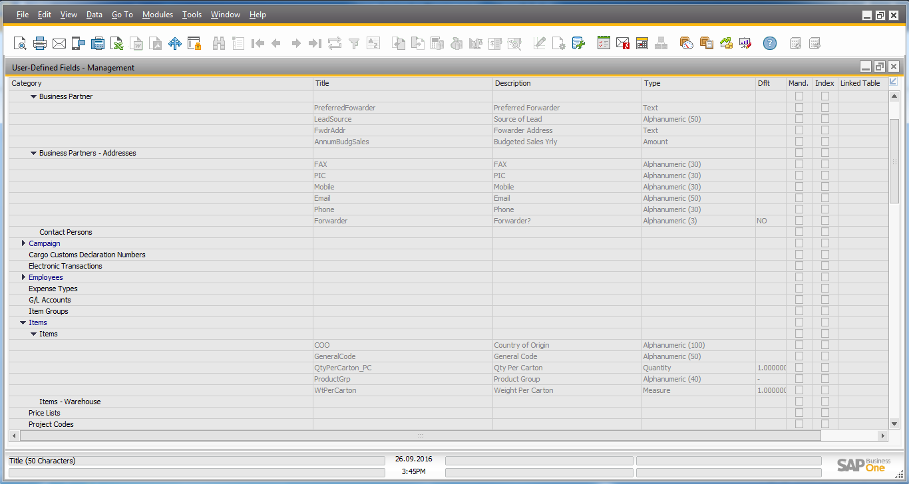

* 1. **Vendor Master Sync**
* Only applicable to “Trade” group **Vendor**
* Also sync related tables (Contact Persons, Addresses, Bank Details)
* Whenever Vendor Master updated, status change to “Pending”
* After sync, change status to “Synchronized”

UDF:



* 1. **Price List Sync**
* Only applicable to “Trade” group **Vendor** price lists
* Whenever price updated, status change to “Pending” for that row (“Sync Status” UDF is row level)
* After sync, change status to “Synchronized” for that row

UDF:

