Test 10
A tour is sent to the server with one waypoint. A new waypoint should apear in the database including id=18, walk id =8 and longitude and latitude values.
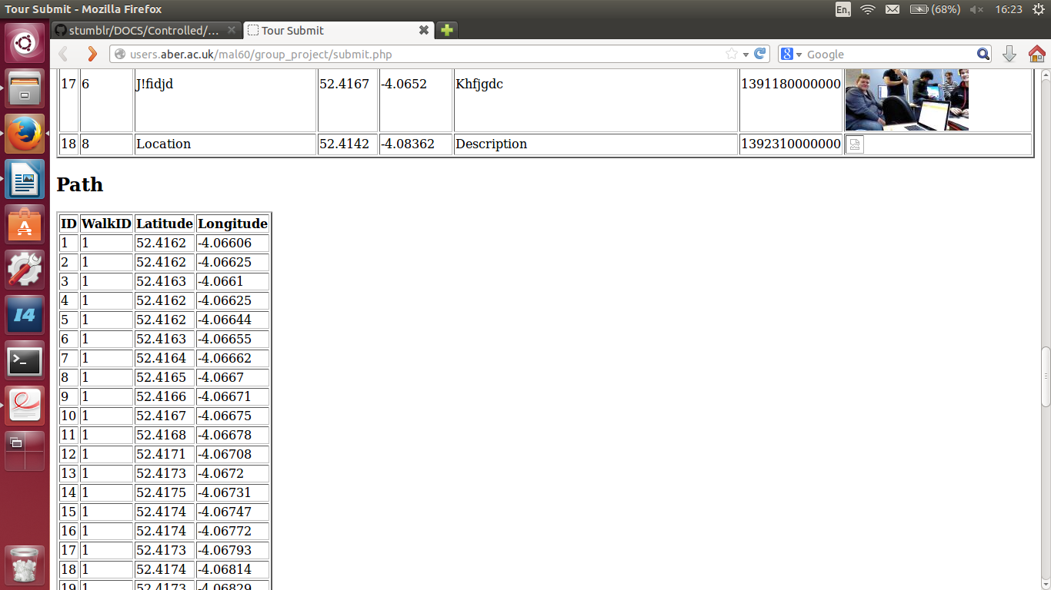
Test 11
A new tour is created and a new waypoint is attempted to add whilst having the GPS off.
Result- message is displayed telling the user to turn on their GPS and they're directed to the page to do this.

Test 12,14,15
New location added to a tour with the data: title “Test Location”, description “Test” and an auto generated timestamp. It should be displayed in the database with id=19.
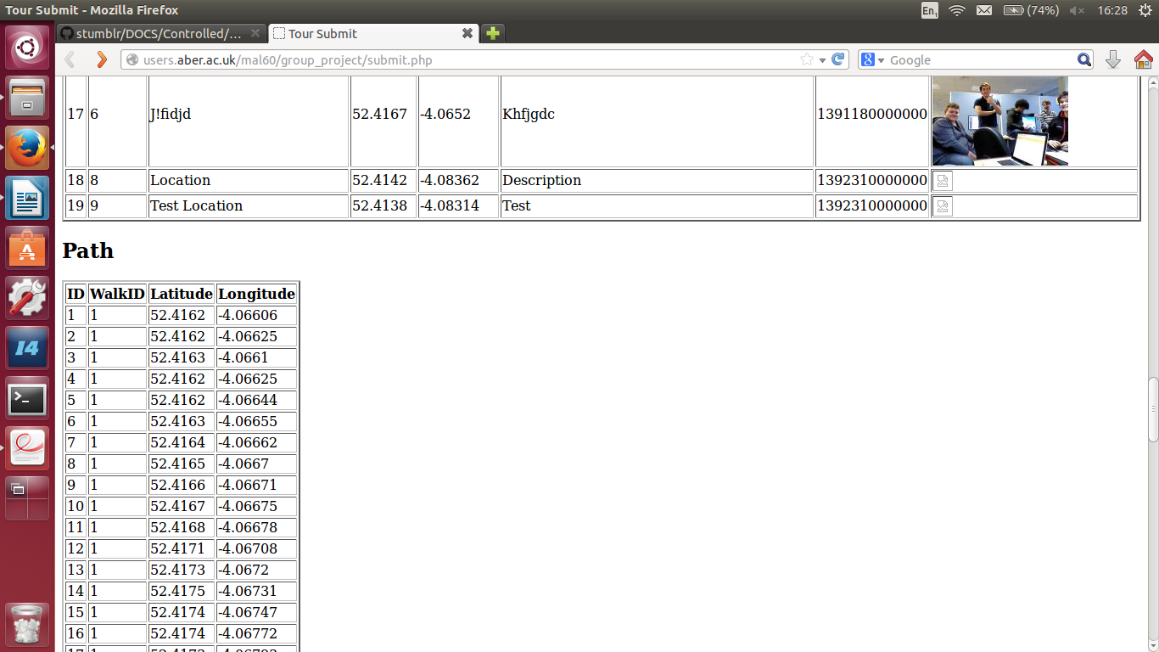
Test 16,17,18
Multiple photos added for one tour. Two images to be uploaded, with descriptions. Id's = 20 and 21. walk id = 10.
