**Data Analysis of the Doc Rivers Transition and the Impact on the Philadelphia 76ers**

**Alex Berger**

**Research Question Overview**

The Philadelphia 76ers have been on top of the standings and dominating the opposition in the 2020-2021 season to land them a consistent top-three spot in the NBA Eastern Conference. The 76ers have been placing top ten in the conference for the past three years but they have yet to make it to the finals, and their postseason struggles angered fans and the team. Brett Brown was the head coach for the team for several years before being replaced by Doc Rivers in hopes that Doc could push the team to the NBA finals where the 76ers have not been to since 2001. The 76ers have been a relatively young team for many years and still rose to the top on many occasions due to the play of Joel Embid, Ben Simmons, Tobias Harris, and some other key players; however, the 76ers roster was lacking experience. Doc Rivers’ coaching style and the new players Doc brought to the team helped the 76ers develop into the Eastern Conference leaders they are this season. Looking at some key player developments and the teams total stats both in defensive (rebounds, steals, blocks, etc.) and offensive (3pt%, FG%, assists, turnovers, etc.) from each game from the 2020-2021 season to see if Doc River’s coaching style of heavy defense and ball movement has helped give Philadelphia the edge.

Coming into the 2020-2021 season, with a new head coach and new star players to add to the previously already stacked starting roster, many people knew the 76ers were going to be a good team, but leading the East most of the season and being top ten in the league all season was surprising. Early in the 2020-2021 season, Philadelphia was on top of the conference with several early wins ending up with a record of 24-12 by the all-star break on March 7th. Winning like this hasn’t been seen from the 76ers in years and the introduction of Doc Rivers and the excelling playing from Tobias Harris and Joel Embid is to credit. The 76ers were awful from the 2013-2014 season up to the 2017-2018 season finishing 14th three times and 15th one time in the Eastern Conference. They were struggling until Joel Embiid started his NBA debut in 2016, though only playing 31 out of 82 games due to injury, he averaged over 20 points per game. The 76ers really did not hit their stride until the 2017-2018 season because previously the 76er’s core organization players could play, Ben Simmons was out the year before due to injury, and Joel Embiid was injured as well. Under Brown; however, Embid and Simmons did give hope back to the franchise leading the 76ers to place third in the eastern conference two seasons in a row (2017-2019). Embiid has proven to be a catalyst for a 76ers victory but he cannot do it alone and not having the proper support becomes more of an issue in the high-intensity playoff games that they have been going to. Embiid, since his NBA debut, has shown his potential and delivered on the promise to bring Philadelphia back to being feared. Having one of, if not the best, center in the league proves to be a major component to the 76ers’ recent success.

Players are undoubtedly the most important reason for success in a sports organization, but the head coach is the glue that holds the team together and allows the players to perform at their most efficient and best. Doc Rivers is what many believe him to be is the glue that will hold the 76ers into a long playoff run and he has been proving that he can run the team and he has proven that he can make choices for the team that will help success. Doc Rivers’ coaching philosophy can be reduced to one word, “Ubuntu.” Ubuntu comes from the Zulu phrase "Umuntu ngumuntu ngabantu," which translates to, "a person can only be a person through others." According to South African Archbishop Desmond Tutu, "Ubuntu is the essence of being human. It speaks of the fact that my humanity is caught up and is inextricably bound up in yours. I am human because I belong." It was a concept championed by Nelson Mandela and referenced by Barack Obama in his 2013 eulogy for the legendary South African leader.

According to Tobias Harris, who played for Rivers in the past for the Los Angeles Clippers, “I think it’s more what he gets out of the whole group because I’m the type of player that my game can fall in line and whatever the coaches ask for me, I can get done. What he’s asking of this team is to play [the] right way, move the basketball, play with another, use your teammates, really be a collective group (sixers wire)”. A result of playing together is creating turnovers when playing defense and on offense making the extra pass (i.e. generating assists) to the open player for an easy score. Both stats, defensive turnovers, and assists can be used as the main factor in winning games.

Rivers has already shown to be more interactive in games and in practices than his predecessor Brown, according to NBC Sports and from an interview with Simmons; “Rivers also doesn’t mind motivating his players through direct criticism. In his first game back after having surgery on his left knee in August, Simmons wasn’t pushing the pace to Rivers’ liking in the first quarter. Rivers “jumped up” to make it known that walking the ball up the floor was unacceptable, “I love that,” Simmons said. “I was just trying to get my legs under me, so that first quarter, it was tough. Once I found them, we got into a flow. I think we went on a stretch where we got five defensive stops in a row and pushed that lead early. But overall, I love that Doc’s going to make me be aggressive and tell me to push the ball (NBC Sports)”. From a lot of angles, Doc seems to be doing his part in pushing the 76ers team to the next level that they could not reach with Brown and that is in thanks to the way Rivers made his transition to Philadelphia and the new player he contracted over to the team. In November of 2020 Rivers accepted the role as head coach of the 76ers and that same month made some of the biggest changes to the team, not only did Rivers hire new staff but more importantly made some trades that really changed the team. Rivers signed a lot of older players that in hopes would mature the rest of the team with a lot of the mole modeling coming from the other big man Dwight Howard, Rivers also traded Josh Richardson and Al Horford for Danny Green and Seth Curry, two prominent long-range shooters.

**Source Description**

The data being used for this report is from *Basketball-Reference* which is part of *Sports-Reference* an independent company from the NBA that tracks a wide range of statistics from a variety of different sports. That data collected for *Basketball-Reference* is provided by *Sportradar*, an official stats partner of the NBA and other sports such as the MLB, NHL, and NFL; their extensive data coverage includes more than 60 sports and 390,000 annual games worldwide. As Stated on *Sportradar*:

Sportradar is the leading global provider of sports data intelligence. The nexus between sports and entertainment, we serve leagues, news media, consumer platforms, and sports betting operators with deep insights and a suite of strategic solutions to help grow their businesses. As a trusted partner of more than 1,000 companies in over 80 countries, Sportradar serves as the official partner of the NBA, NHL, and NASCAR as well as FIFA and UEFA. It is also the only provider entrusted to work with the US sports leagues in an official capacity to distribute sports data (NBA and NHL) around the world for betting purposes. The company monitors and delivers insights from more than 400,000 matches annually across 60 sports categories, having developed the industry’s most proficient software while setting new standards for speed and accuracy. With deep industry relationships, we aren’t just redefining the sports fan experience; we also safeguard the sports themselves through our Integrity Services division and advocacy for an integrity-driven ecosystem that is fair to partners, players, and fans(Sportradar).

The website and data source for this report, *Basketball-Reference*, first launched in April 2004 by Justin Kubatko. The *Sports-Reference* sites first launched in April of 2000 with *Baseball-Reference* created by the current president of the company, Sean Forman. I found this data site by just searching the internet for reliable data on the NBA across all teams and years, this website was chosen mainly for the ability to download each data set to a CSV file that I could in turn work statistical analysis on. The data collection process is through the official NBA which is collected through each team’s analytics department through the process of cameras tracking playing and ball movement and data collectors on the sidelines collecting box score stats for each player. The data itself is very accurately collected and from a proven reliable source, and while possessing a very small amount of missing data making these data sets suitable for statistical analysis. The data set being analyzed is from the 2020-2021 NBA season with data from both the Philadelphia 76ers’ and their opponent for that game and all the box score stats from each team. Each observation in the data is each player on the 76ers team and variables being used in the data analysis are; games played, games started, minutes played, field goals, field goal attempts, three-points, three-point attempts, two-point field goals, two-point field goal attempts, effective field goal percentage, free throws, free throw attempts, offensive/defensive rebounds, assists, steals, blocks, turnovers, personal fouls, and points. The data collected was brought from *Basketball-Reference* to an Excel spreadsheet because it was easier to copy the CSV version of each game’s box scores from each team. The CSV version was copied onto a notebook and then opened in Excel where the columns ‘Game’, ‘Team’, and ‘Win’ was added.

**Analysis**

In this section I will, using PythonTM generated data visualizations, illustrate the importance of key NBA basketball data in determining the outcome (i.e. win or loss) of games. The datasets used are from game box scores of the current NBA season in which the Philadelphia 76ers played.

One obvious initial assumption made famous by legendary football coach John Madden, “Usually the team that scores the most points wins the game.” Figure 1 below confirms the team with the most points will always win.

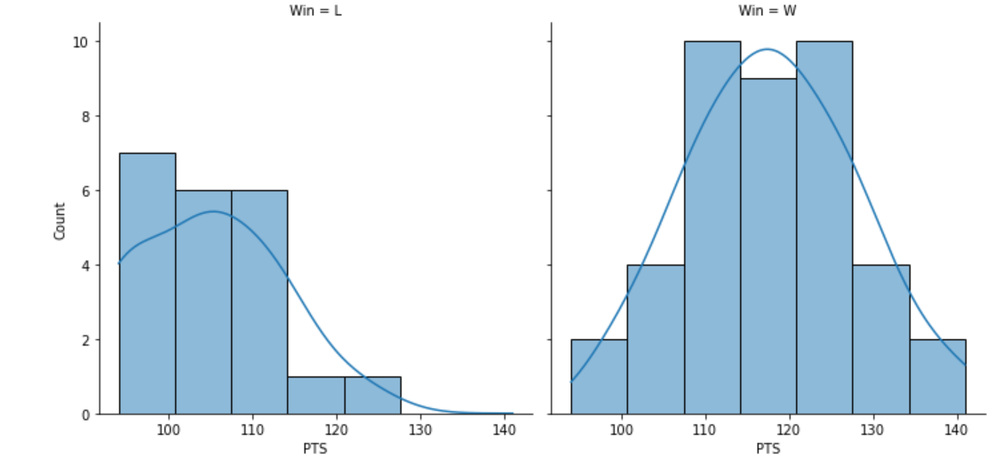

Now I will further analyze data which, according to Coach Rivers and his “Ubuntu” team-first philosophy, plays a major role in scoring more points than the opponent. The first important team category in basketball data is the assist. An assist in basketball is defined as a pass that leads directly to a made basket. You cannot have an assist without points being scored and the ball must be passed directly to the player who scores. As evident from Figure 2, assists lead to more points being scored. And for those games which resulted in a win, assist totals were higher which led to more points being scored. However, why are more points being scored? In general, assisted points is a promotor of teamwork by passing the ball to “open man” who has a better chance of making the sot rather than taking the shot yourself. Figure 3 gives an alternative visualization confirming the importance of assists.

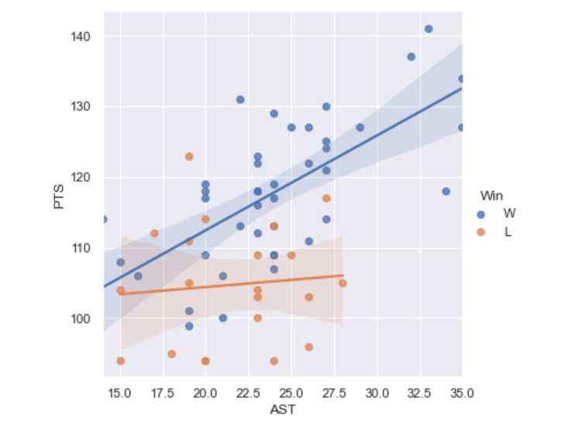



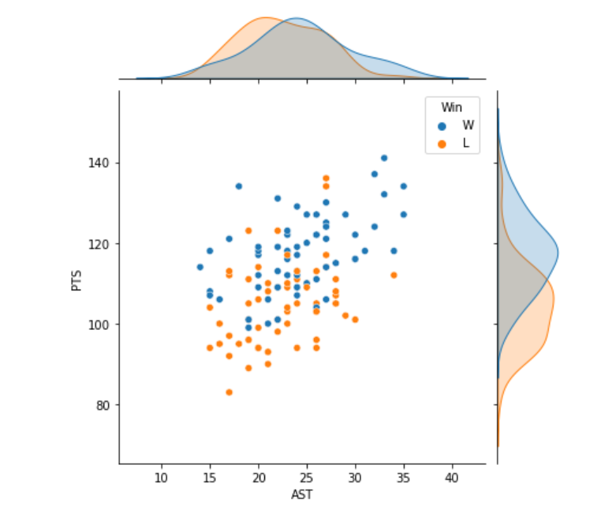

During a basketball season, one will frequently see a headline like, "Turnovers Cost Game" or "Turnovers Costly in Loss". When TV analysts discuss a loss, the number of turnovers is one of the first categories they investigate. A turnover in basketball is whenever a team loses possession of the ball and the other team gains possession. Therefore, a turnover results in a lost, wasted possession without an opportunity to score points. However, can turnovers be directly attributed to a loss of points and games? And conversely, can team defense, another component of Coach Rivers’ fundamentals, force the opponent into turning the ball over leading to more possessions which, in turn, result in more points? Figure 4 attempts to answer that question. It is clear more points are being scored when the 76ers win; however, defensive forced turnovers are not a contributing factor in scoring more points.

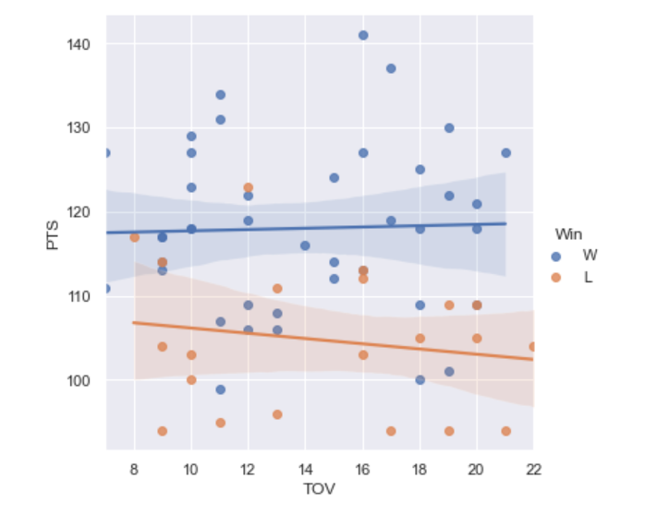

One final data analysis I performed was to determine if scoring is distributed among multiple players. Since assists, by its definition, involves teamwork, spreading points across multiple individuals would be in line with that thought. By the scoring distribution graphed in Figure 5, scoring is indeed not limited to one player but contributed by three teammates. Again, we see “Ubuntu” in action; playing as a team.

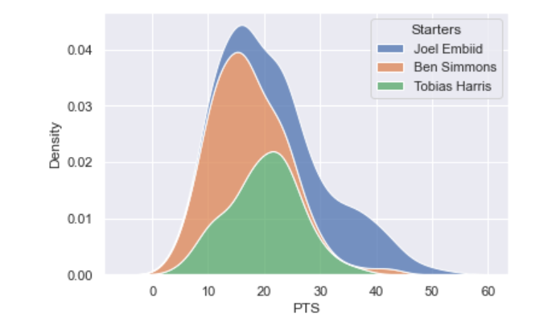

**Discussion**

After several “almost” seasons, the Philadelphia 76ers’ decided to make a coaching change for the 2020-2021 season with the hiring of World Champion coach Doc Rivers. Many began seeing visions of future championships even before one game being played under the new coach:

*“Listen, this is going to put a lot of pressure on Ben and Joel. Because how many years have y’all been blaming everything on Brett Brown? For the last three or four years. Well, now Brett Brown is no longer here, Doc’s got a great pedigree, I like Doc a lot as a person, I think he’s a good coach, so now there’s no more excuses for these people calling in and bashing on Brett Brown.” -- Charles Barkley*

*“Welcome to the city of Brotherly Love Coach @DocRivers !!!! Excited for the future and what we’re building here” -- Joel Embid*

*“I fell out of my chair! I was like, ‘Whoa! Man, that’s awesome,’” Erving said. “I am amped – absolutely – that he is the coach of the Sixers.” – Julius Erving*

However, these “experts” are not data analysts. So now that the season is nearly complete and we have datasets of collected game data, courtesy of www.basketball-reference.com, we again ask, “Has Doc Rivers, and the introduction of his “Ubuntu” philosophy, led to a positive change for the Philadelphia 76ers, since becoming the head coach?” Table 1 below presents the mean of key basketball team data for last season (2020) under then Coach Brown and this season (2021) under new Coach Rivers. One can see that the addition of Coach Rivers has had no significant positive increase. (NOTE: Free throw scoring is the only exception. Free throws attempted/made are scoring opportunities for one player without involvement from teammates).

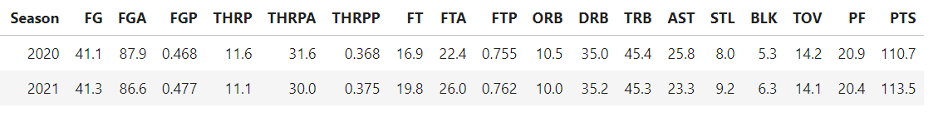

What will be the outcome for the Philadelphia 76ers this year? Will they win the NBA championship which has alluded them for decades? The 2020 season was a “failure” in the eyes of many; however, Coach Doc Rivers and his team are looking to defy similar analytics this year and bring home the title as many have hoped from the day he was hired.

**Works Cited**

2020-21 Philadelphia 76ers roster and stats. (n.d.). Retrieved May 05, 2021, from <https://www.basketball-reference.com/teams/PHI/2021.html>

About Sportradar. (n.d.). Retrieved May 05, 2021, from <https://sportradar.us/about-us/>

Carlin, K. (2021, January 07). Tobias Harris explains how Doc rivers has helped SIXERS SUCCEED. Retrieved May 05, 2021, from <https://sixerswire.usatoday.com/2021/01/05/tobias-harris-explains-just-how-doc-rivers-has-helped-sixers-succeed/>

Grossman, D. (2017, July 04). Philadelphia 76ERS: Could 76ers be the best team in the Atlantic division? Retrieved May 05, 2021, from <https://bleacherreport.com/articles/1014375-philadelphia-76ers-could-76ers-be-the-best-team-in-the-atlantic-division>

How NBA Analytics is Changing basketball: Merrimack college. (2020, June 25). Retrieved May 05, 2021, from <https://onlinedsa.merrimack.edu/nba-analytics-changing-basketball/#:~:text=The%20NBA%20also%20has%20gone,players%2025%20times%20per%20second>

Levick, N. (2020, December 16). Early signs of a key difference between rivers and brown. Retrieved May 05, 2021, from <https://www.nbcsports.com/philadelphia/sixers/sixers-celtics-nba-preseason-doc-rivers-ben-simmons-shake-milton-brett-brown>

N. (2020, October 28). 76ers hire Doc Rivers as head coach. Retrieved May 05, 2021, from <https://www.nba.com/news/76ers-hire-doc-rivers-head-coach>

Pompey, K. (2021, April 16). The Clippers are NBA TITLE contenders, Thanks in no small part to Doc Rivers: Keith Pompey. Retrieved May 05, 2021, from <https://www.inquirer.com/sixers/76ers-clippers-doc-rivers-tyronn-lue-20210416.html>

Powell, S. (2021, April 06). 76Ers prove they can stand tall, even without big man Joel Embiid. Retrieved May 05, 2021, from <https://www.nba.com/news/76ers-prove-they-can-stand-tall-even-without-joel-embiid>

Ryan, M. (2020, September 22). The playbook: WHY Doc Rivers Says Ubuntu led him and the 2008 Celtics to an Nba title. Retrieved May 05, 2021, from <https://sports.yahoo.com/playbook-why-doc-rivers-says-072245595.html?guce_referrer=aHR0cHM6Ly93d3cuZ29vZ2xlLmNvbS8&guce_referrer_sig=AQAAADlioH-MTb5DGt9b7ND4z5wLpy3gwqG1a1d9BA8Fgaln4vJ_PUwkAi9eUni2IpfIVbbfSwreouIYYiGlhICts89lSYFMX92AI3CwseBifS13INDGZs1og1G7yRKrW-KA4qF5stfMv-PWUyLegxiK-FTt6nu1j53NZfPoXISkn4_P&guccounter=2>

Smith, D. (2021, January 05). Sixers: Why Doc rivers may be the best thing to happen to Tobias Harris. Retrieved May 05, 2021, from <https://hoopshabit.com/2021/01/05/sixers-doc-rivers-tobias-harris/>

Spears, M. J. (2018, November 30). Doc rivers: What I've learned in 20 seasons as an NBA head coach. Retrieved May 05, 2021, from <https://theundefeated.com/features/doc-rivers-what-ive-learned-in-20-seasons-as-an-nba-head-coach/>

Staff, N. (2021, March 05). 2021 midseason Report: Philadelphia 76ers. Retrieved May 05, 2021, from <https://www.nba.com/news/2021-midseason-report-philadelphia-76ers>

Washington, S. (2021, March 27). The Philadelphia 76ers are the best team in the NBA. Retrieved May 05, 2021, from https://thesixersense.com/2021/03/27/philadelphia-76ers-best-team-nba/