Setting Up GitHub, Git Repository, GitEye, and Eclipse

[GitHub] Make sure you’ve obtained a GitHub account and a free micro plan.

[GitHub] Sign in to https://github.com

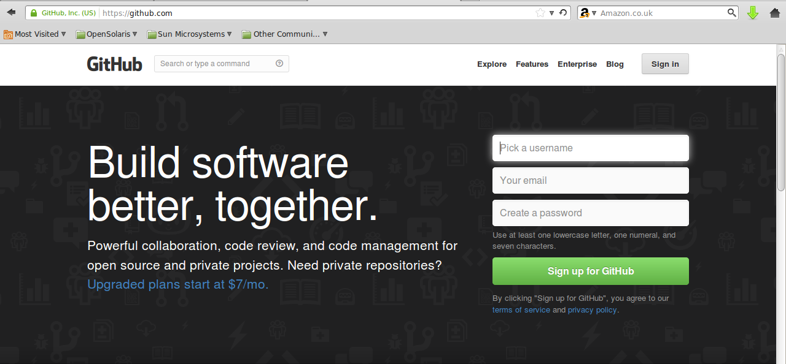

Repository Manager

1. [GitHub] Create a New Repository, give it a preferred / agreed project name, set it to private repository, don't tick 'Initialize this repository with a README' or add any .gitignore / license!

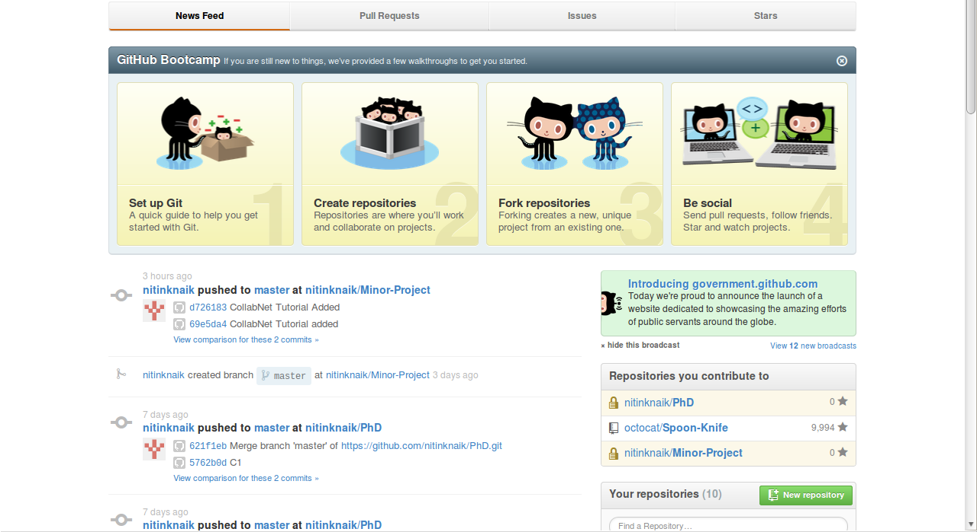
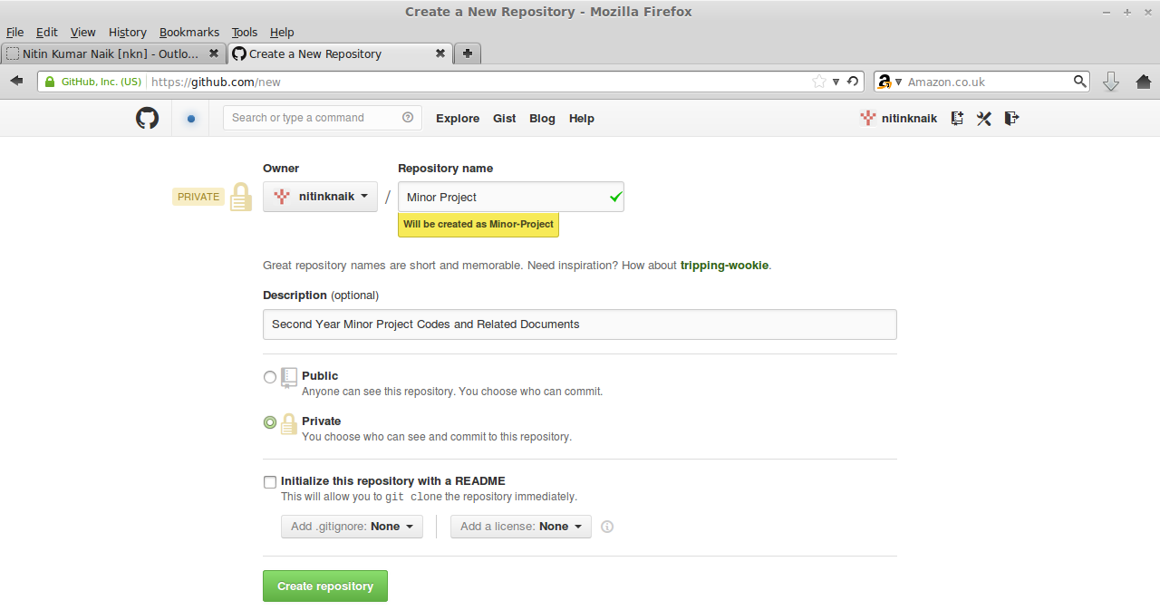

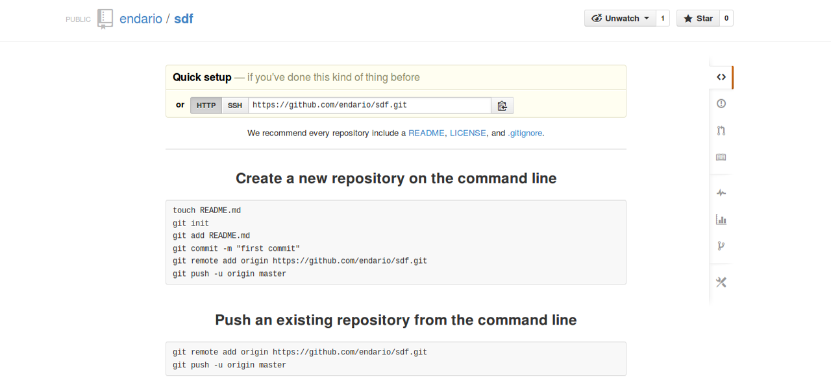

2. [GitHub] Go to Settings (the icon on the right hand side with a spanner) -> Collaborators, and add the usernames of all your team members as collaborators ... and done!

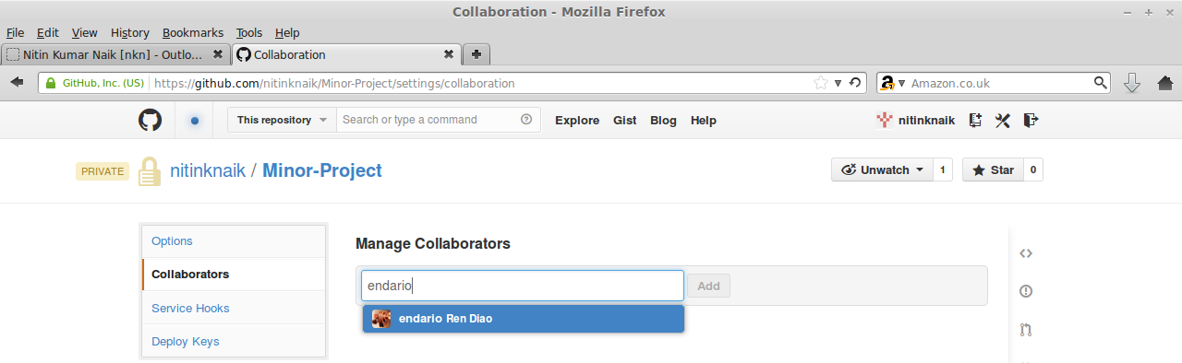
3. [Local] Unzip the repository provided (project.zip) to a preferred local directory

4. [GitEye] Open GitEye, located in /usr/local/giteye/GitEye

5. [GitEye] Click 'Add an existing local Git repository'

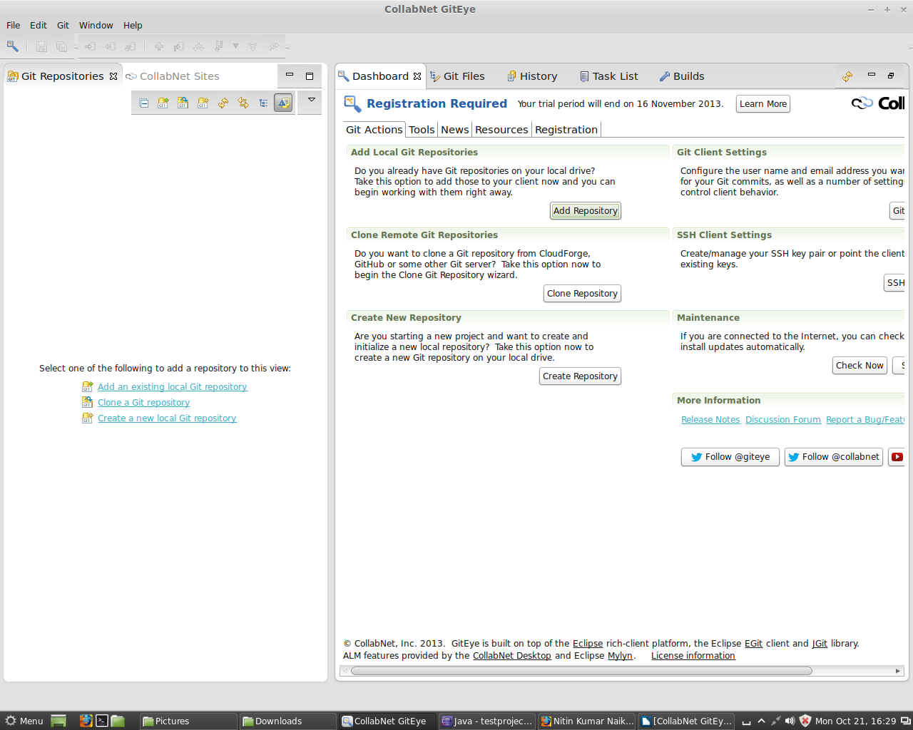

6. [GitEye] Browse to your local Git repository, click OK -> Finish

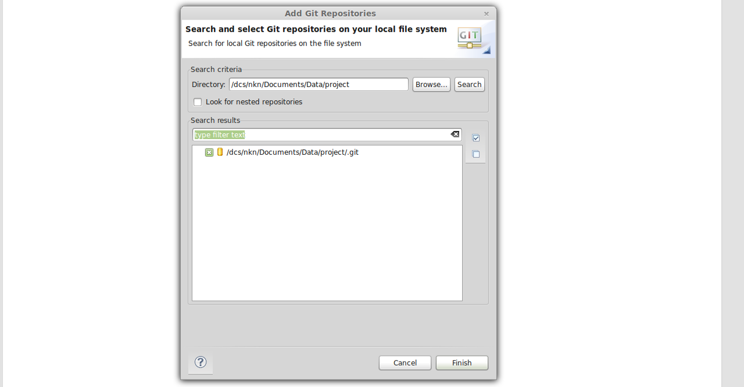
7. [GitEye] Expand the repository tree (click OK when prompted to add a .project file)

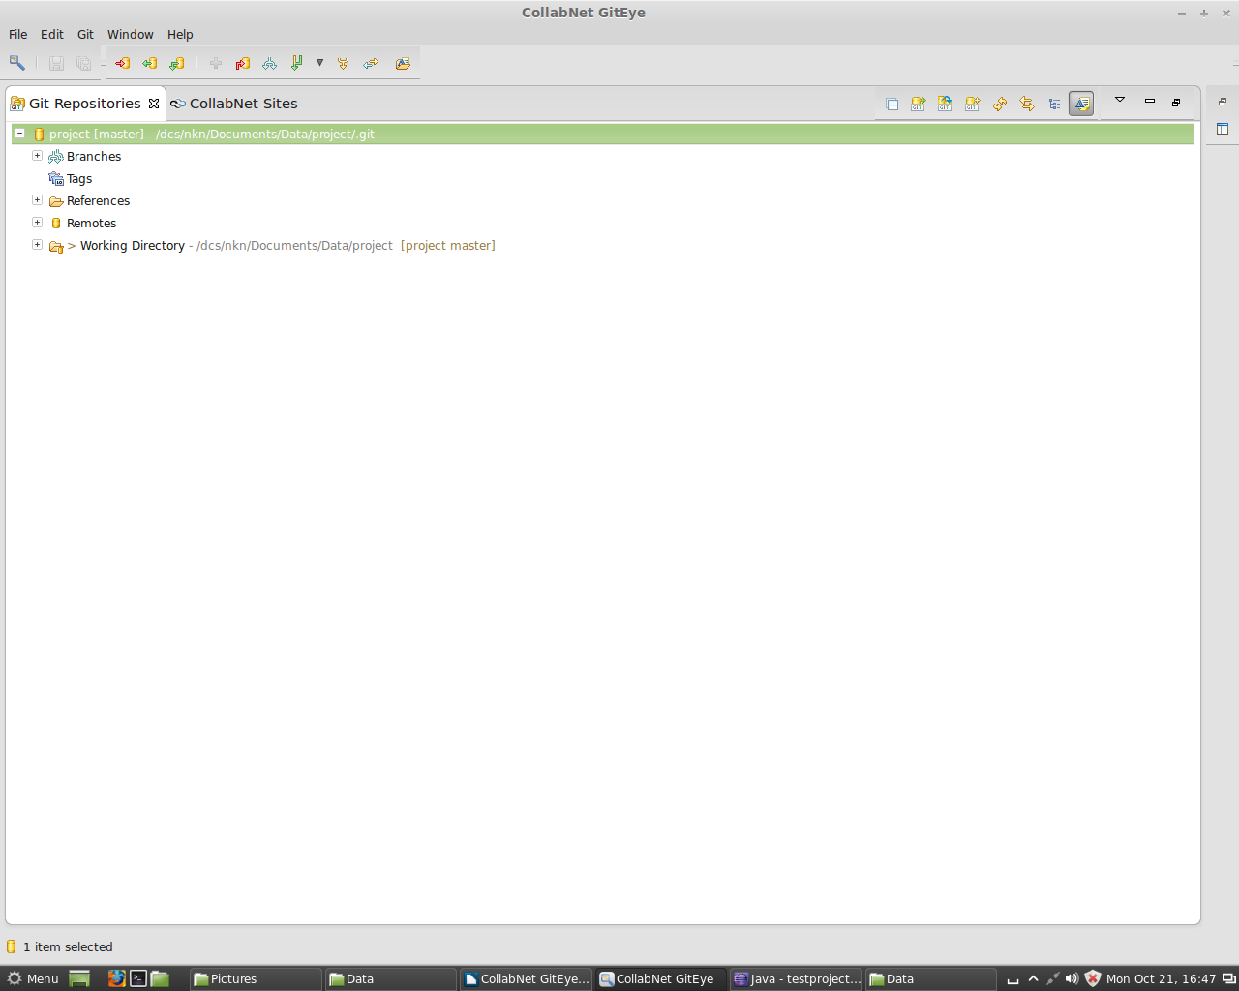

8. [GitEye] Expand 'Remotes', right click 'origin', select 'Configure Push...'

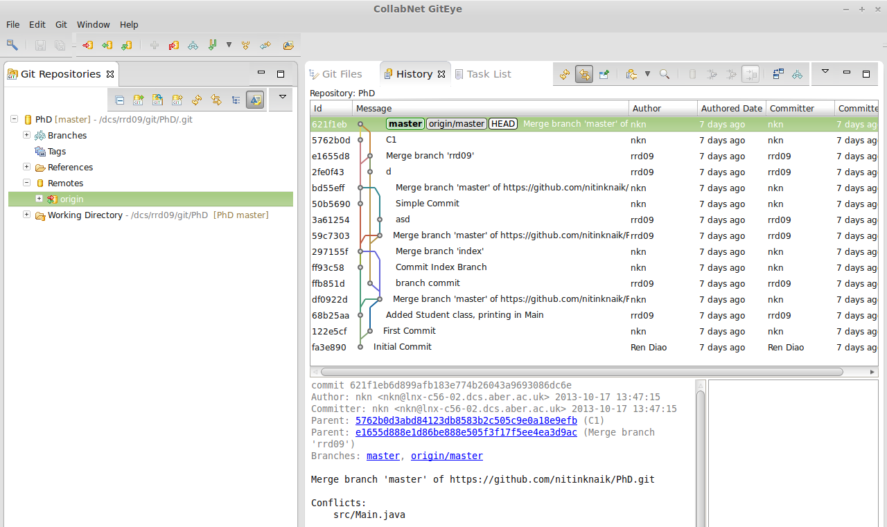

9. [GitEye] Click 'Change'
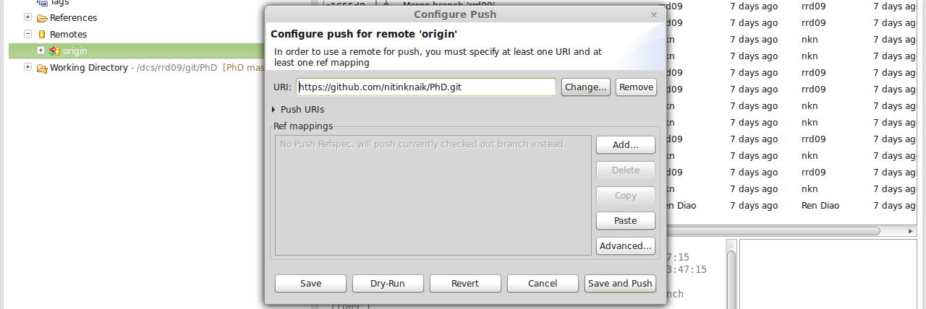
10. [GitEye] Enter your GitHub repository's URL (instead of https://github.com/username/projectname.git), fill in your GitHub authentication details, and click 'store in secure store', and set a master password when prompt. Finally, click 'Finish', then 'Save and push'. (If you clicked wrong, go to top level directory and select 'push changes to upstream').



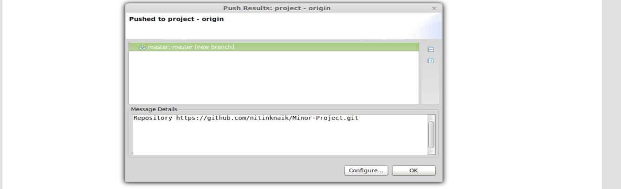

Team Members

1. [GitEye] Open GitEye, located in /usr/local/giteye/GitEye
2. [GitEye] Click 'Clone a Git repository' -> 'Clone URI' -> 'Next'

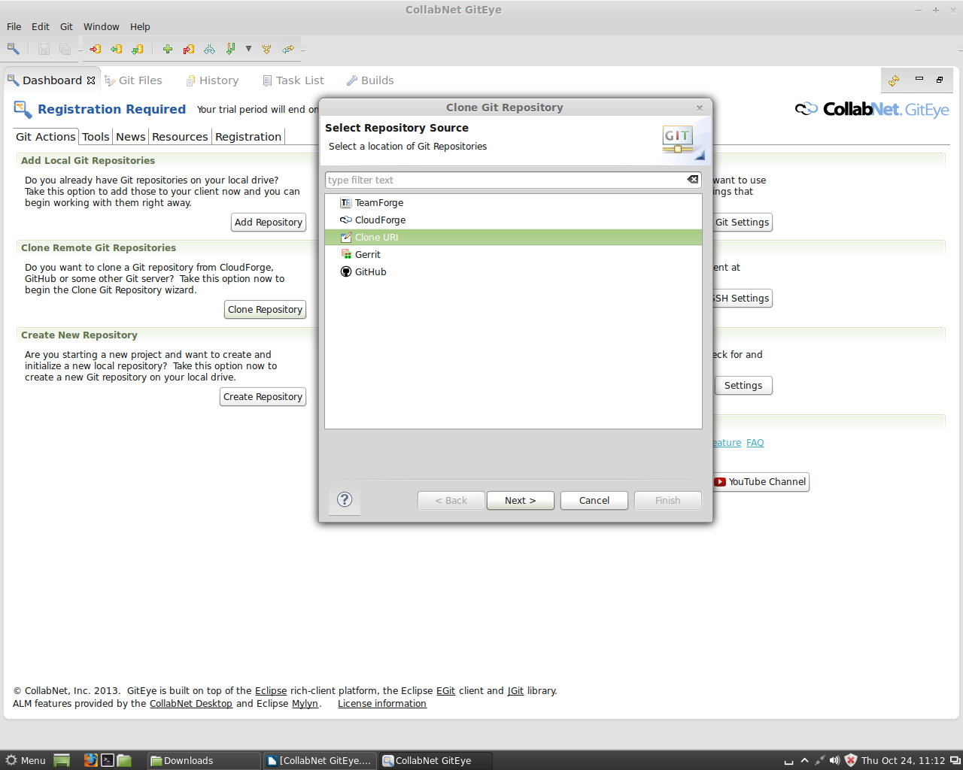
3. [GitEye] Enter your team's GitHub repository URL (instead of https://github.com/username/projectname.git), fill in your GitHub authentication details, and click 'store in secure store', and set a master password when prompt.

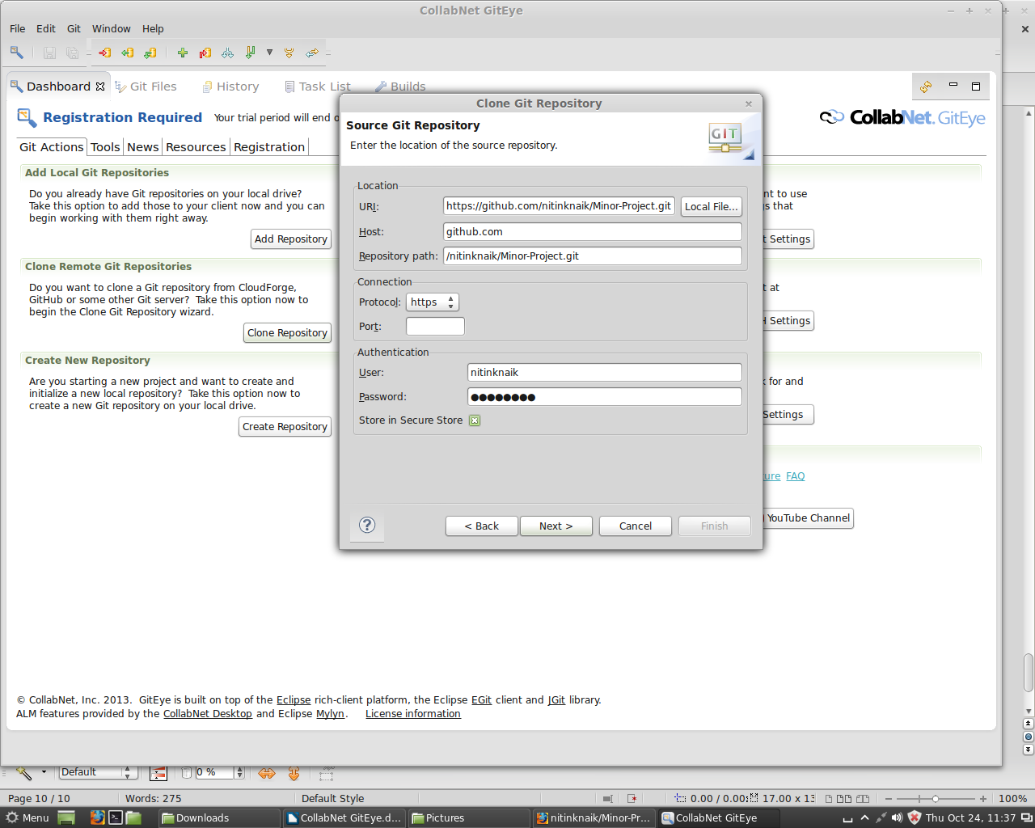
5. [GitEye] Branch selection = master

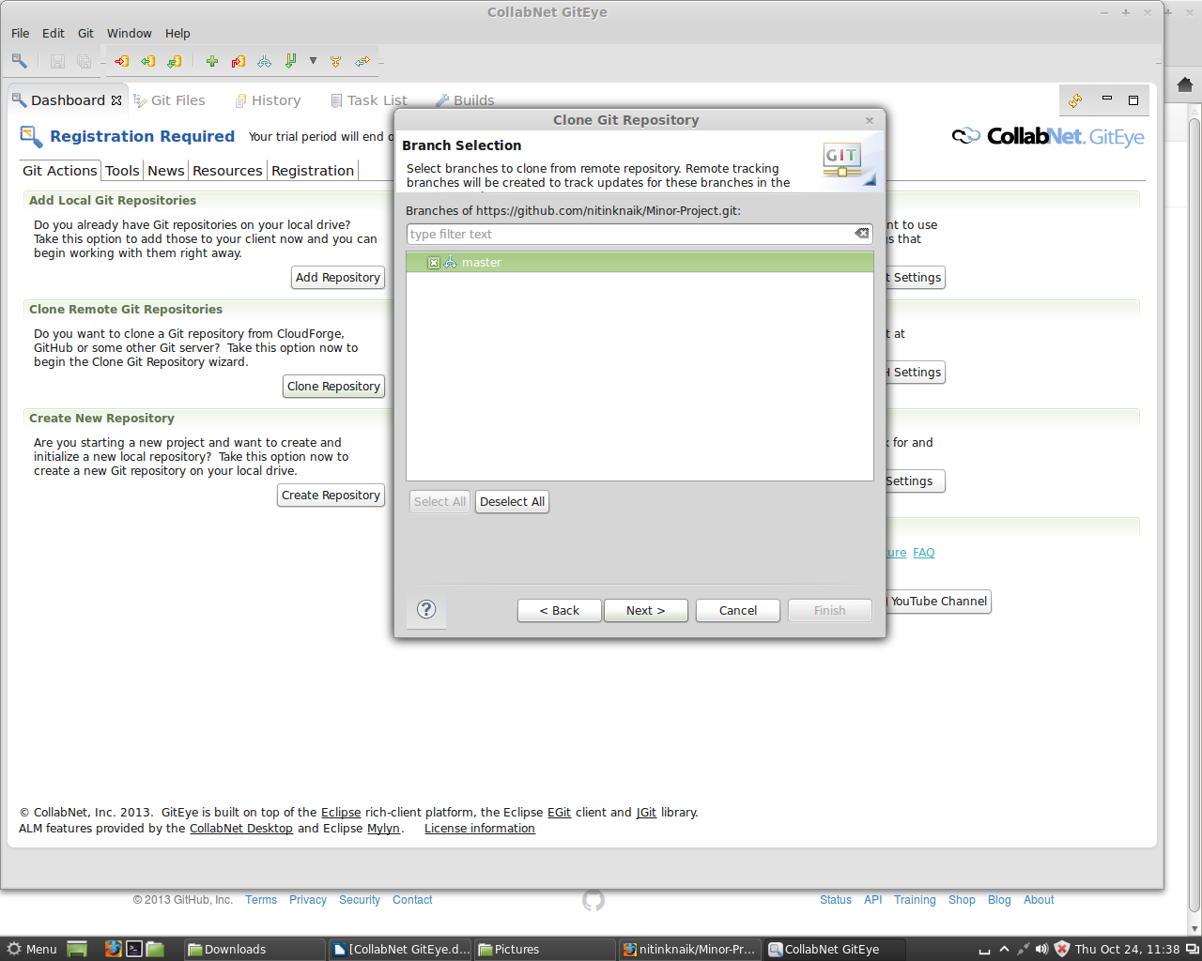
6. [GitEye] Set Destination -> Directory to a preferred local directory

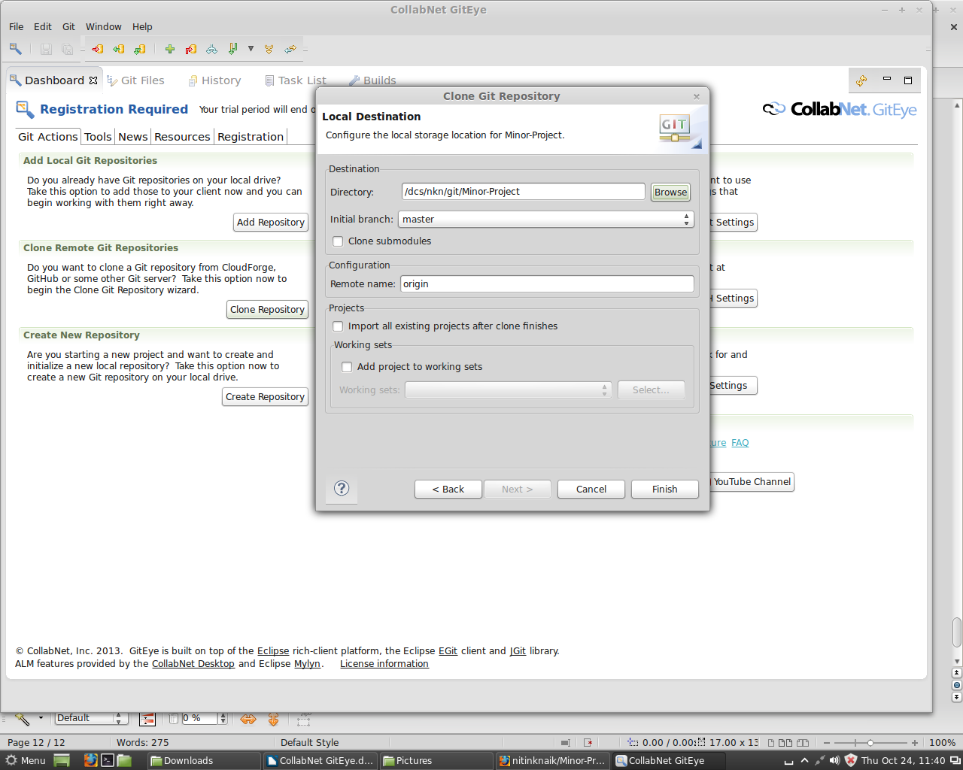
7. [GitEye] Click 'Finish' and done!
Everyone

You may now add any files (such as group meeting minutes, Java source) into the corresponding folders in your local Git repository.
1. [Eclipse] Open Eclipse

2. [Eclipse] File -> New -> Java Project

3. [Eclipse] Project name = any preferred name

4. [Eclipse] Un-tick ‘Use default location’
5. [Eclipse] Browse to your local Git repository folder -> /src

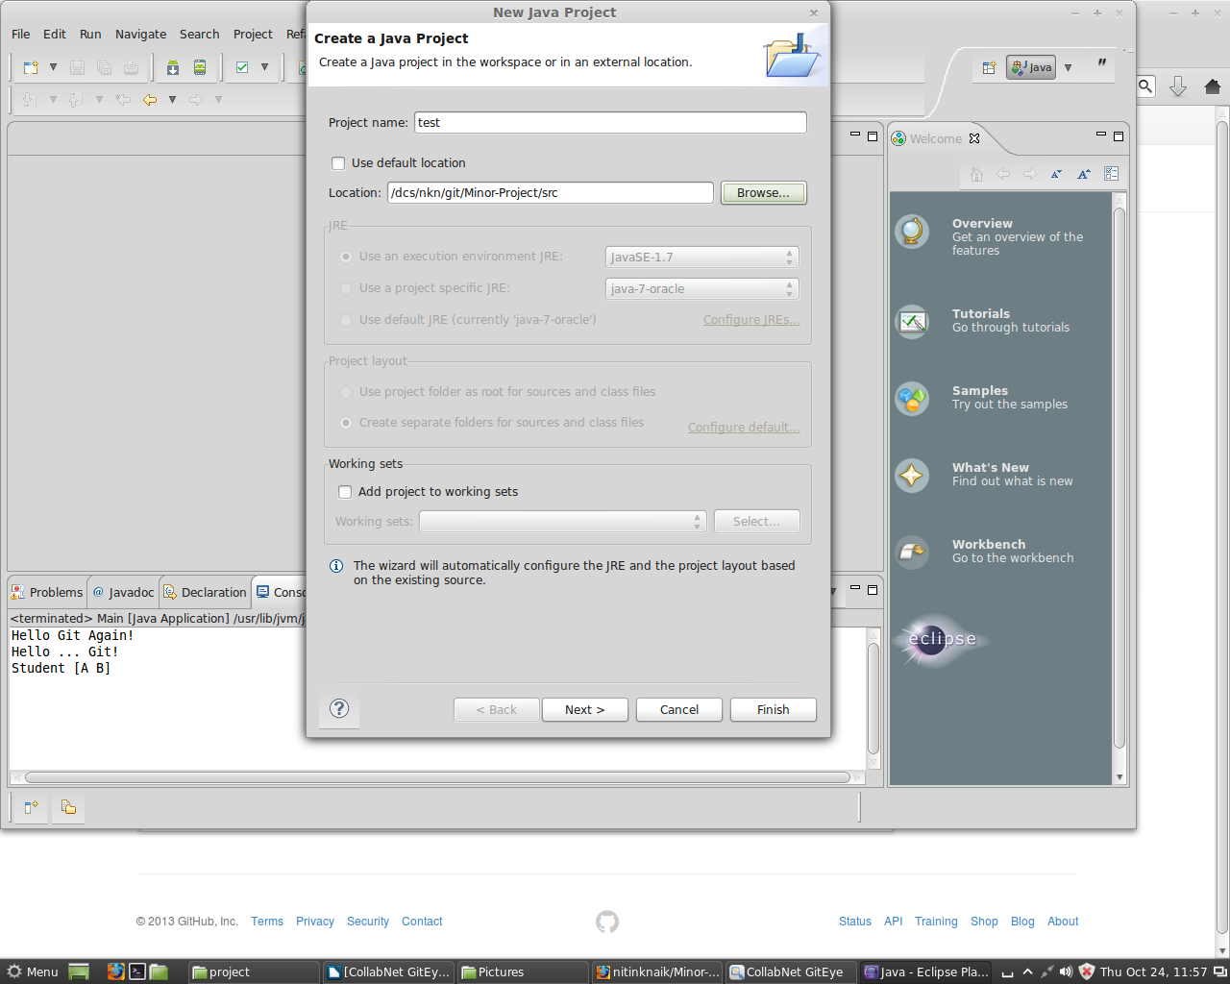
6. [Eclipse] Click OK -> Finish
7. [Eclipse] Test the dummy program (should print to system.out "Hello Git …")

