# Installation of GIT

GIT is a distributed version control and file management system.

You can download the GIT from the following website:

<http://git-scm.com>

Once you open this website you will find this screen:

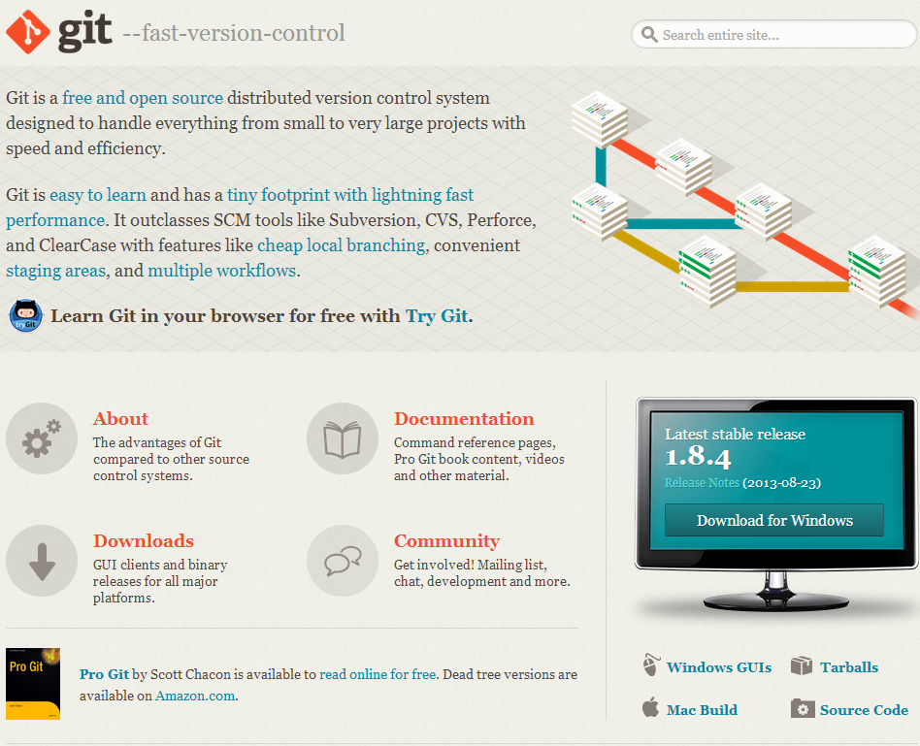

Run the downloaded EXE file and select the following components shown in the figure:

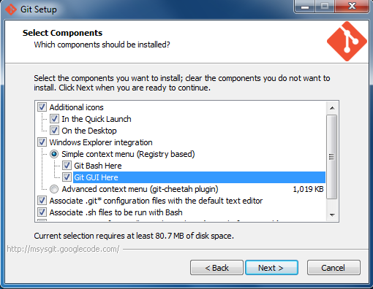

After finishing installation you will find the following icon on your desktop:

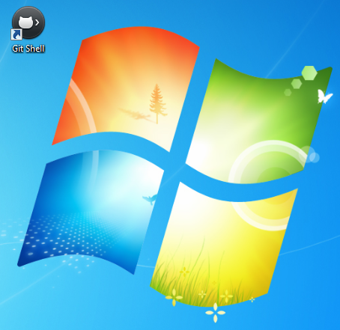

# Installation of SourceTree

SourceTree is a free Git & Mercurial GUI client for Windows or Mac. To download this software go to the website:

<http://www.sourcetreeapp.com/>

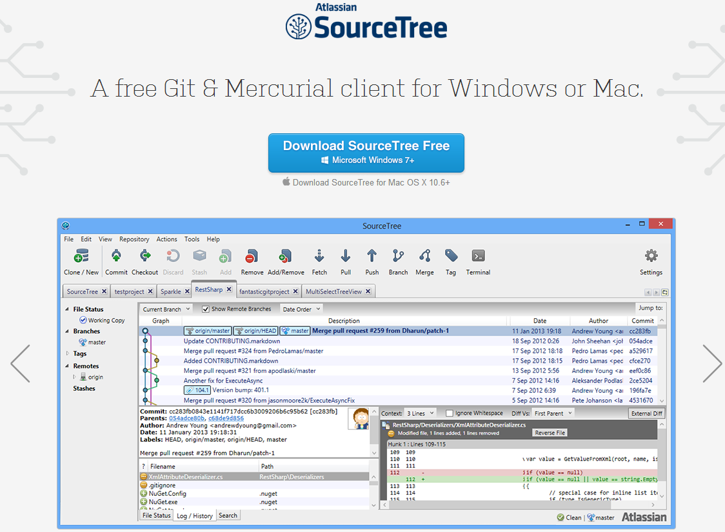

Click and Download the **SourceTreeSetup_1.2.3.exe** file and run it to install on your computer.

To open this software click on the shortcut as shown in the figure:

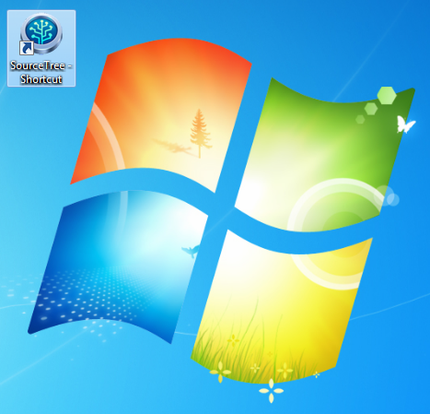

Now it will open the following windows.

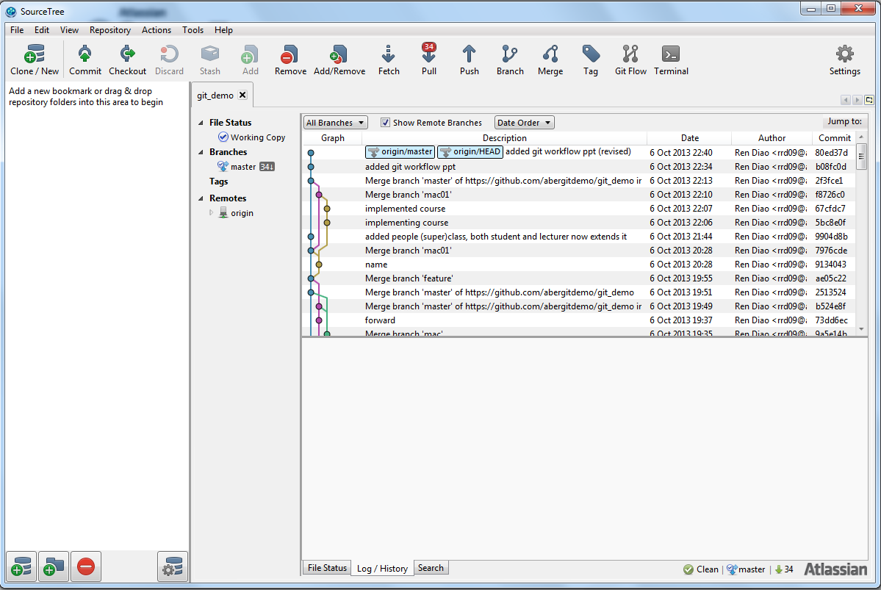

# Creating a student micro account on GitHub

Follow these steps to create a free student micro account on GitHub:

1. Go to the GitHub website with **/edu**

<https://github.com/edu> 

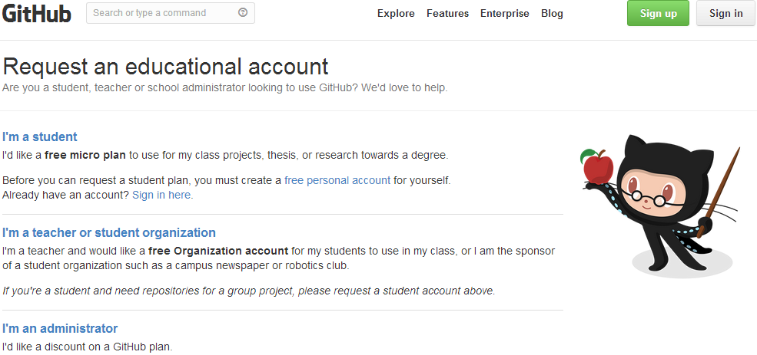  
2. Select the option **I 'm a student**  
  
3. Loging to your existing GitHub account / Create new one (with valid school/university email) and Click on **add and verify**

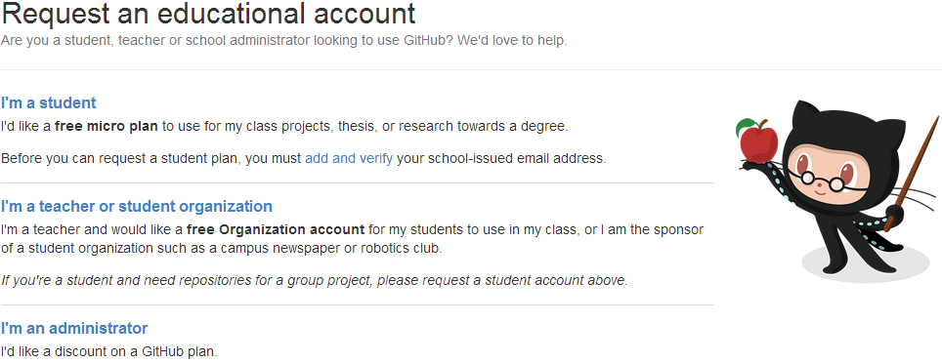

4. Click again on **Verify**

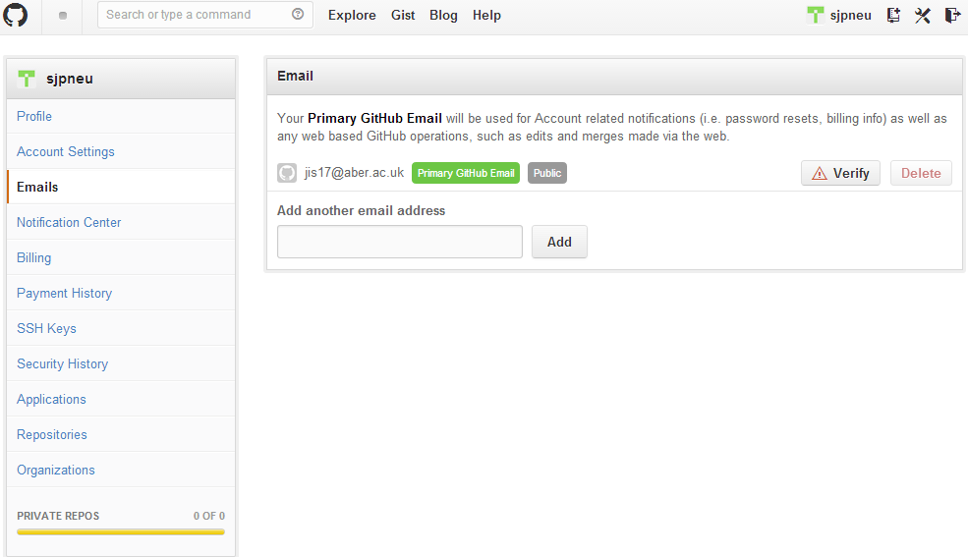  
4. Verify the link GitHub sent to your email account as shown below:

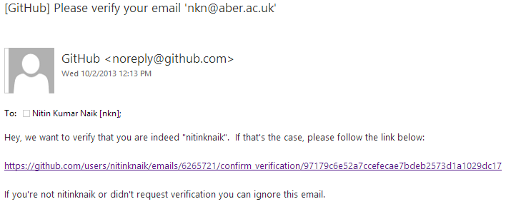  
  
5. Confirm it again clicking on **Confirm** button.

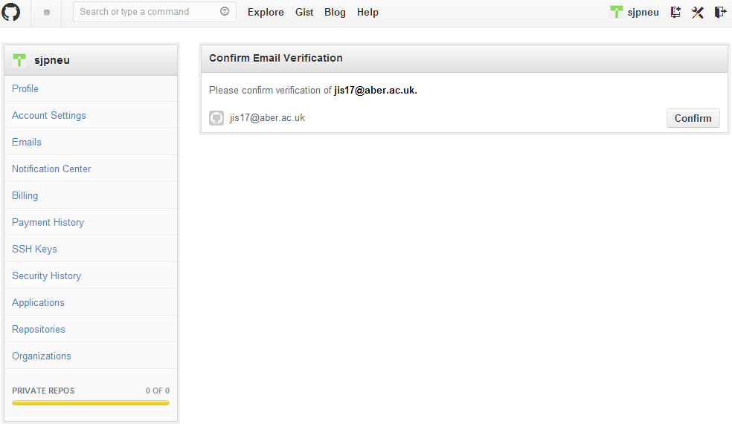

6. Then you will see the below message

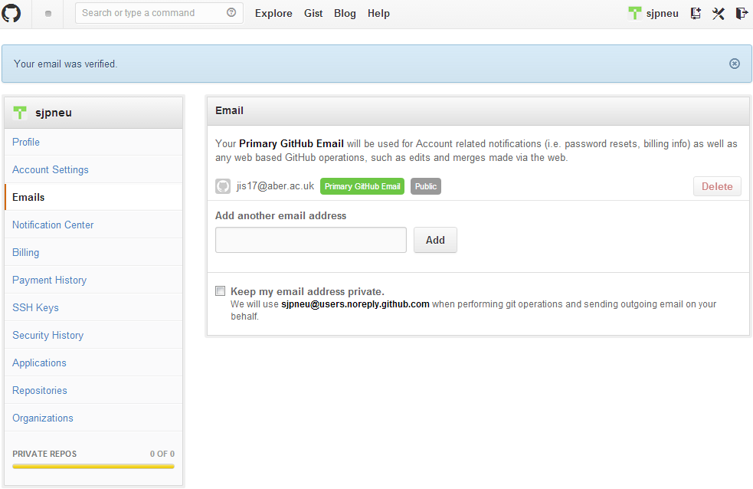

7. Check your email again after 10-15 minutes to see your free student micro account details.

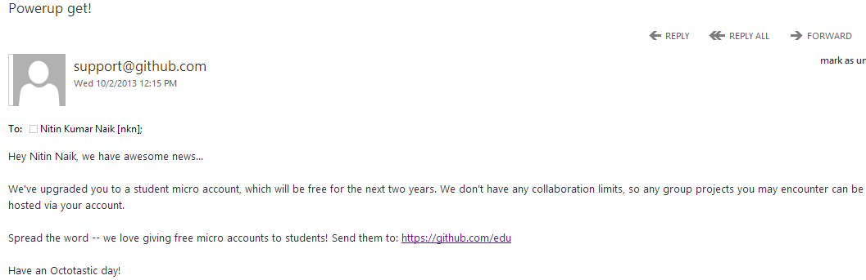

8. Once you have received the free account details on your email you can also check these details by login on GitHub website and clicking on **Account settings/ Billing** option as shown in the figure.

