# How to Obtain a Free Micro Plan on GitHub

# 1. Go to https://github.com/

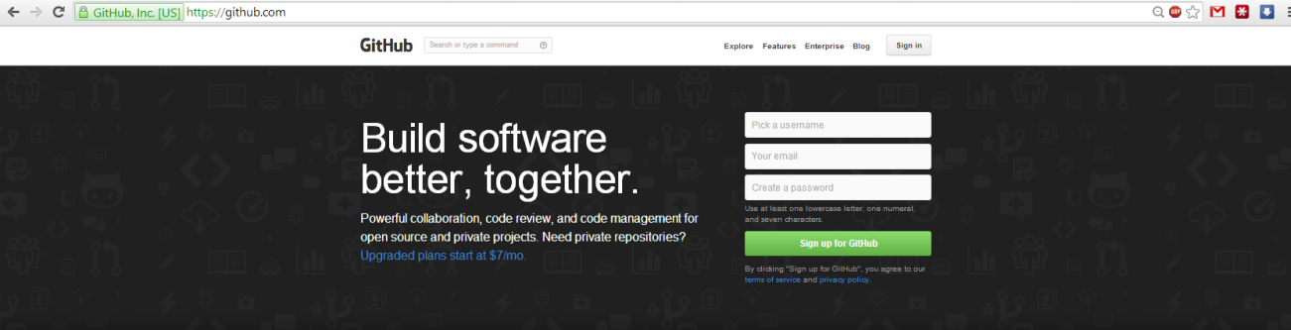  
2. Sign up for a new account using your university email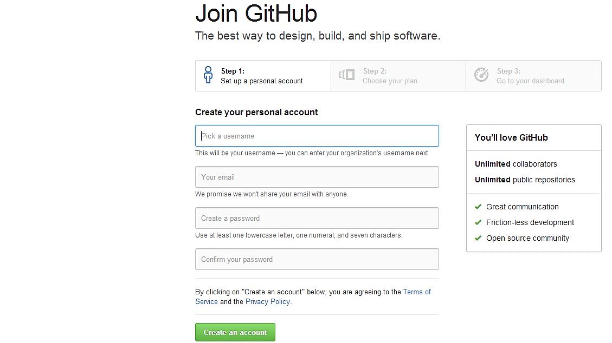  
3. Click the link that GitHub sent to you via email, as shown below: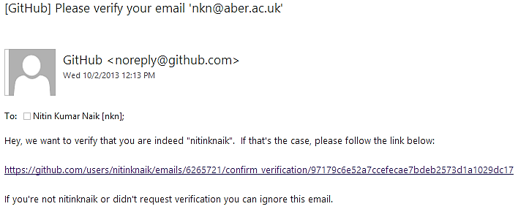

4. Confirm your email by clicking on the Confirm button.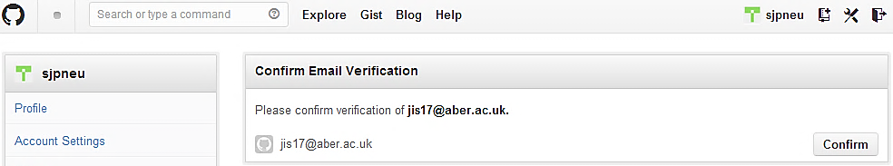

5. You will then see the message below.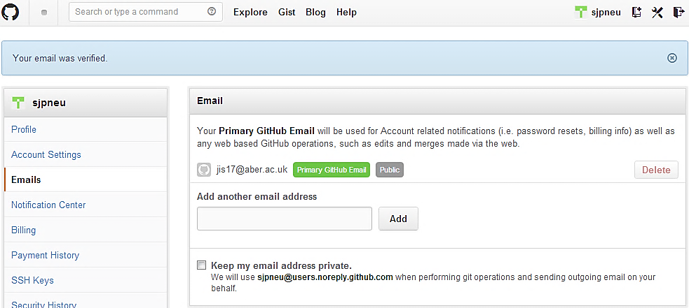

6. Go to https://github.com/edu, click on I’m a student. Fill in the details and Send request.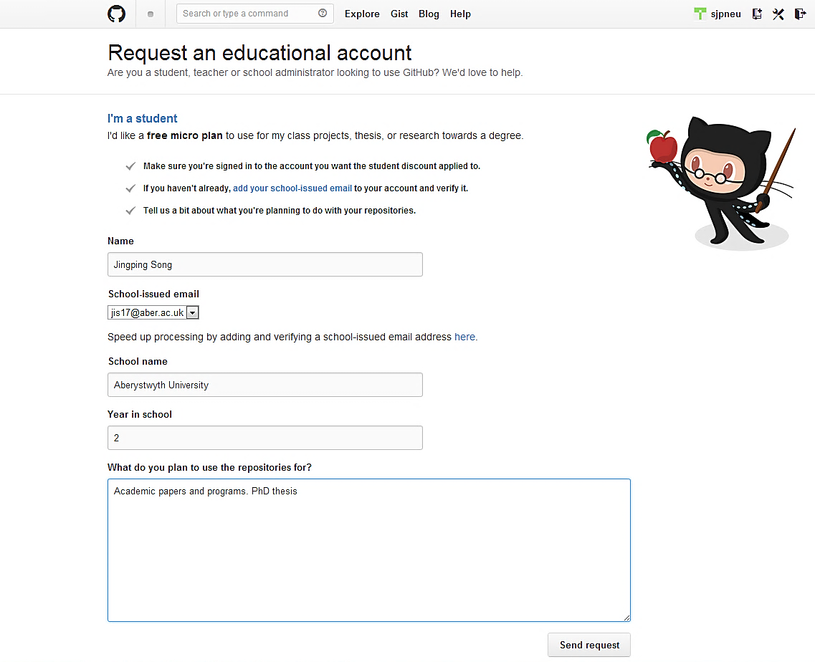

7. It should then display the following message.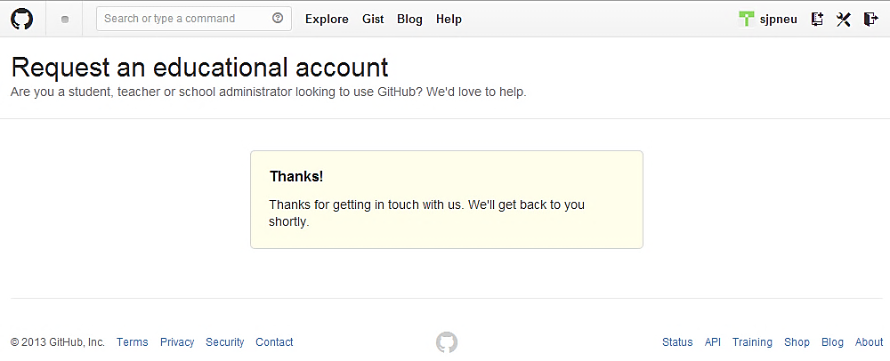

8. You should also (immediately) receive an email confirming your free micro account.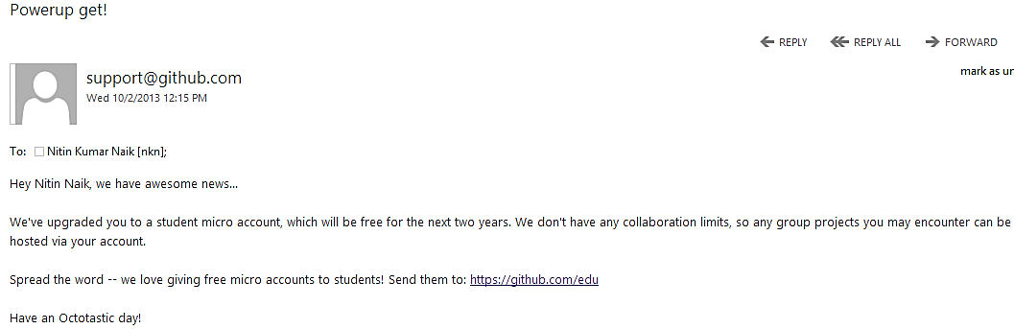

9. You can check by logging in to GitHub, and clicking on Account settings -> Billing.