Autolyse vs. Fermentolyse
A Professional Baker’s Guide
Techniques, Timing, Temperature, When to Use Each Method — and Baking with Ancient Grains
Version 3 · Updated 2026-05-31 · Now including grain blends, baker’s ratios & an expanded modern and ancient grain library

1. Introduction
Both autolyse and fermentolyse are rest periods applied to flour and water — sometimes with starter — before the main mixing and kneading begins. The shared goal is to allow enzymes and hydration time to do work passively, before mechanical energy is applied. The result in both cases: reduced mixing time, better gluten development, improved extensibility, superior flavour, and a more open crumb. The critical difference is what you include during that rest.
“Autolyse for control. Fermentolyse for flavour.” — this baker’s rule of thumb captures the essential trade-off between the two methods.
This second edition extends the guide to ancient grains. Six grains — Emmer, Spelt, Einkorn, Teff, Sorghum and Kamut — behave very differently from modern bread wheat, and the resting techniques covered here must be adapted accordingly. Section 9 explains why these grains differ and how to handle and bake with each of them. This third edition goes further: Section 10 investigates how blends of different grains behave through every stage of the process, from the rest to the bake, and Section 11 expands the grain library with the common modern bread grains alongside further ancient and gluten-free grains.

2. The Science Behind the Rest
During any hydration rest, two enzyme families activate within the flour:
- Proteases — partially break down proteins, loosening the gluten network and making the dough more extensible and easier to shape.
- Amylases — begin converting damaged starches into fermentable sugars, which become food for yeast and bacteria later.

Simultaneously, water molecules fully penetrate flour particles and spontaneous gluten bonds begin forming without any mechanical work. This is the magic of letting time do the labour.

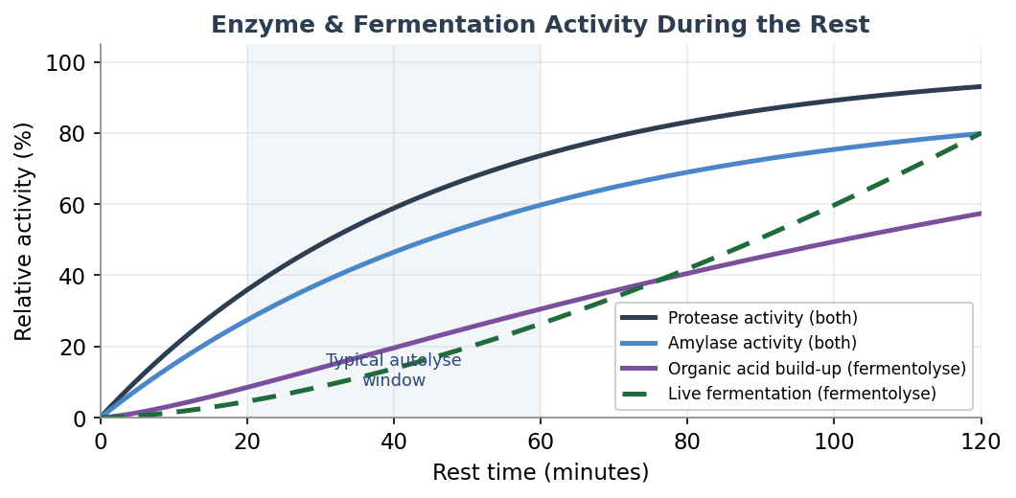
Figure 1 — Relative enzyme activity and fermentation during rest phases. Fermentolyse uniquely adds organic acid build-up (purple) and live fermentation activity (green dashes).

3. Autolyse

3.1 What Is It?
Autolyse was developed by French bread scientist Professor Raymond Calvel in the 1970s. The technique is deceptively simple: combine only flour and water — no salt, no yeast, no starter — and let the mixture rest for 20 to 60 minutes (up to 2 hours for very high-hydration doughs). Nothing else. Then continue with the rest of the recipe.

3.2 What Happens?
- Full hydration of flour particles — even without mixing.
- Protease enzymes begin softening gluten proteins, improving extensibility.
- Amylase enzymes begin converting starches to sugars.
- Gluten bonds form spontaneously — the dough becomes noticeably smoother.
- No fermentation occurs — the process is purely enzymatic and physical.

4. Fermentolyse

4.1 What Is It?
Fermentolyse is a modern variation popularised in the artisan sourdough community. You mix flour, water, AND your sourdough starter during the rest — essentially allowing a low-level fermentation to begin during the hydration phase. Rest times range from 30 minutes to 2 hours, with kitchen temperature playing a much larger role than in autolyse.

4.2 What Happens?
- Everything that happens during autolyse (hydration, protease and amylase activity).
- In addition: lactic acid bacteria (LAB) in the starter begin producing organic acids.
- Wild yeasts begin producing CO₂ and ethanol — fermentation has started.
- Moderate acid levels strengthen the gluten network; high acid levels weaken it.
- Flavour compounds begin developing earlier in the process.

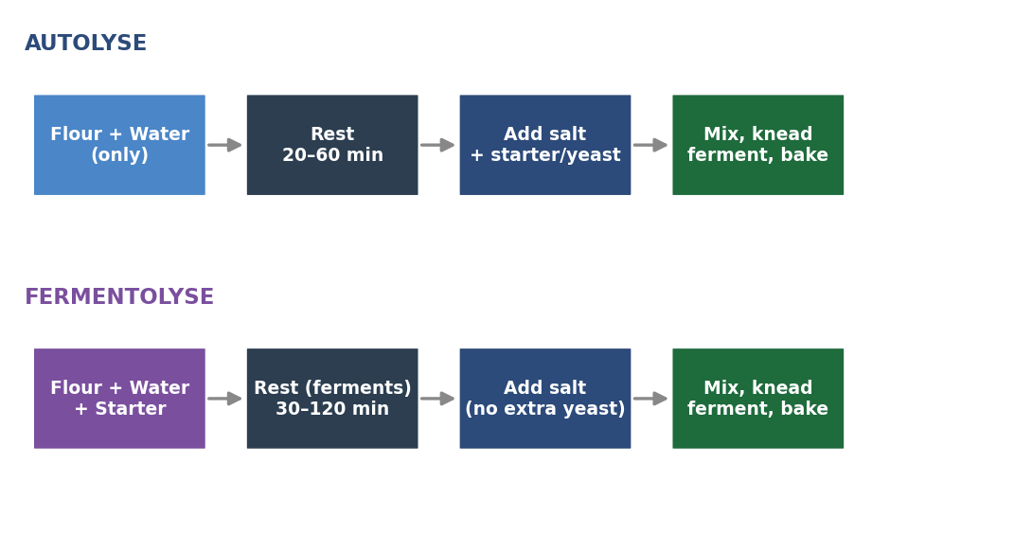
Figure 2 — Process flow for Autolyse (top) vs. Fermentolyse (bottom). Note that salt and commercial yeast are always added after the rest phase in both methods.

5. Side-by-Side Comparison

Feature | Autolyse | Fermentolyse
Ingredients in rest | Flour + Water only | Flour + Water + Starter
Salt included? | No | No
Commercial yeast included? | No | No
Fermentation activity | None | Low-level begins
Gluten development | Hydration + enzymes | Hydration + enzymes + acid
Flavour development | Minimal during rest | Begins during rest
Over-fermentation risk | None | Present in warm kitchens
Control | High | Moderate — temp-dependent
Complexity | Simple | Slightly more involved
Best suited to | All bread types | Sourdough only

6. Pros and Cons

6.1 Autolyse

Pros — Autolyse | Cons — Autolyse
✓ Very safe and predictable — no fermentation risk | ✗ Does not contribute to flavour development
✓ Reduces mixing and kneading time by 30–50% | ✗ Dough can feel slightly slack before salt is added
✓ Improves extensibility — dough is easier to shape | ✗ Less benefit for low-hydration doughs (≤65%)
✓ Better oven spring and open crumb potential | ✗ Minimal benefit for enriched doughs (fat, eggs, sugar)
✓ Works for any bread type — commercial yeast or sourdough | ✗ Adds time to the process without flavour return
✓ Easy to time around your schedule | ✗ Requires separate incorporation of starter later
✓ Ideal for beginners and new recipes

6.2 Fermentolyse

Pros — Fermentolyse | Cons — Fermentolyse
✓ Jumpstarts flavour development — acids build early | ✗ Risk of over-fermentation in warm kitchens
✓ Can improve extensibility/strength balance | ✗ Less predictable — temperature-sensitive
✓ Useful for complex, tangy sourdough flavour profiles | ✗ Extended rest can weaken gluten through over-acidification
✓ Reduces total bulk fermentation time slightly | ✗ Not suitable for commercial yeast bread
✓ Integrates starter evenly before salt is added | ✗ Harder to plan around a rigid schedule
✓ Particularly useful in cool kitchen conditions | ✗ Requires an active, well-fed starter

7. Time & Temperature Reference Tables
Kitchen temperature is the single most important variable in both methods. Warmer temperatures accelerate enzyme activity and — in fermentolyse — fermentation. Use these tables as a starting point and adjust based on your flour, starter activity, and dough hydration.

7.1 Autolyse — Rest Duration by Temperature

Kitchen temp | Minimum rest | Maximum rest | Sweet spot
16°C / 61°F | 55 min | 90 min | 70 min
18°C / 64°F | 50 min | 80 min | 60 min
20°C / 68°F | 40 min | 65 min | 50 min
22°C / 72°F | 35 min | 55 min | 45 min
24°C / 75°F | 28 min | 45 min | 35 min
26°C / 79°F | 22 min | 38 min | 30 min

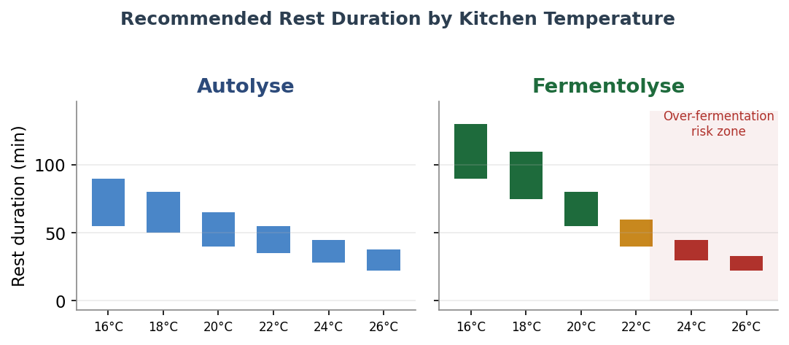
Figure 3 — Recommended rest duration ranges for Autolyse (left) and Fermentolyse (right) at different kitchen temperatures. Note the over-fermentation warning zone for Fermentolyse above 24°C.

7.2 Fermentolyse — Rest Duration by Temperature

Kitchen temp | Minimum rest | Maximum rest | Sweet spot | Risk level
16°C / 61°F | 90 min | 130 min | 110 min | Low
18°C / 64°F | 75 min | 110 min | 90 min | Low
20°C / 68°F | 55 min | 80 min | 65 min | Low
22°C / 72°F | 40 min | 60 min | 50 min | Moderate
24°C / 75°F | 30 min | 45 min | 38 min | High
26°C / 79°F | 22 min | 33 min | 28 min | High

8. Full Bread-Making Timelines
The following timelines show where autolyse and fermentolyse fit within the full baking process for sourdough and commercial yeast bread. Note that sourdough timelines are significantly longer due to the slower fermentation speed of natural leaven.

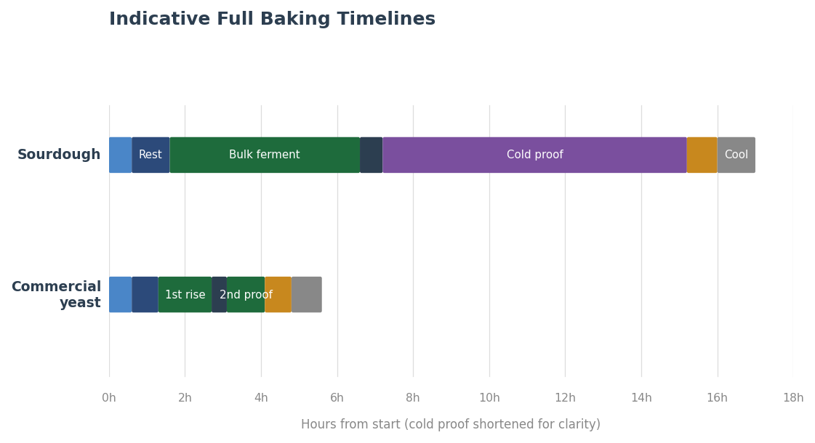
Figure 4 — Indicative timelines for Sourdough (top) and Commercial Yeast bread (bottom). Sourdough typically spans 12–18 hours total including cold proof; commercial yeast 4–6 hours.

8.1 Sourdough Timeline (Fermentolyse)

Phase | Duration | Temperature | Notes
Mix flour + water + starter | 5–10 min | 24–26°C | Rough mix only
Fermentolyse rest | 30–90 min | 24–26°C | Cover; watch in warm kitchens
Add salt, knead / fold | 5–10 min | Ambient | Slap-and-fold or coil folds
Bulk fermentation | 4–6 hours | 24–26°C | Stretch & fold every 30–45 min
Pre-shape | 5 min | Ambient | Gentle, build tension
Bench rest | 20–30 min | Ambient | Covered, let gluten relax
Final shape | 5–10 min | Ambient | Shape to banneton
Cold proof | 8–16 hours | 4°C / 39°F | Develops flavour & structure
Preheat oven + Dutch oven | 45–60 min | 250°C / 480°F | Stone or cast iron
Bake covered | 20 min | 230°C / 450°F | Steam trapped for oven spring
Bake uncovered | 20–25 min | 220°C / 430°F | Until deep crust, hollow sound

8.2 Commercial Yeast Timeline (Autolyse)

Phase | Duration | Temperature | Notes
Mix flour + water (no salt/yeast) | 5–10 min | 20–24°C | Rough mix only
Autolyse rest | 20–45 min | 20–24°C | Cover, do not disturb
Add salt + instant yeast, knead | 8–12 min | Ambient | Window-pane test for gluten
First rise (bulk) | 1–1.5 hours | 24°C / 75°F | Until doubled in volume
Punch down, pre-shape | 5 min | Ambient | Gentle handling
Bench rest | 15–20 min | Ambient | Covered, let gluten relax
Final shape | 5–10 min | Ambient | Shape to tin or free-form
Second proof | 45–60 min | 24–26°C | Until 1.5× original volume
Preheat oven | 20–30 min | 230°C / 450°F | With baking stone if available
Bake with steam | 10–15 min | 230°C / 450°F | Steam pan or spray for crust
Bake without steam | 20–25 min | 210°C / 410°F | Until deep golden, hollow sound
Cool on wire rack | 30–60 min | Room temp | Crumb finishes setting

9. Baking with Ancient Grains
Ancient grains are cereal species that have remained largely unchanged by modern selective breeding. This guide covers six of them. Four are members of the wheat family and contain gluten in varying amounts — Einkorn, Emmer, Spelt and Kamut — while two are unrelated grasses that contain no gluten at all — Teff and Sorghum. Because gluten is the protein network that traps gas and gives bread its rise and chew, this single distinction governs almost everything about how each grain is handled, rested and baked.

9.1 Why Ancient Grains Behave Differently
Within the wheat family, baking behaviour is driven largely by the ratio of two gluten proteins: gliadin (which gives extensibility, i.e. stretch) and glutenin (which gives elasticity, i.e. strength and gas retention). Modern bread wheat has a relatively low gliadin-to-glutenin ratio, so its dough is strong and elastic. The ancient wheats have a much higher proportion of gliadin — in einkorn the ratio can be several times that of modern wheat — which makes their doughs extensible and sticky but weak, slack and prone to tearing. They also ferment and proof faster, and their gluten degrades more quickly if over-mixed or over-acidified.
Teff and Sorghum are not wheat at all. They contain no gluten, so there is no network to develop and the autolyse / fermentolyse concept does not apply in the usual sense. Instead they are worked as batters or blended flours, and structure has to be supplied by a binder (psyllium husk, xanthan gum, or egg) and by starch gelatinisation during baking.

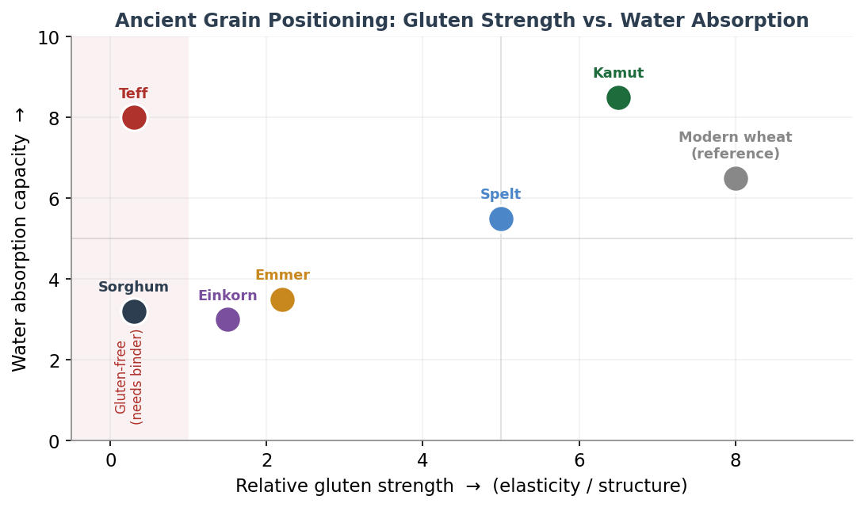
Figure 5 — Where each grain sits on two axes that matter most to the baker: gluten strength (horizontal) and water-absorption capacity (vertical). Grains in the shaded band on the left are gluten-free and require a binder.

9.2 The Six Grains at a Glance

Grain | Botanical / ploidy | Gluten | Flavour | Handling headline
Einkorn | T. monococcum (diploid) | Very weak | Nutty, sweet, golden | Sticky & slack — least water, gentlest hands
Emmer | T. dicoccum (tetraploid) | Weak | Earthy, rustic | Sticky, low elasticity — keep hydration modest
Spelt | T. aestivum ssp. spelta (hexaploid) | Moderate (fragile) | Sweet, wheaty, mellow | Easiest entry; do not overmix or overproof
Kamut | T. turgidum ssp. turanicum (tetraploid) | Strong | Buttery, rich | Thirsty & easy to handle; builds good strength
Teff | Eragrostis tef (grass) | None | Malty, nutty | Gluten-free; whole-grain, needs a binder
Sorghum | Sorghum bicolor (grass) | None | Mild, neutral | Gluten-free; gritty & dry — blend + bind

9.3 Grain-by-Grain Profiles
Einkorn (Triticum monococcum)
The oldest cultivated wheat and the genetic ancestor of the others — a diploid grain with the most delicate gluten of all. Einkorn dough is markedly sticky, wet and slack, with very little elasticity. It absorbs less water than modern wheat, so hydration should be reduced substantially. It also ferments and proofs quickly. Handle it as little as possible: a brief rest is fine, but a long autolyse only worsens the slackness. Despite the weak gluten, einkorn can rise surprisingly well and bakes into a dense, tender, golden, nutty crumb.
- Hydration: reduce by roughly 10–20% versus your usual wheat recipe.
- Mixing: minimal — mix just to combine, then a few gentle folds; never knead aggressively.
- Rest: skip the autolyse, or keep it to 15 minutes at most.
- Proof: shorter than wheat — watch closely, it over-proofs fast.
Emmer (Triticum dicoccum / farro)
A tetraploid grain, one step up from einkorn in complexity but still weak-gluten. Emmer doughs are sticky and slack with low elasticity, and they tend to lose what little structure they have after long fermentation or cold proofing. The flour can feel slightly gritty depending on milling. Emmer rewards a confident but gentle touch and modest hydration; it carries a deep, earthy, rustic flavour and is excellent blended with a stronger wheat.
- Hydration: reduce by roughly 5–15% versus modern wheat.
- Mixing: gentle folds rather than kneading; stop as soon as the dough comes together.
- Rest: a short autolyse of up to 20 minutes is helpful for bran hydration.
- Blending: 30–50% emmer with bread wheat gives flavour while keeping structure.
Spelt (Triticum aestivum ssp. spelta)
A hexaploid wheat closely related to modern bread wheat, and therefore the easiest ancient grain to start with — it can often substitute for wheat at a 1:1 ratio. Its gluten is present and reasonably strong but fragile: it hydrates and builds strength quickly, then breaks down just as quickly if you keep going. The classic spelt mistakes are over-mixing and over-proofing. Reduce water slightly, mix to just-developed, and proof a little short. The reward is a high rise, a crisp crust and a sweet, mellow, wheaty flavour.
- Hydration: similar to wheat or 5% lower; spelt absorbs water fast, so add it gradually.
- Mixing: short — stop the moment the dough is smooth; over-mixing destroys the gluten.
- Rest: a 20–30 minute autolyse works well; fermentolyse suits whole spelt sourdough.
- Proof: err slightly on the short side to avoid a dense, collapsed crumb.
Kamut (Khorasan wheat, Triticum turgidum ssp. turanicum)
A large-kernelled tetraploid ancestor of durum wheat with high protein and, unusually for an ancient grain, strong and forgiving gluten. Bakers often describe Kamut as a dream to work with: it builds excellent strength and is very thirsty, readily taking extra water without becoming unmanageable. The flour is golden and the flavour rich and buttery. Treat it much like a strong modern wheat, but be ready to add more water than usual and to watch the proof, as it can be slightly under-sprung if rushed.
- Hydration: increase by roughly 5–15%; add water progressively until the dough is supple.
- Mixing: normal kneading is fine — Kamut tolerates and benefits from gluten development.
- Rest: a full autolyse of 30–45 minutes improves extensibility.
- Proof: give it adequate time; under-proofed Kamut bakes a little tight.
Teff (Eragrostis tef) — gluten-free
A tiny East-African grass seed, the traditional grain of Ethiopian injera. It is always used whole-grain (the seed is too small to refine), is rich in iron, calcium and fibre, and has a malty, lightly nutty flavour. Teff contains no gluten, so it cannot form a kneadable dough; it is worked as a batter. For the traditional flatbread it is fermented as a thin batter for one to three days and baked on a hot griddle. For raised loaves it must be blended with other gluten-free flours and a binder.
- Form: batter, not dough — hydration is effectively 90–120% or more.
- Binder: psyllium husk, xanthan gum or egg is essential for any raised loaf.
- Rest: allow a 20–60 minute hydration rest (a “soaker”) so the flour fully absorbs liquid.
- Mixing: whisk to combine; do not over-work, which can make the crumb gummy.
- Use: injera and other flatbreads, or 20–30% of a gluten-free flour blend for flavour and nutrition.
Sorghum (Sorghum bicolor) — gluten-free
A mild, neutral-flavoured, pale gluten-free grain that is a workhorse base flour in gluten-free blends. Its drawback is a high starch-gelatinisation temperature and low water-holding capacity, which tend to give a dry, gritty, crumbly texture when used alone. It is therefore almost always blended (with rice, teff or starches) and combined with a binder and extra moisture. Waxy (high-amylopectin) sorghum varieties hold water better and stale more slowly, and are preferable where available.
- Form: batter or blended flour; never a stand-alone kneaded dough.
- Binder: required — psyllium or xanthan plus added moisture to offset its dryness.
- Blending: typically 30–50% of a gluten-free mix; pair with teff or rice for texture.
- Rest: a 30–60 minute soaker improves hydration and reduces grittiness.
- Tip: choose waxy sorghum for softer, longer-keeping results.

9.4 Adapting Autolyse & Fermentolyse for Ancient Grains
The resting techniques in this guide were designed around modern bread wheat. They still apply to ancient grains — but only after adjustment, and only to the gluten-bearing ones. The figure below summarises the two distinct workflows.

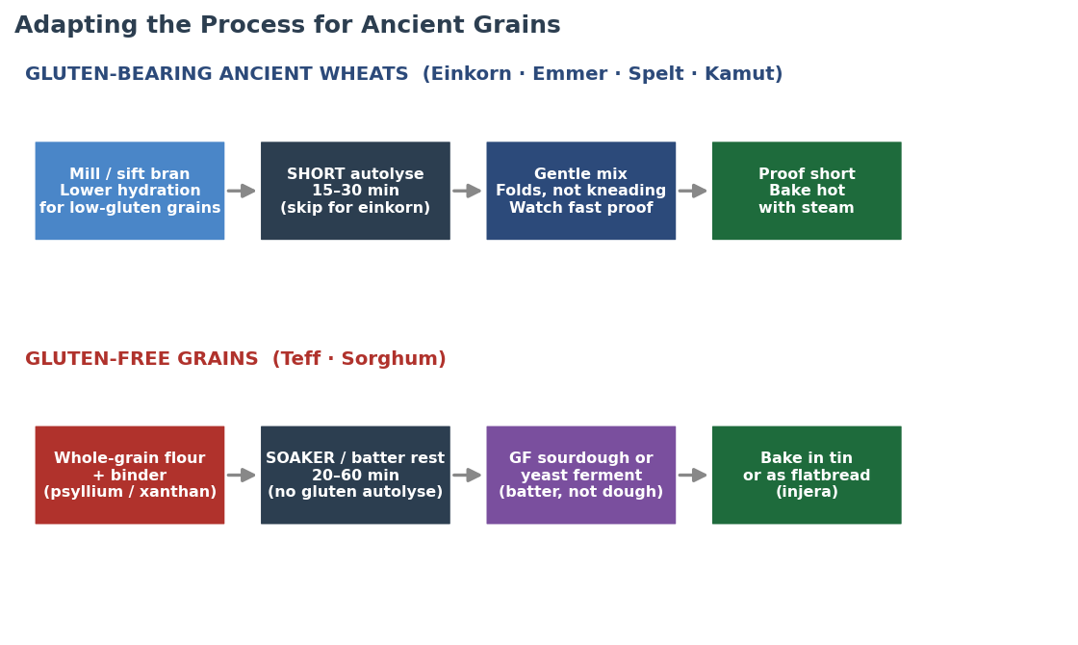
Figure 6 — Two workflows. Gluten-bearing ancient wheats (top) use a shortened, gentler version of the standard process; gluten-free grains (bottom) replace autolyse with a soaker and are fermented and baked as batters.

Gluten-bearing ancient wheats (Einkorn, Emmer, Spelt, Kamut)
- Shorten the rest. Because gliadin-rich gluten is already extensible and degrades quickly, a long autolyse is counter-productive for the weakest grains. Skip it for einkorn, keep it brief (≤20 min) for emmer, 20–30 min for spelt, and a full 30–45 min only for strong, thirsty Kamut.
- Adjust hydration grain by grain. Lower it for einkorn and emmer, hold or slightly lower for spelt, raise it for Kamut. Add water gradually — these flours respond fast.
- Use fermentolyse with care. It still benefits whole-grain spelt and Kamut sourdough, where the acids help manage bran cutting into gluten, but it accelerates an already-fast fermentation. For einkorn and emmer in a warm kitchen, prefer a plain short autolyse or no rest at all.
- Replace kneading with folding. Gentle stretch-and-folds build what structure these grains can hold without tearing the fragile network; aggressive kneading breaks it down.
- Proof short and bake hot. All four proof faster than modern wheat — watch the dough, not the clock — and bake with steam for good oven spring.
Gluten-free grains (Teff, Sorghum)
- There is no gluten autolyse. With no gluten to develop, the autolyse / fermentolyse logic does not apply. Use a soaker instead: rest the flour in its liquid for 20–60 minutes so it fully hydrates and the crumb is less gritty.
- Build structure with a binder. Psyllium husk or xanthan gum (or egg) replaces the role of gluten, holding gas and giving the loaf its shape.
- Ferment as a batter. Gluten-free sourdough or yeast fermentation happens in a pourable batter, not a shapeable dough — exactly as in traditional teff injera, which is fermented one to three days.
- Blend for best results. Both grains shine in blends — teff for flavour and iron, sorghum as a mild base — often with rice flour or starch for lightness.
- Bake in a tin or as flatbread. A batter needs the support of a tin for loaves, or is poured thin and griddled for injera and similar flatbreads.

9.5 Hydration, Rest & Handling Reference
A quick reference for adapting your process to each grain. Treat the hydration figures as starting adjustments relative to your usual modern-wheat recipe, then fine-tune to the dough.

Grain | Hydration vs. wheat | Rest / autolyse | Mixing | Over-proof risk
Einkorn | −10 to −20% | Skip or ≤15 min | Minimal — folds only | High
Emmer | −5 to −15% | ≤20 min | Gentle folds | High
Spelt | Same to −5% | 20–30 min | Short; stop early | Moderate
Kamut | +5 to +15% | 30–45 min | Normal — takes work | Moderate
Teff | Batter (90–120%) | Soaker 20–60 min | Whisk; do not knead | None (no gluten)
Sorghum | Batter (+ extra water) | Soaker 30–60 min | Whisk; needs binder | None (no gluten)

9.6 Troubleshooting Ancient Grain Doughs
- Dough is soup-like and will not hold shape (einkorn/emmer): hydration is too high and/or the rest was too long. Reduce water by 10–15% and skip the autolyse.
- Spelt loaf collapsed or is dense: over-proofed or over-mixed. Shorten both the mix and the final proof next time.
- Kamut dough feels tight and dry: it is thirsty — add more water gradually until supple.
- Gluten-free loaf is gummy inside: under-baked or too little binder — bake longer to a higher internal temperature and check the psyllium/xanthan quantity.
- Sorghum bread is gritty and crumbly: add a soaker, increase moisture, blend with finer flour, and prefer waxy sorghum.
- Ancient-grain sourdough turns sour and slack too fast: fermentation is running ahead — cut the bulk and proof times and lower the dough temperature.

10. Baking with Grain Blends
Few bakers work with a single ancient grain at 100%. In practice the most reliable, best-tasting loaves come from blends — combining the flavour and nutrition of ancient or specialty grains with enough strong wheat (or a binder, for gluten-free mixes) to carry structure. This section explains how blending changes every stage of the process, from the rest through to the bake, and gives quantitative starting points for the four blend families you are most likely to use.

10.1 The Gluten Budget — the One Idea Behind Every Blend
Bread structure depends far more on glutenin (which gives elasticity and traps gas) than on total protein. This is the key to understanding blends, and it explains an apparent paradox: ancient wheats are often higher in total protein than modern bread wheat, yet they make weaker dough. The reason is the ratio of the two gluten proteins. Modern wheat has a low gliadin-to-glutenin ratio (roughly 1.5 to 3.8), so its dough is strong and elastic. Ancient wheats are gliadin-heavy — the ratio climbs through spelt and emmer up to around 12 for einkorn — so their dough is extensible, sticky, slack and fragile.
Think of every recipe as having a gluten budget. Strong modern wheat deposits into it; low-gluten ancient grains, and especially gluten-free flours, draw it down. The art of blending is keeping the budget high enough to hold structure while letting the flavour grain dominate. Once the low-gluten fraction climbs past roughly 40%, you compensate — by adding water for the thirstier grains, switching from kneading to gentle folds, supporting the dough in a banneton or tin, shortening the rest and the proof, and accepting a denser crumb. Above about 60% you usually add a structure aid (vital wheat gluten for wheat blends, psyllium or xanthan for gluten-free).

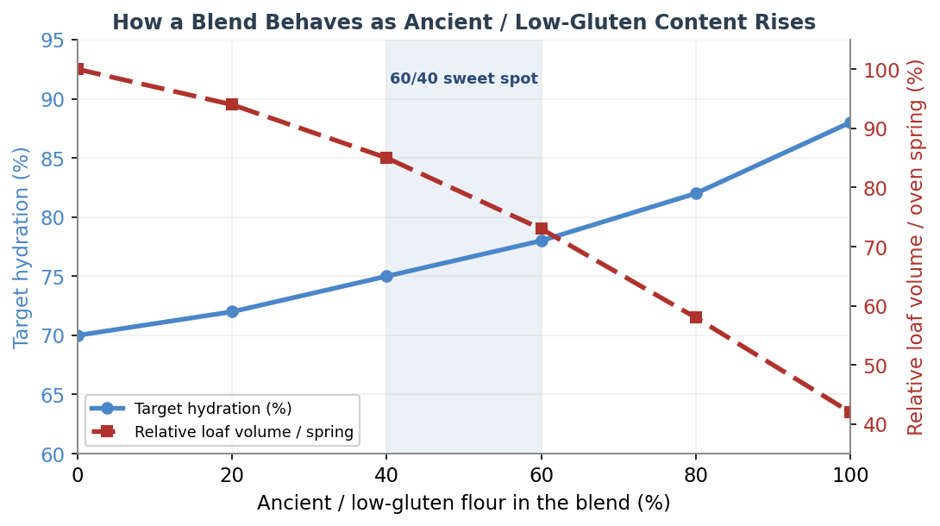
Figure 7 — As the ancient or low-gluten fraction of a blend rises, target hydration climbs (thirstier bran and starch) while loaf volume and oven spring fall. The 40–60% band is the practical sweet spot where flavour dominates but structure still holds.

10.2 Why 60/40 Is the Classic Ratio
The most widely recommended starting point for an ancient-grain loaf is roughly 60% ancient grain to 40% strong white wheat. The 40% high-protein wheat supplies just enough glutenin backbone for a buoyant, sliceable crumb, while 60% ancient flour lets its flavour, colour and aroma lead. Bakers who have trialled the same recipe at 20%, 40% and 100% whole ancient grain consistently land on around 40% whole grain as the best balance of an open, fluffy crumb and whole-grain character — the 20% version is barely distinguishable from white, while a 100% loaf can be so slack it almost pours into the basket. If your only wheat flour is weak (around 10% protein), top up the budget with vital wheat gluten (see Section 11).

10.3 Four Families of Blend
(a) Ancient grain + white wheat — the structure-retaining classic
This is the 60/40 approach and its neighbours. The white wheat carries the loaf, so the process stays close to a normal wheat bake: a standard 30–45 minute autolyse works, hydration sits around 70–78% for a sourdough, and you can shape free-form. Expect good oven spring, with slightly faster crust browning from carotenoid-rich grains like einkorn and Kamut. This family is the most forgiving and the best place to start.
(b) Ancient grain + wholegrain wheat — maximum flavour and nutrition
Replacing the white wheat with wholemeal pushes everything toward the whole-grain end: more flavour and fibre, a thirstier dough, faster fermentation and a denser crumb. A useful rule of thumb is to add roughly 3–4% water for every 25% wholegrain flour you introduce. A long autolyse (one to two hours) or a separate soaker of the wholegrain fraction helps the bran hydrate and stop it cutting the gluten. Drop the desired dough temperature to around 23°C / 75°F, because wholegrain ferments vigorously and over-proofs readily.
(c) Ancient + ancient — stacking the weaknesses
Combining two ancient grains (emmer with spelt, einkorn with Kamut, spelt with Kamut) gives wonderful flavour but no strong-wheat backbone, so structure is the challenge. Let the thirstiest partner set the hydration — a spelt-and-Kamut dough can climb well above 80% because Kamut is so absorbent. Handle gently, support the loaf in a banneton or tin, and consider a small dose of vital wheat gluten (around 1%, with a matching increase in water) or a scald of part of the flour to firm things up. Of the ancient grains, Kamut behaves best and makes the most dependable structural partner.
(d) Ancient or wheat + gluten-free — two different worlds
There are two cases here. A small amount of a gluten-free grain (up to roughly 20–25% teff or sorghum) added to a wheat or ancient dough lends flavour, colour and nutrition while the wheat still carries structure — sorghum in particular is best capped around 25% before the crumb turns dry and tight. But a fully gluten-free blend (for example teff with sorghum and rice, or buckwheat with quinoa and millet) has no gluten budget at all. It is not kneaded dough but a batter, and structure must be rebuilt from a base flour, a starch and a binder. See Section 11.4 for the gluten-free architecture.

10.4 Blend Reference Table — Process Adjustments by Ratio
The table below gives indicative starting points for how the process shifts as the low-gluten or gluten-free fraction of the blend rises. Treat hydration as an adjustment relative to your usual modern-wheat recipe, then fine-tune to the dough in your hands.

Blend (low-gluten %) | Hydration vs. wheat | Autolyse / rest | Mixing | Bulk & proof | Expected volume
0% (all strong wheat) | Baseline | 30–45 min | Full kneading | Standard | Full
20% | +0 to +3% | 30–45 min | Knead, light folds | Slightly faster | Near full
40% | +3 to +6% | 20–40 min | Folds preferred | Faster | Good
60% (sweet spot) | +5 to +10% | 15–30 min | Gentle folds | Watch closely | Moderate
80% | +8 to +15% | 0–20 min | Minimal; folds only | Fast; over-proofs | Reduced
100% ancient | Grain-specific | Skip or ≤15 min | Just combine | Very fast | Low / dense
Gluten-free blend | Batter (90%+) | Soaker only | Whisk; needs binder | Single batter rise | Tin / flatbread

10.5 Stage-by-Stage: What Changes in a Blend
- Autolyse / fermentolyse: white-dominant blends take a normal 30–45 minute rest; high-wholegrain blends benefit from a longer 1–2 hour autolyse or a soaker; above roughly 30% rye, einkorn or sprouted flour, shorten or skip the rest because the gluten is fragile and enzyme activity is high.
- Hydration: raise it for thirsty grains (wholegrain wheat, Kamut, rye, sorghum) and lower it for slack einkorn; add water gradually, as blends respond quickly.
- Mixing: the more low-gluten flour, the more you favour stretch-and-folds over kneading — aggressive kneading tears the weak network rather than building it.
- Bulk fermentation: bran and germ feed the yeast, so blends ferment faster than white dough; reduce the desired dough temperature and watch the dough, not the clock.
- Proofing: more ancient or wholegrain flour means a shorter proof and a higher over-proof risk; under-proof slightly rather than over-proof.
- Shaping: expect stickier, slacker dough as the low-gluten fraction rises; use wet hands, a bench knife and banneton or tin support.
- Baking: bake wholegrain and ancient blends a little cooler (around 190–220°C / 375–425°F) and tent with foil if the crust browns before the crumb sets; steam the first 15–20 minutes for spring and crust. Expect less oven spring and a tighter crumb than a white loaf.

10.6 A Worked Example — 60% Emmer / 40% White Wheat Sourdough
To make the principles concrete, here is how the 60/40 emmer blend from the brief would run through the full process. Quantities are in baker's percentages (flour totals 100%).
- Flour: 60% wholegrain emmer, 40% strong white bread flour. Water: start at 75% (emmer is moderately thirsty but its weak gluten will not hold the very highest hydrations). Starter: 20% ripe levain. Salt: 2%.
- Rest: a short 20-minute autolyse of the flours and water only — long enough to hydrate the emmer bran, short enough not to slacken the dough further.
- Mix & bulk: add levain and salt, then 3–4 sets of gentle coil folds in the first 2 hours. Bulk about 4–5 hours at 24–26°C — noticeably faster than an all-white dough.
- Shape & proof: shape with a light touch into a banneton for support; cold proof 10–14 hours at 4°C rather than a long warm proof, to limit over-proofing and firm the dough for scoring.
- Bake: 250°C / 480°F in a covered Dutch oven, 20 minutes covered, then 20–25 minutes uncovered at 225°C / 435°F. Expect a rustic, earthy loaf with a moderately open crumb and a faster-browning crust.

11. An Expanded Grain Library — Modern & Ancient
Blending is only as good as your knowledge of the grains you reach for. This section adds the common modern bread grains and several further ancient and gluten-free grains to the six profiled in Section 9, so you can choose blend partners with confidence. Each grain is described by its gluten status, flavour, behaviour and typical role in a blend. Protein figures are indicative and vary widely with cultivar, growing conditions and milling extraction.

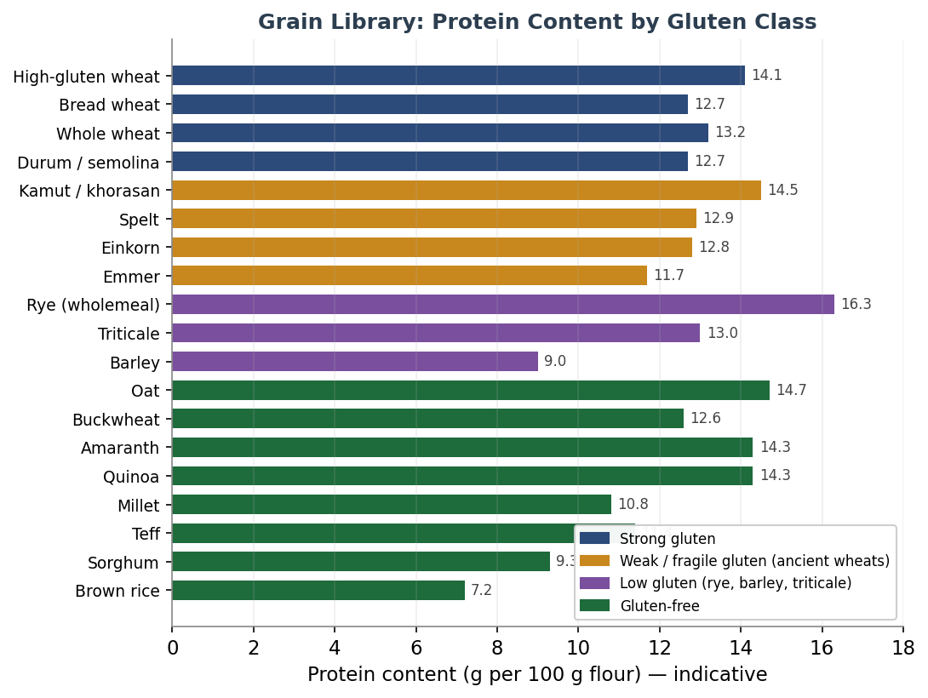
Figure 8 — Indicative protein content of the grain library, coloured by gluten class. Note that protein content alone does not predict structure: rye and the ancient wheats can be high in protein yet weak in dough, because structure depends on glutenin quality, not total protein.

11.1 Gluten-Strong Grains (the structural backbone)
Modern bread wheat (Triticum aestivum)
The reference baseline and the strongest, most reliable structure-builder. Its balanced gliadin-to-glutenin ratio (roughly 1.5–3.1) makes it the dependable carrier in almost every blend. Bread flour runs about 12.7% protein, all-purpose about 11.7%, and high-gluten flour 14% or more. It is the wheat that deposits most into the gluten budget.
Whole wheat / wholemeal
The whole grain of common wheat, around 13.2% protein, but the bran physically cuts gluten strands so its effective strength is lower than the protein figure suggests. It is thirstier and ferments faster than white flour. Commonly used up to 50% with no other change; for higher proportions, add water and lengthen the autolyse.
Durum / semolina (Triticum durum)
Pasta wheat, also the basis of southern Italian breads such as the protected Pane di Altamura. High in protein (semolina about 12.7%, the grain around 14%) with a deep golden colour and sweet, nutty flavour, but its gluten is strong-yet-inextensible, so it needs gentle, slightly longer mixing and a 30–60 minute autolyse to hydrate fully. Often used at 80% durum with 20% bread flour, or blended to lend colour and chew.

11.2 Low-Gluten & Specialty Grains
Rye (Secale cereale)
Rye is the great exception. Its gluten is weak, and structure instead comes from pentosans (arabinoxylans) — gums that absorb a great deal of water and give rye dough its characteristic sticky, paste-like body. Rye is thirsty (a 100% rye dough can need 90–100% hydration or more), ferments fast, and is high in enzymes, so it is almost always worked as a sourdough to keep the crumb from turning gummy. Kneading does nothing useful — mix only until combined. As a blend partner, 20–30% rye adds flavour and keeping quality while wheat still carries structure; add about 3% extra water per 10% rye, and shorten the rest.
Barley (Hordeum vulgare)
Low in functional gluten (about 7–10% protein) but rich in beta-glucan, a soluble fibre that boosts water absorption and dough viscosity while reducing loaf volume. Mild and slightly sweet; best as a minority flour (up to roughly 10–25%) for flavour and nutrition rather than structure.
Triticale (×Triticosecale)
A wheat-rye hybrid with moderate but lower-quality gluten (often above 13% protein) and more lysine than either parent. It is more workable than rye but less so than wheat, and it is high in alpha-amylase, so ferment and proof a little cooler and shorter. Common blends are 50:50 or 70:30 with wheat.

11.3 Gluten-Free Grains & Pseudocereals
None of these forms a gluten network. They are used in gluten-free blends or, in small amounts, as flavour and nutrition boosters in wheat doughs. The three pseudocereals (buckwheat, amaranth, quinoa) are botanically not grasses at all.
Oat (Avena sativa)
Gluten-free in pure form (though often cross-contaminated), about 14.7% protein and rich in beta-glucan. Adds moisture, softness and a gentle sweetness; used at 5–25% in wheat blends to increase water absorption and stability, or as part of a gluten-free mix.
Buckwheat (Fagopyrum esculentum)
An assertive, earthy pseudocereal (about 12.6% protein) high in lysine. Can anchor a gluten-free batter loaf with psyllium, or add depth at 10–30% of a blend. Its strong flavour is divisive — use it deliberately.
Amaranth (Amaranthus spp.)
A tiny, mineral-rich pseudocereal with a complete protein profile and almost no prolamin, so it cannot leaven alone. Nutty and slightly peppery; best as a minority component (up to about 25%) of a gluten-free blend for nutrition.
Quinoa (Chenopodium quinoa)
A complete-protein pseudocereal (about 14% protein) with an assertive, slightly bitter flavour that mellows on baking. Pairs with millet and buckwheat in gluten-free loaves; rinse or toast to tame the saponin bitterness.
Millet (Panicum miliaceum)
Mild, slightly sweet and pale (about 10.8% protein), millet is a friendly, neutral base for gluten-free blends and adds a tender crumb and gentle corn-like note. Needs soaking and a binder.
Rice, corn & fonio
Rice flour (brown about 7.2%, white about 6% protein) is the neutral workhorse base of most gluten-free blends, often around 60% of the mix. Corn/maize adds colour and a sweet note in flatbreads. Fonio, a fine West African ancient grain, is gluten-free but forms unusually strong gels, making it a promising structural element in gluten-free baking.

11.4 Building Structure Without Gluten
Gluten-free blends abandon the gluten budget entirely and rebuild structure from three parts: a base flour for body and flavour, a starch for lightness, and a binder to trap gas and hold the crumb together. A reliable framework is roughly 70% base flour, 25% starch and 5% protein or binder. Psyllium husk is the standout binder — research on gluten-free bread found it cut crumb firmness by 65–75% over three days of storage and substantially slowed staling, working as a gel that mimics gluten's gas-trapping role. A typical dose is about 5 g of blond psyllium husk per 100 g of flour, hydrated in roughly ten times its weight of water. Xanthan gum and eggs play a similar structural role.

Component | Role | Typical share | Examples
Base flour | Body, flavour, nutrition | ~70% | Rice, sorghum, teff, buckwheat, millet
Starch | Lightness, soft crumb | ~25% | Tapioca, potato, corn starch
Binder / protein | Traps gas, holds structure | ~5% | Psyllium, xanthan, egg

11.5 Vital Wheat Gluten — Topping Up the Budget
For wheat and ancient blends that fall short on structure, vital wheat gluten (VWG) is the simplest fix. It is wheat protein isolated to about 80% gluten, and it raises the dough's elasticity and gas-holding directly. (It is not an option for gluten-free baking — it is pure gluten.)
- Dosage: roughly 1–4% of flour weight for most breads; up to higher levels in very high-fibre or high-ancient blends.
- The math: VWG is about 80% protein, so adding roughly 1.5 g per 100 g of flour raises the flour's protein by about one percentage point. To take a 10% flour to 13%, add about 5 g per 100 g.
- Always add a matching amount of water — VWG is thirsty, and it will tighten the dough if you do not.
- Best used in rye, oat, teff, spelt, einkorn, emmer and buckwheat blends, where it lightens an otherwise dense crumb and improves rise.

A blend is a negotiation: flavour grain for character, strong wheat or a binder for structure. Know each grain's gluten budget, and you can blend with intent rather than by guesswork.

12. When to Use Which Method
Use this decision guide to choose the right method for your bake. The key variables are bread type, kitchen temperature, hydration level, flour type, and your flavour goals. The final rows cover the ancient grains added in this edition.

Situation | Recommendation | Notes
Commercial yeast, hydration ≥65% | Autolyse 20–45 min | Reduces kneading time
Commercial yeast, hydration <65% | Skip — not needed | Gluten forms easily
Enriched dough (brioche, milk bread) | Skip both | Fat interferes with gluten
Whole grain or rye-heavy dough | Autolyse 45–60 min | Bran needs longer hydration
Sourdough — beginner / new starter | Autolyse | Safe, predictable
Sourdough — high hydration ≥75% | Either method | Both work well
Sourdough — cool kitchen <20°C | Fermentolyse | Lower fermentation risk
Sourdough — warm kitchen >24°C | Autolyse | Avoid over-fermentation
Sourdough — complex tangy flavour | Fermentolyse | Acids build earlier
Sourdough — mild open crumb | Autolyse | Cleaner gluten development
Sourdough — whole wheat / spelt | Fermentolyse | Acids manage bran cutting
Stiff sourdough ≤68% hydration | Autolyse | Fermentolyse risk higher
Spelt or Kamut sourdough | Short autolyse 20–30 min | Strong-ish gluten; do not overdo
Einkorn or Emmer (low gluten) | Skip or ≤15 min autolyse | Long rest worsens slack dough
Teff / Sorghum (gluten-free) | Soaker + GF ferment | Autolyse concept does not apply

13. Professional Baker’s Tips
Golden Rules
- Never include salt in either rest period — salt tightens gluten and competes with hydration.
- Always cover the dough during the rest to prevent skin formation.
- Use your dough temperature as your primary guide, not your clock.
- For fermentolyse, use a starter at peak activity — not freshly fed and not past peak.
- When in doubt, go shorter rather than longer — you can add time, but you cannot reverse over-fermentation.

Working with Ancient Grains
- Match the technique to the grain: shorten or skip the rest for low-gluten wheats, lengthen for Kamut, and use a soaker for gluten-free grains.
- Add water gradually — einkorn and emmer want less, Kamut wants more, and all of them respond quickly.
- Favour gentle folds over kneading for the fragile-gluten grains; reserve full kneading for Kamut.
- Blend ancient flour with strong bread wheat (a 50–60% ancient to 40–50% wheat ratio is a reliable starting point) for flavour with dependable structure.
- For teff and sorghum, never skip the binder — it does the structural job gluten cannot.

Temperature Control
- If your kitchen is above 25°C, use cold water to control dough temperature.
- The ideal dough temperature for sourdough is 24–26°C — a probe thermometer is a worthwhile investment.
- In winter kitchens below 18°C, extend rest times and consider slightly warm water.

Troubleshooting (general)
- Dough feels weak after fermentolyse: starter was too active or rest too long. Reduce rest by 20–30%.
- Dough still stiff after autolyse: hydration may be low for the flour. Extend rest or add a little water.
- Bread lacks flavour despite fermentolyse: starter may have been underfed. Ensure peak activity before use.
- Over-proofed dough during fermentolyse: kitchen too warm. Switch to autolyse or move to a cooler spot.

14. Quick Reference Summary

 | Autolyse | Fermentolyse
Best for | All bread types | Sourdough only
Includes starter? | No | Yes
Typical duration | 20–60 min | 30–120 min
Key benefit | Control & extensibility | Flavour complexity
Temperature sensitivity | Low | High
Beginner-friendly? | Yes | Once experienced
Ancient low-gluten grains | Shorten or skip | Use with care
Gluten-free grains | Use a soaker instead | GF sourdough (batter)
Risk | Very low | Moderate

“Autolyse for control. Fermentolyse for flavour. For ancient grains — know your grain first.”
If you are new to a recipe, working in a warm environment, or using a very active starter, autolyse is your safe harbour. Once you know your dough, your starter and your kitchen, fermentolyse becomes a powerful tool for early flavour. And whenever you reach for an ancient grain, let its gluten — weak, moderate, strong, or absent — decide how you handle it. Both rest techniques reward patience: the real work happens while you step away from the dough.

