Autolyse vs. Fermentolyse
A Professional Baker's Guide
Techniques, Timing, Temperature & When to Use Each Method

1. Introduction
Both autolyse and fermentolyse are rest periods applied to flour and water — sometimes with starter — before the main mixing and kneading begins. The shared goal is to allow enzymes and hydration time to do work passively, before mechanical energy is applied. The result in both cases: reduced mixing time, better gluten development, improved extensibility, superior flavour, and a more open crumb. The critical difference is what you include during that rest.
"Autolyse for control. Fermentolyse for flavour." — this baker's rule of thumb captures the essential trade-off between the two methods.

2. The Science Behind the Rest
During any hydration rest, two enzyme families activate within the flour:
- Proteases — partially break down proteins, loosening the gluten network and making the dough more extensible and easier to shape.
- Amylases — begin converting damaged starches into fermentable sugars, which become food for yeast and bacteria later.

Simultaneously, water molecules fully penetrate flour particles and spontaneous gluten bonds begin forming without any mechanical work. This is the magic of letting time do the labour.

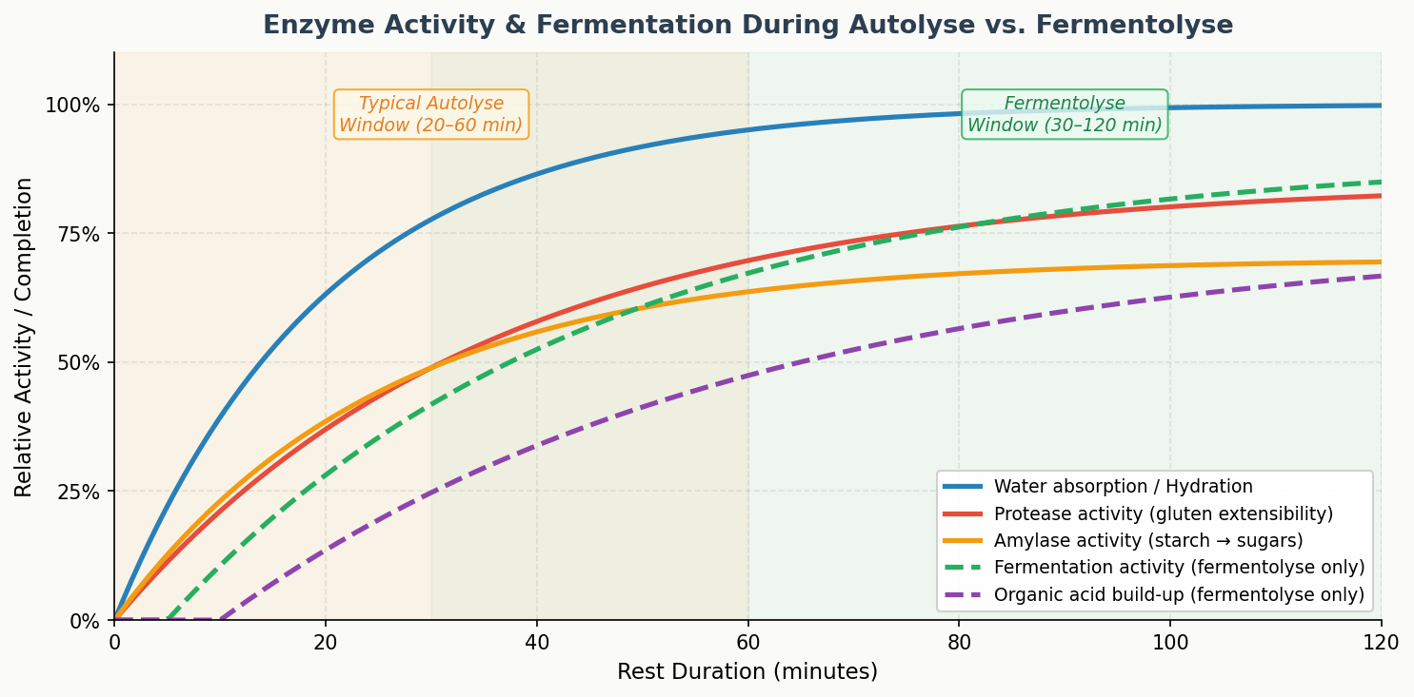
Figure 1 — Relative enzyme activity and fermentation during rest phases. Fermentolyse uniquely adds organic acid build-up (purple) and live fermentation activity (green dashes).

3. Autolyse

3.1 What Is It?
Autolyse was developed by French bread scientist Professor Raymond Calvel in the 1970s. The technique is deceptively simple: combine only flour and water — no salt, no yeast, no starter — and let the mixture rest for 20 to 60 minutes (up to 2 hours for very high-hydration doughs). Nothing else. Then continue with the rest of the recipe.

3.2 What Happens?
- Full hydration of flour particles — even without mixing.
- Protease enzymes begin softening gluten proteins, improving extensibility.
- Amylase enzymes begin converting starches to sugars.
- Gluten bonds form spontaneously — the dough becomes noticeably smoother.
- No fermentation occurs — the process is purely enzymatic and physical.

4. Fermentolyse

4.1 What Is It?
Fermentolyse is a modern variation popularised in the artisan sourdough community. You mix flour, water, AND your sourdough starter during the rest — essentially allowing a low-level fermentation to begin during the hydration phase. Rest times range from 30 minutes to 2 hours, with kitchen temperature playing a much larger role than in autolyse.

4.2 What Happens?
- Everything that happens during autolyse (hydration, protease and amylase activity).
- In addition: lactic acid bacteria (LAB) in the starter begin producing organic acids.
- Wild yeasts begin producing CO₂ and ethanol — fermentation has started.
- Moderate acid levels strengthen the gluten network; high acid levels weaken it.
- Flavour compounds begin developing earlier in the process.

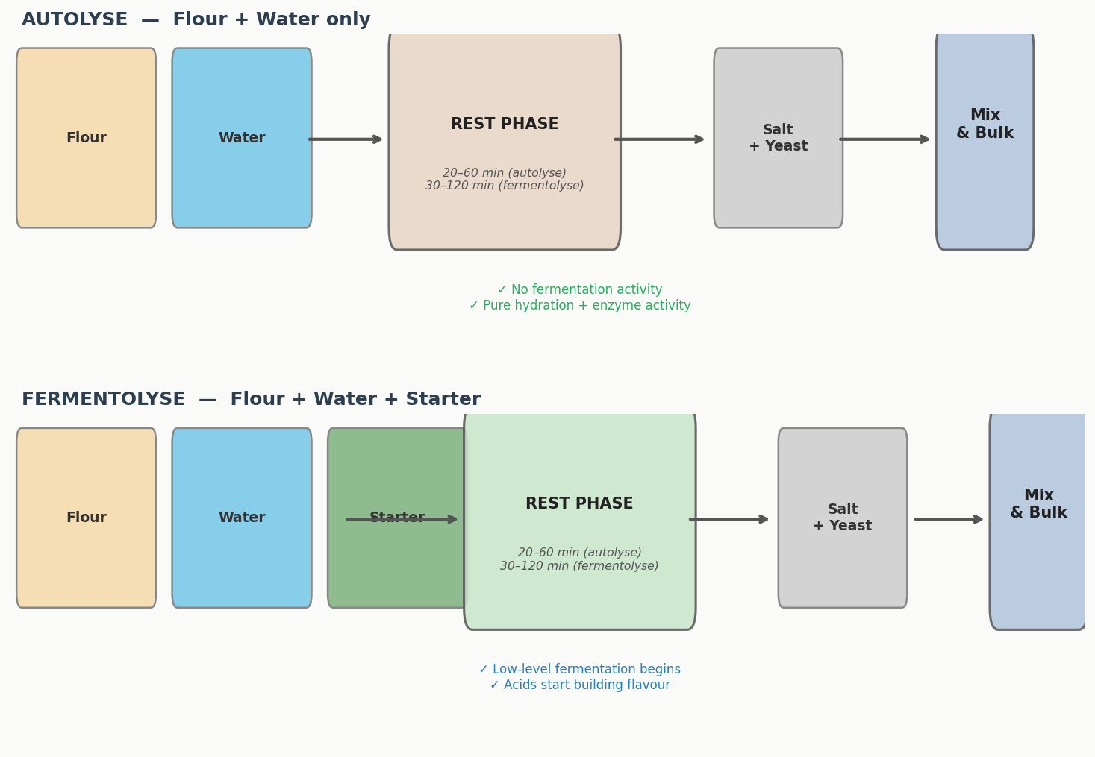
Figure 2 — Process flow for Autolyse (top) vs. Fermentolyse (bottom). Note that salt and commercial yeast are always added after the rest phase in both methods.

5. Side-by-Side Comparison

Feature | Autolyse | Fermentolyse
Ingredients in rest | Flour + Water only | Flour + Water + Starter
Salt included? | No | No
Yeast / Starter | Not included | Starter included
Fermentation during rest | None | Low-level begins
Gluten development | Passive hydration + enzymes | Hydration + enzymes + acid conditioning
Flavour development | Minimal during rest | Begins during rest
Risk of over-fermentation | None | Present — temperature-dependent
Control & predictability | High | Moderate
Suitable for commercial yeast? | Yes | No
Suitable for sourdough? | Yes | Yes — preferred for flavour

6. Pros and Cons

6.1 Autolyse

✅ Autolyse — Pros | ❌ Autolyse — Cons
Very safe and predictable — no fermentation risk | Does not contribute to flavour development
Reduces mixing and kneading time by 30–50% | Dough can feel slightly slack before salt is added
Improves extensibility — dough is easier to shape | Less benefit for low-hydration doughs (≤65%)
Better oven spring and open crumb potential | Minimal benefit for enriched doughs (fat, eggs, sugar)
Works for any bread type — commercial yeast or sourdough | Adds time to the process without flavour return
Easy to time around your schedule | Requires separate incorporation of starter later
Ideal for beginners and new recipes

6.2 Fermentolyse

✅ Fermentolyse — Pros | ❌ Fermentolyse — Cons
Jumpstarts flavour development — acids build early | Risk of over-fermentation in warm kitchens
Can improve extensibility/strength balance | Less predictable — temperature-sensitive
Useful for complex, tangy sourdough flavour profiles | Extended rest can weaken gluten through over-acidification
Reduces total bulk fermentation time slightly | Not suitable for commercial yeast bread
Integrates starter evenly before salt is added | Harder to plan around a rigid schedule
Particularly useful in cool kitchen conditions | Requires an active, well-fed starter

7. Time & Temperature Reference Tables
Kitchen temperature is the single most important variable in both methods. Warmer temperatures accelerate enzyme activity and — in fermentolyse — fermentation. Use these tables as a starting point and adjust based on your flour, starter activity, and dough hydration.

7.1 Autolyse — Rest Duration by Temperature

Parameter | 18°C / 64°F | 20°C / 68°F | 22°C / 72°F | 24°C / 75°F | 26°C / 79°F | 28°C / 82°F
Min rest (min) | 60 | 45 | 40 | 30 | 25 | 20
Max rest (min) | 90 | 75 | 60 | 45 | 35 | 30
Sweet spot (min) | 75 | 60 | 50 | 37 | 30 | 25
Notes | Slow hydration | Ideal cool day | Standard | Standard warm | Watch closely | Keep very short

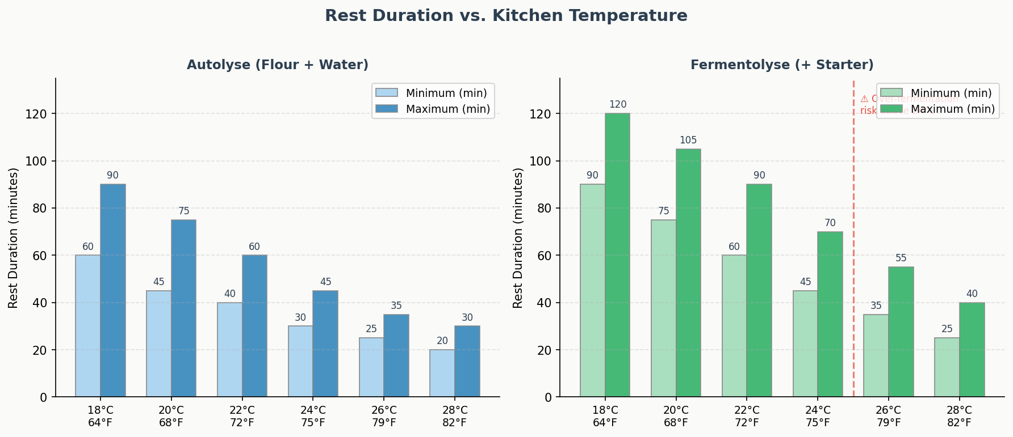
Figure 3 — Recommended rest duration ranges for Autolyse (left) and Fermentolyse (right) at different kitchen temperatures. Note the over-fermentation warning zone for Fermentolyse above 24°C.

7.2 Fermentolyse — Rest Duration by Temperature

Parameter | 18°C / 64°F | 20°C / 68°F | 22°C / 72°F | 24°C / 75°F | 26°C / 79°F | 28°C / 82°F
Min rest (min) | 90 | 75 | 60 | 45 | 35 | 25
Max rest (min) | 120 | 105 | 90 | 70 | 55 | 40
Sweet spot (min) | 105 | 90 | 75 | 57 | 45 | 32
Risk level | Low | Low | Moderate | Moderate | High | Very High
Notes | Very safe | Safe | Monitor | Monitor closely | Use autolyse instead | Not recommended

8. Full Bread-Making Timelines
The following timelines show where autolyse and fermentolyse fit within the full baking process for sourdough and commercial yeast bread. Note that sourdough timelines are significantly longer due to the slower fermentation speed of natural leaven.

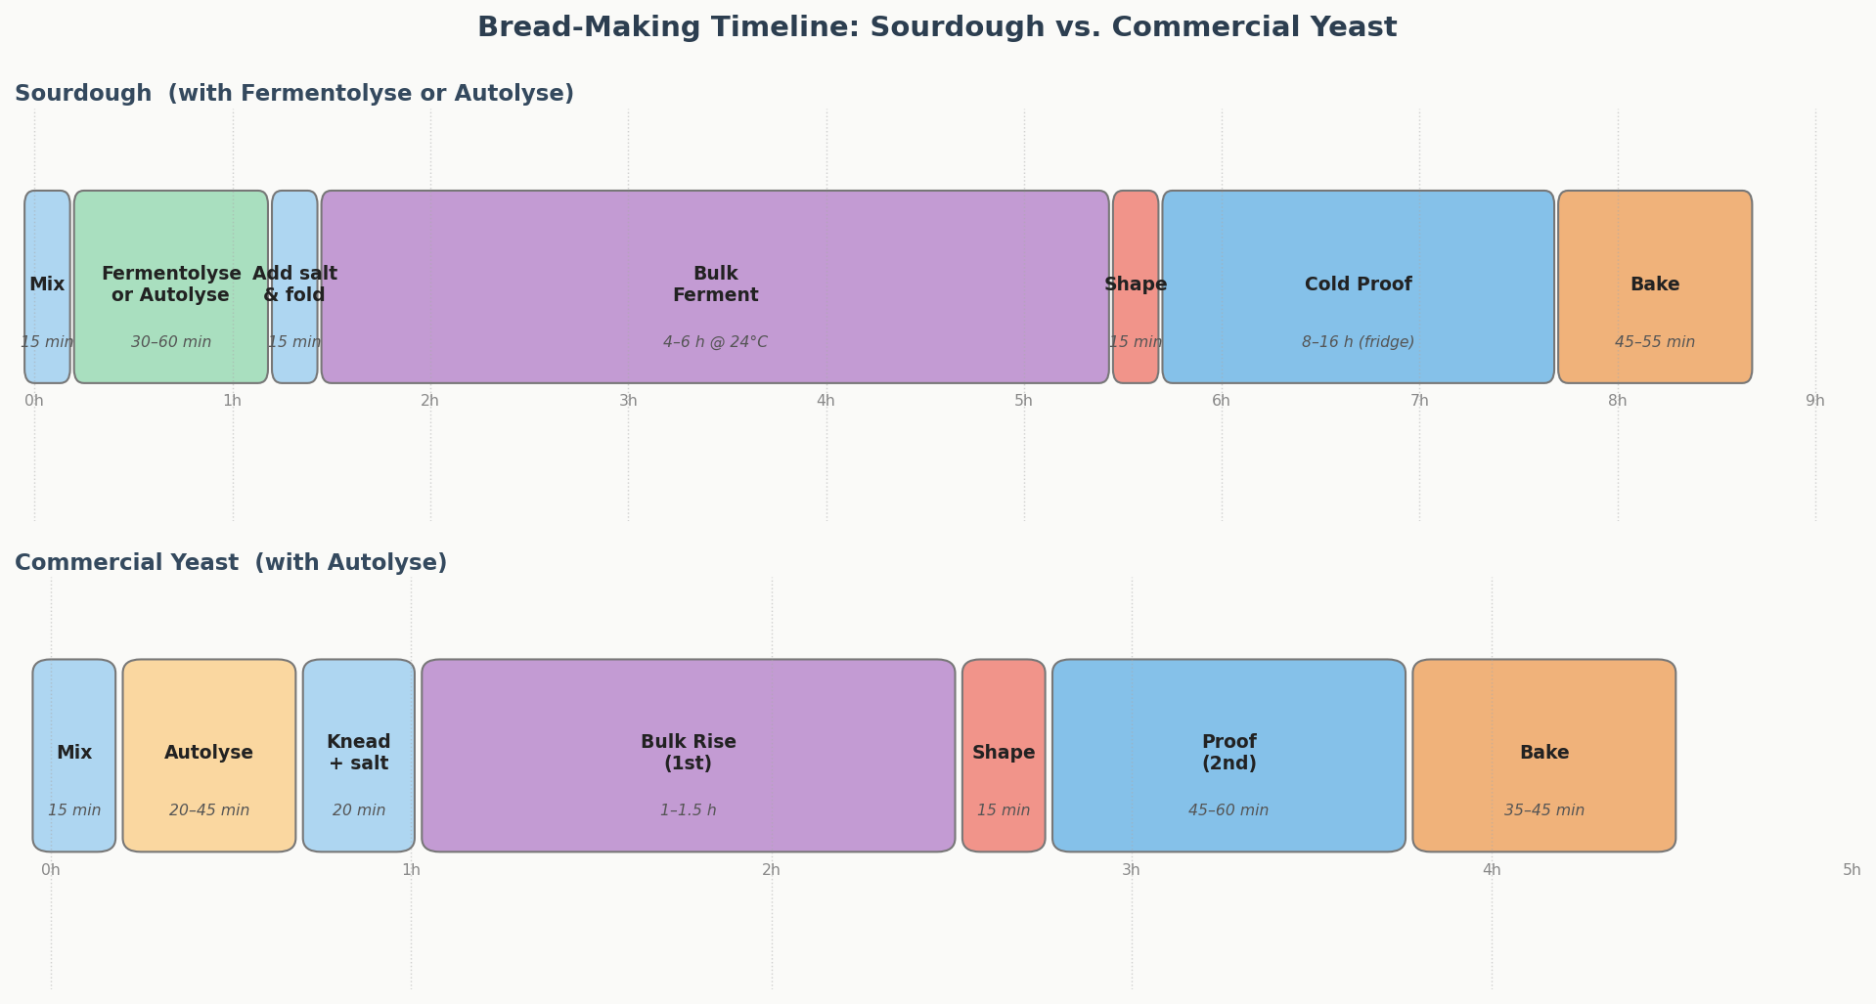
Figure 4 — Indicative timelines for Sourdough (top) and Commercial Yeast bread (bottom). Sourdough typically spans 12–18 hours total including cold proof; commercial yeast 4–6 hours.

8.1 Sourdough Timeline (Fermentolyse or Autolyse)
Phase | Duration | Temperature | Notes
Mix flour + water (+ starter for fermentolyse) | 10–15 min | 20–24°C | Rough mix — no salt yet
Autolyse / Fermentolyse rest | 30–60 min | 20–24°C | Cover, do not disturb
Add salt, fold to incorporate | 5–10 min | Ambient | Dimple salt into dough
Bulk fermentation (stretch & folds) | 4–6 hours | 22–24°C | 4–6 sets of folds every 30 min
Pre-shape | 5 min | Ambient | Gentle bench rest 20–30 min
Final shape | 5–10 min | Ambient | Build surface tension
Cold proof (retard) | 8–16 hours | 4–5°C (fridge) | Develops flavour and structure
Preheat oven + Dutch oven | 45–60 min | 250°C / 480°F | Cast iron must be screaming hot
Bake (covered) | 20 min | 250°C / 480°F | Steam creates crust and oven spring
Bake (uncovered) | 20–25 min | 220°C / 425°F | Achieve deep caramelised crust
Cool on wire rack | 1–2 hours | Room temp | Crumb sets during cooling — do not cut early

8.2 Commercial Yeast Timeline (Autolyse)
Phase | Duration | Temperature | Notes
Mix flour + water (no salt, no yeast) | 5–10 min | 20–24°C | Rough mix only
Autolyse rest | 20–45 min | 20–24°C | Cover, do not disturb
Add salt + instant yeast, knead | 8–12 min | Ambient | Window pane test to check gluten
First rise (bulk) | 1–1.5 hours | 24°C / 75°F | Until doubled in volume
Punch down, pre-shape | 5 min | Ambient | Gentle handling
Bench rest | 15–20 min | Ambient | Covered, let gluten relax
Final shape | 5–10 min | Ambient | Shape to tin or free-form
Second proof | 45–60 min | 24‒26°C | Until 1.5x original volume
Preheat oven | 20–30 min | 230°C / 450°F | With baking stone if available
Bake with steam | 10–15 min | 230°C / 450°F | Steam pan or spray for crust
Bake without steam | 20–25 min | 210°C / 410°F | Until deep golden, hollow sound
Cool on wire rack | 30–60 min | Room temp | Crumb finishes setting

9. When to Use Which Method
Use this decision guide to choose the right method for your bake. The key variables are bread type, kitchen temperature, hydration level, and your flavour goals.

Situation | Recommendation | Notes
Commercial yeast, any hydration ≥65% | Autolyse 20–45 min | Reduces kneading time
Commercial yeast, hydration <65% | Skip — not needed | Gluten forms easily
Enriched dough (brioche, milk bread) | Skip both | Fat interferes with gluten
Whole grain or rye-heavy dough | Autolyse 45–60 min | Bran needs longer hydration
Sourdough — beginner / new starter | Autolyse | Safe, predictable
Sourdough — high hydration ≥75% | Either method | Both work well
Sourdough — cool kitchen <20°C | Fermentolyse | Lower fermentation risk
Sourdough — warm kitchen >24°C | Autolyse | Avoid over-fermentation
Sourdough — complex tangy flavour goal | Fermentolyse | Acids build earlier
Sourdough — mild open crumb goal | Autolyse | Cleaner gluten development
Sourdough — whole wheat / spelt | Fermentolyse | Acids manage bran cutting
Stiff sourdough ≤68% hydration | Autolyse | Fermentolyse risk higher

10. Professional Baker's Tips

Golden Rules
- Never include salt in either rest period — salt tightens gluten and competes with hydration.
- Always cover the dough during the rest with plastic wrap or a damp towel to prevent skin formation.
- Use your dough temperature as your primary guide, not your clock.
- For fermentolyse, use a starter at peak activity — not freshly fed and not past peak.
- When in doubt, go shorter rather than longer — you can always add more time, but you cannot reverse over-fermentation.

Temperature Control
- If your kitchen is above 25°C, use cold water to control dough temperature.
- The ideal dough temperature for sourdough is 24–26°C — a probe thermometer is a worthwhile investment.
- In winter kitchens below 18°C, extend rest times and consider using slightly warm water.

Troubleshooting
- Dough feels weak and slack after fermentolyse: Starter was too active or rest was too long. Reduce rest time by 20–30%.
- Dough is still stiff after autolyse: Hydration may be low for the flour type. Extend rest or add a tablespoon of water.
- Bread lacks flavour despite fermentolyse: Starter may have been underfed. Ensure peak activity before use.
- Overproofed dough during fermentolyse: Kitchen too warm. Switch to autolyse or move the dough to a cooler spot.

11. Quick Reference Summary
 | Autolyse | Fermentolyse
Best for | All bread types | Sourdough only
Includes starter? | No | Yes
Typical duration | 20–60 min | 30–120 min
Key benefit | Control & extensibility | Flavour complexity
Temperature sensitivity | Low | High
Beginner-friendly? | Yes | Once experienced
Risk | Very low | Moderate
Flavour impact | Minimal | Significant

End of Document — Autolyse vs. Fermentolyse | 2026-05-30

